“Київський фаховий коледж зв’язку”

Циклова комісія Комп’ютерної та програмної інженерії

**ЗВІТ ПО ВИКОНАННЮ**

**ЛАБОРАТОРНОЇ РОБОТИ №4**

з дисципліни: «Операційні системи»

**Тема: «Команди Linux для архівування та стиснення даних. Робота з текстом»**

Виконали студенти

групи БІКС-03

Маламуж В.С.

Румянцев Г.А.

Хоменко А.П.

Перевірив викладач

Сушанова В.С.

Київ 2023

**Мета роботи:**

1. Отримання практичних навиків роботи з командною оболонкою Bash.
2. Знайомство з базовими командами для архівування та стиснення даних.
3. Знайомство з базовими діями при роботі з текстом у терміналі.

**Матеріальне забезпечення занять**

1. ЕОМ типу IBM PC.

2. ОС сімейства Windows (Windows 7).

3. Віртуальна машина – Virtual Box (Oracle).

4. Операційна система GNU/Linux – CentOS.

5. Сайт мережевої академії Cisco netacad.com та його онлайн курси по Linux

**Завдання для попередньої підготовки.**

*Performed by Volodymyr Malamuzh*

На базі розглянутого матеріалу дайте відповіді на наступні питання:

* 1. Яке призначення команд *tar*, *xz*, *zip*, *bzip*, *gzip*? Зробіть короткий опис кожної команди та виділіть їх основні параметри. Яким чином їх можна встановити.

The tar, xz, zip, bzip, and gzip commands are used to compress and archive files and directories.

* tar is a utility for archiving files and directories. It is usually used in conjunction with a compression program such as gzip or bzip2. The main parameters of the tar command include:

-c - create a new archive

-x - unpack an existing archive

-f - specifies the name of the archive to be created or unpacked

To install tar on a Unix-like operating system, run the command in a terminal:

sudo apt-get install tar

* xz is a data compression program that uses the LZMA2 compression algorithm. The main parameters of the xz command include:

-c - output compressed data to standard output

-d - decompress the compressed data

-k - keep the original file after compression

To install xz on a Unix-like operating system, run the command in a terminal:

sudo apt-get install xz-utils

* zip is a program for creating, compressing, and unpacking ZIP archives. The main parameters of the zip command include:

-r - recursively create an archive from a folder

-e - encrypt the archive

-d - delete a file from the archive

To install zip on a Unix-like operating system, run the command in a terminal:

sudo apt-get install zip

* bzip2 is a data compression program that uses the BZip2 algorithm. The main parameters of the bzip2 command include:

-c - output compressed data to standard output

-d - decompress the compressed data

-k - keep the original file after compression

To install bzip2 on a Unix-like operating system, run the command in the terminal:

sudo apt-get install bzip2

* gzip is a data compression program that uses the GZip algorithm. The main parameters of the gzip command include:

-c - prints compressed data to standard output

-d - decompress the compressed data

-k - keep the original file after compression

To install gzip on a Unix-like operating system, run the command in a terminal:

sudo apt-get install gzip

* 1. Наведіть три приклади реалізації архівування та стискання даних різними командами.
* gzip: is one of the most common commands for archiving and compressing data on Unix-like systems. It uses the DEFLATE algorithm to compress files, which reduces their size.
* tar: is another common archiving command that allows you to combine multiple files into a single archive file. This command does not compress the files, but simply combines them into a transferable format.
* zip: is another popular archiver that allows you to compress files and combine them into a single archive. It uses either the DEFLATE or bzip2 compression algorithm, depending on the parameter used.
  1. Яке призначення команд cat, less, more, head and tail? Зробіть короткий опис кожної команди та виділіть їх основні параметри. Яким чином їх можна встановити

The cat, less, more, head, and tail commands are command-line tools that allow you to view and edit text. The main purpose of each of these commands is as follows:

* cat - The cat command is used to read and display the contents of files in the terminal. It can also be used to merge files. Main parameters:

-n: print line numbers;

-b: print line numbers, do not print blank lines.

The cat command can be installed using the system's package manager or compiled from the source code from the developer's official website.

* less - the less command is designed to read and display the contents of files in the terminal page by page. Additionally, less allows you to search for text in a file, move back and forth through pages, scroll up and down pages, find line spacing, and more. Main options:

-f: print the contents of the file in file-follow mode.

-N: print line numbers.

* more - the more command is an older analogy of less and is also designed to display the contents of files page by page. However, it has limited capabilities compared to less, for example, it does not allow you to search for text in a file, move back and forth through pages, scroll up and down pages, or find line spacing. Main options:

-N: print line numbers.

* head - the head command is designed to display the first N lines of a file in the terminal. Main parameters:

-n N: print the first N lines of the file.

* tail - is used to print the last N lines of the file to the terminal. Main parameters:

-n N: print the last N lines of the file.

Most modern operating systems include the less, more, head, and tail commands as part of the standard installation, so they usually don't need to be installed separately. If they are missing, you can install them using the package manager.

For Ubuntu or Debian, the installation commands for each of these commands are as follows:

less: sudo apt-get install less

more: sudo apt-get install moreutils

head and tail: they are part of the coreutils package, which is usually already installed.

For CentOS or Fedora, the installation commands for each of these commands are as follows:

less: sudo yum install less

more: sudo yum install moreutils

head and tail: these are part of the coreutils package, which is usually already installed.

* 1. Поясніть принципи роботи командної оболонки з каналами, потоками та фільтрами

The command shell uses pipes, streams, and filters for convenient and efficient data processing.

* Channels are a mechanism that allows you to pass the output of one program to the input of another program, which allows you to create complex data processing structures.
* Streams are virtual channels that transfer data between programs in real time, without saving it in intermediate files. There are three types of streams: standard input (stdin), standard output (stdout), and standard error output (stderr). Each program automatically opens these streams at runtime and can use them to read input data or write output data.
* Filters are programs that take input from a stream and process it to output the result to standard output or pass it to the input of another program through a channel.
  1. Яке призначення команди grep?

The grep command is designed to search for input text in a file or set of files. It searches for strings that match a certain regular expression (pattern) and prints these strings to standard output.

The main parameters of the grep command are:

-i: ignore case sensitive characters;

-v: print strings that do not match the pattern;

-c: print the number of lines that match the pattern;

-l: print the names of the files containing the matching pattern;

-r: search subdirectories recursively.

**Хід роботи.**

*Performed by Rumyantsev Hennadiy*

* 1. Опрацюйте всі приклади команд, що представлені у лабораторних роботах курсу ***NDG Linux Essentials - Lab 9: Archiving and Compression*** та ***Lab 10: Working With Text.*** Створіть таблицю для опису цих команд***

|  |  |
| --- | --- |
| Назва команди | Її призначення та функціональність |
| mkdir mybackups | Створення нової директорії **mybackups** у домашньому каталозі користувача |
| tar -cvf mybackups/udev.tar /etc/udev | Команда **tar** використовується для об’єднання кількох файлів в один файл. В даному випадку вміст директорії **/etc/udev** буде збережено в архів **udev.tar** у директорії **mybackups**. Параметр **-c** повідомляє команді tar створити файл tar. Параметр **-v** означає "verbose", який наказує команді tar продемонструвати, що вона робить. Параметр **-f** використовується для вказівки назви файлу tar. |
| tar | Originally, tar was used to archive data on tape devices. But it also allows you to write the output to a file, and this method has become widely used in Linux for its intended purpose |
| gzip | The gzip command is designed for lossless data compression using the utility of the same name, which uses the Lempel-Ziv algorithm (LZ77) with Huffman encoding. The purpose of using this utility is to save disk space. |
| bzip2 | The bzip2 command is designed to compress data without loss using a utility that uses the Barrows-Wheeler algorithm. The purpose of using this utility is to save disk space. |
| xz | the XZXZ Utils command is a tool for developing high compression ratios for the POSIX platform |
| zip | This command includes only files ending in .c in the current directory and its subdirectories. |
| unzip | Unzip files) from the ZIP archive (a / s) (you can specify several through a space): |

\*\*\***Скріншоти** виконання команд в терміналі можна **не представляти**, достатньо **коротко описати команди в таблиці**.

* 1. Ознайомтесь з командою tar та за її допомогою виконати у терміналі наступні дії:
* створити файл з розширенням .tar;
* створити файл з розширенням .tar, що складається з декількох файлів і каталогів одночасно;
* перегляду вмісту файлу;
* витягти вміст файлу tar;
* створити архівний файл tar, стиснений за допомогою bzip;
* витягти вміст файлу tar bzip;
* створити архівний tar файл, стисненого за допомогою gzip;
* витягти вміст файлу tar gzip.
* Створив файл з розширенням .tar
* 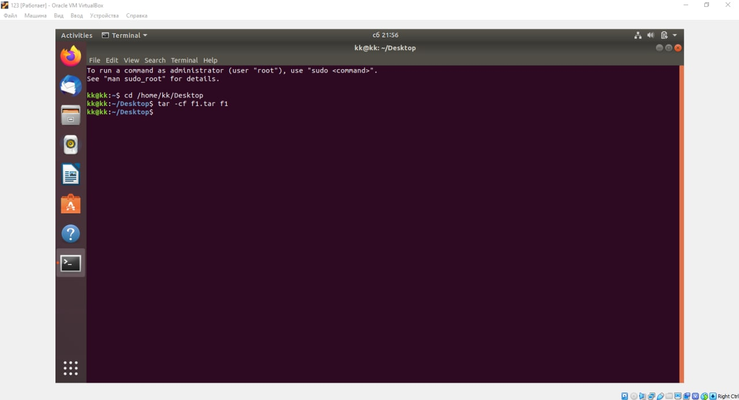
* 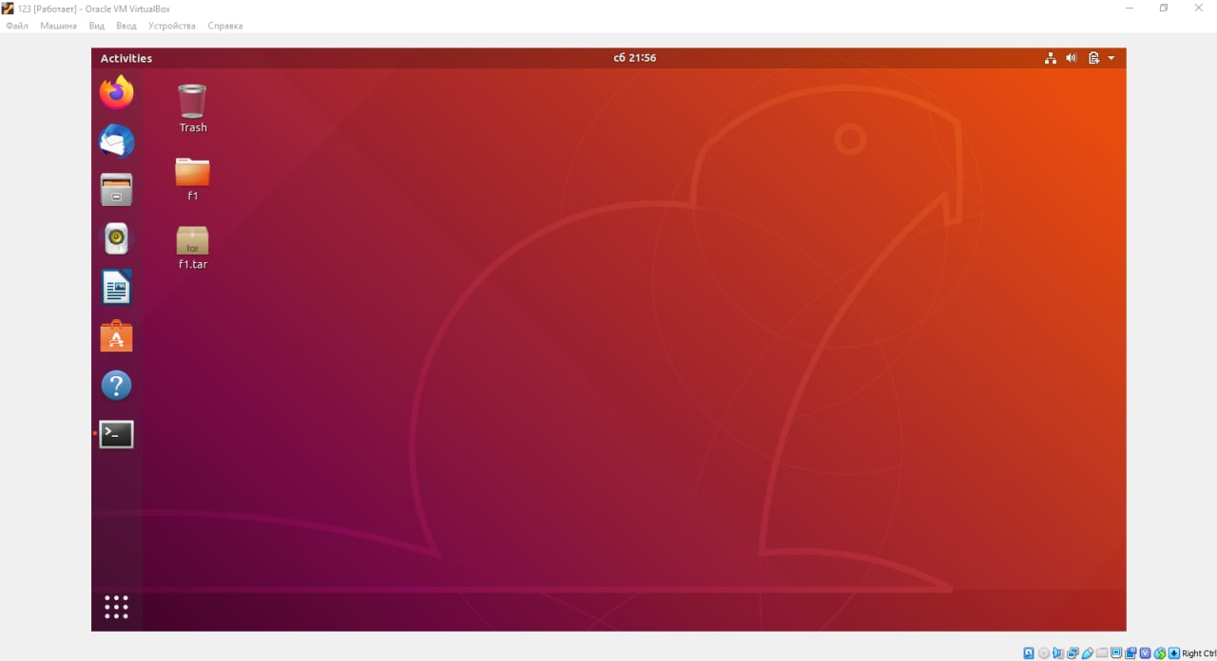
* Created a file with the extension .tar consisting of several filesЗображення, що містить текст

  Автоматично згенерований опис
* 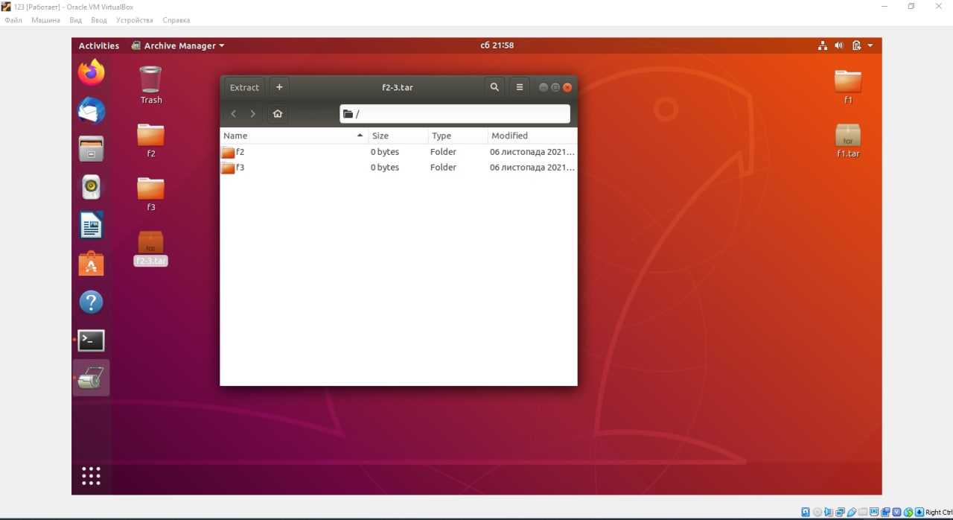
* Viewed the contents of the file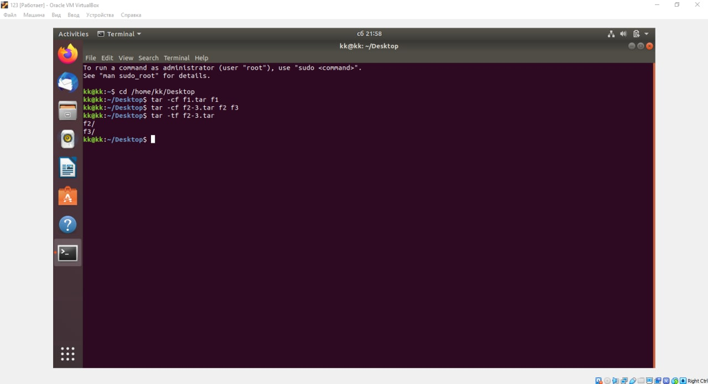
* Extract the contents of the file with the extension .tar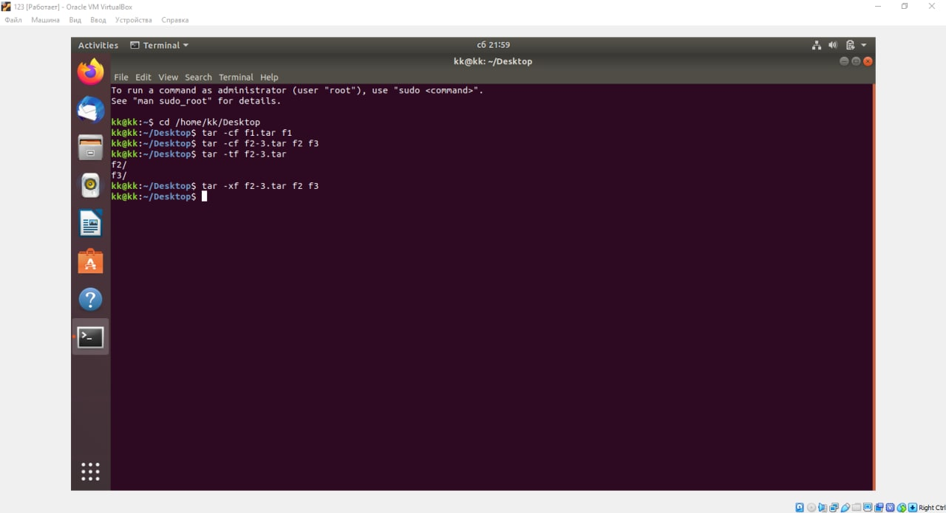
* 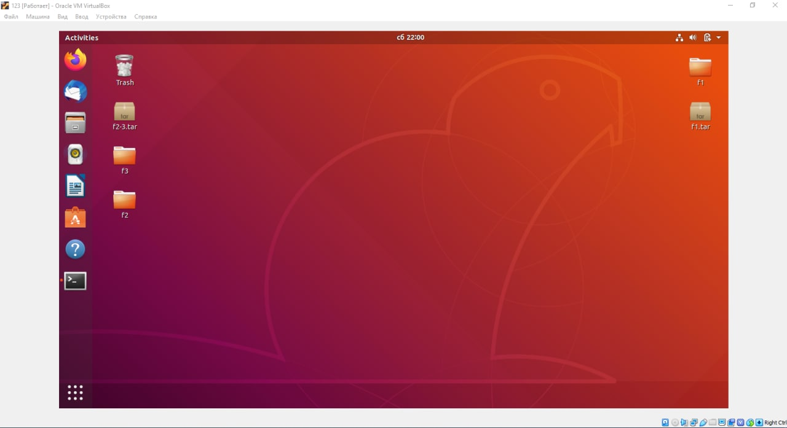
* I created a tar archive compressed with bzipЗображення, що містить текст

  Автоматично згенерований опис
* 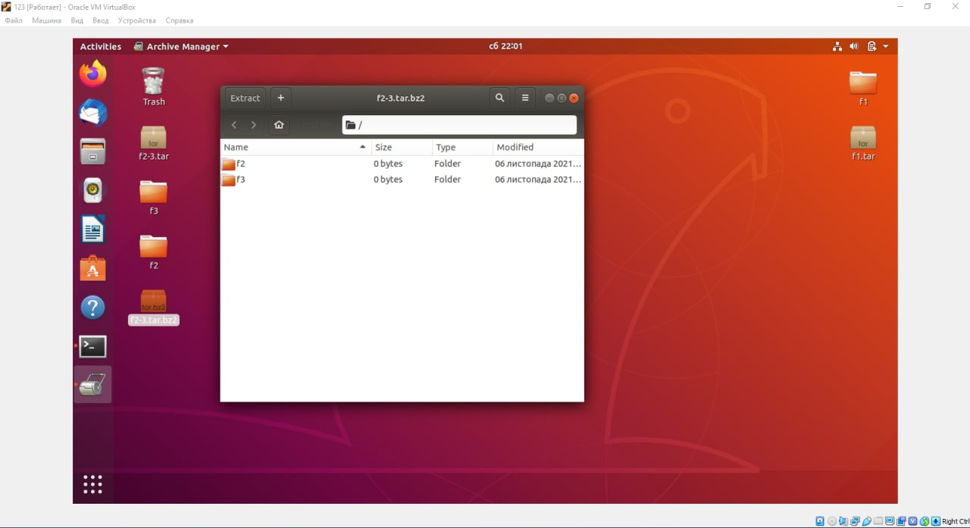
* Extract the contents of the bzip tar fileЗображення, що містить текст

  Автоматично згенерований опис
* Зображення, що містить текст, електроніка, знімок екрана, дисплей

  Автоматично згенерований опис
* Created an archive tar file compressed using gzipЗображення, що містить текст, знімок екрана, монітор, електроніка

  Автоматично згенерований опис
* 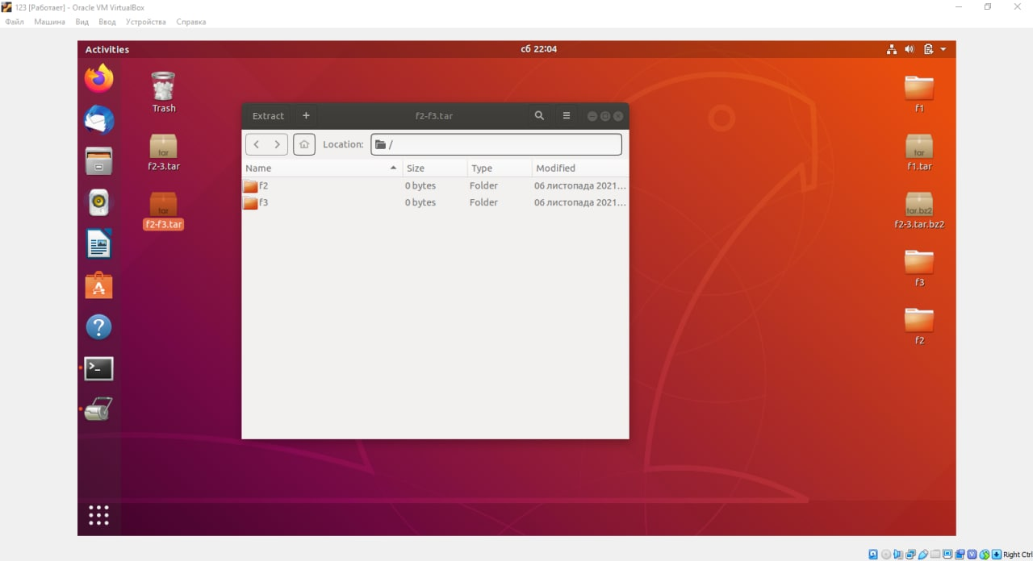
* Extract the contents of the gzip tar file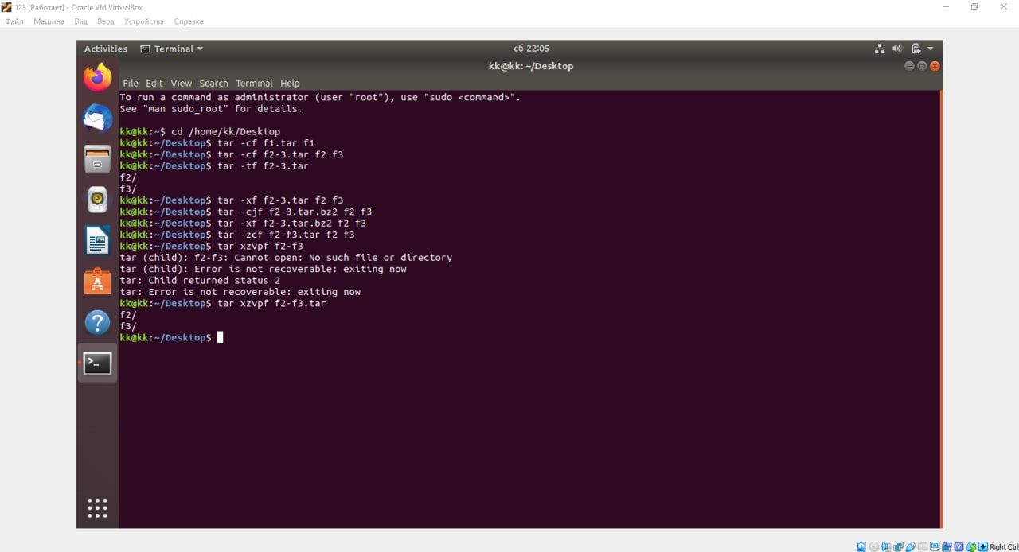
* Зображення, що містить текст, електроніка, знімок екрана, дисплей

  Автоматично згенерований опис

**Контрольні запитання**

*Performed by Khomenko Anton*

1. Надайте порівняльну характеристику процесам стискання та архівування.

**Compression** is a process of reducing the size of a file or a set of files. It involves using a compression algorithm to remove redundant or unnecessary data from the original file, which helps to reduce the size of the file. The compressed file is typically stored in a different format than the original file, and it requires a decompression program to restore the original file.

There are many different compression algorithms, including LZ77, LZ78, Huffman coding, and Arithmetic coding. Some popular compression formats include ZIP, RAR, 7Z, and Gzip.

The main advantage of compression is that it reduces the size of files, which can save disk space and make it easier to transfer files over the internet. However, compression can also have some disadvantages, such as reduced performance when accessing compressed files, as decompression can be a resource-intensive process.

**Archiving** is a process of grouping multiple files into a single archive file. The archive file is typically compressed to reduce its size, but archiving is not the same as compression. Archiving preserves the original files' structure, metadata, and attributes, and it does not remove any data from the original files.

Archiving is often used to store related files together, such as all the files for a particular project or all the files for a particular software application. Some popular archive formats include ZIP, RAR, 7Z, and TAR.

The main advantage of archiving is that it simplifies file management by grouping related files together. Archiving can also help to reduce the overall size of the files, especially if the archive format used includes compression. However, archiving does not reduce the size of individual files as effectively as compression does.

In summary, compression and archiving are two different processes that are often used together. Compression reduces the size of individual files, while archiving groups multiple files together. Both processes can help to save disk space and make it easier to manage files, but they each have their own advantages and disadvantages.

2. Які програми, крім наведених в роботі, можуть використовуватись для стискання та архівування файлів та каталогів в ОС Linux? Наведіть приклади та їх короткий опис.

Tar stands for Tape Archive. It is a command-line utility that is used for creating and extracting archive files. Tar is commonly used for archiving a collection of files into a single file for backup or transfer purposes. It supports several compression algorithms such as gzip, bzip2, and xz.

Example: To create a compressed tar archive of a directory, use the command tar -czvf archive_name.tar.gz directory_name.

Gzip is a popular compression utility for Linux. It is used to compress individual files and can be used in conjunction with other utilities to create compressed archive files.

Example: To compress a file using gzip, use the command gzip file_name. This will create a compressed file named file_name.gz.

Bzip2 is another popular compression utility that provides a higher compression ratio than gzip. It is used for compressing large files and is often used for software distribution.

Example: To compress a file using bzip2, use the command bzip2 file_name. This will create a compressed file named file_name.bz2.

Zip is a popular archive utility for creating and extracting archive files. It is a widely used format for compressing and archiving files on Windows systems, but it is also supported in Linux.

Example: To create a zip archive of a directory, use the command zip -r archive_name.zip directory_name.

7zip is an open-source archive utility that provides higher compression ratios than other utilities. It supports a wide range of archive formats and encryption algorithms.

Example: To create a compressed 7zip archive of a directory, use the command 7z a archive_name.7z directory_name.

These are just a few examples of the many utilities available for compressing and archiving files in Linux.

3. Порівняйте алгоритми стискання, що використовуються в командах (програмах), використовуваних в Linux. Які з алгоритмів можна вважати найшвидшим та найефективнішим?

Each algorithm has its own strengths and weaknesses, and the choice of which one to use will depend on the specific needs of the user.

gzip is one of the most widely used compression algorithms in Linux. It uses the DEFLATE algorithm to compress files and is fast and efficient, although not as efficient as some other algorithms. One of the advantages of gzip is that it is compatible with a wide range of systems and can be used to compress files for transmission over the internet.

bzip2 is a more modern compression algorithm that uses the Burrows-Wheeler transform and a variant of the move-to-front algorithm to achieve high levels of compression. Bzip2 is slower than gzip but is more efficient in terms of compression ratio. Bzip2 is especially useful for compressing large files that need to be stored on disk.

xz is a newer compression algorithm that uses the LZMA2 algorithm to achieve high levels of compression. Xz is generally slower than both gzip and bzip2 but is more efficient in terms of compression ratio. Xz is especially useful for compressing large files that need to be transmitted over the internet.

In terms of speed, gzip is generally the fastest of the three algorithms, followed by bzip2 and xz. However, in terms of compression ratio, xz is generally the most efficient, followed by bzip2 and gzip.

4. Опишіть програмні засоби для стискання та архівування, що можуть бути використані у вашому мобільному телефоні.

There are several compression and archiving software options that can be used on an iPhone, including:

WinZip is a popular file compression and archiving tool that is available for both Windows and iOS devices. With WinZip, users can compress files into a variety of formats, including Zip, Zipx, and RAR, and can also extract files from compressed archives. In addition to compression and archiving, WinZip also supports encryption and cloud storage integration.

iZip is a free compression and archiving tool for iOS devices that supports a wide range of file formats, including Zip, Zipx, RAR, 7Z, TAR, and GZIP. In addition to compression and archiving, iZip also supports file sharing, file management, and encryption.

Documents by Readdle is a free file manager app for iOS devices that includes built-in support for file compression and archiving. With Documents, users can compress files into Zip archives, and can also extract files from Zip, RAR, and 7Z archives. In addition to compression and archiving, Documents also supports file sharing, cloud storage integration, and PDF editing.

FileApp is another free file manager app for iOS devices that includes built-in support for file compression and archiving. With FileApp, users can compress files into Zip archives and can also extract files from Zip and RAR archives. In addition to compression and archiving, FileApp also supports file sharing, cloud storage integration, and PDF viewing.

Each app offers its own set of features and capabilities, so it is important to choose the app that best meets the specific needs of the user.

5. Опишіть та порівняйте програмні засоби для стискання та (де)архівування даних у ОС сімейства Windows.

There are several software tools for compressing and archiving data in Windows operating systems, including:

WinZip is one of the most popular file compression and archiving tools for Windows. With WinZip, users can compress files into a variety of formats, including Zip, Zipx, and RAR, and can also extract files from compressed archives. In addition to compression and archiving, WinZip also supports encryption, cloud storage integration, and file sharing.

WinRAR is another popular file compression and archiving tool for Windows. With WinRAR, users can compress files into a variety of formats, including RAR, ZIP, 7Z, and TAR, and can also extract files from compressed archives. WinRAR also supports encryption, password protection, and file splitting.

7-Zip is a free and open-source file compression and archiving tool for Windows. With 7-Zip, users can compress files into a variety of formats, including 7Z, ZIP, and TAR, and can also extract files from compressed archives. 7-Zip also supports encryption, password protection, and file splitting.

PeaZip is another free and open-source file compression and archiving tool for Windows. With PeaZip, users can compress files into a variety of formats, including 7Z, ZIP, and TAR, and can also extract files from compressed archives. PeaZip also supports encryption, password protection, and file splitting.

In terms of features and capabilities, WinZip and WinRAR offer a wider range of compression and archiving options than 7-Zip and PeaZip. However, 7-Zip and PeaZip are both free and open-source, while WinZip and WinRAR are commercial products that require a paid license to use all features.

6. Поясніть яким чином стиснення та архівування даних може бути використано для резервування даних. В яких ще задачах системного адміністрування воно може бути використано.

Data compression and archiving can be used for data backup in several ways. By compressing data before backing it up, the amount of storage space required to store the backup data can be reduced. This is particularly useful when backing up large amounts of data, as it can save significant amounts of storage space and reduce backup times. Additionally, archiving data before backing it up can help to organize the backup data and make it easier to manage.

In addition to data backup, data compression and archiving can also be used for other system administration tasks, such as:

File transfer: Compressing files before transferring them over a network or via email can reduce the amount of bandwidth required for the transfer, making it faster and more efficient.

Storage management: Archiving files that are no longer needed on a regular basis can help to free up storage space on a system or network.

Software distribution: Compressing software packages before distributing them can reduce the size of the package, making it faster and easier to distribute.

Disaster recovery: Archiving critical system files and configurations can help to ensure that they are easily recoverable in the event of a system failure or disaster.

Overall, data compression and archiving can be used for a wide range of system administration tasks, helping to improve efficiency, reduce storage requirements, and simplify data management.

7. Яке призначення директорії файлу /dev/null?

The /dev/null file directory in Linux is a special file that serves as a black hole or a trash can for data. Any data written to /dev/null is discarded and not saved to disk. It is often used to discard unwanted output from a command or to send output to a place where it won't cause any harm.

The /dev/null directory serves as a convenient way to discard unwanted output and is commonly used in shell scripts to suppress output or to prevent errors from being displayed to the user.

**Conclusion:**

*Linux commands for archiving and compressing data are a very powerful tool for storing and transferring large amounts of data. These commands allow you to create archives, which can include files and folders, and compress them to reduce their size. In general, data archiving and compression commands are very useful for managing the amount of data on your computer. They allow you to back up files and directories, transfer them over a network with less bandwidth, and reduce the size of files, which allows you to store more data on disk.*