“Київський фаховий коледж зв’язку”

Циклова комісія Комп’ютерної та програмної інженерії

**ЗВІТ ПО ВИКОНАННЮ**

**ЛАБОРАТОРНОЇ РОБОТИ №4**

з дисципліни: «Операційні системи»

**Тема: «Створення скриптових сценаріїв та визначення апаратної конфігурації системи»**

Виконали студенти

групи БІКС-03

Маламуж В.С.

Румянцев Г.А.

Хоменко А.П.

Перевірив викладач

Сушанова В.С.

Київ 2023

**Тема: “Створення скриптових сценаріїв та визначення апаратної конфігурації системи”**

**Мета роботи:**

1. Отримання практичних навиків роботи з командною оболонкою Bash.
2. Знайомство знайомство з базовими діями при роботі зі скриптовими сценаріями.

**Матеріальне забезпечення занять**

1. ЕОМ типу IBM PC.

2. ОС сімейства Windows (Windows 7).

3. Віртуальна машина – Virtual Box (Oracle).

4. Операційна система GNU/Linux – CentOS.

5. Сайт мережевої академії Cisco netacad.com та його онлайн курси по Linux

**Завдання для попередньої підготовки.**

***Performed by student Volodymyr Malamuzh***

1. На базі розглянутого матеріалу дайте відповіді на наступні питання:
   1. Охарактеризуйте поняття скриптового сценарію у командній оболонці.

In the command shell, a script is a file with a sequence of commands that are executed sequentially when this file is run. Such a file usually contains an automated script to perform certain tasks or processes.

These scripts allow you to automate routine processes and provide more efficient work with the command shell.

Scripts can accept arguments, which makes them more versatile and suitable for performing various tasks. They can also contain conditional statements, loops, functions, and other programming language constructs, which makes them very powerful.

Scripts can be used to automate many processes, such as copying, moving, and deleting files, processing text files, working with network services, and more. They are also a useful tool for administrators who have to manage many systems and servers, allowing them to automate processes across multiple platforms.

* 1. Яким чином створюються та редагуються скрипти, що треба зробити щоб запустити скрипт?

Linux scripts are usually created in a text editor and saved with the .sh extension.

To create and edit a script, you can open any text editor and enter the necessary commands.

To run a script on Linux, you need to follow these steps:

* Open a terminal or command prompt on Linux.
* Find the path to the script you want to run.
* Make the script executable with the command chmod +x /path/to/myscript.sh. This command changes the access rights to the file and allows it to be executed as a program.
* Run the script by entering the command ./path/to/myscript.sh in the terminal.

After completing these steps, the script should run. It is important to remember that the script must be written with the appropriate rights.

* 1. Які основні компоненти материнської плати ви знаєте?
* Central processing unit (CPU) - the main processor that performs calculations.
* Socket - a connector for installing the CPU on the motherboard.
* RAM slots - for connecting RAM, which provides quick access to the data needed to run programs.
* System Bus - provides communication between all components on the motherboard.
* BIOS - The main input/output system that initializes the computer and provides communication between the RAM, processor, and other devices.
* Bus controller - provides communication between various components on the motherboard, such as SATA, PCI, USB, etc.
* Graphics card connector - A specialized connector for installing a graphics card.
* Expansion connectors (PSI slots) - allow you to connect additional devices such as video cards, sound cards, network cards, etc.
* Power supply - provides power to all components on the motherboard.
  1. Коротко охарактеризуйте для яких пристроїв оперують поняттями MBR та GPT?

MBR (Master Boot Record) and GPT (GUID Partition Table) are formats for allocating disk space on hard disks. Both formats are used to create partitions on a hard disk that can be used to store data and install an operating system.

MBR is an older technology and supports partitions up to 2 TB. It is used to run most older computers with operating systems such as Windows XP, Windows 7, and Linux.

GPT is a newer technology and supports partitions over 2 TB. It is used to run most modern computers with operating systems such as Windows 10, MacOS, and Linux. In addition, GPT is more error-resistant and has a greater ability to store more information about partitions.

* 1. В чому суть операції монтування, для чого вона потрібна?

Mounting is the process of associating a file system with a specific partition on a disk so that the contents of the partition become available to the user. After the partition is mounted, the user can access the files stored on this partition as if they were regular files in the operating system.

Mounting is necessary for accessing data stored on external media such as USB drives, flash cards, external hard drives, and other storage devices. Mounting can also be used to access different partitions on the internal hard disk, which can be partitioned to store different types of data.

**Хід роботи.**

***Task 1 was performed by Volodymyr Malamuzh***

* 1. Опрацюйте всі приклади команд, що представлені у лабораторних роботах курсу ***NDG Linux Essentials - Lab 11: Basic Scripting*** та ***Lab 12: Understanding Computer Hardware.*** Створіть таблицю для опису цих команд***

|  |  |
| --- | --- |
| Назва команди | Її призначення та функціональність |
| sh test.sh | prints the string Hello, World! to the console. |
| test –f /dev/ttyS0 | |  | | --- | | 0 if the file exists | |  | |
| test ! –f /dev/ttyS0 | |  | | --- | | 0 if the file doesn’t exist | |  | |
| test –d /tmp | |  | | --- | | 0 if the directory exists | |  | |
| test –x `which ls` | |  | | --- | | substitute the location of ls then test if the user can execute | |  | |
| test 1 –eq 1 | |  | | --- | | 0 if numeric comparison succeeds | |  | |
| test ! 1 –eq 1 | |  | | --- | | NOT – 0 if the comparison fails | |  | |
| test 1 –ne 1 | |  | | --- | | Easier, test for numeric inequality | |  | |
| test “a” = “a” | |  | | --- | | 0 if the string comparison succeeds | |  | |
| test “a” != “a” | |  | | --- | | 0 if the strings are different | |  | |
| test 1 –eq 1 –o 2 –eq 2 | |  | | --- | | -o is OR: either can be the same | |  | |
| test 1 –eq 1 –a 2 –eq 2 | -a is AND: both must be the same |
| for | are used when you have a finite collection over which you want to iterate. |
| while | operates on a list of unknown size. Its job is to keep running and on each iteration perform a test to see if it should run another time. |
| arch | To see which family the CPU of the current system belongs to |
| lscpu | For more information concerning the CPU. |
| free | To view the amount of RAM in your system, including the swap space |
| free -m | to force the output to be rounded to the nearest megabyte (MB) |
| free -g | to force the output to be rounded to the nearest gigabyte (GB) |
| lspci | To view all of the devices connected by the PCI bus |
| lsusb | To display the devices connected to the system via USB |
| fdisk | can be used to display further information about the partitions |
| umount | to unmount disk |

\*\*\***Скріншоти** виконання команд в терміналі можна **не представляти**, достатньо **коротко описати команди в таблиці**.

***Task 2 was performed by Rumiantsev Hennadiy***

1. Створіть скриптові сценарії з виводом текстових повідомлень для користувача (продемонструйте скріншоти):

* сценарій має виводити привітання до поточного користувача вказуючи поточну дату та інформацію про поточну систему;
* сценарій має виводити інформацію про апаратну конфігурацію поточної системи (використовуйте команди розглянуті в Lab 12).
* 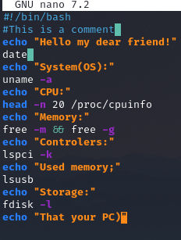

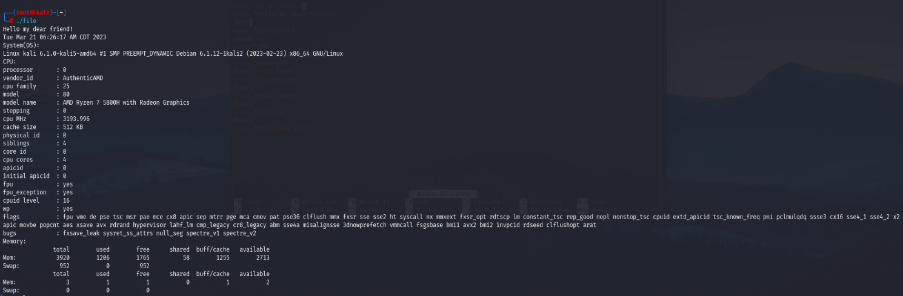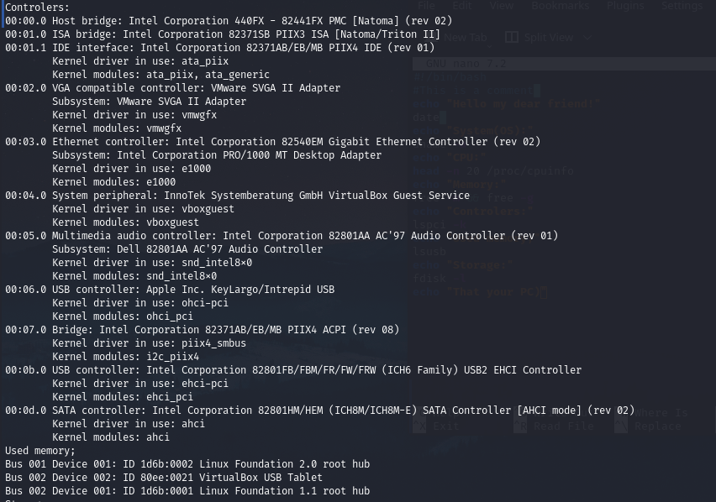

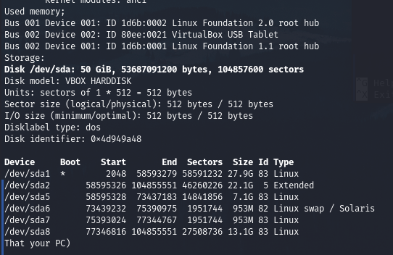

**Контрольні запитання**

***Performed by student Khomenko Anton***

1. Яким чином у скриптах можна опрацьовувати змінні та створювати розгалужені та циклічні сценарії?

In Linux scripts, variables can be handled using shell variables or environment variables. Shell variables are used for storing temporary values within the script, while environment variables are used to store values that can be accessed by other programs as well.

To create branching scenarios in Linux scripts, the if statement is commonly used.

To create loop scenarios in Linux scripts, the for loop and while loop are commonly used. The syntax of the for loop is as follows:

In both loops, the break statement can be used to exit the loop and the continue statement can be used to skip to the next iteration of the loop.

1. В чому відмінність між командами arch та lscpu?

Both arch and lscpu commands are used in Linux to get information about the system and the CPU architecture, but they provide different types of information.

The arch command displays the machine architecture name of the Linux operating system, such as x86_64, armv7l, or aarch64. This command can be used to determine whether a system is running a 32-bit or 64-bit architecture.

The lscpu command, on the other hand, provides detailed information about the CPU architecture of the system, such as the number of CPU cores, the clock speed, and the byte order. This command can be used to check the CPU specifications of a system, and it can be especially useful for identifying whether a system supports certain features like virtualization.

The arch command provides the machine architecture name of the Linux operating system, while the lscpu command provides detailed information about the CPU architecture of the system.

1. Якою командою можна отримати інформацію про стан використання RAM поточною системою?

The free command can be used to get information about the current system's RAM usage status.

The free command displays the total amount of physical memory, the amount of memory that is currently used, and the amount of memory that is available for use. It also displays information about the swap space usage if it's configured.

This command will display the memory usage in kilobytes. Alternatively, you can also use the -h.

This command will display the memory usage in gigabytes, megabytes, and kilobytes. The free command can be useful for monitoring the memory usage of the system and identifying any potential memory issues.

1. Які команди для перегляду стану підключення периферійних пристроїв можна використати в терміналі?

We can use the following commands in the terminal to view the connection status of peripheral devices:

lsusb: This command lists all USB devices connected to the system. It displays detailed information about each device, such as the device ID, manufacturer, and product name.

lspci: This command lists all PCI devices connected to the system. It displays detailed information about each device, such as the device ID, vendor, and device name.

lsblk: This command lists all block devices, such as hard drives and USB drives, that are connected to the system. It displays detailed information about each device, such as the device name, size, and mount point.

dmesg: This command displays the system's kernel ring buffer, which contains information about the system's hardware and software status. It can be used to diagnose connection issues with peripheral devices.

ip link show: This command displays the status of all network interfaces, including Ethernet and Wi-Fi adapters. It displays detailed information about each interface, such as the MAC address and connection status.

1. Які можливості застунку gparted?

GParted is a popular graphical partition editor for Linux that allows users to manage and manipulate disk partitions on their system. Some of the possibilities and features of GParted include:

Partitioning: GParted allows users to create, delete, resize, move, copy, and paste partitions on their hard drive.

Filesystem support: GParted supports a wide variety of filesystems, including ext2, ext3, ext4, NTFS, FAT32, and many more. This allows users to work with partitions that are formatted in different filesystems.

Filesystem checks and repairs: GParted allows users to check and repair filesystem errors on their partitions. This can be useful for ensuring the integrity and reliability of data stored on the partitions.

Bootable media creation: GParted allows users to create bootable media, such as a USB drive or CD, which can be used to boot into GParted and perform partitioning operations.

Live partition resizing: GParted can resize partitions while the system is running, without the need to boot into a separate live environment or shutdown the system.

Data preservation: GParted can preserve data on the partition while resizing, copying, or moving the partition, minimizing the risk of data loss.

**Conclusion:**

**Creating scripted scenarios and determining the hardware configuration of the system are important tasks to ensure the efficiency and effectiveness of computer systems.**

**Creating scripted scenarios allows you to automate the processes of working with software and expand the capabilities of the operating system. Thanks to scripts, you can create convenient user interfaces that provide quick access to the necessary operations and functions.**

**On the other hand, determining the hardware configuration of the system allows you to ensure maximum performance and efficiency of the computer. This includes determining the necessary hardware components, such as the processor, RAM, and hard disk, as well as optimizing the system settings to work with certain software applications.**