**Тема: “Збереження службових даних системи та її мережева конфігурація”**

**Мета роботи:**

1. Отримання практичних навиків роботи з командною оболонкою Bash.
2. Знайомство з базовими структурами для збереження системних даних - процеси, память, лог-файли та повідомлення про стан ядра.
3. Знайомство зі стандартом FHS.
4. Знайомство з діями при налаштуванні мережі.

**Матеріальне забезпечення занять**

1. ЕОМ типу IBM PC.

2. ОС сімейства Windows (Windows 7).

3. Віртуальна машина – Virtual Box (Oracle).

4. Операційна система GNU/Linux – CentOS.

5. Сайт мережевої академії Cisco netacad.com та його онлайн курси по Linux

**Завдання для попередньої підготовки.**

*Performed by student Malamuzh Volodymyr*  
На базі розглянутого матеріалу дайте відповіді на наступні питання:

* 1. Розкрийте поняття “псевдо файлової системи”, для чого воно потрібно системі?

A pseudo-file system is a virtual data structure that mimics a file system but does not use any connection to physical storage devices. This means that the data stored in a pseudo-file system is not located on the hard disk, it is only a virtual representation of the data that is stored in RAM or other resources.

The pseudo-file system is an important element of operating systems such as Linux and UNIX. It provides convenient access to various system resources, such as information about processes, memory, network, and other system attributes. All these resources can be accessed through the file system interface, which greatly simplifies their interaction with the system.

* 1. Чому користувачі не так часто звертаються на пряму до каталогу /proc, яким чином з нього можна отримати інформацію?

Users don't often access the /proc directory directly on Linux because it contains many virtual files and directories that have complex and incomprehensible names. In addition, access to these files requires administrator privileges.

To get information from the /proc directory, you can use special programs or commands that allow you to read the contents of files containing information about system resources.

Here are some examples:

* The cat /proc/cpuinfo command shows information about the system's processor, including its type, frequency, and number of cores.
* The cat /proc/meminfo command provides information about the system's memory usage, including total, used, and free memory.
* The cat /proc/loadavg command displays the system's process minimization values for the last 1, 5, and 15 minutes.
* The ls /proc/[PID]/ command allows you to view information about a specific process, where [PID] is the process identifier.
  1. Яке призначення файлів /proc/cmdline, /proc/meminfo та /proc/modules?

The /proc/cmdline file contains the command line that was used as the kernel parameters when it was booted. This file can be useful for system administrators who want to check kernel settings, as well as for software developers who want to check what parameters are being used during development and testing of their software.

The /proc/meminfo file contains information about the system's memory usage, including total, used, and free memory, buffer usage, and caching. It is useful for system administrators who want to monitor memory usage, as well as for software developers who want to determine how much memory their programs are using.

The /proc/modules file contains a list of loaded kernel modules. It is used by system administrators who want to check which kernel modules are loaded on the current system, as well as by software developers who want to check whether a required kernel module is supported on the system. Additionally, the /proc/modules file can be useful for troubleshooting kernel module loading issues.

* 1. Яке призначення команди free?

The free command is used to display information about the system's memory usage. The command shows the total amount of available, used, and free memory, including physical memory, page alignment, and buffer/cache alignment.

In addition, the free command can show information about memory usage by processes.

It can be useful for system administrators who want to monitor memory usage and detect possible memory problems, such as OOM (Out of Memory) or memory leak.

* 1. Для чого потрібні лог-файли, наведіть приклади їх застосування?

Log files are an important tool for tracking the operation of the system and programs, saving information about errors and events that occurred in the system. The main examples of using log files:

* Security auditing: log files can be used to store information about system logins, operations, and other events that occur on the system. This helps to find and resolve security issues.
* Error tracking: log files store information about errors that occurred in the system or programs, which helps you understand the causes of errors and resolve them.
* Tracking program activity: Log files can help you track the activities of programs and services running on the system. This can help identify problematic programs and understand what they are doing.
* Monitoring system performance: Log files can help you track system performance, resources, and performance. For example, they can indicate which processes are consuming more resources or what could lead to a system failure.
* Performance analysis: log files can be used to analyze the performance of programs and the system. For example, they can show how long some operations take to complete, what resources they use, and what can be done to improve performance.
* Recovery: Log files can help you recover a system after a failure or crash. Information stored in log files can help restore the system to a pre-failure state.
  1. Яке призначення файлу /var/log/dmesg?

The /var/log/dmesg file stores the results of the Linux kernel startup. When the system starts up, the Linux kernel performs various initialization routines, initializes the hardware, and starts various device drivers. The dmesg file contains the messages generated by these procedures and allows you to monitor their operation and identify possible problems. The information in the dmesg file can help you identify problems with devices that are not working properly, as well as problems with the system configuration. You can also view the dmesg file to see what devices are installed on the system and what drivers are used to support them.

* 1. Для чого розроблено FHS?

FHS (Filesystem Hierarchy Standard) is a standard that defines the structure of directories and files in the Linux operating system and other UNIX-like systems. This standard was developed to provide ease of installation and management of software packages on Linux systems.

FHS provides a standard directory hierarchy for Linux systems, including directories for storing programs, configuration files, libraries, kernel, documentation, etc. This makes it easier for software developers and system administrators to navigate the Linux file system and provides a standard way to organize data on hard drives.

FHS makes the process of deploying and managing applications easier and more consistent. In addition, the standard allows for greater compatibility between different Linux distributions and a lower entry threshold for newcomers to the Linux world.

* 1. Які основні команди є у Linux для перегляду та конфігурації мережі

Linux has several commands for viewing and configuring the network, the main ones are as follows:

* ifconfig - a command that displays information about the status of network interfaces. It displays the IP address, MAC address, connection status, and other information about the network interfaces.
* ip addr is a command that displays information about the status of network interfaces that have been configured in the system. It displays the IP address, MAC address, connection status, and other information about the network interfaces.
* route is a command that displays the routing table. It shows the path that should be used to transmit packets to a particular network or IP address.
* traceroute is a command that allows you to determine the route that packets must take to reach a specific network or IP address.
* ping - a command used to check the availability of a specific network or IP address.
* ss - a command that shows information about network connections that are open on the machine in real time.
* netstat - a command that displays network connection statistics and information about active connections on the system.
* nmap is a command used to scan the network and identify active hosts, ports, and services.

**Хід роботи.**

*Performed by student Malamuzh Volodymyr*

* 1. Опрацюйте всі приклади команд, що представлені у лабораторних роботах курсу ***NDG Linux Essentials - Lab 13: Where Data is Stored*** та ***Lab 14: Network Configuration.*** Створіть таблицю для опису цих команд***

|  |  |
| --- | --- |
| Назва команди | Її призначення та функціональність |
| su | Change the current user to root |
| ls /proc | View the contents of the /proc system directory (root access required) |
| cat | View information about the process |
| jobs | To see which commands are running in the current terminal |
| ping localhost > /dev/null & | Start ping command in the background |
| fg %1 | Bring the first command to the foreground |
| bg %1 | To have this process continue executing in the background |
| kill | stop the last command |
| killall | stop all of the commands |
| top | sorts the processes in descending order of percentage of CPU usage |
| man kill | Read more about the assigned values |
| sleep | used to pause a program (shell script) for a specific period of time. |
| pkill | to terminate the remaining sleep command, using the name of the program rather than the PID |
| ps | can be used to view processes. |
| ps -e | so all processes are displayed. |
| ps -o | to specify which columns to output. |
| --sort | to specify which column(s) to sort by. |
| free | will show overall system memory usage |
| ipconfig | In order to determine your Internet Protocol (IP) address |
| route | To view the table of routing information |
| dig | to resolve the name to an IP address |
| netstat | performs a large variety of tasks related to networking. |
| ss | to display network statistics |

\*\*\***Скріншоти** виконання команд в терміналі можна **не представляти**, достатньо **коротко описати команди в таблиці**.

*Performed by student Rumyantsev Gennadiy*

* 1. Виконайте практичні завдання у терміналі (продемонструйте скріншоти):
* в даній лабораторній роботі використовувалась команда *cat*, дослідіть її можливості та опишіть для яких задач вона призначена;
* продемонструйте приклади, коли команда *cat* використовується для створення файлу, перегляду вмісту файлу, перенаправлення інформації у інший файл, склеювання декількох файлів в один;
* які параметри команди *cat* треба використати, щоб пронумерувати рядки файлу, відобразити недруковані символи, видалити порожні рядки?
* опишіть можливості команди *dig* та наведіть приклади;
* опишіть можливості команди *netstat* та наведіть приклади;.

1. Cat reads data from files and outputs their contents. This is the easiest way to display the contents of a file on the command line, also cat can create,change file and filter text

Options:

* -n, -number - output the number of each result line.
* -b, -number-nonblank - output the number of each result line, except empty lines. This option overrides -n.
* -E, -show-ends - display "$" at the end of each line.
* -s, -squeeze-blank - exclude repeated empty lines from the output.
* -T, -show-tabs - show tab characters as ^I.
* -v, -show-nonprinting -show non-printable characters, except tabs and end of line.
* -t -show-nonprinting characters except the end of the line.
* -e -show-nonprinting, except tabulation.
* -A, -show-all -show all non-printable characters.
* -help -display help and exit.
* -version - print version information and exit.
* 2. View the content:
* 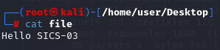
* 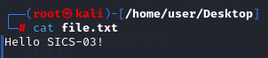
* Create file:
* 
* 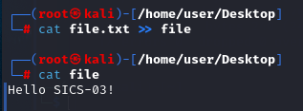
* merge multiple files into one:
* 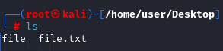
* 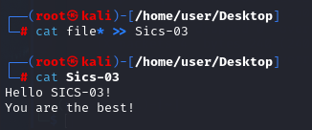
* 3. numbering of file lines
* 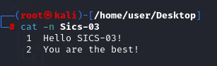
* Displaying unprintable characters:
* 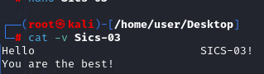
* removing empty lines
* 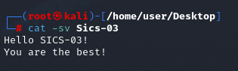
* 4.
* The dig command is a multifunctional tool for querying DNS servers. It allows you to get more information about a particular domain, in order to know, for example, the IP addresses it uses.
* 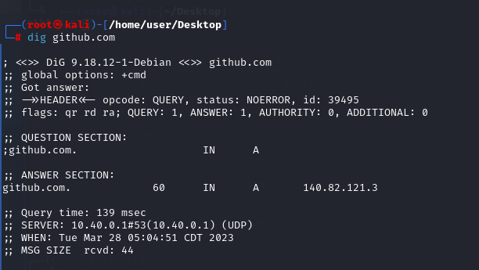
* 5.
* The netstat command works together with the ifconfig command to display the status of the TCP/IP network interface. The netstat command shows statistics for sending and receiving packets, as well as information about sending and receiving errors, which can be useful when troubleshooting SLIP connections
* 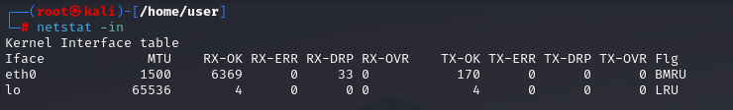

**Контрольні запитання**

*Performed by student Khomenko Anton*

1. Як пов'язані між собою команди cat та tac?

The cat command is used to concatenate and display the contents of one or more files. It takes one or more filenames as arguments, and outputs the contents of those files to the terminal in the order they were specified.

The tac command, on the other hand, is used to display the contents of a file in reverse order, line by line. It is essentially the opposite of the cat command, where instead of displaying the contents of a file in the order they were specified, it displays them in reverse order.

One interesting thing to note is that the name tac is simply cat spelled backwards, which is why they are related in name as well as function. The tac command can be useful for viewing log files or other files where the most recent entries are at the end of the file. By using tac, you can easily view the most recent entries without having to manually scroll through the entire file.

1. Що робить команда ss?

In Linux, the ss command is used to display network connection statistics, i.e., it shows information about the status of the network. It can also be used to configure the network.

With the ss command, you can display information about active network connections, ports being listened to, the status of network interfaces, and other information about the Linux kernel network stack.

In addition, the ss command can be useful for diagnosing network problems, identifying ports in use, and examining other characteristics of network activity, such as packet size, sending frequency, and so on.

1. В чому відмінність між командами ps --forest та pstree?

The ps --forest and pstree commands are used to display the hierarchy of processes on a system. However, there are some differences between these commands.

The ps --forest command displays information about processes in the form of a hierarchy tree. It includes all child processes that belong to the same process tree as the parent process. It also includes the PID of the process, the PID of its parent process, and other information about each process.

The pstree command displays information about processes in the form of a hierarchy tree. It includes all processes running on the system and shows their hierarchy. It also includes information about each process, such as PID, process name, command line arguments, and other information.

The main difference between these commands is that ps --forest displays information only about the process tree starting from the specified root process, while pstree displays information about all processes running on the system.

It is also worth noting that pstree is a third-party command and is not included in the standard set of utilities in most Linux distributions, while ps is a standard utility in Linux.

1. У яких каталогах зберігаються налаштування системи?

The /etc directory is one of the most important system configuration directories. This directory contains settings for system services, program configuration files, database files, network settings, and more.

/usr is the directory with most programs and system files that are not required to run the system. This directory usually contains the settings of applications that are installed using package managers.

/var is a directory that stores variable files that often change during system operation. You can find files such as log files, cached files, databases, file systems stored on remote servers, etc.

/home is the directory where users' home folders are stored. Each user has their own directory in /home where they can store their files and documents.

/boot is the directory where the files needed to boot the system are stored. This directory usually contains the Linux kernel and the bootloader configuration file.

/sbin and /bin are the directories that contain the basic utilities and commands of the system. /bin usually contains the basic commands for working with the file system and network, while /sbin contains commands for system administration.

1. У яких каталогах можна знайти встановлені в системі програми, доступні для користувача?

On Linux systems, the programs installed on the system are usually stored in certain standard directories that depend on various factors, such as the type of system, distribution, installation method, etc. Some of the main directories for storing programs available to users on Linux systems are as follows:

/usr/bin - this is one of the main directories for program binaries available to users. This is usually where the standard programs installed through the package manager are located.

/usr/local/bin - this directory is used to store binary files of programs that are installed from the source or from third-party sources and are available only to local users.

/opt is a directory used to install additional programs. It usually contains additional programs such as graphic editors, analysis programs, etc.

~/bin is a directory that is created for each user in the home directory, and in which you can store your own program binaries.

1. У яких каталогах можна знайти встановлені системні програми і програми призначені для виконання суперкористувачем?

On Linux systems, system programs and programs intended to be run by the superuser (root) are usually located in different directories, depending on their functions and purpose. Some of the main directories where you can find system programs and programs that are intended to be run by the superuser include the following:

/bin is the directory where the basic system programs that are needed to boot and run the system are stored. They are available to all users.

/sbin - this directory contains system programs that are executed only by the superuser. They are usually used to manage the system or network.

/usr/sbin - this directory contains system programs that are necessary for the system to work, but are usually not included in the main composition. They are available only to the superuser.

/usr/local/sbin - this directory contains system programs that are necessary for the system to work, but are installed from the source or from third-party sources. They are also available only to the superuser.

1. Поясніть призначення команд ping, ifconfig, traceroute.

The ping command is used to check the availability of a network device such as a computer, server, or router. It sends an ICMP message to the specified IP address and waits for a response. If the device is reachable, a response is returned, otherwise, no message is returned, indicating that the device is unreachable. The ping command can also be used to measure the time it takes to send a message to a device and receive a response.

The ifconfig command is used to view and change network interface settings, such as the IP address, netmask, default gateway, and other parameters. It can be used to configure a new network interface or to change the settings of an existing interface. In addition, the ifconfig command can be used to check the current network settings.

The traceroute command is used to determine the path of a packet from source to destination over the Internet. It allows you to check which routes are used to transfer data from source to destination and determine the time required for each step. The traceroute command works by sending packets to a destination with an increasing TTL (Time-to-Live) value for each packet. When a router receives a packet with a TTL of zero, it sends an error message to the source, which allows it to determine the last router on the path to the destination.

1. Як називаються мережеві інтерфейси в Linux?

Network interfaces in Linux can have different names depending on the type of interface and the method of communication with the network. The main names of network interfaces in Linux:

Ethernet: This is the most common type of network interface. Ethernet network interface names usually start with "eth" or "en", for example, eth0, enp0s3, etc.

Wi-Fi: Wireless network interfaces have names that start with "wlan" or "wlp", for example, wlan0, wlp2s0.

Loopback: This is a virtual network interface that is used to connect to a regular network interface on the same computer. The name of a loopback network interface is always "lo".

PPP: A PPP (Point-to-Point Protocol) network interface is used to connect to the Internet via a modem or ISDN. The names of PPP network interfaces can vary depending on the number of interfaces, but they are usually named "ppp0".

USB: Network interfaces that connect via USB usually have names that start with "usb", such as usb0.

1. Як за допомогою команди ifconfig вивести параметри тільки одного мережевого інтерфейсу (наприклад, eth1), а не всіх?

To display the parameters of only one network interface (for example, eth1), you can use the following command with the specification of the interface name:

*ifconfig eth1*

This command displays only the parameters of the network interface named "eth1".

**Conclusion:**

The storage of system service data and network configuration is an important component of the security and reliability of computer systems and networks. This process allows you to quickly restore the system in the event of a system crash or recover information after deleting or damaging files, which is especially important for business users who depend on their computer systems to conduct their work**.**