**Work-case 6**

1. You need to install several command prompts in the operating system workspace (besides bash, you can choose 2 more):

● Which commands can be used to do this;

● Describe briefly the capabilities of each of them.

2. Create 10 new users in your system and assign them to groups:

● Technical support (technical support, system administrators);

● Developers (developers, technical specialists in their field);

● Financiers (accounting, economists, etc.)

● Founders (management);

● Guests.

3. Define a default command prompt for each user:

● Technical support - bash;

● Developers - command prompt 1 (task 1);

● Financiers - deny access to command prompts;

● Founders - command prompt 2 (task 1);

● Guests - deny access to the command prompts.

4. Demonstrate examples of how each user group works in its own command prompt - for example, collecting information about the system, determining the basic configuration, system date, current directories, etc.

1.Prepared by Malamuzh Volodymyr

.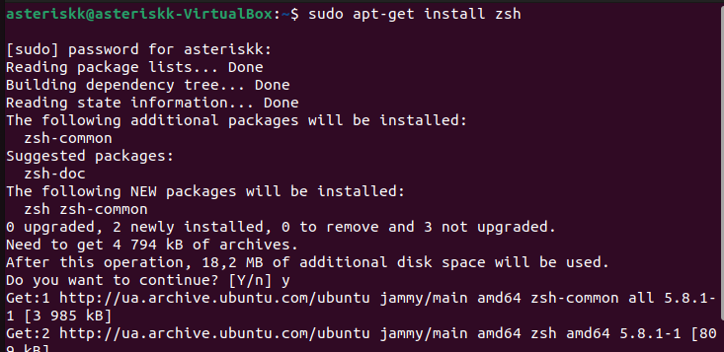



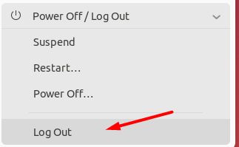

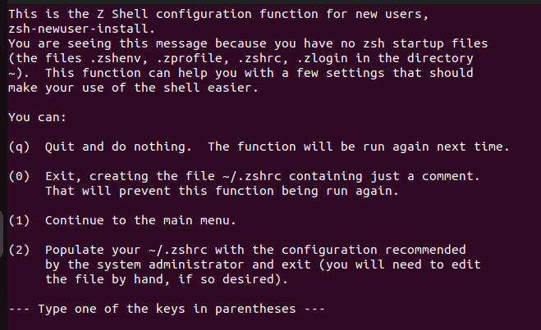

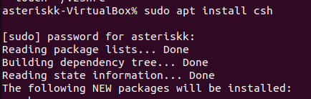

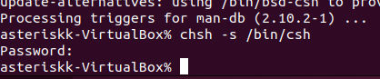

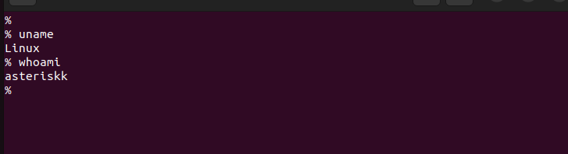

2.Prepared by Khomenko Anton



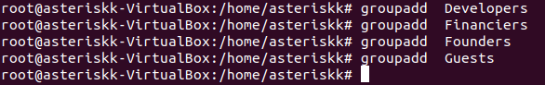’’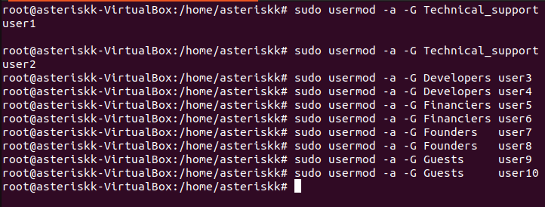

3.Prepared by Rumiantsev Hennadiy(3-4)

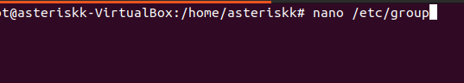

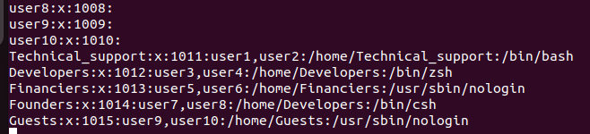

4.

