***The work was done collectively by students Malamuzh Volodymyr and Rumyantsev Gennadiy***

3.

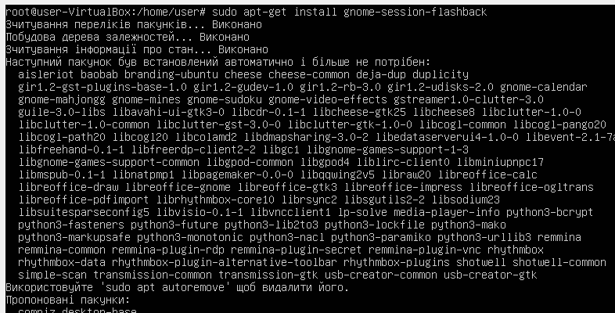

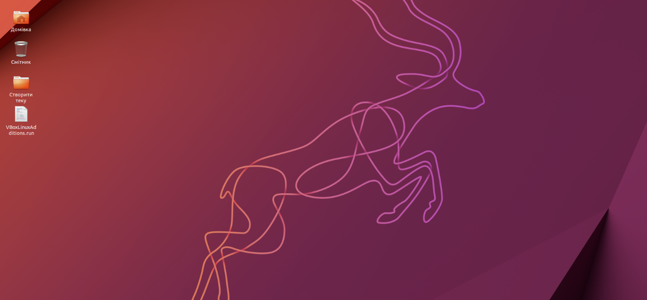

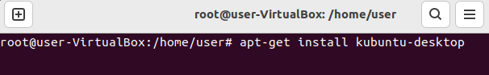

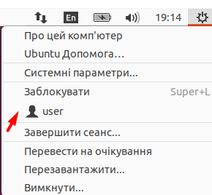

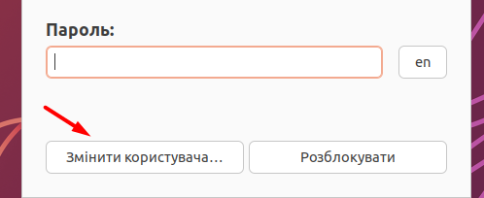

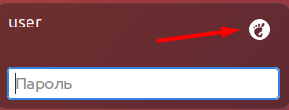

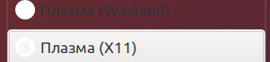

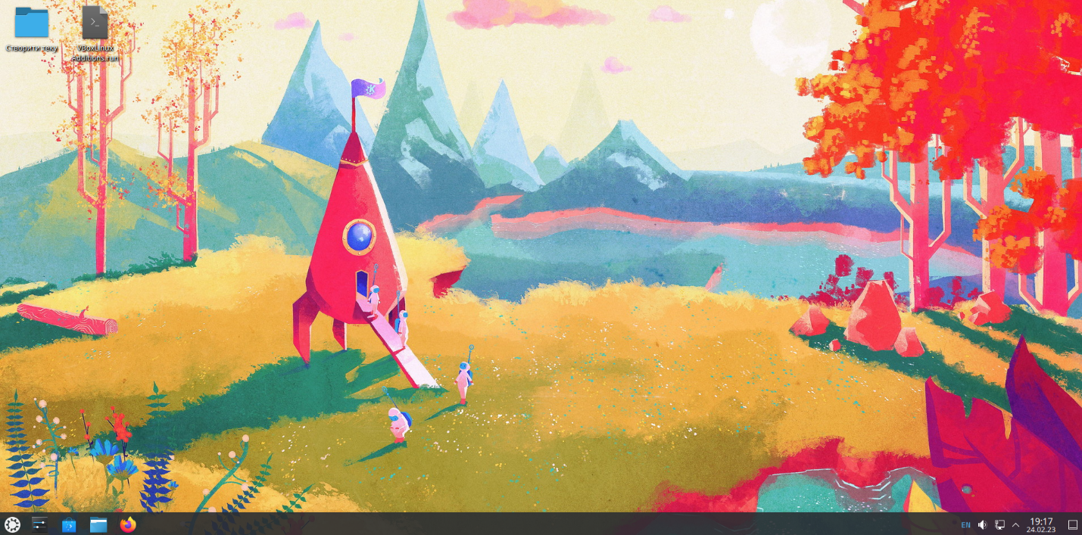

4. GNOME 2 and KDE Plasma are two different graphical desktop environments on Linux and other Unix-like operating systems. GNOME 2 is the default desktop environment for many Linux distributions until 2011. It has a simple and concise interface, usually with the task bar located at the bottom of the screen and the default menu on the top bar. GNOME 2 was a very stable and reliable environment that was used by many users, especially those who felt that KDE required more system resources and had a less pleasant interface. KDE Plasma is one of the most modern and flexible desktop environments on Linux. It has a large number of settings and features, including the ability to install various themes and widgets on the desktop. The Plasma interface is a bit more complex compared to GNOME 2, but at the same time allows users to customize their desktop to their own preferences. In summary, GNOME 2 and KDE Plasma are two different Linux desktop environments that have their own advantages and disadvantages. GNOME 2 was very stable and reliable, while KDE Plasma is a more flexible and customizable environment, which may be important for users who value customization and personalization more.