Low Level Document (LLD)

Insurance Claim Probability

Yash Mahajan

**DECLARATION**

I certify that the ideas included in this written submission are our own, and when the ideas or words of others have been used, we have properly credited and referenced the original sources.

Also, we affirm that we followed all rules governing academic honesty and integrity and did not invent, falsify, or misrepresent any idea, data, fact, or source in my work.

We are aware that any infraction of the aforementioned rules may result in disciplinary action by the Institute and may also result in sanctions on the sources who were improperly cited or from whose sufficient permission was not obtained when required.

**Revision History**

|  |  |  |  |  |  |
| --- | --- | --- | --- | --- | --- |
| **Version** | **Date** | **Author** | **Reviewer** | **Approver** | **Comments** |
| 0.1 | 13/02/2023 | Yash Mahajan | Yash Mahajan |  | Proposed version |
| 0.2 | 15-02-2023 | Yash Mahajan | Yash Mahajan |  | suggested some options to be included, including key notes, screen validations, and characteristics. |
| 0.3 | 17-02-2023 | Yash Mahajan | Yash Mahajan |  | Comments on the document format that should be changed, such as adding a section for open issues, etc. |
| 0.4 | 19-02-2023 | Yash Mahajan | Yash Mahajan |  | suggested several modifications, such as a revised sequence diagram and data design parts, etc. |
| 1.0 | 25-02-2023 | Yash Mahajan | Yash Mahajan |  | Standard version |

Table of Contents

1. Introduction ………………………………………………………………………………….6

1.1 Scope of the document…………………………………………………………………6

1.2 Intended Audience………………………………………………………………………6

1.3 System Overview………………………………………………………………………..7

1. Project Briefing……………………………………………………………………………….
2. Problem Statement…………………………………………………………………………..
3. Problem Solution……………………………………………………………………………..
4. Objective of Project…………………………………………………………………………..
5. Scope of Project………………………………………………………………………………
6. Block Diagram…………………………………………………………………………………
7. Requirements Gathering…………………………………………………………………….
8. Analysis……………………………………………………………………………………….
9. Final Screenshot of Project Output…………………………………………………………
10. **Introduction:**

## **1.1 Scope of the Document**

## This section will provide information on the document's scope. The LLDs will be at the component level, therefore there will only be one LLD for the website gateway.

## **1.2 Intended Audience**

## This section will discuss the various types of audiences who will consult or evaluate this paper.

## **1.3 System Overview**

## This part will include an overview of the system application, including information about the system being developed and its stakeholders.

## What other external systems will this be connecting with?

1. **Project Briefing:**

# More than two thirds of insurance businesses claim that predictive analytics has reduced their expenses and underwriting issues. With the advancement of artificial intelligence, insurance companies are increasingly turning to machine learning to achieve key objectives including cost reduction, enhanced underwriting, and fraud detection. In particular, insurance companies can use machine learning to quickly screen cases, fairly evaluate them, and calculate charges. This information emphasises how essential machine learning is for any insurance organisation. Insurance companies can predict their own profit and loss with ease by taking into account the likelihood of an insurance claim.

1. **Problem Statement:**

## To develop a machine learning-based method for predicting insurance claims based on several factors.

1. **Problem Solution:**

## Create a web application to forecast insurance claims, which can assist citizens in determining whether or not a person can submit an insurance claim.

1. **Objective of the Project:**

Objective of this project is to create a system which will predict the probability of insurance claims.

1. **Scope of Project:**

When a user requests insurance, it will be very helpful for insurance firms if they can immediately inform the user whether or not they are eligible to do so.

1. **Block Diagram:**

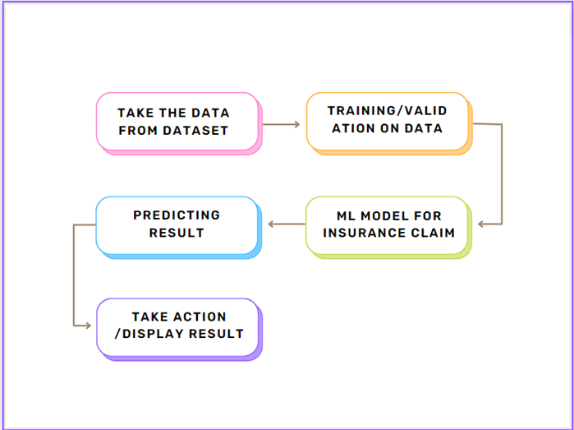

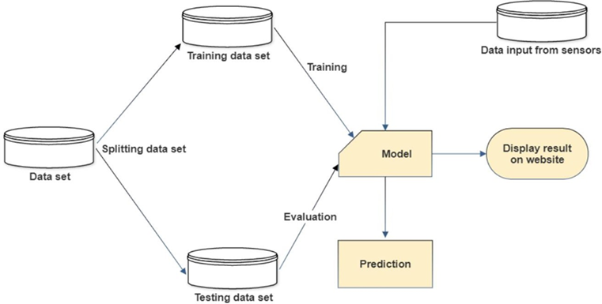

1. **Requirements Gathering:**

* Window 10 Operating system
* Jupyter Notebook
* At least 1Team member for the research part
* Project integration idea from IEEE website
* Few Github Non copyrighted source codes

1. **Analysis:**

Machine learning for predicting insurance claims. Future forecasting piques the interest of insurance firms greatly. A potential to lessen the company's financial loss is provided by accurate prediction. Payment errors made by insurance firms in processing claims are a significant contributor to rising expenses. In addition, reprocessing the claims results in high administrative expenditures as a result of the payment inaccuracies.

As seen below, this dataset has 7 features:

Age: The policyholder's age

sex: The policyholder's gender (male = 1, female = 0).

Body mass index (BMI) measures body composition by comparing weights to heights and identifying weights that are too high or too low in relation to height. The optimum range is 18.5 to 25 steps. average number of steps taken by the policyholder each day

number of the policyholder's children or dependents

smoker: The policyholder's smoking status (non-smoker=0; smoker=1)

Region: The policyholder's primary residence in the United States (northeast = 0, northwest = 1, southeast = 2, southwest = 3).

charges: Individual health insurance bills for medical expenses

1. 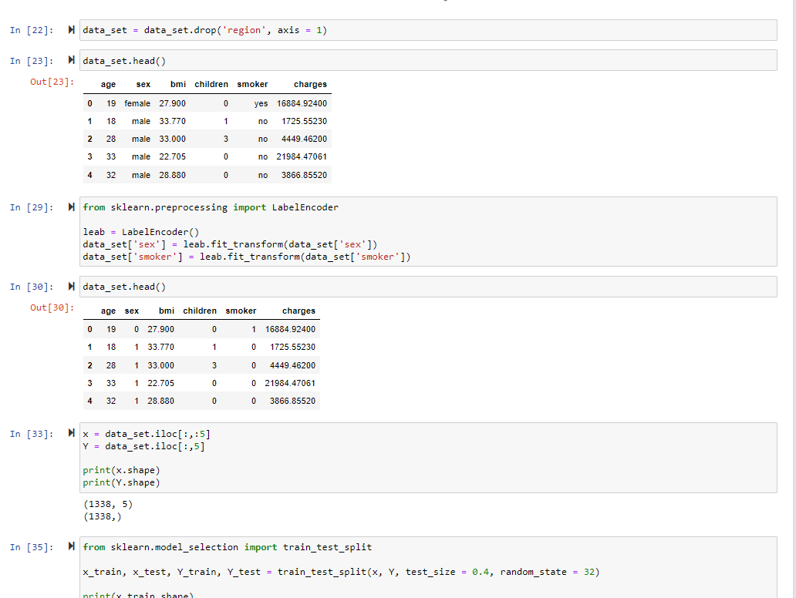**Final Screenshot of Project Output**

