|  |
| --- |
| Name: _______________________________________________ |
|  |
| **A-level Maths Settling In** |
| **Initial Assessment** |
|  |
|  |
| **Time:** 1 hour |
| **Total marks available:** 67 |
| **You may use a calculator** |
|  |
|  |
| This assessment consists of a sample of GCSE Maths questions designed to show whether you have the required skills to access the A-level maths course. |

**Q1.**

* Ella wants to invest £6000 in a savings account for 2 years.

   She finds information about savings accounts at two different banks.

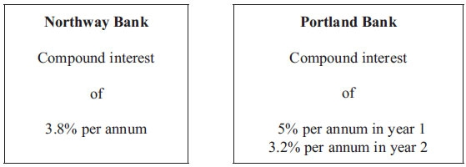

Ella wants to choose the bank that pays the greater total amount of interest for the 2 years.

Which bank should she choose?  
 You must show all your working.

**(Total for Question is 4 marks)**

**Q2.**

Triangles *ABD* and *BCD* are right-angled triangles.

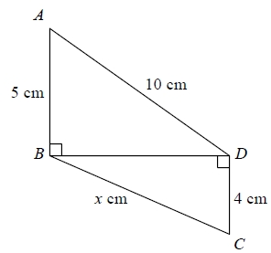

Work out the value of *x*.   
Give your answer correct to 2 decimal places.

...........................................................

**(Total for question = 4 marks)**

**Q3.**

Here is a speed-time graph for a car journey.   
The journey took 100 seconds.

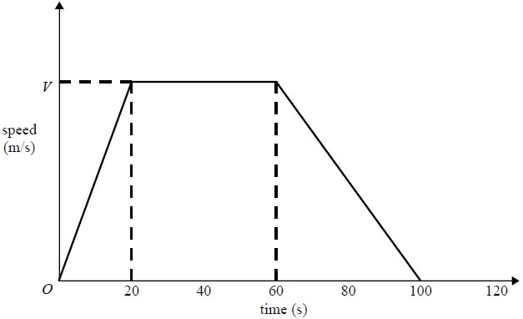

The car travelled 1.75km in the 100 seconds.

(a)  Work out the value of *V*.

...........................................................

**(3)**

(b)  Describe the acceleration of the car for each part of this journey.

.............................................................................................................................................

.............................................................................................................................................

.............................................................................................................................................

.............................................................................................................................................

**(2)**

**(Total for question = 5 marks)**

**Q4.**

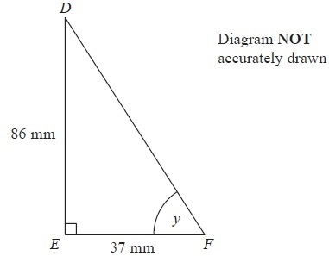

*DEF* is a right-angled triangle.

*DE* = 86 mm

*EF* = 37 mm

Calculate the size of the angle marked *y*.

Give your answer correct to 1 decimal place.

...........................................................°

**(Total for Question is 3 marks)**

**Q5.**

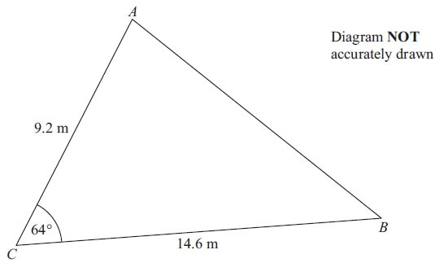

*AC* = 9.2 m  
*BC* = 14.6 m  
 Angle *ACB* = 64°

(a) Calculate the area of the triangle *ABC*.  
      Give your answer correct to 3 significant figures.

. . . . . . . . . . . . . . . . . . . . . . m2

**(2)**

(b) Calculate the length of *AB*.  
      Give your answer correct to 3 significant figures.

**(3)**

**(Total for Question is 5 marks)**

**Q6.**

The functions f and g are such that



(a)  Find the value of f(10)

...........................................................

**(1)**

(b)  Find g–1(*x*)

g–1(*x*) = ...........................................................

**(2)**

(c)  Show that ff(*x*) = 9*x* – 48

**(2)**

**(Total for question = 5 marks)**

**Q7.**

Make *t* the subject of the formula 2(*d* – *t*) = 4*t* + 7

*t* =  . . . . . . . . . . . . . . . . . . . . . .

**(Total for Question is 3 marks)**

**Q8.**Factorise fully 20*x*2 − 5

...........................................................

**(Total for question = 2 marks)**

**Q9.**

Prove algebraically that the difference between the squares of any two consecutive integers is equal to the sum of these two integers.

**(Total for question is 4 marks)**

**Q10.**

(a) Write down the equation of a straight line that is parallel to *y* = 5*x* + 6

      ..............................................................................................................................................

**(1)**

(b) Find an equation of the line that is perpendicular to the line *y* = 5*x* + 6 and passes through the point (–2, 5).

      ..............................................................................................................................................

**(3)**

**(Total for Question is 4 marks)**

**Q11.**

*y* = f(*x*)

The graph of *y* = f(*x*) is shown on the grid.

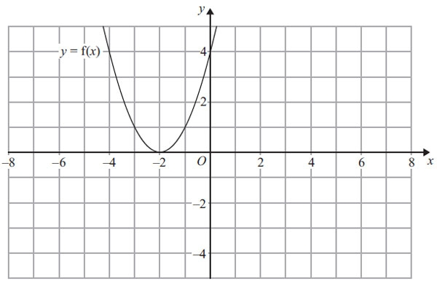

(a) On the grid above, sketch the graph of *y* = – f(*x*).

**(2)**

The graph of *y* = f(*x*) is shown on the grid.

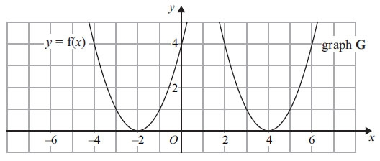

The graph **G** is a translation of the graph of *y* = f(*x*).

(b) Write down the equation of graph **G**.

      ..............................................................................................................................................

**(1)**

**(Total for Question is 3 marks)**

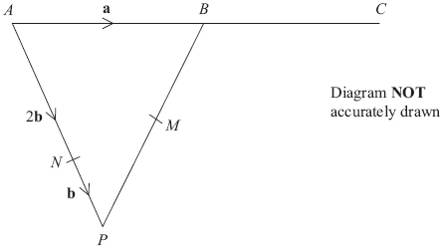**Q12.**

*APB* is a triangle.  
*N* is a point on *AP*.



(a) Find the vector, in terms of **a** and **b**.

     ..............................................................................................................................................

**(1)**

*B* is the midpoint of *AC*.  
*M* is the midpoint of *PB*.

**\*** (b) Show that *NMC* is a straight line.

**(4)**

**(Total for Question is 5 marks)**

**Q13.**

(a)  Simplify     *a*4 × *a*3

...........................................................

**(1)**

(b)  Simplify     (*b*2)7

...........................................................

**(1)**

(c)  Write down the value of 30

...........................................................

**(1)**

(d)  Write down the value of 4–1

...........................................................

**(1)**

**(Total for question = 4 marks)**

**Q14.**

Solve the simultaneous equations

                         3*x* – 2*y* = 7   
                          7*x* + 2*y* = 13

      ..............................................................................................................................................

**(Total for Question is 3 marks)**

**Q15.**

Solve 

*x* = ...........................................................

**(Total for question = 4 marks)**

**Q16.**

Jack is building a wall.

He uses 300 bricks to build part of the wall.   
This part of the wall is 5 metres long and 1.5 metres high.

The complete wall will be 8 metres long and 1.5 metres high.

How many more bricks does Jack need to complete the wall?

...........................................................

**(Total for question = 3 marks)**

**Q17.**

Rationalise the denominator of 

Give your answer in its simplest form.

You must show your working out.

      ..............................................................................................................................................

**(Total for Question is 3 marks)**

**Q18.**

(a)  Write down the value of 

...........................................................

**(1)**

(b)  Find the value of 

...........................................................

**(2)**

**(Total for question = 3 marks)**

**Mark Scheme**

Q1.

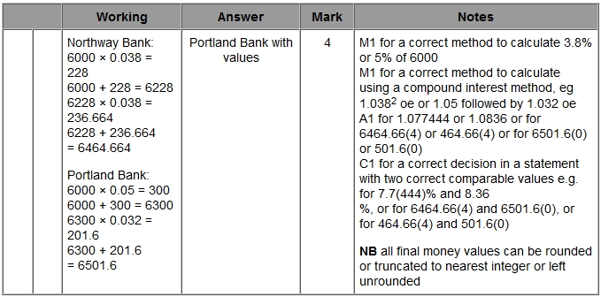

**Q2.**

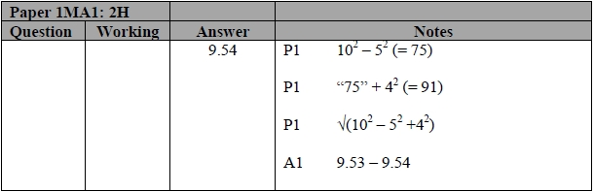

**Q3.**

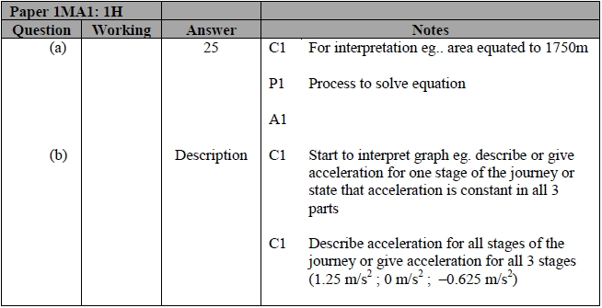

**Q4.**

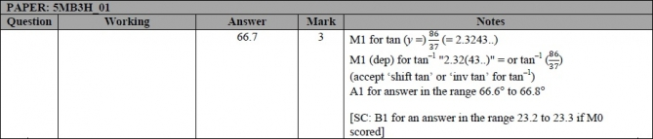

**Q5.**

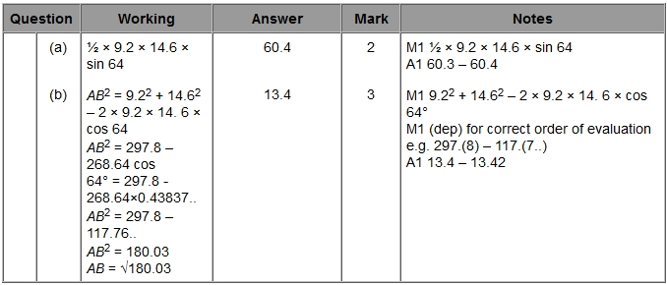

**Q6.**

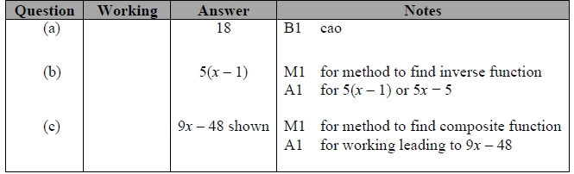

**Q7.**

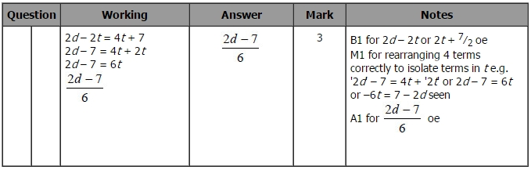

**Q8.**

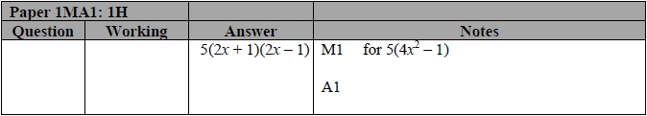

**Q9.**

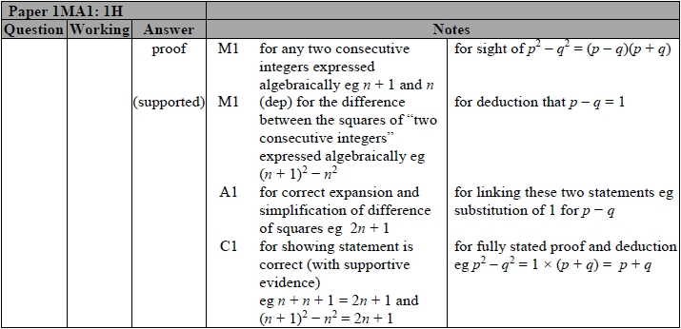

**Q10.**

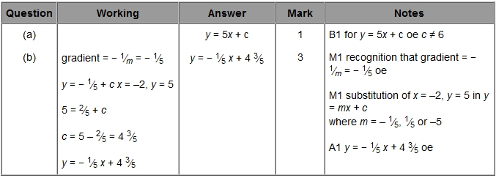

**Q11.**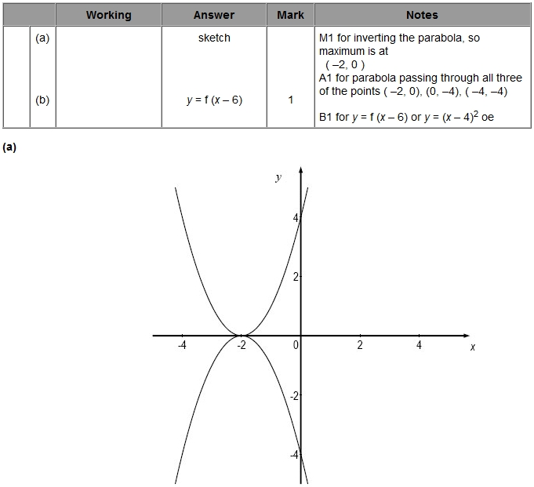

**Q12.**

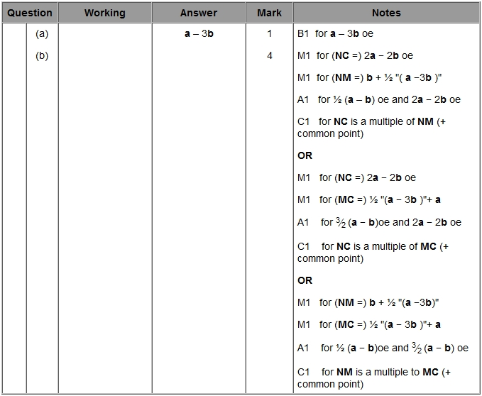

**Q13.**

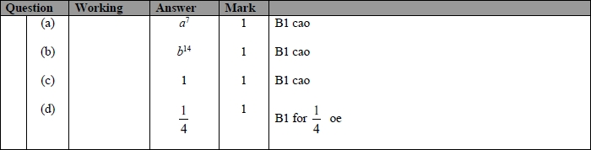

**Q14.**

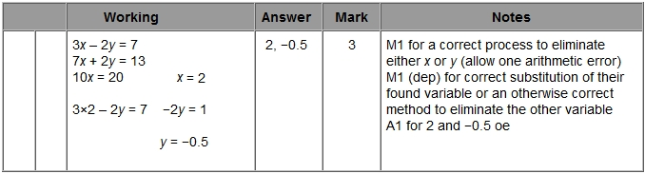

**Q15.**

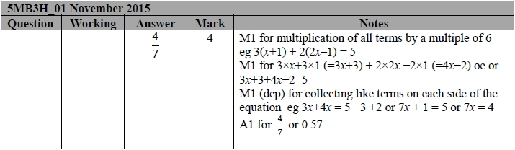

**Q16.**

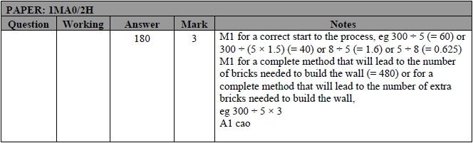

**Q17.**

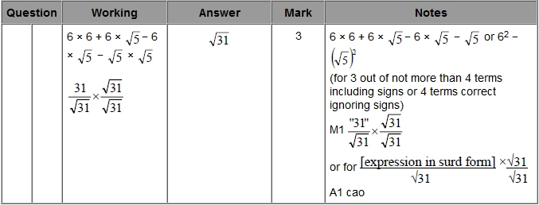

**Q18.**

