**Y12 Further Maths Assessment – HT2 – Section A**

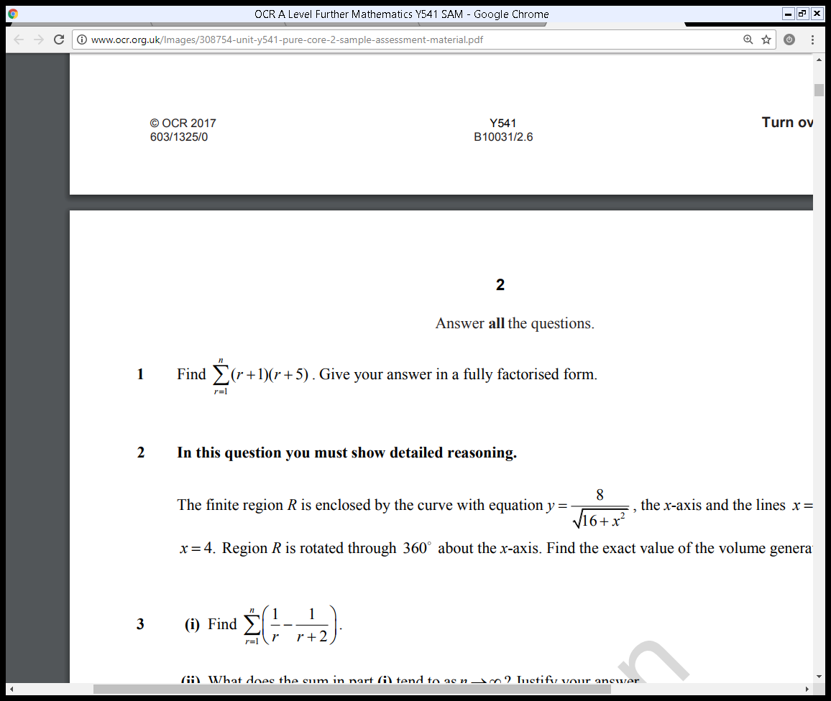  
**A1.**

**(4 marks)**

**A2.**

where *a* is a real constant and *a≠* 6

(a)  Find **A**–1 in terms of *a*.

**(3)**

Given that **A** + 2**A**–1 = **I**, where **I** is the 2 × 2 identity matrix,

(b)  find the value of *a*.

**(3)**

**(6 marks)**

**A3.**

(a)  Use the standard results for  and for  show that, for all positive integers *n*,



where *a* and *b* are integers to be found.

**(4)**

(b)  Hence find the value of



**(4)**

**(8 marks)**

**A4.**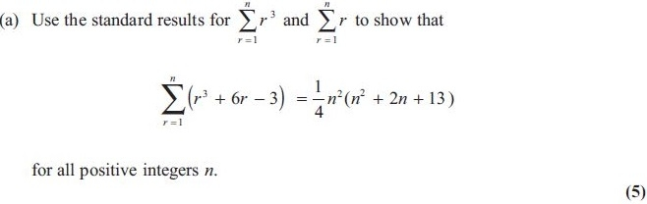

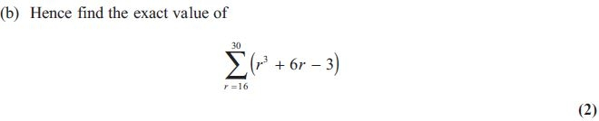

**(7 marks)**

**Y12 Further Maths Assessment – HT2 – Section B**

**B1.** 

(a)  Show that f (4) = 0

**(1)**

(b)  Use algebra to solve f (*x*) = 0 completely.

**(4)**

**(5 marks)**

**B2.** The point *P* represents a complex number *z* on an Argand diagram, where

|*z* + 1| = |2*z* − 1|

and the point *Q* represents a complex number *w* on the Argand diagram, where

|*w*| = |*w* − 1 + i|

Find the exact coordinates of the points where the locus of *P* intersects the locus of *Q*.

**(7 marks)**

**B3.** The quadratic equation

4*x*2 + 3*x* + 1 = 0

has roots *α* and *β*.

(a)  Write down the value of (*α* + *β*) and the value of *αβ*.

**(2)**

(b)  Find the value of (*α*2 + *β*2).

**(2)**

(c)  Find a quadratic equation which has roots

(4*α* – *β*) and (4*β* – *α*)

       giving your answer in the form p*x*2 + *qx* + *r* = 0 where *p*, *q* and *r* are integers to   
       be determined.

**(4)**

**(8 marks)**

**B4.**

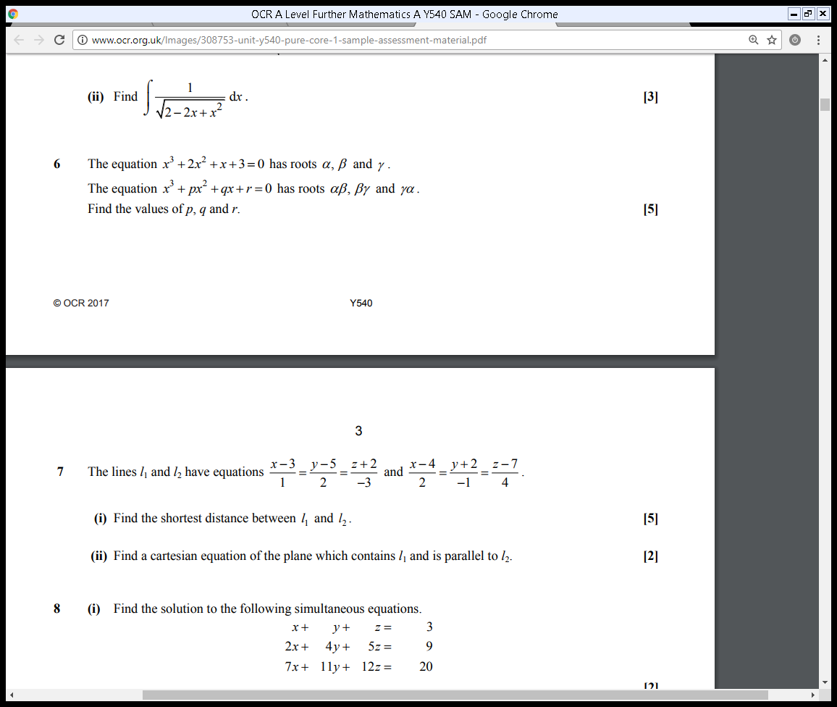

**(5 marks)**

**Mark Scheme**

A1.

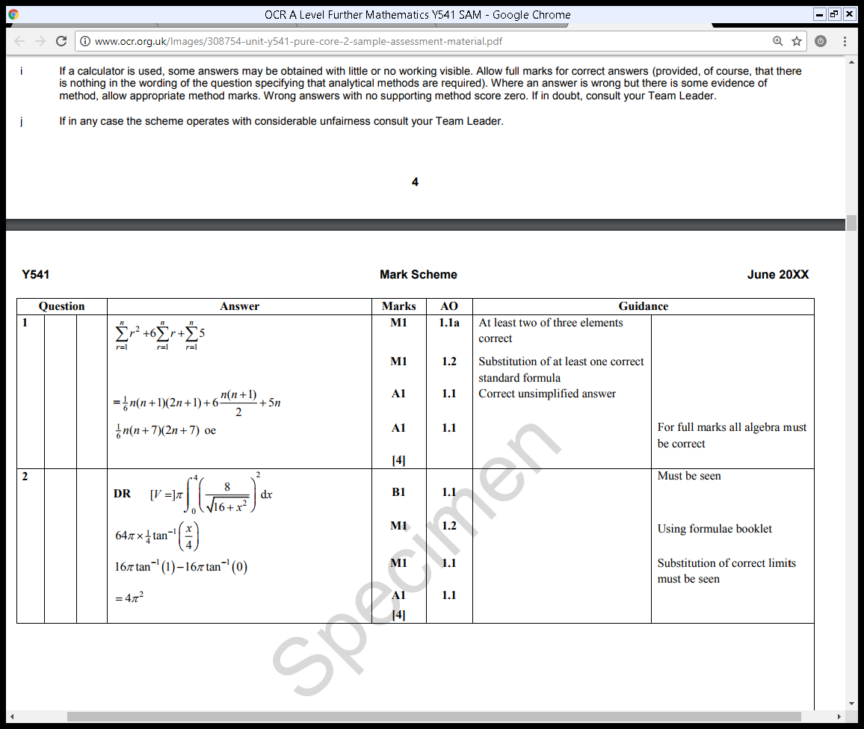

A2.

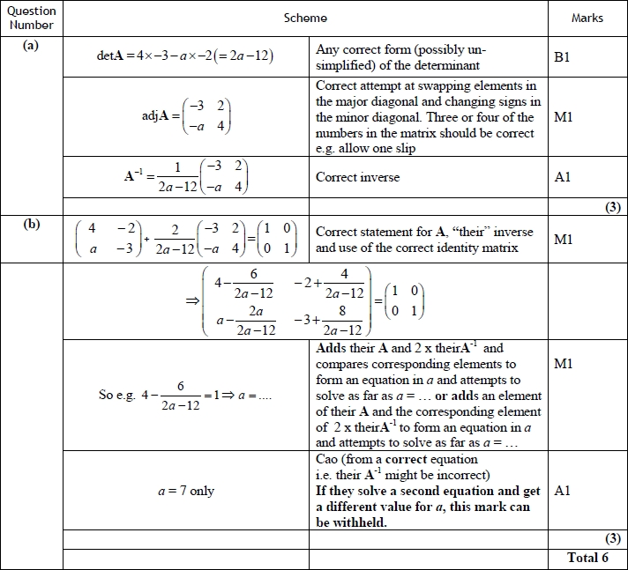

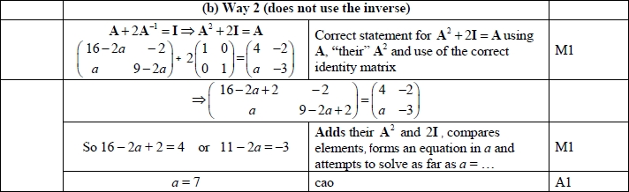

A3.

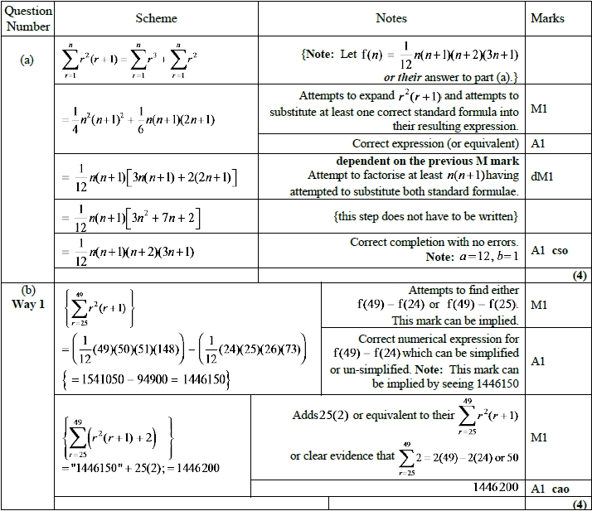

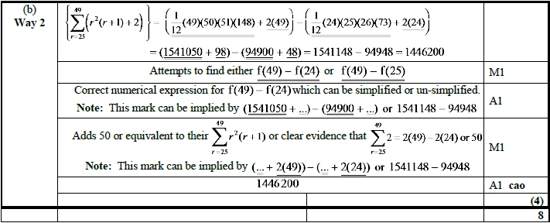

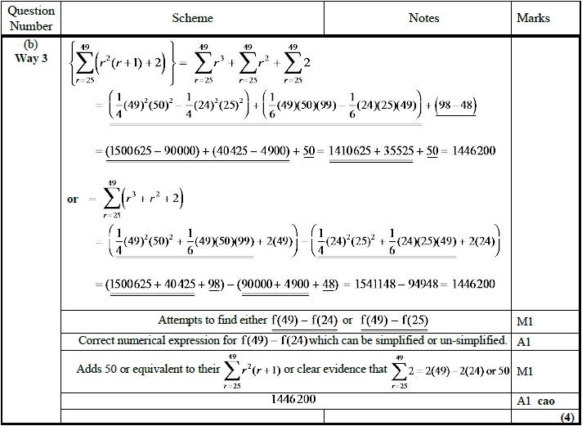

 A4.

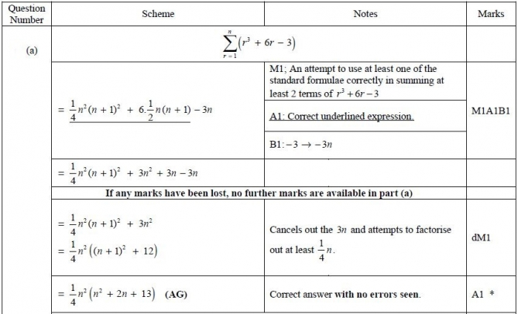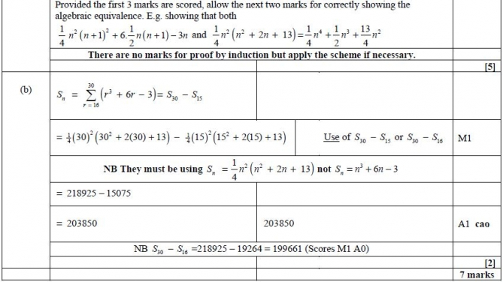

B1

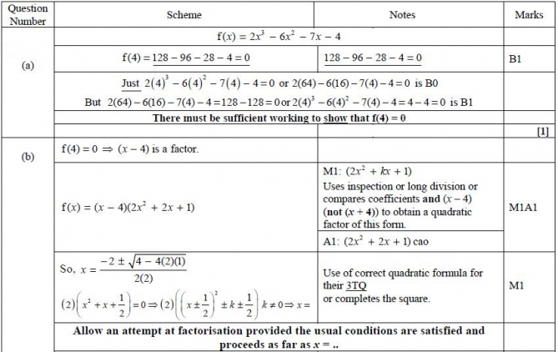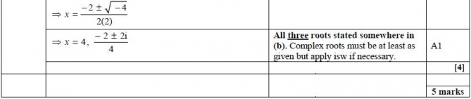

B2.

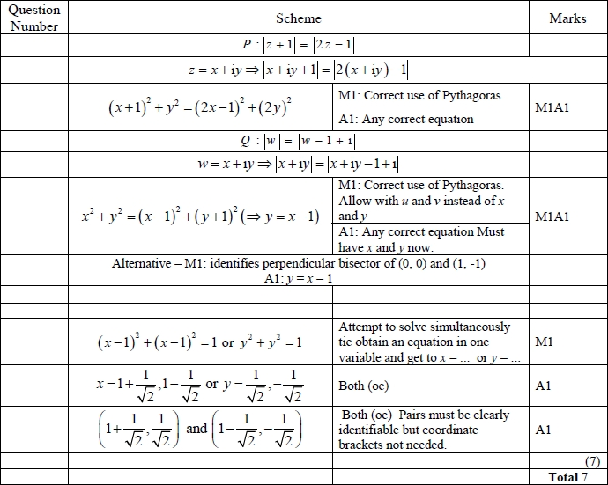

**B3.**

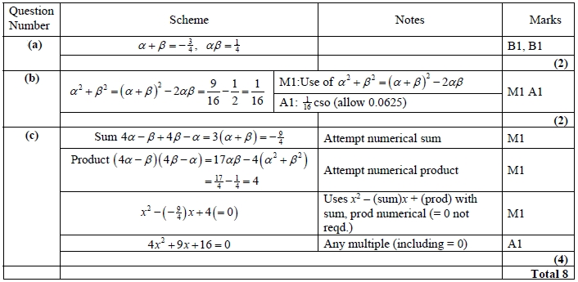

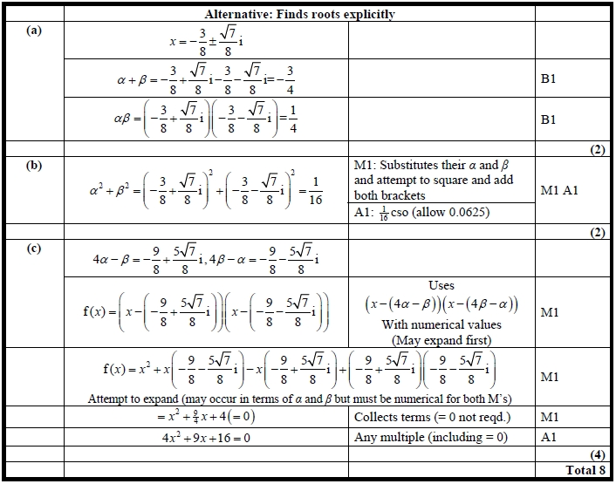

B4.

