**Year 13 Further Maths Half Term 1 Assessment**

**1** Express  in terms of powers of , giving your answer in its simplest form. **(6 marks)**

**2** Solve, giving your answers, where appropriate, in the form *r*(cos *θ* + isin *θ*)   
where –π < θ ⩽ π

**a**  showing the solutions on an Argand diagram. **(6 marks)**

**b**  showing the solutions on an Argand diagram. **(6 marks)**

**3** A project is modelled by the activity network shown below.

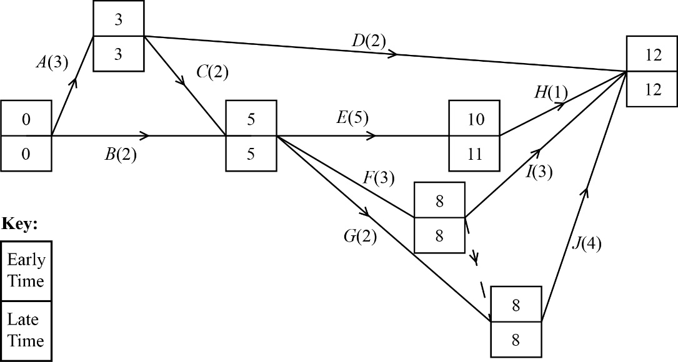

**a** Use the grid below to schedule the project, allocating one worker per activity and using the minimum number of workers. **(3 marks)**

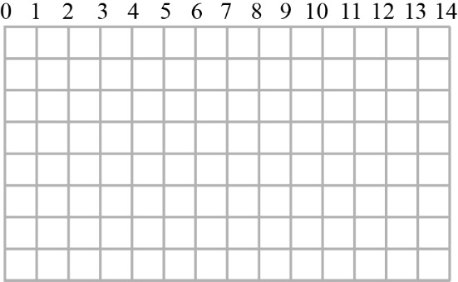

**b** On the grid below, draw a resource histogram to show the number of workers required each day when each activity begins at its earliest time. **(2 marks)**

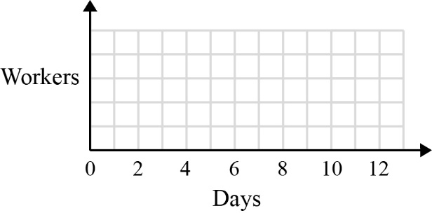

**Question 3 continued**

Two workers are available for the project.

Worker 1 can do any activity.

Worker 2 cannot help with activities *C, D* and *H*, but can do activities *G*, *I* and *J* alone.

If the workers share an activity then its duration is reduced by one day.

**c** Explain how the two workers can share the work so that activity *F* can start on the fifth day of the project.

**(2 marks)**

**d** Explain how the project can be completed in fewer than 20 days with these two workers.

**(4 marks)**

**4** A gas particle of mass 3 × 10−6 kg is moving with velocity ((*t*2 − 7*t*)**i** + 2**j**) m s−1.

When *t* = 8 seconds it instantaneously collides directly with a second particle of the same mass but moving with constant velocity (4**i** + **j**) m s−1. At the point of collision, the two particles coalesce and this new larger particle begins to move immediately after impact with constant velocity *v*.

**a** Find the speed of the new larger gas particle immediately after the collision. **(4 marks)**

**b** A third gas particle has velocity (2**i** − 3**j**) m s−1. Find the angle between the directions of motion of this third particle and the new larger particle. **(5 marks)**

**5** The line  has equation



The plane  has equation

2*x* – *y* + 4*z* = 4

The line  is a reflection of the line  in the plane 

Find an exact vector equation of the line .

**(9 marks)**

**END OF TEST**

**TOTAL MARKS 47**

|  |  |  |  |  |
| --- | --- | --- | --- | --- |
| Q | Scheme | Marks | AOs | Pearson Progression Step and Progress Descriptor |
| **1** | Hence | **M1**  **M1**  **A1**  **M1**  **M1**  **A1** | 1.1a  1.1a  1.1b  1.1b  1.1b  1.1b | 5th  Be able to derive multiple angle formulae and expressions using de Moivre’s theorem |
| (6 marks) | | | | |
| Notes  **M1** for use of de Moivre’s theorem  **M1** for use of binomial expansion  **A1** for correct expansion  **M1** for choosing real terms  **M1** for replacing  **A1** cao | | | | |

|  |  |  |  |  |
| --- | --- | --- | --- | --- |
| Q | Scheme | Marks | AOs | Pearson Progression Step and Progress Descriptor |
| **2a** | P:\Text_Extraction\UK\GCE_ALevel\raw\Corrections\Batch05\Batch 5 Second proof to CSC\D60992_MS_Q4a_figure_3.jpg | **B1**  **M1**  **A1**  **A1**  **B1**  **B1** | 1.1a  1.1b  1.1b  1.1b  2.5  2.5 | 8th  Be able to find the *n*th roots of equations of the form  and know that they form the vertices of a regular *n*-gon in the Argand diagram |
|  | **(6)** |  |  |

|  |  |  |  |  |
| --- | --- | --- | --- | --- |
| **2b** | P:\Text_Extraction\UK\GCE_ALevel\raw\Corrections\Batch05\Batch 5 Second proof to CSC\D60992_MS_Q4b_figure_4.jpg | **B1**  **M1**  **M1**  **A1**  **B1**  **B1** | 1.1a  1.1b  1.1b  1.1b  2.5  2.5 | 8th  Be able to find the *n*th roots of equations of the form  and know that they form the vertices of a regular *n*-gon in the Argand diagram |
|  | **(6)** |  |  |
| (12 marks) | | | | |

|  |
| --- |
| Notes  **2a**: **B1** for rewriting equation  **M1** for use of de Moivre’s theorem  **A1** for at least four roots found by substituting *n*  **A1** for all roots correct in the interval of the principal argument  **B1** for all lines the same length  **B1** for correct spacing around the circle  **2b**: **B1** for rewriting equation  **M1** for rewriting in terms of cos and sin  **M1** for use of de Moivre’s theorem  **A1** for substitutes values for *n* and use of the interval of the principal argument  **B1** for all roots the same length  **B1** for correct spacing around the circle |

|  |  |  |  |  |
| --- | --- | --- | --- | --- |
| Q | Scheme | Marks | AOs | Pearson Progression Step and Progress Descriptor |
| **3a** | C:\Users\mahoney_e\AppData\Local\Microsoft\Windows\Temporary Internet Files\Content.Word\D61017_Figure_18.jpg | **M1**  **A1**  **A1** | 3.1a | 6th  Be able to construct a scheduling diagram |
|  | **(3)** |  |  |
| **3b** | C:\Users\mahoney_e\AppData\Local\Microsoft\Windows\Temporary Internet Files\Content.Word\D61017_Figure_19.jpg | **M1**  **A1** | 1.1b | 5th  Be able to draw and interpret resource histograms |
|  | **(2)** |  |  |
| **3c** | Worker 1 does *C* | **M1** | 2.4 | 7th  Be able to interpret and modify schedules to meet requirements |
| Both workers share *A* and *B* for three hours in total | **A1** | 2.4 |  |
|  | **(2)** |  |  |
| **3d** | e.g.  Share *A*, *B* (three days)  Worker 1 does *C* (two days)  Worker 1 does *D* while Worker 2 does *G* (two days)  Share *E, F, I* (eight days)  Worker 1 does *H* while Worker 2 does *J* (four days) | **M1**  **A1**  **M1**  **M1** | 2.4 | 8th  Solve critical path problems using scheduling in unfamiliar contexts |
|  | **(4)** |  |  |
| (11 marks) | | | | |
| Notes  **3a M1:** Critical activities on one continuous line.  **A1:** At least four non-critical activites scheduled.  **A1:** Three workers scheduled correctly.  **3b M1:** Plausible histogram, no holes or overhangs.  **A1:** All correct.  **3d M1:** Worker 1 allocated correctly to some activities.  **M1:** Worker 2 allocated correctly to some activities.  **M1:** No precedences violated.  **A1:** Feasible solution < 20 hours. | | | | |

|  |  |  |  |  |
| --- | --- | --- | --- | --- |
| Q | Scheme | Marks | AOs | Pearson Progression Step and Progress Descriptor |
| **4a** | When *t* = 8, *u*1 = (8**i**+ 2**j**) m s−1 | **M1** | 1.1a | 4th  Extend the definition of momentum and impulse to two dimensions |
| Also given: *u*2 = (4**i** + **j**) m s−1  States that the combined particle has mass 2(3 × 10−6) = 6 × 10−6 and a single velocity, *v*. | **M1** | 3.1a |
| Use the vector form of the conservation of momentum:  (3 × 10−6)(*u*1 + *u*2) = (6 × 10−6)*v* gives *v* = 6**i** + 1.5**j** | **M1** | 1.1b |
| Speed of new larger particle m s−1 (3 s.f.) | **A1** | 1.1a |
|  | **(4)** |  |  |
| **4b** |  | **M1** | 2.2a | 4th  Extend the definition of momentum and impulse to two dimensions |
| above **i** | **A1** | 3.2a |
|  | **M1** | 2.2a |
| below **i** | **A1** | 3.2a |
| Angle between two particles after collision = 14.04 + 56.31  = 70.4°(3 s.f.) | **A1** | 1.1b |
|  | **(5)** |  |  |
| (9 marks) | | | | |
| Notes | | | | |

|  |  |  |  |  |
| --- | --- | --- | --- | --- |
| Q | Scheme | Marks | AOs | Pearson Progression Step and Progress Descriptor |
| **5** | States that a general point on  has position vector | **M1** | 1.1b | 6th  Find the point of intersection of a line and a plane |
| Makes an attempt to substitute  into  For example,  is seen | **M1** | 3.1a |
| Solves the equation to find  and concludes that the point of intersection is | **M1** | 1.1b |
| States that a vector equation of the line through  and perpendicular to  is | **M1** | 3.1a |
| Attempts to finds a point on this line that is also on  by substituting,  and  into | **M1** | 3.1a |
| Solves  to obtain | **A1** | 1.1b |
| Concludes that the point,    is halfway between  and a point on ; therefore, a point on  has position vector,    (continued) | **M1** | 3.2a |

|  |  |  |  |  |
| --- | --- | --- | --- | --- |
|  | Attempts to find the equation of  using the points  and | **M1** | 1.1b |  |
| Finds a correct vector equation of  :  Accept  instead of  and any multiple of | **A1** | 1.1b |
| (9 marks) | | | | |
| Notes | | | | |