**Year 13 Further Maths Half Term 2 Assessment**

**1.**

**a** Using the definitions for cosh *x* and sinh *x* in terms of exponentials, show that

cosh2 *x* – sinh2 *x* = 1

**(3 marks)**

**b** Find the exact value of *x* for which

2 tanh *x* – cosh *x* = 0

giving your answer as a natural logarithm.

**(5 marks)**

**2**

**a** Find the polar equation for the Cartesian equation 

giving your answer in the form 

**(3 marks)**

**b** Show that the curve with Cartesian equation  has polar equation 

where *A* is a constant to be found.

**(3 marks)**

**3** Sketch the following curves, where *a* is a positive constant.

**a** 

giving the coordinates of the point where the curve intersects the half line 

**(2 marks)**

**b** ,

giving the coordinates of the points where the curve intersects the initial line and the half line  **(3 marks)**

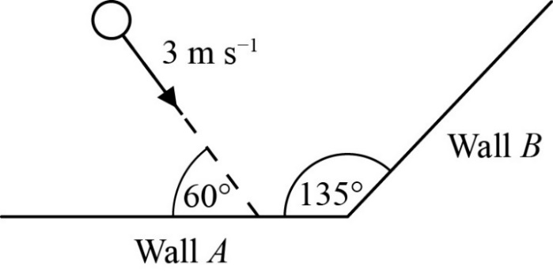**4**

Two infinitely long, smooth vertical walls, *A* and *B*, are fixed on a smooth horizontal surface and intersect at an angle of 135o. A smooth sphere of mass 0.25 kg is projected across the surface towards wall A with a speed of 3 m s-1 and at an angle of 60o to wall *A,* as shown in the diagram below.

The coefficient of restitution between the sphere and each of the walls is denoted by *e*.

After its initial collision with wall *A* the ball is known to rebound and collide, at some point, with wall *B*

**a** Show that the range of possible values for *e* is given by 

**(3 marks)**

The exact value of *e* is found to be 

**b** After colliding with wall *B* the direction of motion of the sphere makes an angle *θ* ° with wall *B*.

Find the value of *θ*

**(3 marks)**

**c** Find the overall kinetic energy lost due to the two collisions.

**(6 marks)**

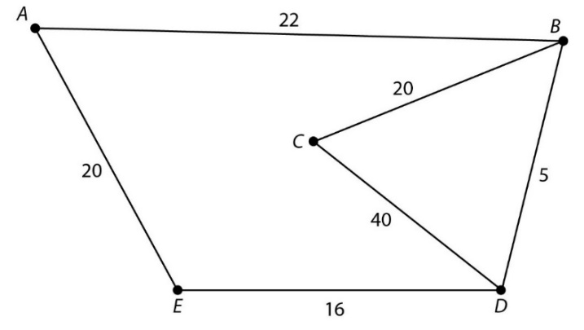**5**

The figure shows roads connecting five towns. The numbers show distances in kilometres.

Below are the distance and route matrices after the third iteration of Floyd’s algorithm:

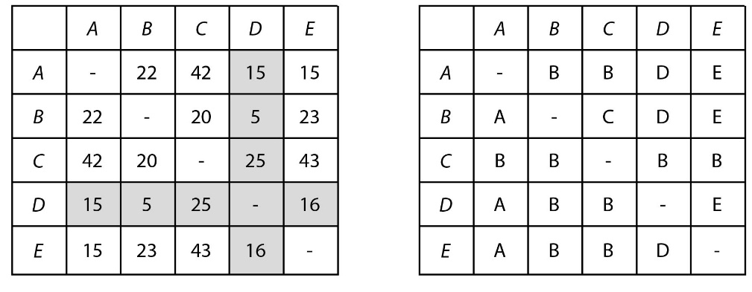

**a** Perform the fourth iteration.

(**4 marks**)

There are no changes on the fifth iteration.

**b** Explain how to find the shortest distance and route from town *C* to town *A* using your answer from part **a**.

State the route and the distance.

(**4 marks**)

**6** The cubic equation  has roots  and 

**a** Write down the values of ,  and 

**(1 mark)**

**b** Given that  and $γ∈R$ find the value of 

**(3 marks)**

**c** Find the value of *k*.

**(2 marks)**

**7** Prove by induction that for all positive integer *n*, 

**(6 marks)**

**END OF TEST**

**TOTAL MARKS 51**

**MARK SCHEME**

|  |  |  |
| --- | --- | --- |
| **1a** |  | **M1** |
|  | **M1** |
|  | **A1\*** |
| **Alt** | cosh2 *x* – sinh2 *x* = (cosh *x* + sinh *x*)(cosh *x* – sinh *x*) | **M1** |
|  | **M1** |
|  | **A1\*** |
|  | **(3)** |
| **1b** |  | **M1** |
| 2 sinh *x* = cosh2 *x*  2 sinh *x* = 1 + sinh2 *x*  sinh2 *x* – 2 sinh *x* + 1 = 0 | **M1** |
| (sinh *x* – 1)2 = 0  sinh *x* = 1 | **M1**  **A1** |
|  | **A1** |
|  | **(5)** |
| (8 marks) | | | |

|  |
| --- |
| Notes  **1a M1:** Uses correct exponential forms of sinh *x* and cosh *x*  **M1:** Expands at least one bracket correctly  **A1*:** Obtains 1 with no errors. Both LHS and RHS of given answer to have been seen  **Alt M1:** Correct factorisation of cosh2 *x* – sinh2 *x*  **M1:** Uses correct exponential forms of sinh *x* and cosh *x*  **A1*:** Obtains 1 with no errors. Both LHS and RHS of given answer to have been seen  **1b M1:** Uses  **M1:** Uses cosh2 *x* = 1 + sinh2 *x* and obtains 3TQ in sinh *x*  **M1:** Solves their 3TQ in sinh *x* (usual rules)  **A1:** Correct value for sinh *x*  **A1:**  only |

|  |  |  |
| --- | --- | --- |
| **2a** |  | **M1**  **M1**  **A1** |
|  |  | **(3)** |
| **2b** |  | **M1**  **M1**  **A1\*** |
|  |  | **(3)** |

**2a M1** Attempts to substitute

**M1** Makes *r* the subject

**A1** Any correct form

**2b M1** Attempts to substitute

**M1** Use of double angle formula

**A1\*** cao

|  |  |  |
| --- | --- | --- |
| **3a** |  | **B1**  **B1** |
|  |  | **(2)** |
| **3b** |  | **B1**  **B1**  **B1** |
|  |  | **(3)** |

|  |  |  |
| --- | --- | --- |
| **4a** | Derives (or simply states) relationship between angles before (60) and after  colliding with Wall *A*: | **M1** |
| Deduces for sphere to hit wall *B*: | **M1** |
| Thus: | **A1\*** |
|  | **(3)** |
| **4b** | Uses  with  to find: | **M1** |
| Thus deduces sphere meets wall *B* at an angle: | **M1** |
| Hence:  (5.1 or better) | **A1** |
|  | **(3)** |

|  |  |  |
| --- | --- | --- |
| **4c** | Uses parallel and perpendicular directions, and NEL formula, to find, for speed of sphere, *v*, after colliding with wall *A*:  and | **M1** |
| Thus uses Pythagoras to find: | **M1** |
| Similarly establishes parallel and perpendicular relationships for before and after the sphere collides with wall *B*, where the sphere leaves with speed *w*, at an angle , such that:  and/or | **M1** |
| Uses Pythagoras or  value from part **4bi** to find *w* or : | **M1** |
| Uses correct formula to find KE lost over both collisions, *L*: | **M1** |
| Thus Overall KE lost,  joules (accept 0.77 or better) | **A1** |
|  | **(6)** |

|  |  |  |  |  |  |  |  |  |  |  |  |  |  |  |  |  |  |  |  |  |  |  |  |  |  |  |  |  |  |  |  |  |  |  |  |  |  |  |  |  |  |  |  |  |  |  |  |  |  |  |  |  |  |  |  |  |  |  |  |  |  |  |  |  |  |  |  |  |  |  |  |  |  |  |  |
| --- | --- | --- | --- | --- | --- | --- | --- | --- | --- | --- | --- | --- | --- | --- | --- | --- | --- | --- | --- | --- | --- | --- | --- | --- | --- | --- | --- | --- | --- | --- | --- | --- | --- | --- | --- | --- | --- | --- | --- | --- | --- | --- | --- | --- | --- | --- | --- | --- | --- | --- | --- | --- | --- | --- | --- | --- | --- | --- | --- | --- | --- | --- | --- | --- | --- | --- | --- | --- | --- | --- | --- | --- | --- | --- | --- |
| **5a** | |  |  |  |  |  |  |  |  |  |  |  |  |  | | --- | --- | --- | --- | --- | --- | --- | --- | --- | --- | --- | --- | --- | |  | ***A*** | ***B*** | ***C*** | ***D*** | ***E*** |  |  | ***A*** | ***B*** | ***C*** | ***D*** | ***E*** | | ***A*** | - | 20 | 40 | 15 | 15 | ***A*** | *A* | *D* | *D* | *D* | *E* | | ***B*** | 20 | - | 20 | 5 | 21 | ***B*** | *D* | *B* | *C* | *D* | *D* | | ***C*** | 40 | 20 | - | 25 | 41 | ***C*** | *D* | *B* | *C* | *B* | *D* | | ***D*** | 15 | 5 | 25 | - | 16 | ***D*** | *A* | *B* | *B* | *D* | *E* | | ***E*** | 15 | 21 | 41 | 16 | - | ***E*** | *A* | *D* | *D* | *D* | *E* | | **M1** |
| **A1** |
| **M1** |
| **A1** |
|  | **(4)** |
| **5b** | Using row 3, column 1 | **M1** |
| Shortest distance from *C* to *A* is 40 | **A1** |
| From route matrix *CA* goes via *D*, so *CDA* |  |
| *CD* goes via *B*, from route matrix | **M1** |
| So, *CBDA* | **A1** |
|  | **(4)** |
| (8 marks) | | | |
| **Notes**  **5a M1** first row distances  **A1** All distances  **M1** row *C* correct routes  **A1** All routes  Condone dashes top left to bottom right diagonal | | | |

|  |  |  |
| --- | --- | --- |
| **6a** | States   and | **B1** |
|  | **(1)** |
| **6b** | Deduces that  is a root. | **M1** |
| Finds | **M1** |
| Uses  to state | **A1** |
|  | **(3)** |
| **6c** | Uses  to write | **M1** |
| Solves to find | **A1** |
|  | **(2)** |

|  |  |  |
| --- | --- | --- |
| **7** | ,  and | **B1** |
| Assume the general statement is time for *n* = *k*  So assume  is true. | **M1** |
| Begins to build an expression for *n* = *k* + 1  So,  Therefore | **M1** |
| Multiplies  by  to obtain a common denominator, | **M1** |
| Attempts to simplify: | **M1** |
| Demonstrates an understanding of the process of mathematical induction,  Then the general statement is true for .  As the general result has been shown to be true for   then the general result is true for all | **A1** |