**Y12 Further Maths Assessment – HT1 - Section A: Complex Numbers**

**Q1.**

Given that –2 + 3i is a root of the equation

*z*2 + *pz* + *q* = 0

where *p* and *q* are real constants,

(a)  write down the other root of the equation.

**(1)**

(b)  Find the value of *p* and the value of *q*.

**(3)**

**(Total for question = 4 marks)**

**Q2.**

*z* = 3 + 2i,     *w* = 1 − i

Find in the form *a* + *b*i, where *a* and *b* are real constants,

(a)  *zw*

**(2)**

(b)  , showing clearly how you obtained your answer.

**(3)**

Given that

|*z* + *k*| = √53, where *k* is a real constant

(c)  find the possible values of *k*.

**(4)**

**(Total for question = 9 marks)**

**Q3.**

Given that *z*1 = –3 – 4*i* and *z*2 = 4 – 3i

(a)  show, on an Argand diagram, the point *P* representing *z*1 and the point *Q* representing *z*2

**(2)**

(b)  Given that *O* is the origin, show that *OP* is perpendicular to *OQ*.

**(2)**

(c)  Show the point *R* on your diagram, where *R* represents *z*1+ *z*2

**(1)**

(d)  Prove that *OPRQ* is a square.

**(2)**

**(Total for question = 7 marks)**

**Q4.**

Given that *z*1 = 1 − i,

(a) find arg(*z*1).

**(2)**

Given that also *z*2 = 3 + 4i, find, in the form *a* + i*b*, *a,b* ∈

(b) *z*1 *z*2,

**(2)**

(c) 

**(3)**

In part (b) and part (c) you must show all your working clearly.

**(Total 7 marks)**

**Y12 Further Maths Assessment – HT1 - Section B: Matrices**

**Q5.**

**A** = 

(a) Show that **A** is non-singular.

**(2)**

(b) Find **B** such that **BA**2 = **A**.

**(4)**

**(Total 6 marks)**

**Q6.**A right angled triangle *T* has vertices *A*(1, 1), *B*(2, 1) and *C*(2, 4). When *T* is transformed by the matrix **P** = , the image is *T* '.

(a) Find the coordinates of the vertices of *T* '.

**(2)**

(b) Describe fully the transformation represented by **P**.

**(2)**

The matrices **Q** =  and **R** =  represent two transformations. When *T* is transformed by the matrix **QR**, the image is *T* ''.

(c) Find **QR**.

**(2)**

(d) Find the determinant of **QR**.

**(2)**

(e) Using your answer to part (d), find the area of *T* ''.

**(3)**

**(Total 11 marks)**

**Q7.**

Given that **X** = , where *a* is a constant, and *a* ≠ 2,

(a) find **X**−1 in terms of *a*.

**(3)**

Given that **X** + **X**−1 = **I**, where **I** is the 2×2 identity matrix,

(b) find the value of *a*.

**(3)**

**(Total 6 marks)**

**Mark Scheme**

Q1.

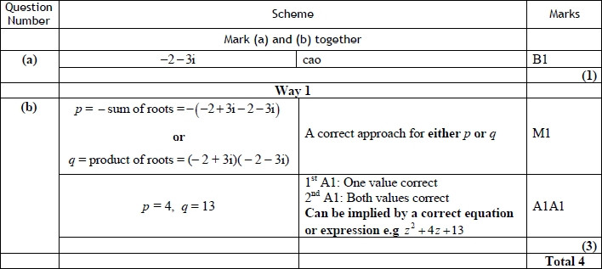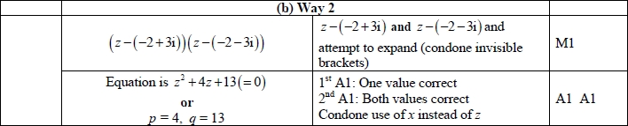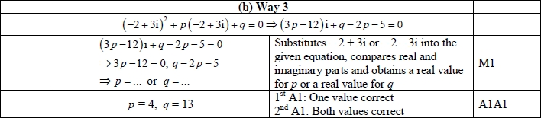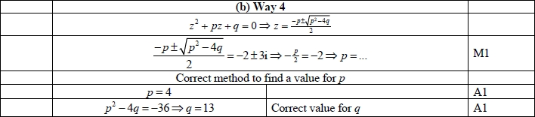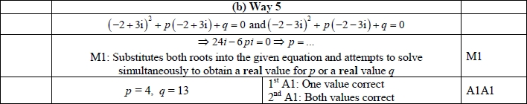

**Q2.**

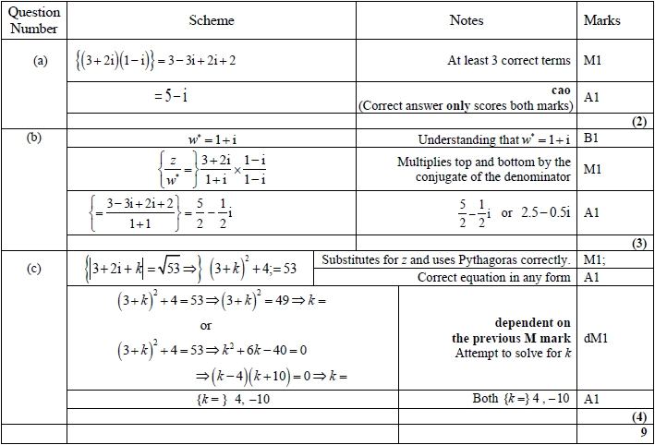

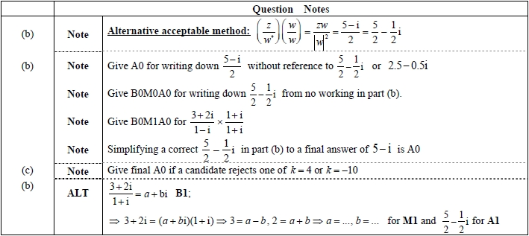

**Q3.**

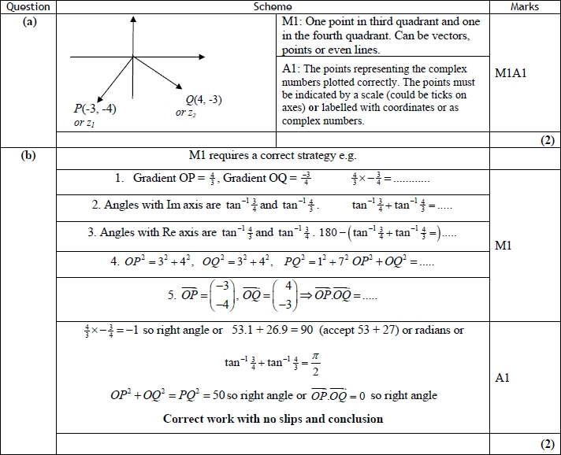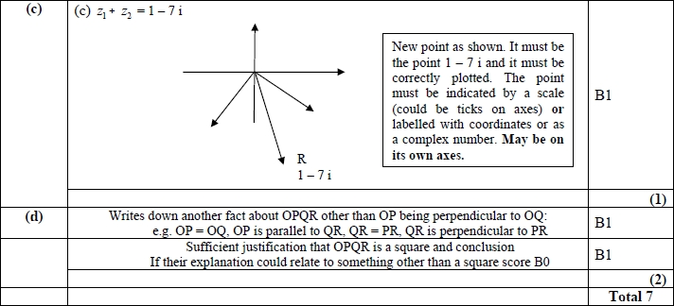

**Q4.**

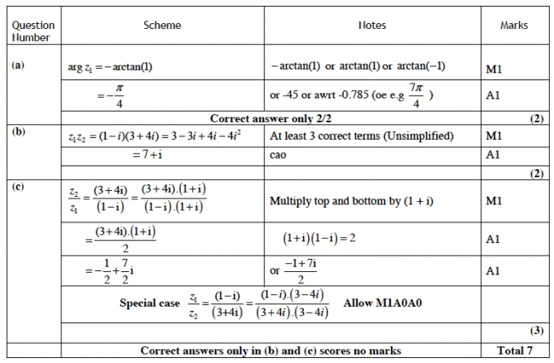

**Q5.**

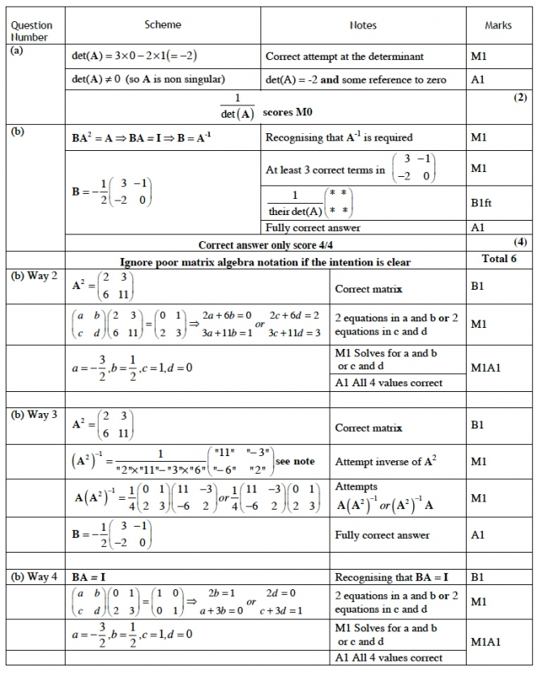

**Extra Notes**

**(b) Way 3**

Attempting inverse of **A**2 needs to be recognisable as an attempt at an inverse

E.g. (**A**2)−1 =  (A changed **A**2)

**Q6.**

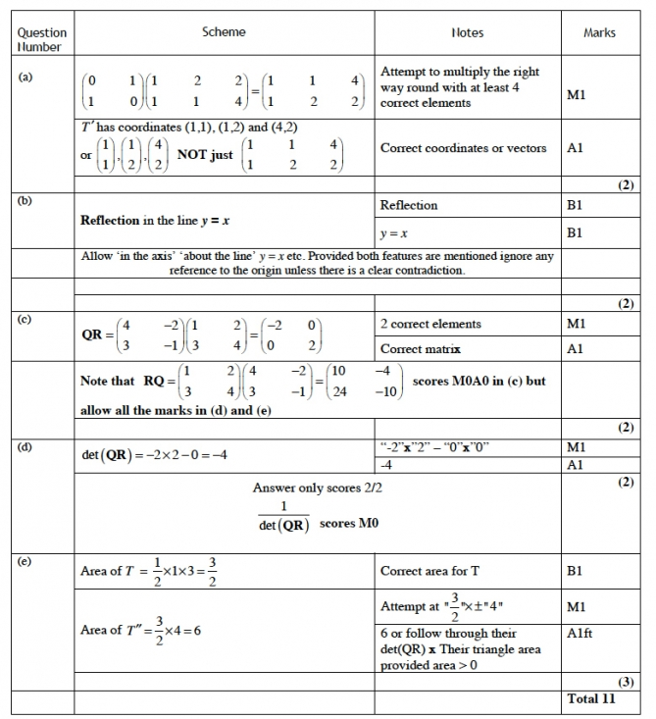

**Q7.**

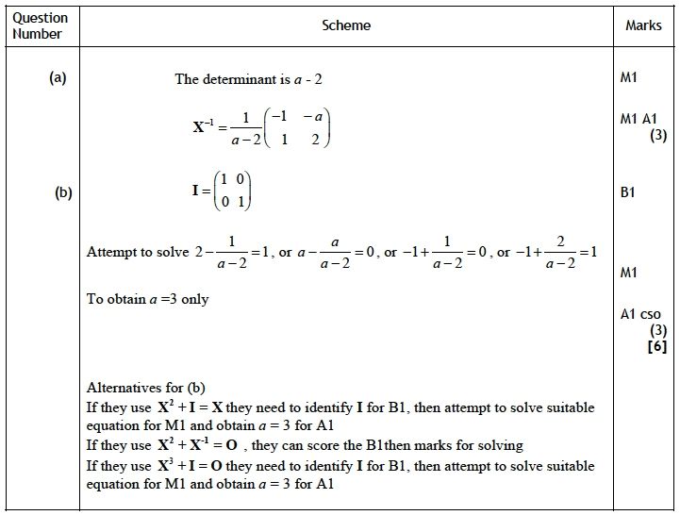

Notes:

(a) Attempt ad-bc for first M1   
 for second M1

(b) Final A1 for correct solution only