**Candidate Name:**

**Maths Teachers** (please circle): VLH & FUO or DM & KS

|  |  |
| --- | --- |
| **Pearson Edexcel Level 3** | |
| **GCE Mathematics**  **Advanced Subsidiary**  **Pure & Applied Mathematics Combined Paper** | |
| **Mock Exam**  **Time: 2 hours** | **Paper Reference(s)** |
| **8MA0/AHSMOCK** |
| **You must have:**  **Calculator** | |

**Candidates may use any calculator permitted by Pearson regulations. Calculators must not have the facility for algebraic manipulation, differentiation and integration, or have retrievable mathematical formulae stored in them.**

**Instructions**

• Use black ink or ball-point pen.

• If pencil is used for diagrams/sketches/graphs it must be dark (HB or B).

• Fill in the boxes at the top of this page with your name, centre number and candidate number.

• **Answer all the questions** and ensure that your answers to parts of questions are clearly labelled.

• Answer the questions in the spaces provided – there may be more space than you need.

• You should show sufficient working to make your methods clear. Answers without working may not gain full credit.

• Inexact answers should be given to three significant figures unless otherwise stated.

**Information**

• A list of **‘Mathematical Formulae’** is provided **at the back** of this paper

• There are 14 questions in this question paper. The total mark for this paper is 100.

• The marks for each question are shown in brackets – use this as a guide as to how much time to spend on each question.

**Advice**

• Read each question carefully before you start to answer it.

• Try to answer every question.

• Check your answers if you have time at the end.

• If you change your mind about an answer, cross it out and put your new answer and any working underneath.

**1** Simplify , giving your answer in the form , where *p* and *q* are positive rational numbers. **(4 marks)**

**2 **

**a** Find the discriminant of f(*x*) in terms of *k* giving your answer as a simplified quadratic.

**(3 marks)**

**b** If the equation f(*x*) = 0 has two equal roots, find the possible values of *k*. **(2 marks)**

**c** Show that when *k* = 8, f(*x*) > 0 for all values of *x*. **(3 marks)**

**3** A stone is thrown from the top of a cliff. The height *h*, in metres, of the stone above  
the ground level after *t* seconds is modelled by the function 

**a** Give a physical interpretation of the meaning of the constant term 115 in the model.

**(1 mark)**

**b** Write *h*(*t*) in the form *A* – *B*(*t* – *C*)2, where *A*, *B* and *C* are constants to be found.

**(3 marks)**

**c** Using your answer to part **b**, or otherwise, find, with justification

**i** the time taken after the stone is thrown for it to reach ground level **(3 marks)**

**ii** the maximum height of the stone above the ground and the time after which this   
maximum height is reached. **(2 marks)**

**4** , *x* ∈ ℝ

Sketch the graph *y* = g(*x*). Label any asymptotes and any points of intersection   
with the coordinate axes. **(5 marks)**

**5** The points *A* and *B* have coordinates (3*k* − 4, −2) and (1, *k* + 1) respectively, where *k* is a constant. Given that the gradient of *AB* is 

**a** show that *k* = 3 **(2 marks)**

**b** find an equation of the line through *A* and *B* **(3 marks)**

**c** find an equation of the perpendicular bisector of *A* and *B,* leaving your answer  
in the form  where *a*, *b* and *c* are integers. **(4 marks)**

**6** **a** Find an equation of the straight line passing through the points with coordinates  
(4, −7) and (−6, 11), giving your answer in the form ,where *a*, *b*  
and *c* are integers. **(3 marks)**

The line crosses the *x*-axis at point *A* and the *y*-axis at point *B* and *O* is the origin.

**b** Find the area of triangle *AOB*. **(3 marks)**

**7** The equations of two circles are  and 

**a** Find the centre and radius of each circle, giving your answers in terms of *q*  
where necessary. **(6 marks)**

**b** Given that the distance between the centres of the circles isfind the two  
possible values of *q*. **(3 marks)**

**8** 

Use the factor theorem and division to factorise f(*x*) completely. **(6 marks)**

**9 a** Expand in ascending powers of *x*, up to and including the term in ,  
simplifying each coefficient in the expansion. **(4 marks)**

**b** Showing your working clearly, use your expansion to find, to 5 significant figures,  
an approximation for  **(3 marks)**

**10** **a** Prove that if  then *x* > 0 **(4 marks)**

**b** Show, by means of a counter example, that the inequality   
is not true for all vaues of *x*. **(2 marks)**

**11** **a** Explain what is meant by the word ‘population’. **(1 mark)**

Jo needs to conduct a survey to investigate the type of kitchen cleaner people prefer. She wants a random sample of people who use kitchen cleaners. She decides to stand in a busy high street on a Saturday afternoon and attempt to get shoppers to answer her questions.

**b** State the sampling technique Jo has used. **(1 mark)**

Having been unsuccessful in obtaining enough data from her previous attempt, Jo decides to look at the electoral register for a town and selects a sample of 50 households to contact. She decides to select every 10th name on the electoral register to add to her sample.

**c** State the sampling technique Jo has used. **(1 mark)**

**d** Give two reasons why Jo may again be unsuccessful getting the data required using this sampling technique. **(2 marks)**

**e** Suggest an alternative method for Jo to use and explain your reasons. **(2 marks)**

**12** Before redecorating the school canteen the headteacher decided to survey the opinion of staff and students.

**a** Explain why the headteacher decided to take a stratified sample of staff and students. **(1 mark)**

**b** Suggest a suitable sampling frame. **(1 mark)**

**c** Identify the sampling units. **(1 mark)**

There are 250 students and 30 staff at the school.

**d** Explain how the headteacher could take a stratified sample of size 60. **(3 marks)**

**e** Suggest a problem that might arise with the sampling frame when selecting the staff and students.

**(1 mark)**

**13** A travel agent sells flights to different destinations from Southstead airport. The distance of the destination from the airport is denoted *d* where *d* is measured in 100 km units so that *d* = 2.2 represents a distance of 220 km. Values of *d* and the associated fare £*f* are recorded for a random sample of 6 destinations.

|  |  |  |  |  |  |  |
| --- | --- | --- | --- | --- | --- | --- |
| **Destination** | *A* | *B* | *C* | *D* | *E* | *F* |
| ***d* (100 km)** | 2.2 | 4.0 | 6.0 | 2.5 | 8.0 | 5.0 |
| ***f* (£)** | 18 | 20 | 25 | 23 | 32 | 28 |

**a** Using the axes below, complete a scatter diagram to illustrate this information.

(**2 marks**)

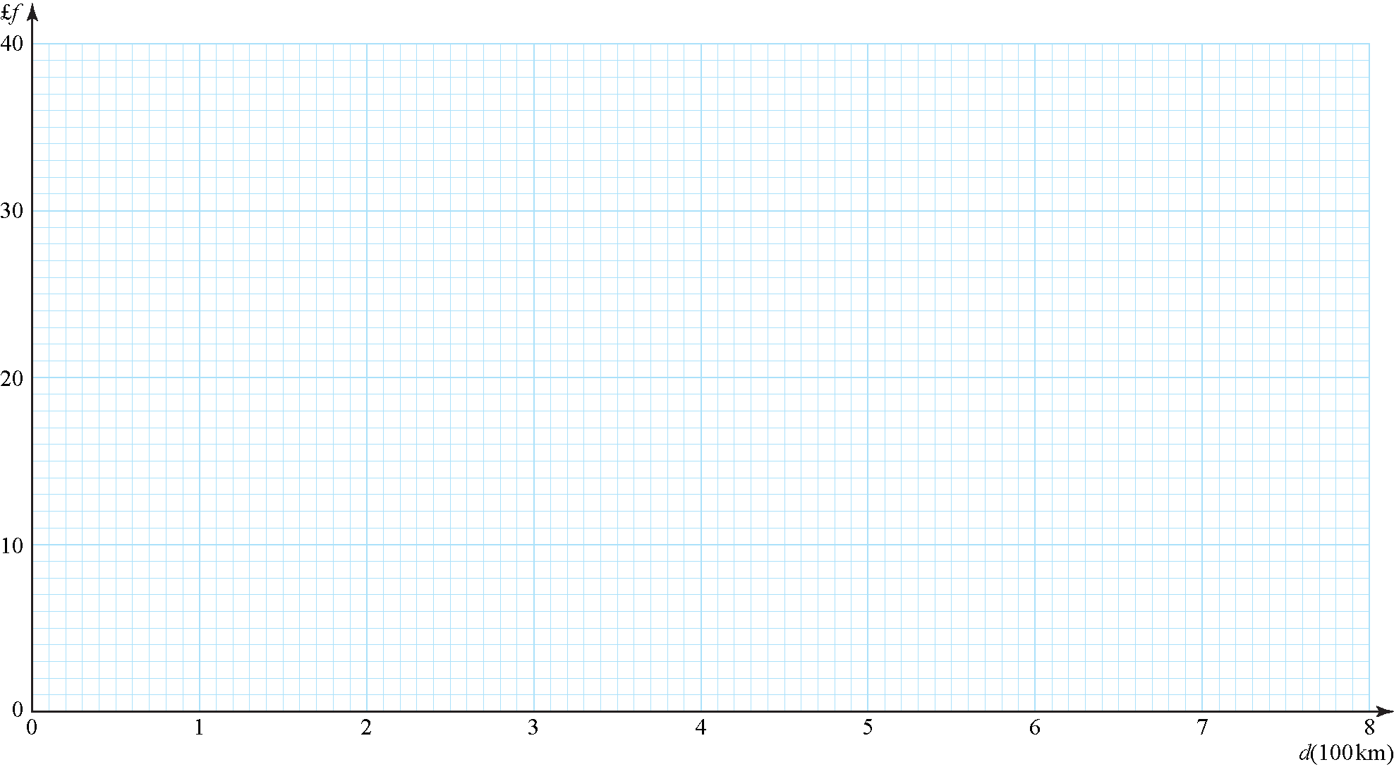

**b** Explain why a linear model may be appropriate to describe the relationship between *f* and *d*. (**1 mark**)

**c** State which of *f* and *d* should be considered the response variable. (**1 mark**)

**d** Use a line of best fit to estimate a fare £*f* for a flight to a destination which is 700 km away.

(**2 marks**)

**e** Comment on the reliability of your estimate, giving a reason for your answer.

(**1 mark**)

Jane is planning her holiday and wishes to fly from Southstead airport to a destination 180 km away.

**f** State if it is sensible for Jane to estimate the fare of her flight using the scatter graph, giving a reason for your answer. (**1 mark**)

**14** Data relating to the lifetimes (to the nearest hour) of a random sample of 200 light bulbs from the production line of a manufacturer were summarised in a grouped frequency table. The mid-point of each class in the table was represented by *x* and the corresponding frequency for that class by *f*. The data were then coded using:



and summarised as follows:



Calculate estimates of the mean and the standard deviation of the lifetimes of this sample of bulbs. (**9 marks**)

**END OF TEST (100 MARKS TOTAL)**

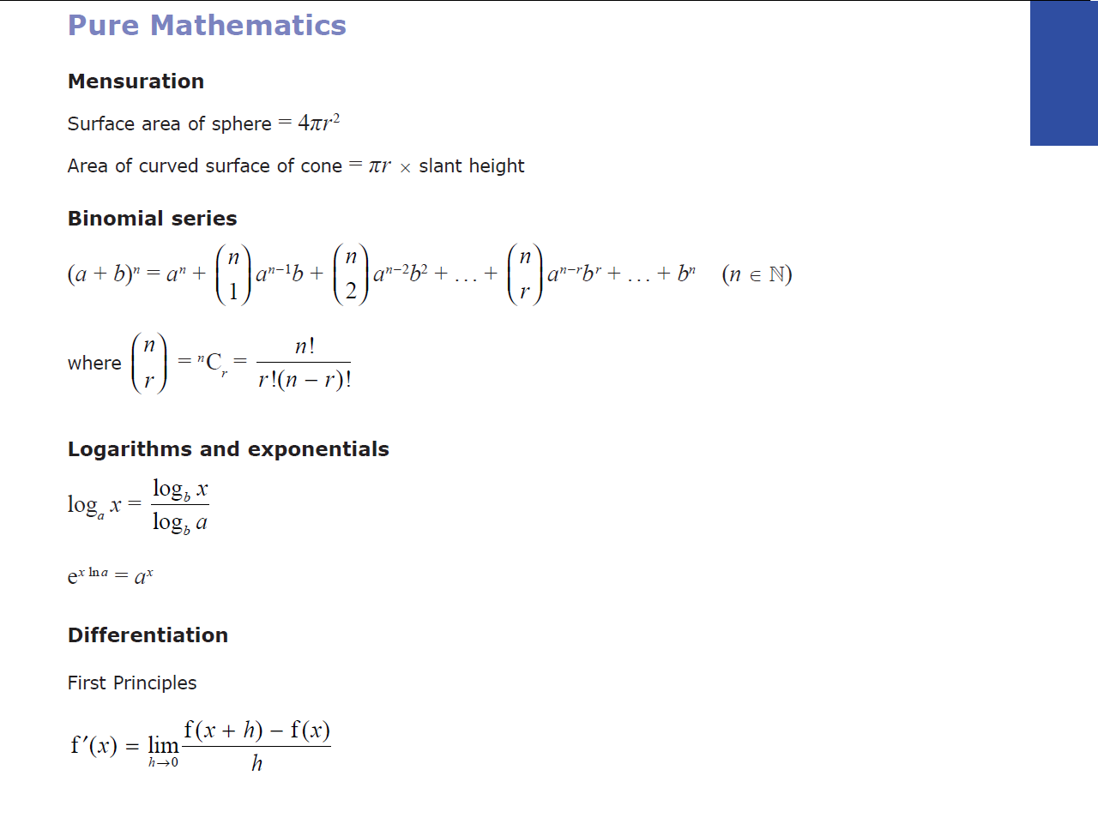**Mathematical Formulae for AS Mathematics**

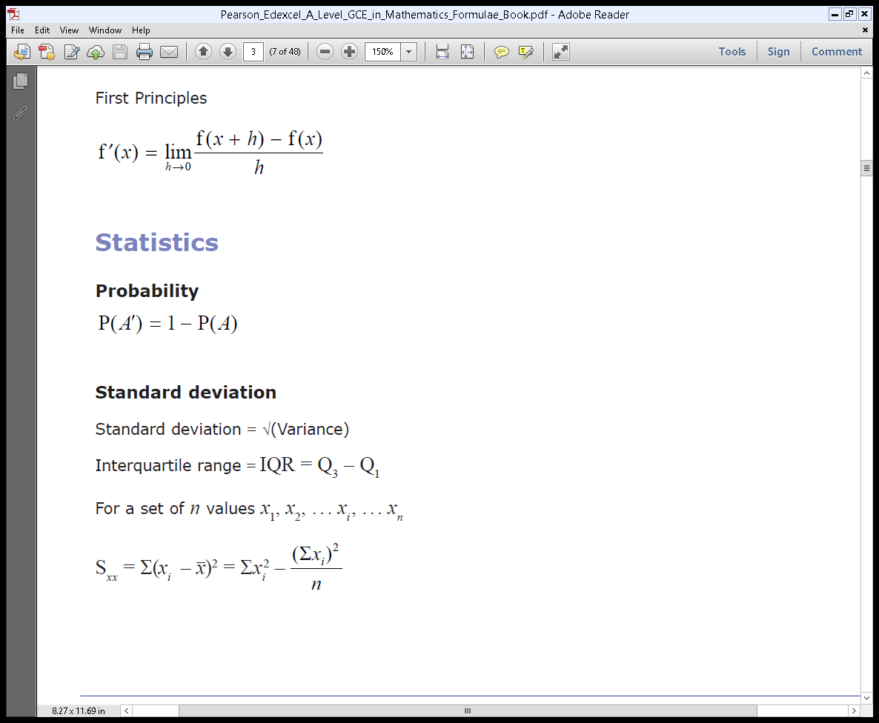

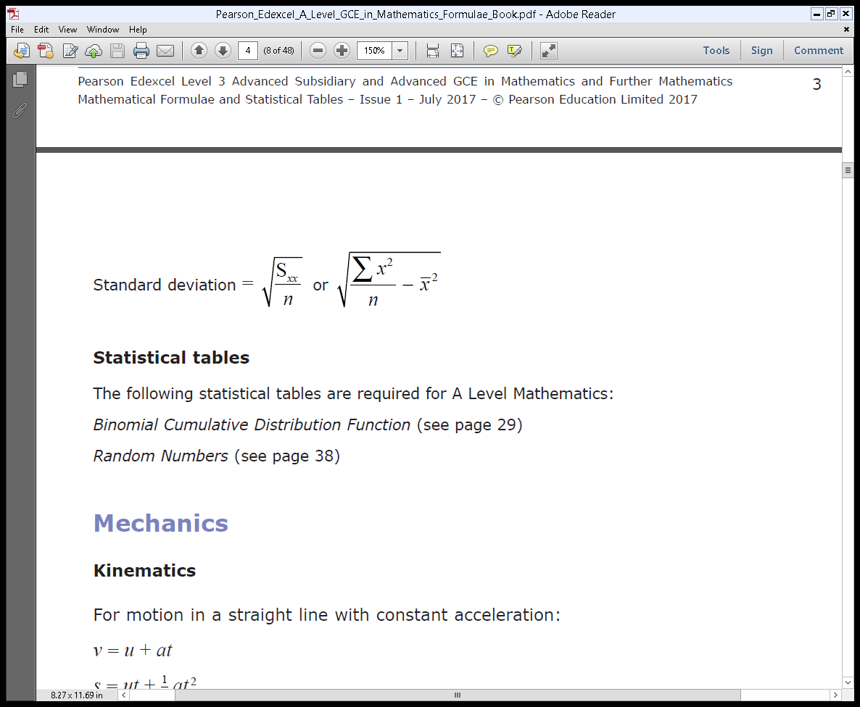

|  |  |  |
| --- | --- | --- |
| **Q** | **Scheme** | **Marks** |
| **1** | Attempt to multiply the numerator and denominator by . For example, | **M1** |
| Attempt to multiply out the numerator (at least 3 terms correct). | **M1** |
| Attempt to multiply out the denominator (for example, 3 terms correct but **must** be rational or 64 – 3 seen or implied). | **M1** |
| *p* and *q* stated or implied (condone if all over 61).  or | **A1** |
| **(4 marks)** | | |

|  |  |  |
| --- | --- | --- |
| **Q** | **Scheme** | **Marks** |
| **2a** | Statement that discriminant is *b*2 – 4*ac*, and/or implied by writing | **M1** |
| Attempt to simplify the expression by multiplying out the brackets. Condone sign errors and one algebraic error (but **not** missing *k* term from squaring brackets and must have *k*2, *k* and constant terms).  o.e. | **M1** |
|  | **A1** |
|  | **(3)** |
| **2b** | Knowledge that two equal roots occur when the discriminant is zero. This can be shown by writing *b*2 – 4*ac* = 0, or by writing | **M1** |
|  | **A1** |
|  | **(2)** |
| **2c** | Correct substitution for *k* = 8: | **B1** |
| Attempt to complete the square for their expression of f(*x*). | **M1** |
| Statement (which can be purely algebraic) that f(*x*) > 0, because, for example, a squared term is always greater than or equal to zero, so one more than a square term must be greater than zero or an appeal to a reasonable sketch of *y* = f(*x*). | **A1** |
|  | **(3)** |
| **(8 marks)** | | |
| **Notes**  **2a**  Not all steps have to be present to award full marks. For example, the second method mark can still be awarded if the answer does not include that step.  **2b**  Award full marks for *k* = 6, *k* = 10 seen. Award full marks for valid and complete alternative method (e.g. expanding (*x* – *a*)2 comparing coefficients and solving for *k)*.  **2c**  An alternative method is acceptable. For example, students could differentiate to find that the turning point of the graph of *y* = f(*x*) is at (8, 1), and then show that it is a minimum. The minimum can be shown by using properties of quadratic curves or by finding the second differential. Students must explain (a sketch will suffice) that this means that the graph lies above the *x*-axis and reach the appropriate conclusion. | | |

|  |  |  |
| --- | --- | --- |
| **Q** | **Scheme** | **Marks** |
| **3a** | 115 (m) is the height of the cliff (as this is the height of the ball when *t* = 0). Accept answer that states 115 (m) is the height of the cliff plus the height of the person who is ready to throw the stone or similar sensible comment. | **B1** |
|  | **(1)** |
| **3b** | Attempt to factorise the – 4.9 out of the first two (or all) terms.  or | **M1** |
| or | **M1** |
| o.e.  (N.B. 122.65625 =)  Accept the first term written to 1, 2, 3 or 4 d.p. or the full answer as shown. | **A1** |
|  | **(3)** |
| **3ci** | Statement that the stone will reach ground level when  *h*(*t*) = 0, or is seen. | **M1** |
| Valid attempt to solve quadratic equation (could be using completed square form from part **b**, calculator or formula). | **M1** |
| Clearly states that *t* = 6.25 s (accept *t* = 6.3 s) is the answer, or circles that answer and crosses out the other answer, or explains that *t* must be positive as you cannot have a negative value for time. | **A1** |
|  | **(3)** |
| **3cii** | *h*max = awrt 123  ft A from part **b**. | **B1ft** |
| *t* =or *t* = 1.25  ft C from part **b**. | **B1ft** |
|  | **(2)** |
| **(9 marks)** | | |
| **Notes**  **3c**  Award 4 marks for correct final answer, with some working missing. If not correct B1 for each of *A*, *B* and *C* correct.  If the student answered part **b** by completing the square, award full marks for part **c**, providing their answer to their part **b** was fully correct. | | |

|  |  |  |  |
| --- | --- | --- | --- |
| **Q** | **Scheme** | | **Marks** |
| **4** | **Figure 2**  cid:image001.png@01D2F97D.9E481CC0 | Asymptote drawn at *x* = 6 | **B1** |
| Asymptote drawn at *y* = 5 | **B1** |
| Pointlabelled. Condone clearly on *y* axis. | **B1** |
| Pointlabelled.  Condoneclearly on *x* axis. | **B1** |
| Correctly shaped graph drawn in the correct quadrants formed by the asymptotes. | **B1** |
|  | **(5)** |
| **(5 marks)** | | | |

|  |  |  |
| --- | --- | --- |
| **5a** | Use of the gradient formula to begin attempt to find *k*.  or  (i.e. correct substitution into gradient formula and equating to ). | **M1** |
| 2*k* + 6 = −15 + 9*k*  21 = 7*k*  *k* = 3* (must show sufficient, convincing and correct working). | **A1\*** |
|  |  | **(2)** |
| **5b** | Student identifies the coordinates of either *A* or *B*. Can be seen or implied, for example, in the subsequent step when student attempts to find the equation of the line.  *A(*5, −2) or *B*(1, 4). | **B1** |
| Correct substitution of their coordinates into *y* = *mx* + *b* or *y* − *y*1 = *m*(*x* − *x*1) o.e. to find the equation of the line. For example,  or  or  or | **M1** |
| or | **A1** |
|  |  | **(3)** |

|  |  |  |
| --- | --- | --- |
| **5c** | Midpoint of *AB* is (3, 1) seen or implied. | **B1** |
| Slope of line perpendicular to *AB* is, seen or implied. | **B1** |
| Attempt to find the equation of the line (i.e. substituting their midpoint and gradient into a correct equation). For example,  or | **M1** |
| or . Also accept any multiple of providing *a*, *b* and *c* are still integers. | **A1** |
|  | **(4)** |
| **(9 marks)** | | |

|  |  |  |
| --- | --- | --- |
| **Q** | **Scheme** | **Marks** |
| **6a** |  | **B1** |
| Correct substitution of (4, −7) or (−6, 11) and their gradient into *y* = *mx* + *b* or *y* − *y1* = *m*(*x* − *x*1) o.e. to find the equation of the line. For example,  or or or . | **M1** |
| 5*y* + 9*x* − 1 = 0 or −5*y* − 9*x* + 1 = 0 only | **A1** |
|  | **(3)** |
| **6b** | so. Award mark for seen. | **B1** |
| so . Award mark for  seen. | **B1** |
| Area = | **B1** |
|  | **(3)** |
| **(6 marks)** | | |

|  |  |  |
| --- | --- | --- |
| **Q** | **Scheme** | **Marks** |
| **7a** | Student attempts to complete the square twice for the first equation (condone sign errors). | **M1** |
| Centre (−5, 6) | **A1** |
| Radius = 8 | **A1** |
| Student attempts to complete the square twice for the second equation (condone sign errors). | **M1** |
| Centre (3, *q*) | **A1** |
| Radius = | **A1** |
|  | **(6)** |
| **7b** | Uses distance formula for their centres and. For example, | **M1** |
| Student simplifies to 3 term quadratic. For example, | **M1** |
| Concludes that the possible values of *q* are 2 and 10 | **A1** |
|  | **(3)** |
| **(9 marks)** | | |

|  |  |  |
| --- | --- | --- |
| **Q** | **Scheme** | **Marks** |
| **8** | Correctly shows that either f(3) = 0, f(−2) = 0 or  = 0 | **M1** |
| Draws the conclusion that (*x* – 3), (*x* + 2) or (2*x* + 1) must therefore be a factor. | **M1** |
| Either makes an attempt at long division by setting up the long division, or makes an attempt to find the remaining factors by matching coefficients. For example, stating  or  or | **M1** |
| For the long division, correctly finds the the first two coefficients.  For the matching coefficients method, correctly deduces that  *a* = 2 and *c* = 2 or correctly deduces that *r* = 2 and *q* = −3 or correctly deduces that *u* = 1 and *w* = –6 | **A1** |
| For the long division, correctly completes all steps in the division.  For the matching coefficients method, correctly deduces that  *b* = 5 or correctly deduces that *p* = −5 or correctly deduces that *v* = –1 | **A1** |
| States a fully correct, fully factorised final answer:  (*x* – 3)(2*x* + 1)(*x* + 2) | **A1** |
| **(6 marks)** | | |
| **Notes**  Other algebraic methods can be used to factorise h(*x*). For example, if (*x* – 3) is known to be a factor then  by balancing (M1)  by factorising (M1)  by factorising (A1) | | |

|  |  |  |
| --- | --- | --- |
| **Q** | **Scheme** | **Marks** |
| **9a** | States or implies the expansion of a binomial expression to the 8th power, up to and including the *x*3 term.  or | **M1** |
| Correctly substitutes 1 and 3*x* into the formula: | **M1** |
| Makes an attempt to simplify the expression (2 correct coefficients (other than 1) or both 9*x*2 and 27*x*3). | **M1 dep** |
| States a fully correct answer: | **A1** |
|  | **(4)** |
| **9b** | States *x* = 0.01 or implies this by attempting the substitution: | **M1** |
| Attempts to simplify this expression (2 calculated terms correct):  1 + 0.24 + 0.0252 + 0.001512 | **M1** |
| 1.266712 = 1.2667 (5 s.f.) | **A1** |
|  | **(3)** |
| **(7 marks)** | | |

|  |  |  |
| --- | --- | --- |
| **Q** | **Scheme** | **Marks** |
| **10a** | Makes an attempt to expand the binomial expression (must be terms in *x*0, *x*1, *x*2, *x*3 and at least 2 correct). | **M1** |
|  | **A1** |
| 0 < 3*x* | **A1** |
| *x* > 0* as required. | **A1\*** |
|  | **(4)** |
| **10b** | Picks a number less than or equal to zero, e.g. *x* = −1, and attempts a substitution into both sides. For example, | **M1** |
| Correctly deduces for their choice of *x* that the inequaltity does not hold. For example, 3 ≮ 0 | **A1** |
|  | **(2)** |
| **(6 marks)** | | |

|  |  |  |
| --- | --- | --- |
| **Q** | **Scheme** | **Marks** |
| **11a** | A complete collection of relevant individual people or items. | **B1** |
|  | **(1)** |
| **11b** | Opportunity (convenience). | **B1** |
|  | **(1)** |
| **11c** | Systematic. | **B1** |
|  | **(1)** |
| **11d** | Two from:   * not random * electoral register may have errors * there may not be enough (500) households on the register. | **B1**  **B1** |
|  | **(2)** |
| **11e** | **Either**: random sampling – it avoids bias.  **Or**: quota sampling – no sampling frame required, continue until all quotas filled. | **B1** |
| **Either:** Random sampling from people buying kitchen cleaners in a large store, as this would reduce potential bias.  **Or:** Quota sampling from people based on a chosen set of ages and genders who use kitchen cleaners, continuing until all quotas are filled, as this would avoid the need for a sampling frame and allow for a more clearly representative sample. | **B1** |
|  | **(2)** |
| **(7 marks)** | | |

|  |  |  |
| --- | --- | --- |
| **Q** | **Scheme** | **Marks** |
| **12a** | One of:   * to obtain a representative sample * large number of students compared to staff so would be unfair to take same numbers of both. | **B1** |
|  | **(1)** |
| **12b** | A list of the names of staff and students. | **B1** |
|  | **(1)** |
| **12c** | A member of staff or a student. | **B1** |
|  | **(1)** |
| **12d** | Find proportions for different strata out of 60 (either explained or some sensible calculation seen). | **M1** |
| students,  staff. | **A1** |
| Select at random using a random number generator. | **B1** |
|  | **(3)** |

|  |  |  |
| --- | --- | --- |
| **12e** | One of:   * absence on the day of the survey * sampling frame may contain errors. | **B1** |
|  | **(1)** |
| **(7 marks)** | | |
| **Notes**  **12d**  Must be whole numbers for A1. | | |

|  |  |  |
| --- | --- | --- |
| Q | Scheme | Marks |
| **13a** | All points correctly plotted. | **B2** |
|  | **(2)** |
| **13b** | The **points** lie reasonably close to a **straight line** (o.e.). | **B1** |
|  | **(1)** |
| **13c** | *f* | **B1** |
|  | **(1)** |
| **13d** | Line of best fit plotted for at least 2.2 ⩽ *x* ⩽ 8 with *D* and *F* above and *B* and *C* below. | **M1** |
| 26 to 31 inclusive (must be correctly read from *x* = 7 from the line of best fit). | **A1** |
|  | **(2)** |

|  |  |  |
| --- | --- | --- |
| **13e** | It is reliable because it is interpolation (700 km is within the range of values collected). | **B1** |
|  | **(1)** |
| **13f** | No, it is not sensible since this would be extrapolation (as 180 km is outside the range of distances collected). | **B1** |
|  |  | **(1)** |
| (8 marks) | | |
| Notes  **13a** First B1 for at least 4 points correct, second B1 for all points correct.  **13b** Do not accept‘The points lie reasonably close to a line’. Linear or straight need to be noted.  **13e** Also allow ‘It is reliable because the points lie reasonably close to a straight line’.  **13f** Allow the answer ‘It is sensible since even though it is extrapolation it is not by much’ provided that the answer contains both ideas (i.e. it IS extrapolation but by a small amount compared to the given range of data). | | |

|  |  |  |
| --- | --- | --- |
| **Q** | **Scheme** | **Marks** |
| **14** | = −2.335 (seen or implied)    = 2.5 + 755.0  = 749.1625 (Accept awrt 749)  *σy* =  = 6.3594…  *σx* = 2.5 × 6.3594…  = 15.8986… (Accept awrt 15.9) | **B1**  **M1**  **M1**  **A1**  **M1 A1**  **A1**  **M1**  **A1** |
|  |  | **(9)** |
| **(9 marks)** | | |