**A-level Maths, Year 13 Half-term 2 Assessment**

**Section A: Pure Maths**

**1.** **a** Prove that  **(3 marks)**

**b** Use the result to solve, for $0≤θ≤\frac{π}{2}$, the equation 

Give your answer in terms of π. Check for extraneous solutions. **(4 marks)**

**2** Figure 1 shows a logo comprised of a rhombus surrounded by two arcs. Arc *BAD* has centre *C* and arc *BCD* has centre *A*. Some of the dimensions of the logo are shown in the diagram.

**Figure 1**

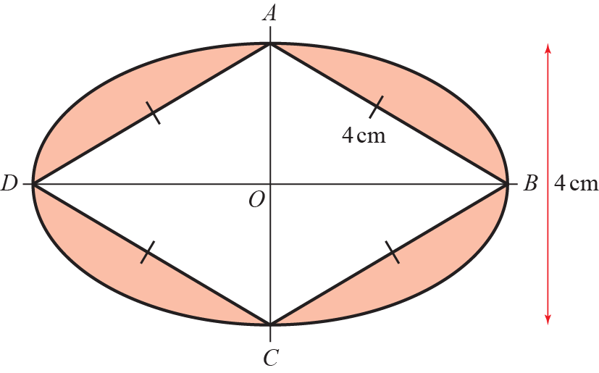

Prove that the shaded area of the logo is **(8 marks)**

**3.** (*a*)Write 2 sin 𝜃– cos 𝜃in the form *R* sin (𝜃– *α*), where *R* and *α* are constants, *R* > 0 and

0 < *α* ⩽ 90°. Give the exact value of *R* and give the value of *α* to one decimal place.

**(3)**



Figure 3 shows a sketch of the graph with equation *y* = 2 sin 𝜃– cos 𝜃, 0 ⩽ 𝜃< 360°

(*b*)Sketch the graph with equation

*y* = | 2 sin 𝜃– cos 𝜃 |, 0 ⩽ 𝜃< 360°

stating the coordinates of all points at which the graph meets or cuts the coordinate axes.

**(3)**

The temperature of a warehouse is modelled by the equation

f(*t*) = 5 + | 2 sin (15*t*)° – cos (15*t*)° |, 0 ⩽ *t* < 24

where f(*t*) is the temperature of the warehouse in degrees Celsius and *t* is the time measured in hours from midnight.

State

(*c*)(i) the maximum value of f(*t*),

(ii) the largest value of *t*, for 0 ⩽ *t* < 24, at which this maximum value occurs. Give

your answer to one decimal place.

**(3)**

**(Total 9 marks)**

**A-level Maths, Year 13 Half-term 2 Assessment**

**Section B: Applied Maths**

**1** The table below shows the number of gold, silver and bronze medals won by two teams in an athletics competition.

|  |  |  |  |
| --- | --- | --- | --- |
|  | **Gold** | Silver | Bronze |
| **Team *A*** | 29 | 17 | 18 |
| **Team *C*** | 21 | 23 | 17 |

The events *G*, *S* and *B* are that a medal is gold, silver or bronze respectively. Let *A* be the event that team A won a medal and *C* team C won a medal. A medal winner is selected at random. Find

**a** P(*G*) **(2 marks)**

**b** P([*A**S*]') **(2 marks)**

**c** Explain, showing your working, whether or not events *S* and *A* are statistically independent. Give reasons for your answer. **(2 marks)**

**d** Determine whether or not events *B* and *C* are mutually exclusive. Give a reason for your answer. **(2 marks)**

**e** Given that 30% of the gold medal winners are female, 60% of the silver medal winners are female and 40% of the bronze medal winners are female, find the probability that a randomly selected medal winner is female. **(2 marks)**

**2.**



**Figure 1**

A non-uniform rod *AB* has length 3 m and mass 4.5 kg. The rod rests in equilibrium, in a horizontal position, on two smooth supports at *P* and at *Q*, where *AP* = 0.8 m and *QB* = 0.6 m, as shown in Figure 1. The centre of mass of the rod is at *G*. Given that the magnitude of the reaction of the support at *P* on the rod is twice the magnitude of the reaction of the support at *Q* on the rod, find

(*a*) the magnitude of the reaction of the support at *Q* on the rod, **(3)**

(*b*) the distance *AG*. **(4)**

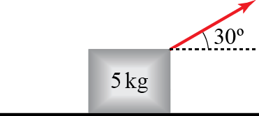**3.** An object resting on a rough surface is attached to a rope angled at 30° to the horizontal. The rope is being pulled with a force of *P* N. The mass of the object is 5 kg.

**a** Calculate the magnitude of (i) the frictional force and (ii) the normal reaction force of the surface on the object, giving your answers in terms of *P* and *g* where appropriate. **(4)**

**b** If *P* = 20, the object does not slip. Use this information to give a bound on $μ$ in the form of an inequality.

**(6)**

**END OF TEST (51 MARKS)**

**Mark Scheme**

|  |  |  |
| --- | --- | --- |
| **1** | Use Pythagoras’ theorem to show that the length oforor states | **M1** |
|  | Makes an attempt to findor.  For example,is seen. | **M1** |
|  | Correctly states thator | **A1** |
|  | Makes an attempt to find the area of the sector with a radius of 4 and a subtended angle of  For example,is shown. | **M1** |
|  | Correctly states that the area of the sector is | **A1** |
|  | Recognises the need to subtract the sector area from the area of the rhombus in an attempt to find the shaded area.  For example,is seen. | **M1** |
|  | Recognises that to find the total shaded area this number will need to be multiplied by 2. For example, | **M1** |
|  | Using clear algebra, correctly manipulates the expression and gives a clear final answer of | **A1** |
|  |  | **8** |

|  |  |  |
| --- | --- | --- |
| **2a** |  | **M1** |
| Usesandto write:  Award one mark for each correct use of a trigonometric identity. | **A2** |
|  | **(3)** |
| **2b** | States that: | **B1** |
| Simplifies this to write: | **M1** |
| Correctly finds  Additional answers might be seen, but not necessary in order to award the mark. | **M1** |
| States  Note that. For these values 3*θ* lies in the third quadrant, thereforeandare both negative and cannot be equal to a positive surd. | **A1** |
|  | **(4)** |

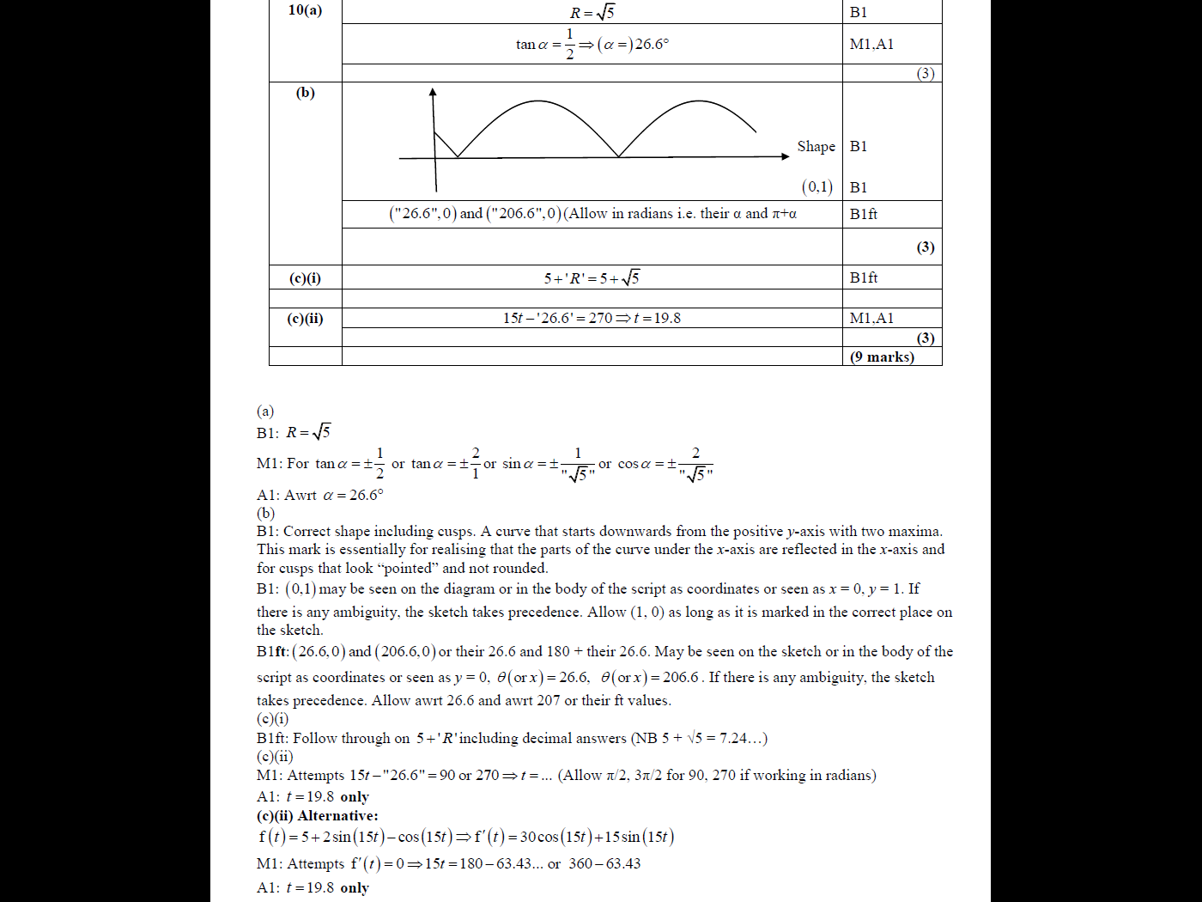

**3 (a)**

|  |  |  |
| --- | --- | --- |
| 1a | = | M1 |
| = 0.4 | A1 |
|  | (2) |
| 1b | = | M1 |
| = 0.864 | A1 |
|  | (2) |
| 1c | P(*S**A*) == 0.136 ≠ P(*S*) × P(*A*) ==0.163… | **M1** |
| So, *S* and *A* are not statistically independent. | **A1** |
|  | **(2)** |
| 1d | *B* and *C* are not mutally exclusive | B1 |
| Being in team *C* does not exclude the possibility of winning a bronze medal | B1 |
|  | (2) |
| 1e | = | M1 |
| = 0.424 | A1 |
|  | (2) |

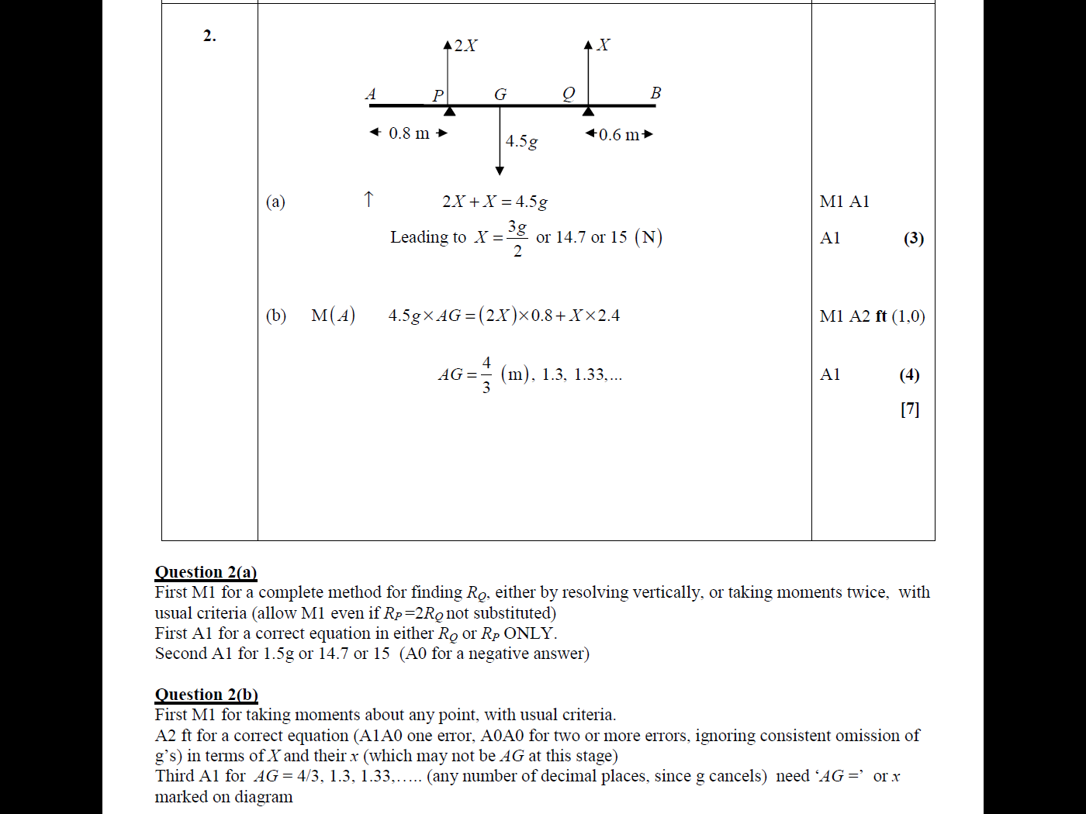

|  |  |  |
| --- | --- | --- |
| **3** |  |  |
|  |  |
| **3a** | Res(→) *F* = *P* cos 30 | **M1** |
|  | **A1** |
| Res(↑) *R* = 5*g* − *P* sin 30 | **M1** |
|  | **A1** |
|  | **(4)** |
| **3b** | If *P* = 20,  Substitute into *R*  *R* = 39 N | **M1**  **A1** |
| Substitute into F  *F* = or 17.320… (N) | **M1**  **A1** |
| If limiting equilibrium, *μ*or 0.444…  So *μ* ⩾or *μ* ⩾ 0.44 | **M1**  **A1ft** |
|  | **(6)** |