**A-level Maths, Half-term 1 Assessment – Section A (Algebra & Functions)**

**Q1.**

Simplify the following expressions fully.

(a)   

**(1)**

(b)   

**(2)**

**(Total for question = 3 marks)**

**Q2.**

(i)  Given that  = 7*a*, find the value of *a*.

**(2)**

(ii)  Show that  = 15 √2 + 20

You must show all stages of your working.

**(3)**

**(Total for question = 5 marks)**

**Q3.**

Find the range of values of *x* for which

(a)  4(*x* – 2) ≤ 2*x* + 1

**(2)**

(b)  (2*x* – 3)(*x* + 5) > 0

**(3)**

(c)  **both** 4(*x* – 2) ≤ 2*x* + 1 **and** (2*x* – 3)(*x* + 5) > 0

**(1)**

**(Total for question = 6 marks)**

**Q4.** The equation

*kx*2 + 4*x* + *k* = 2, where *k* is a constant,

has two distinct real solutions for *x*.

(a)  Show that *k* satisfies

*k*2 − 2*k* − 4 < 0

**(4)**

(b)  Hence find the set of all possible values of *k*.

**(3)**

**(Total for question = 7 marks)**

**Q5.**

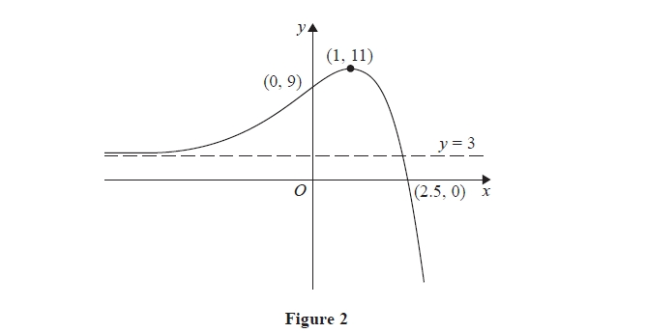

Figure 2 shows a sketch of part of the curve with equation *y* = f(*x*).   
The curve crosses the coordinate axes at the points (2.5, 0) and (0, 9), has a stationary point   
at (1, 11), and has an asymptote *y* = 3

On **separate** diagrams, sketch the curve with equation

(a)  *y* = 3f(*x*)

**(3)**

(b)  *y* = f(– *x*)

**(3)**

On each diagram show clearly the coordinates of the points of intersection of the curve   
with the two coordinate axes, the coordinates of the stationary point, and the equation of   
the asymptote.

**(Total for question = 6 marks)**

**A-level Maths, Half-term 1 Assessment – Section B (Co-ordinate Geometry)**

**Q6.**

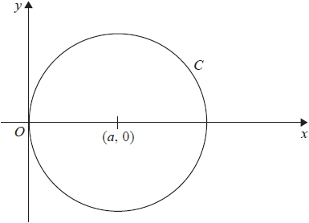

**Figure 3**

Figure 3 shows a circle *C*

*C* touches the *y*-axis and has centre at the point (*a*, 0) where *a* is a positive constant.

(a)  Write down an equation for *C* in terms of *a*

**(2)**

Given that the point *P*(4, –3) lies on *C*,

(b)  find the value of *a*

**(3)**

**(Total for question = 5 marks)**

**Q7.**

A circle, with centre *C* and radius *r*, has equation

*x*2 + *y*2 − 8*x* + 4 *y* − 12 = 0

Find

(a)  the coordinates of *C*,

**(2)**

(b)  the exact value of *r*.

**(2)**

The circle cuts the *y*-axis at the points *A* and *B*.

(c)  Find the coordinates of the points *A* and *B*.

**(3)**

**(Total for question = 7 marks)**

**Q8.**

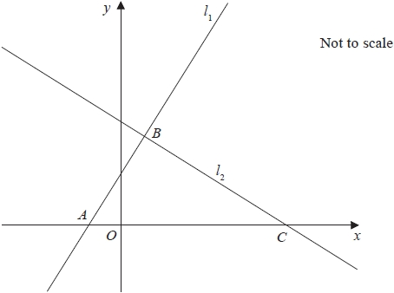

**Figure 2**

The straight line *l*1 has equation 2*y* = 3*x* + 5

The line *l*1 cuts the *x*-axis at the point *A*, as shown in Figure 2.

(a)  (i)  State the gradient of *l*1

(ii)  Write down the *x* coordinate of point *A*.

**(3)**

Another straight line *l*2 intersects *l*1 at the point *B* with *x* coordinate 1 and crosses the *x*-axis at the point *C*, as shown in Figure 2.

Given that *l*2 is perpendicular to *l*1

(b)  find an equation for *l*2 in the form *ax* + *by* + *c* = 0, where *a*, *b* and *c* are integers,

**(5)**

(c)  find the exact area of triangle *ABC*.

**(3)**

**(Total for question = 11 marks)**

**Mark Scheme**

Q1.

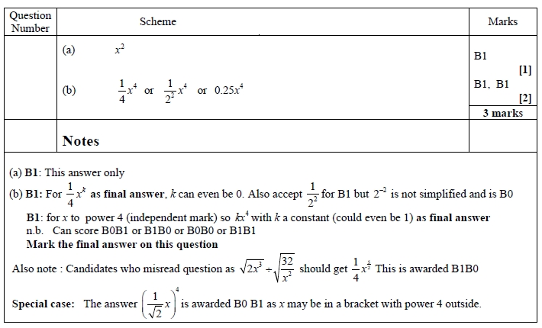

**Q2.**

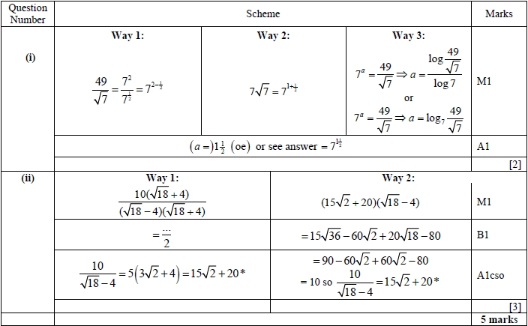

**Q3.**

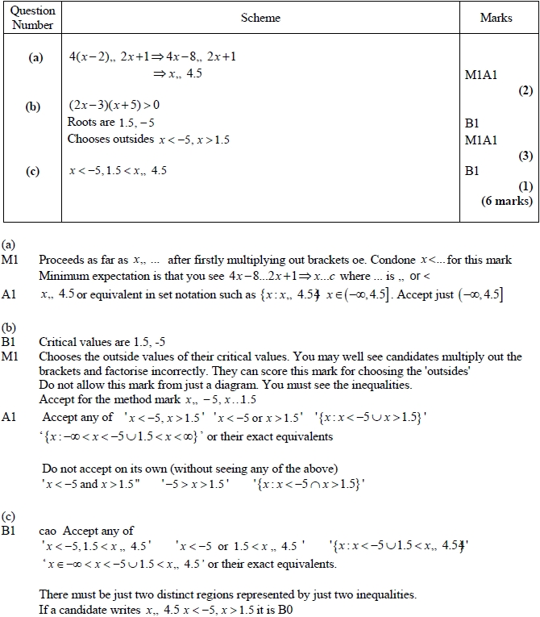

**Q4.**

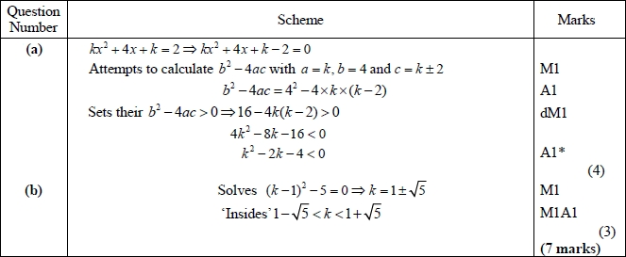

**Q5.**

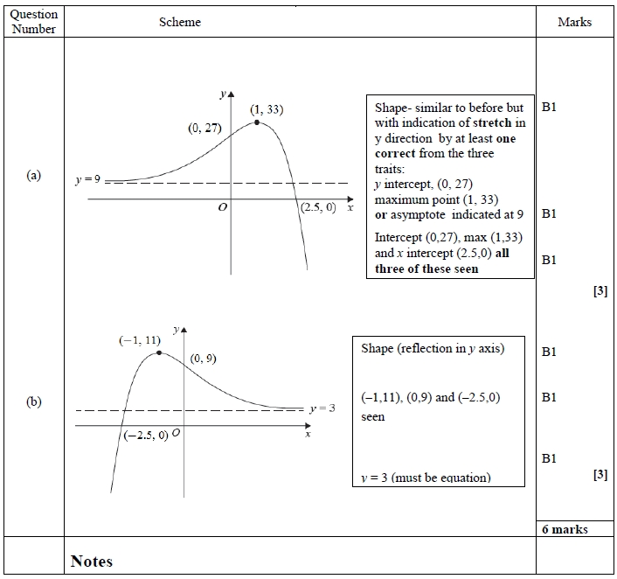

**Q6.**

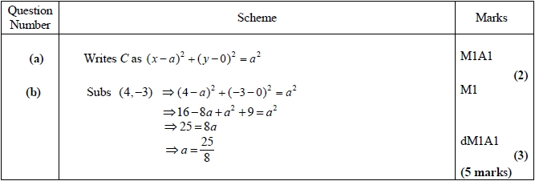

**Q8.** 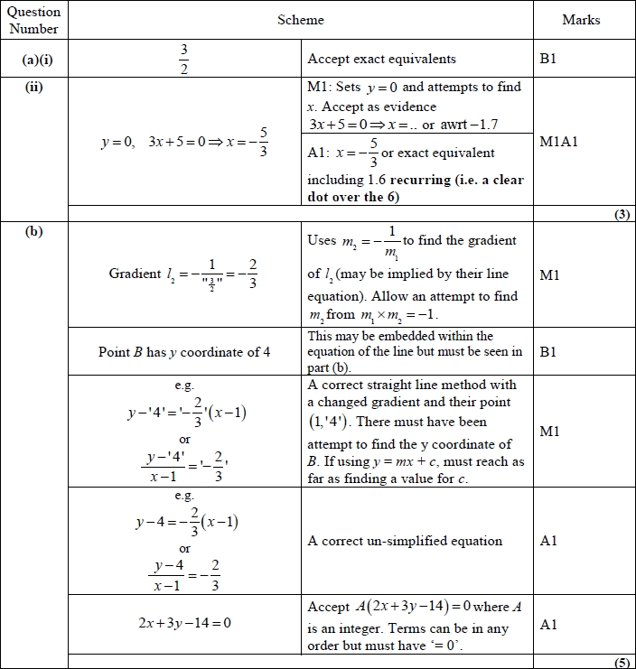

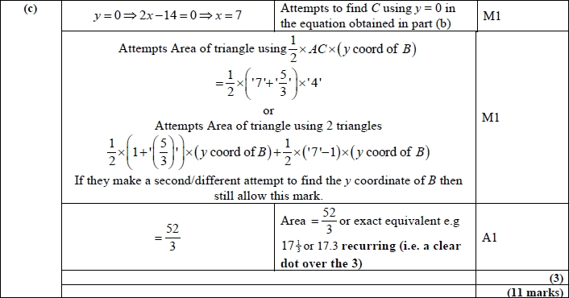

**Q7.**

