**A-level Maths, Year 13 Half-term 1 Assessment**

1 Prove by exhaustion that  for positive integers from 1 to 6 inclusive. **(3 marks)**

**2** 

Find the values of the constants *A*, *B*, *C* and *D*. **(5 marks)**

**3** **a** Find the binomial expansion of  in ascending powers of *x* up to and including the *x*2 term, simplifying each term. **(4 marks)**

**b** State the set of values of *x* for which the expansion is valid. **(1 mark)**

**c** Show that when , the exact value of  is . **(2 marks)**

**d** Substitute  into the binomial expansion in part **a** and hence obtain an approximation to. Give your answer to 5 decimal places. **(3 marks)**

**4** To investigate if there is a correlation between daily mean pressure (hPa) and daily mean wind speed (kn) the location Hurn 2015 was randomly selected from:

Camborne 2015 Camborne 1987

Hurn 2015 Hurn 1987

Leuchars 2015 Leuchars 1987

Leeming 2015 Leeming 1987

Heathrow 2015 Heathrow 1987.

Source: Pearson Edexcel GCE AS and AL Mathematics data set

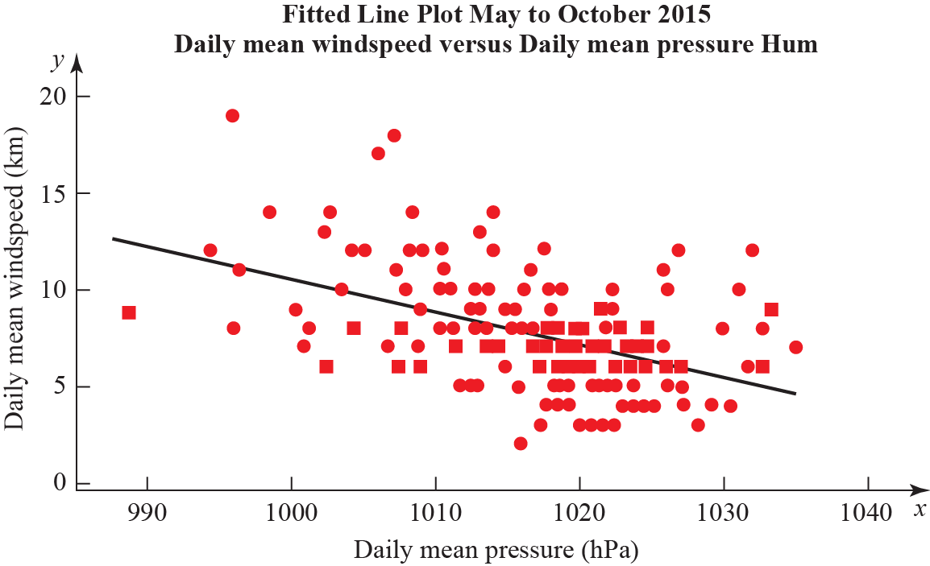The statistical software output for these data is shown below.

Correlation coefficient

Daily mean winds and Daily mean pressure = −0.477

*p*-value < 0.001

Regression summary output for daily mean wind speed versus daily mean pressure

|  |  |  |  |
| --- | --- | --- | --- |
|  | **Coefficients** | **Lower 95%** | **Upper 95%** |
| **Intercept** | 180.00 | 133.5424 | 226.4128 |
| **Daily Mean Pressure(hPa)**  **Gradient** | −0.1694 | −0.21512 | −0.12377 |

**a** State what is measured by the product moment correlation coefficient. **(1 mark)**

**b** Comment on the correlation between the two variables. **(1 mark)**

**c** Give an interpretation of the correlation between the two variables. **(1 mark)**

**d** Test at 5% significance level whether or not the product moment correlation coefficient for the population is less than zero. State your hypotheses clearly. **(3 marks)**

**e** Write down the regression model for daily mean wind speed versus daily mean pressure. **(2 marks)**

**f** Interpret the gradient of the line of regression stated in part **e**. **(1 mark)**

**g** The regression model (equation of regression) was used to predict the daily mean wind speed of 11.15 knots for a daily mean pressure of 995 hPa. Comment on the accuracy of this prediction. **(1 mark)**

**5** The value of a car, *V* in £, is modelled by the equation , where *a* and *b*  
are constants and *t* is the number of years since the car was purchased. The line *l* shown in Figure 1 illustrates the linear relationship between *t* and for . The line meets the vertical axis at   
(0, log440 000) as shown. The gradient of is .



**Figure 1**

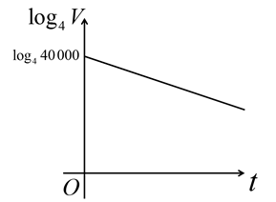

**a** Write down an equation for . **(2 marks)**



**b** Find, in exact form, the values of *a* and *b*. **(4 marks)**

**c** With reference to the model, interpret the values of the constant *a* and *b*. **(2 marks)**

**d** Find the value of the car after 7 years. **(1 mark)**

**e** After how many years is the value of the car less than £10 000? **(2 marks)**

**f** State a limitation of the model. **(1 mark)**

**6** A particle of mass 6 kg is initially at rest and is then acted upon by a force **R** = on a bearing of 300°.

**a** Find the exact value of *a*. **(3 marks)**

**b** Calculate the magnitude of **R**. **(2 marks)**

**c** Work out the magnitude of the acceleration of the particle. **(2 marks)**

**d** Find the time it takes for the particle to travel a distance of 640 m. **(2 marks)**

**END OF TEST**

**TOTAL MARKS 49**

|  |  |  |  |  |
| --- | --- | --- | --- | --- |
| **1** | Makes an attempt to substitute any of *n* = 1, 2, 3, 4, 5 or 6 into | **M1** | 1.1b | 5th  Complete proofs by exhaustion. |
| Successfully substitutes *n* = 1, 2, 3, 4, 5 **and** 6 into | **A1** | 1.1b |
| Draws the conclusion that as the statement is true for all numbers from 1 to 6 inclusive, it has been proved by exhaustion. | **B1** | 2.4 |
| (3 marks) | | | | |

|  |  |  |  |  |
| --- | --- | --- | --- | --- |
| Q | Scheme | Marks | AOs | Pearson Progression Step and Progress descriptor |
| **2** | Makes an attempt to set up a long division.  For example:  is seen. | **M1** | 2.2a | 5th  Divide polynomials by linear expressions with a remainder. |
| Award 1 accuracy mark for each of the following:  seen, 2*x* seen, −21 seen.  For the final accuracy mark either *D* = 138 or  or the remainder is 138 must be seen. | **A4** | 1.1b |
| (5 marks) | | | | |
| Notes  This question can be solved by first writing  and then solving for *A*, *B*, *C* and *D*. Award 1 mark for the setting up the problem as described. Then award 1 mark for each correct coefficient found. For example:  Equating the coefficients of *x*3: *A* = 1  Equating the coefficients of *x*2: 6 + *B* = 8, so *B* = 2  Equating the coefficients of *x*: 12 + *C* = −9, so *C* = −21  Equating the constant terms: −126 + *D* = 12, so *D* = 138. | | | | |

|  |  |  |  |  |
| --- | --- | --- | --- | --- |
| Q | Scheme | Marks | AOs | Pearson Progression Step and Progress descriptor |
| **3a** | Writes:  as | **M1** | 2.2a | 6th  Understand the binomial theorem for rational n. |
| Uses the binomial expansion to write: | **M1** | 2.2a |
| Simplifies to obtain: | **M1** | 1.1b |
| Writes the correct final answer: … | **A1 ft** | 1.1b |
|  | **(4)** |  |  |
| **3b** | Either states or states | **B1** | 3.2b | 6th  Understand the conditions for validity of the binomial theorem for rational n. |
|  | **(1)** |  |  |
| **3c** | Makes an attempt to substitute  into  For example | **M1** | 1.1b | 6th  Understand the binomial theorem for rational n. |
| Continues to simplify the expression:  And states the correct final answer: | **A1** | 1.1b |
|  | **(2)** |  |  |

|  |  |  |  |  |
| --- | --- | --- | --- | --- |
| **3d** | Substitutes  into  Obtains: | **M1 ft** | 2.2a | 6th  Understand the binomial theorem for rational n. |
| States that | **M1 ft** | 1.1b |
| Deduces that | **A1 ft** | 1.1b |
|  | **(3)** |  |
| (10 marks) | | | | |
| Notes  **3a**  Award 3 marks if a student has used an incorrect expansion but worked out all the other steps correctly.  **3d**  Award all three marks if a student provided an incorrect answer in part **a**, but accurately works out an approximation for root 2 consistent with this incorrect answer. | | | | |

|  |  |  |  |  |
| --- | --- | --- | --- | --- |
| Q | Scheme | Marks | AOs | Pearson Progression Step and Progress descriptor |
| **4a** | Linear association between two variables. | **B1** | 1.2 | 2nd  Know and understand the language of correlation and regression. |
|  | **(1)** |  |  |
| **4b** | Negative correlation. | **B1** | 1.2 | 2nd  Know and understand the language of correlation and regression. |
|  | **(1)** |  |  |
| **4c** | As daily mean pressure increases (rises) daily mean wind speed decreases (falls) in Hurn May to October in 2015.  or  As daily mean pressure decreases (falls) daily mean wind speed increases (rises) in Hurn May to October in 2015. | **B1** | 3.2 | 5th  Interpret the PPMC as a measure of correlation. |
|  | **(1)** |  |  |
| **4d** | H0 : = 0, H1 : < 0  *p-*value < 0.05  There is evidence to reject H0.  There is (strong) evidence of negative correlation between the daily mean wind speed and daily mean pressure. | **B1**  **M1**  **A1** | 2.5  1.1b  2.2b | 6th  Carry out a hypothesis test for zero correlation. |
|  | **(3)** |  |  |
| **4e** | Daily mean wind speed = 180 − 0.170 × daily mean pressure. | **B2** | 1.1b | 4th  Use the principles of bivariate data analysis in the context of the large data set. |
|  | **(2)** |  |  |

|  |  |  |  |  |
| --- | --- | --- | --- | --- |
| **4f** | The regression model suggests for every hPa increase in daily mean pressure the daily mean wind speed decreases by 0.1694 knots.  or  The regression model suggests for every hPa decrease in daily mean pressure the daily mean wind speed increases by 0.1694 knots. | **B1** | 3.2 | 4th  Use the principles of bivariate data analysis in the context of the large data set. |
|  | **(1)** |  |  |
| **4g** | Sensible comment. For example,  Not very accurate as very few or no points  Not very accurate as near the bottom range for the data. | **B1** | 3.5b | 4th  Make predictions using the regression line within the range of the data. |
|  | **(1)** |  |  |
| (10 marks) | | | | |
| **Notes**  **4e**  B1 *y* = 180.0 − 0.1694*x* unless *x* and *y* are defined. | | | | |

|  |  |  |  |  |
| --- | --- | --- | --- | --- |
| **Q** | **Scheme** | **Marks** | **AOs** | **Pearson Progression Step**  **and Progress descriptor** |
| **5a** | Uses the equation of a straight line in the form  or  o.e. | **M1** | 1.1b | 6th  Set up, use and critique exponential models of growth and decay. |
| Makes correct substitution.  o.e. | **A1** | 1.1b |
|  | **(2)** |  |  |
| **5b** | Either correctly rearranges their equation by exponentiation  For example,  or takes the log of both sides of the equation . For example, . | **M1** | 1.1b | 6th  Set up, use and critique exponential models of growth and decay. |
| Completes rearrangement so that both equations are in directly comparable form  and  or and . | **M1** | 1.1b |
| States that *a* = 40 000 | **A1** | 1.1b |
| States that | **A1** | 1.1b |
|  | **(4)** |  |  |
| **5c** | *a* is the initial value of the car o.e. | **B1** | 2.2a | 6th  Set up, use and critique exponential models of growth and decay. |
| *b* is the annual proportional decrease in the value of the car o.e. (allow if explained in figures using their *b*. For example, (since *b* is ≈0.87) the car loses 13% of its value each year.) | **B1** | 2.2a |
|  | **(2)** |  |  |

|  |  |  |  |  |
| --- | --- | --- | --- | --- |
| **5d** | Substitutes 7 into their formula from part b. Correct answer is £15 157, accept awrt £15 000 | **B1ft** | 3.4 | 4th  Understand the properties of functions of the form *ax*. |
|  |  | **(1)** |  |  |
| **5e** | Uses  with their values of *a* and *b* or writes  (could be inequality). | **M1** | 3.4 | 5th  Solve exponential equations using logarithms. |
| Solves to find *t* = 10 years. | **A1ft** | 1.1b |
|  | **(2)** |  |  |
| **5f** | Acceptable answers include.  The model is not necessarily valid for larger values of *t.*  Value of the car is not necessarily just related to age.  Mileage (or other factors) will affect the value of the car. | **B1** | 3.5b | 6th  Set up, use and critique exponential models of growth and decay. |
|  | **(1)** |  |  |
| **(12 marks)** | | | | |
| **Notes**  **5b**  2nd M mark can be implied by correct values of *a* and *b*.  **5c**  Accept answers that are the equivalent mathematically. For example, for *b*. the value of the car in 87% of the value the previous year. | | | | |

|  |  |  |  |  |
| --- | --- | --- | --- | --- |
| **Q** | **Scheme** | **Marks** | **AOs** | **Pearson Progression Step and Progress descriptor** |
| **6a** | Either states that or | **M1** | 1.1b | 5th  Use Newton’s second law to model motion in two directions. |
| Correctly find | **M1** | 1.1b |
| Interprets *a* in the context of the question, stating | **A1** | 3.2 |
|  | **(3)** |  |  |
| **6b** | States that the magnitude of | **M1** | 1.1b | 5th  Use Newton’s second law to model motion in two directions. |
| States *R* = 20 (N). | **A1 ft** | 1.1b |
|  | **(2)** |  |  |
| **6c** | States *F* = *ma* or implies use of *F* = *ma*. For example 20 = 6 × *a* is seen. | **M1** | 3.3 | 5th  Use Newton’s second law to model motion in two directions. |
| Correctly findsm s−2. | **A1 ft** | 1.1b |
|  | **(2)** |  |  |
| **6d** | States thator implies it use by writing | **M1** | 3.1b | 5th  Use Newton’s second law to model motion in two directions. |
| Solves to find(s). Accept awrt 19.6 (s). | **A1 ft** | 1.1b |
|  | **(2)** |  |  |
| **(9 marks)** | | | | |
| **Notes**  **6b**  Award ft marks for a correct answer using their value from part **a** for the **i** component of the force.  **6c**  Award ft marks for a correct answer using their value from part **b** for the resultant force.  **6d**  Award ft marks for a correct answer using their value from part **c** for the acceleration. | | | | |