Pearson Edexcel Level 3
GCE Further Mathematics
Advanced Subsidiary
Paper 1: Core Pure Mathematics
Specimen paper  Time: 1 hour 40 minutes | Paper Reference(s)
Specimen paper  Time: 1 hour 40 minutes | 8FM0/01
You must have:
Mathematical Formulae and Statistical Tables, calculator

Candidates may use any calculator permitted by Pearson regulations. Calculators must not have the facility for algebraic manipulation, differentiation and integration, or have retrievable mathematical formulae stored in them.

Instructions
• Use black ink or ball-point pen.
• If pencil is used for diagrams/sketches/graphs it must be dark (HB or B).
• Answer all questions and ensure that your answers to parts of questions are clearly labelled.
• Answer the questions in the spaces provided – there may be more space than you need.
• You should show sufficient working to make your methods clear. Answers without working may not gain full credit.
• Inexact answers should be given to three significant figures unless otherwise stated.

Information
• A booklet ‘Mathematical Formulae and Statistical Tables’ is provided.
• There are 9 questions in this paper. The total mark is 80.
• The marks for each question are shown in brackets – use this as a guide as to how much time to spend on each question.

Advice
• Read each question carefully before you start to answer it.
• Try to answer every question.
• Check your answers if you have time at the end.
• If you change your mind about an answer, cross it out and put your new answer and any working underneath.
1.
P = 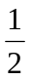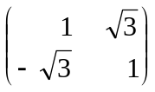, Q = 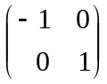 .

The matrices and 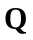 represent linear transformations, 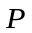 and 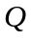 respectively, of the plane.
The linear transformation 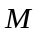 is formed by first applying and then applying 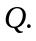

(a) Find the matrix 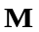 that represents the linear transformation 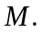
(2)

(b) Show that the invariant points of the linear transformation form a line in the plane, stating the equation of this line.
(3)
(Total for Question 1 is 5 marks)
___________________________________________________________________________

2. (a) Sketch, on an Argand diagram, the set of points

X = {z ∈ ℂ : |z – 4 – 2i| < 3} ∩ {z ∈ ℂ : 0 ≤ arg (z) ≤ 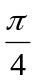}.
(3)

On your diagram

(b) shade the part of the diagram that is included in the set,

(c) use solid lines to show the parts of the boundary that are included in the set, and use dashed lines to show the parts of the boundary that are not included in the set.

(d) Show that the complex number z = 5 + 4i is in the set 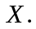
(3)
(Total for Question 2 is 6 marks)
___________________________________________________________________________

3. (a) Find, in terms of the real constant k, the determinant of the matrix

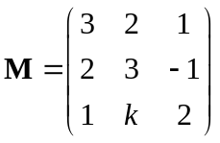.
(2)

Three distinct planes 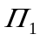, 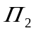 and 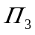 are defined by the equations

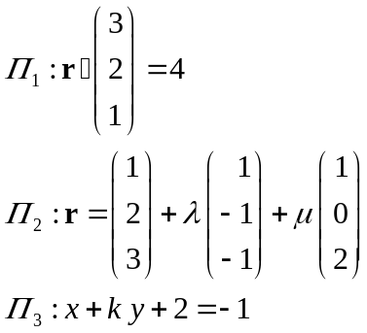

where and 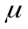 are scalar parameters.

(b) Find an equation in Cartesian form for

(i) 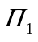,

(ii) .
(4)
Given that the three planes , and form a sheaf,

(c) use the answer to part (a) to explain why k ≠ 1.
(2)
(Total for Question 3 is 8 marks)
___________________________________________________________________________

4. A company manufacturing radios agreed a 20 year contract with a retailer to supply their radios.

In the first year of the contract, 500 radios were supplied to the retailer. In each subsequent year, the number of radios supplied to the retailer was 50 more than in the previous year.

The amount received by the company for each radio during year of the contract was

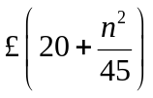.

The total cost of producing the radios during year was modelled as 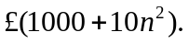

- Show that, according to the model, the profit made by the company in year n, £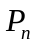, is given by
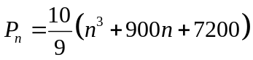.
(2)

(b) Use the standard results for summations to show that the total profit made by the company in the first 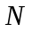 years of the contract, £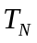, is given by

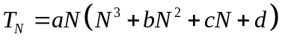,

where , , and are constants to be found.
(5)

At the end of the 20 years, the company found that their total profit made from this contract just exceeded £500 000.

(c) Assess the model in the light of this information.
(2)
(Total for Question 4 is 9 marks)
___________________________________________________________________________

5. f(z) = 8z³ + 12z² + 6z + 65.

Given that 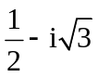 is a root of the equation f(z) = 0,

(a) write down the other complex root of the equation,
(1)

(b) use algebra to solve the equation f(z) = 0 completely.
(3)

(c) Show the roots of f(z) on a single Argand diagram.
(2)

(d) Show that the roots of f(z) form the vertices of an equilateral triangle in the complex plane.
(2)
(Total for Question 5 is 8 marks)
___________________________________________________________________________

6. (a) Prove by induction that, for all n ∈ ℤ⁺,

f(n) = n⁵ + 4n

is divisible by 5.
(6)

(b) Show that f(–x) = –f(x) for all x ∈ ℕ.
(1)

(c) Hence prove that f(n) is divisible by 5 for all n ∈ ℤ.
(2)
(Total for Question 6 is 9 marks)
___________________________________________________________________________

7. The population of the Zebu cattle in a particular country is modelled by two sub-populations, adults and juveniles. In this model, the only factors affecting the population of the Zebu are the birth and survival rates of the population.

Data recorded in the years preceding 2018 was used to suggest the annual birth and survival rates. The results are shown in the table below, with values to 2 significant figures. It is assumed that these rates will remain the same in future years.

 | Birth rate | Survival Rate
Adult population | 0.23 | 0.97
Juvenile population | 0 | 0.87

It is also assumed that of the surviving juvenile population become adults each year.

Let 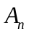 and 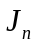 be these respective sub-populations, in millions of adults and juveniles, n years after 1st January 2018. Then the adult population in year n + 1 satisfies the equation

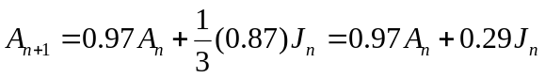.

(a) Form the corresponding equation for the juvenile population in year n + 1 under this model, justifying your values.
(2)

The total population on 1st January 2018 was estimated, to 2 significant figures, as 1.5 million Zebu, with 1.2 million of these being adults.

(b) Find the value of p and the matrix 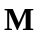 such that the population of Zebu can be modelled by the system
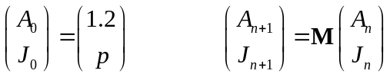,

giving p to 2 significant figures and each entry of M to 2 decimal places.
(3)

(c) Using the model formed in part (b), find, to 3 significant figures,

(i) the total Zebu population that was present on 1st January 2017,

(ii) the predicted juvenile Zebu population on 1st January 2025.
(5)

As a result of the predictions of this model the country will export 15 000 juveniles to a neighbouring country at the end of each year.

(d) Adapt the model from 2018 onwards to include this export.
(2)
(e) State one limitation of this model.

(1)
(Total for Question 7 is 13 marks)
___________________________________________________________________________

8.
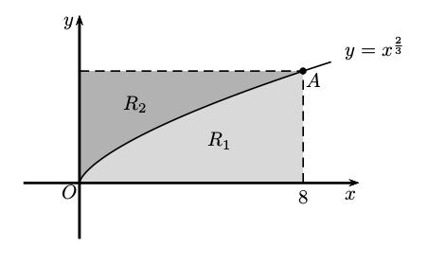
Figure 1
Figure 1 shows a sketch of part of the curve with equation 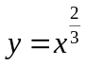, x ≥ 0.
The curve passes through the point  with coordinate 8.
The region 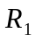 is bounded by the curve, the vertical line passing through A and the x-axis.
The region 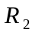 is bounded by the curve, the horizontal line passing through A and the y-axis.
The solid 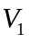 is formed by rotating the region 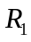 through 360° about the x-axis.
The solid 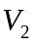 is formed by rotating the region 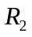 through 360° about the y-axis.

(a) Show that the exact volume of the solid is 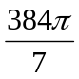.
(4)

The two solids and 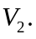 are placed in an empty container. A solid is selected at random and then replaced in the container. This is repeated 10 times.

Given that the probability of selecting each type of solid is proportional to its volume,

(b) find, to 4 decimal places, the probability that the solid is selected exactly 8 times.
(7)
(Total for Question 8 is 11 marks)
___________________________________________________________________________
9. A small comet 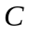 is passing near to a planet. The planet can be modelled as a sphere with centre 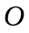 taken as a fixed point in space, so that the motion of the comet is relative to the origin .

The diameter of the planet is 13000 km. The comet is monitored by satellites orbiting the planet. When the monitoring begins the comet is at position 146i + 234j – 85k and is moving with vector –21i – 33j + 13k every hour, where the units are in thousands of kilometres.

Assuming the comet maintains a straight line course throughout its motion,

(a) determine whether or not the comet will collide with the planet.
(6)

Two of the satellites, A, and B, have position vectors OA = 5i + 12k and OB = 54i + 12j – 3k at the beginning of monitoring. They return to these positions every 4 hours.

(b) Find the expected angle ACB between the comet and the satellites A and B when they first return to their initial positions. Give your answer to the nearest 0.1°.
(4)

(c) Give a reason why the answer to (b) may differ from the true value.
(1)
(Total for Question 9 is 11 marks)
___________________________________________________________________________

TOTAL FOR PAPER IS 80 MARKS

