8MA0/02: AS Paper 2 Part B Mechanics Mark scheme
Question | Scheme | Marks | AOs
1(a) | Use of 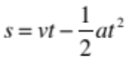 | M1 | 2.1
1(a) | 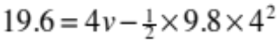 | A1 | 1.1b
1(a) | v = 24.5 or 25 (m s⁻¹) | A1 | 1.1b
1(a) |  | (3)
(b) | 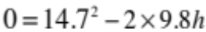 | M1 | 2.1
(b) | h = 11.0 or 11 (m) | A1 | 1.1b
 |  | (2)
(c) | New value of speed would be lower. | B1 | 3.5a
(c) |  | (1)
(6 marks)
Notes:
(a)
M1: Complete method to give equation in v only (could involve 2 or more suvat equations and then elimination) with usual rules
A1: Correct equation
A1: Correct answer
(b)
M1: Complete method to find h
A1: 11.0 or 11 (m)
(c)
B1: New value of speed will be lower

Question | Scheme | Marks | AOs
2(a) | V Shape  0  120 | B1 | 1.1b
2(a) | V , 120 | B1 | 1.1b
2(a) |  | (2)
(b) | 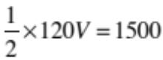 | M1 | 3.1b
(b) | 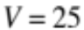 | A1 | 1.1b
(b) |  | (2)
(c) | Area of triangle = Distance travelled = (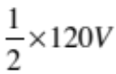) = 1500 | B1 | 2.4
(c) | This does not depend on T so T can take any value where 0 < T < 120 | B1 | 2.4
(c) |  | (2)
(d) | Include a constant speed phase in the motion | B1 | 3.5c
 |  | (1)
(7 marks)
Notes:
(a)
B1: Triangle, starting at the origin with base on axis and apex between t = 0 and t = 120
B1: V and 120 correctly marked (allow a delineator)
(b)
M1: Identifying correct strategy to solve problem to give equation in V only
A1: V = 25
(c)
B1: Area of triangle only depends on base and height
B1: So T can take any value 0 < T < 120
(d)
B1: e.g. Include a smooth change from acceleration phase to deceleration phase.
e.g. Have a variable acceleration and/or deceleration phase

Question | Scheme | Marks | AOs
3(a)(i)  (ii) | Equation of motion for P with usual rules | M1 | 3.3
3(a)(i)  (ii) | 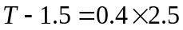 | A1 | 1.1b
3(a)(i)  (ii) | T = 2.5 (N) | A1 | 1.1b
3(a)(i)  (ii) | Equation of motion for Q with usual rules | M1 | 3.3
3(a)(i)  (ii) | 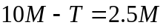 | A1 | 1.1b
3(a)(i)  (ii) | 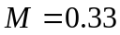 | A1 | 1.1b
 |  | (6)
(b) | 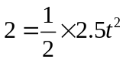 | M1 | 3.4
(b) | 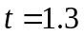 (s) | A1 | 1.1b
(b) |  | (2)
(c) | e.g. the mass of the rope | B1 | 3.5b
 |  | (1)
(9 marks)
Notes:
(a) (i)
M1: Resolve horizontally for P
A1: Correct equation
A1: Correct answer. Ignore units
(a)(ii)
M1: Resolve vertically for Q
A1: Correct equation
A1: Correct answer
(b)
M1: Use 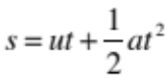
A1: 1.3. Ignore units
(c)
B1: e.g. the pulley may not be smooth,
air resistance

Question | Scheme | Marks | AOs
4(a) | 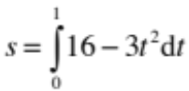 | M1 | 1.1a
4(a) | 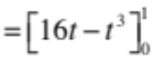 | A1 | 1.1b
4(a) | 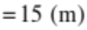 | A1 | 1.1b
4(a) |  | (3)
(b) | 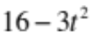= 0 | M1 | 3.1b
(b) | 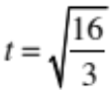 oe | A1 | 1.1b
(b) |  | (2)
(c) | 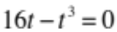 | M1 | 3.1b
(c) | 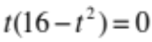 | M1 | 1.1b
(c) | 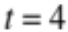 | A1 | 1.1b
(c) |  | (3)
(8 marks)
Notes:
(a)
M1: Attempt to integrate, one power going up
A1: Correct integral and limits or indefinite integral with C = 0 and t = 1.
A1: 15 (m)
(b)
M1: Identifying correct strategy to solve problem of finding direction change by equating v to 0 and solving for t
A1: correct answer – any surd or decimal equivalent to at least 2 sf

(c)
M1: Identifying correct strategy to solve problem by using use s = 0 and equating their integral to 0
M1: Attempt to solve
A1: t = 4

