Question | Scheme | Marks | AOs
1(a) | 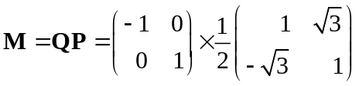 | M1 | 1.1a
1(a) | 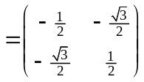 or 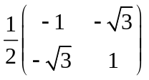 | A1 | 1.1b
1(a) |  | (2)
(b) | 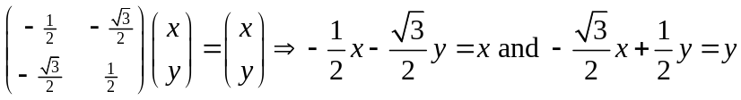 | M1 | 3.1a
(b) | 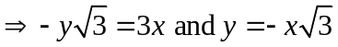 | M1 | 1.1b
(b) | First equation gives 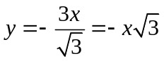, so equations are the same, hence M fixes all points on the line 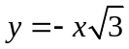. | A1ft | 2.1
(b) |  | (3)
(5 marks)
Notes:
(a)
M1: Attempts the multiplication of the matrices the correct way round. If no working shown, needs correct answer to imply the method.
A1: Correct matrix.
(b)
M1: Extracts simultaneous equations using their matrix 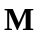, or using 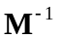 from 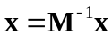.
M1: Gathers terms from their two equations.
A1ft: Shows the equations are consistent and deduces the correct line. Accept equivalent equations as long as both have been shown to be the same. Follow through only on an incorrect order of matrices from part (a). If wrong order of matrices is used in (a) the equation will end up being 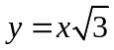.
ALT (b)
M1: Identifies P is a rotation (through clockwise) AND Q is a reflection (in the y-axis).
M1: Hence deduce s is a reflection (through line at angle 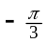 to the -axis) and so has a line of fixed points.
A1ft: All reasoning correct (including correct reflections/rotations if stated) and identifies the equation of the line. Follow through as above.

Question | Scheme |  | Marks | AOs
 | 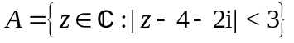, 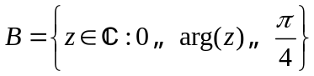 and 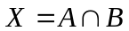.
2(a) | 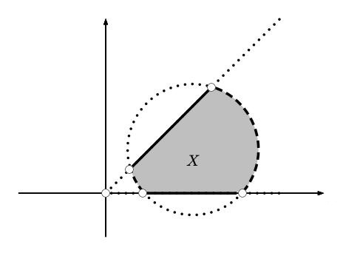
2(a) |  | Circle | B1 | 1.1b
2(a) |  | Sector | B1 | 1.1b
2(a) |  | Set X | B1ft | 1.1b
2(a) |  |  | (3)
(b) | so 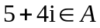 |  | M1 | 1.1b
(b) | 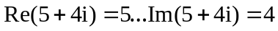 and 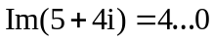, so 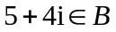 OR 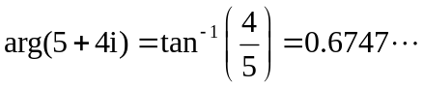 and 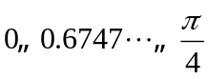, so |  | M1 | 2.2a
(b) | As 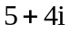 is in both  and , so 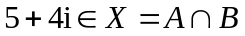 |  | A1 | 2.1
(b) |  |  | (3)
(6 marks)
Notes:
(a)
B1: A circle/relevant arcs of circle in the first (and fourth) quadrant(s) only with centre above the real axis (shown dotted above). If only arcs shown, they should be only in the first quadrant, as shown dashed above.
B1: Correct sector/portion of sector intersecting the circle, above the real axis and below the line .
B1: Correct region shaded, inside their circle and sector (as long as they intersect), with indication that the arcs of the circle are excluded, but the rays of the sector are included - dotted/dashed lines for excluded and solid for included. Ignore lines that are not part of the boundary. If the circle was initially drawn solid, accept if it is clearly indicated the arcs are not included.
(b)
M1: Attempts to show that is inside the circle, ie considers 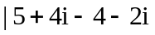| (or its square) and compares with 3 (or 9).
M1: Attempts to show that is inside the sector, ie finds the argument and checks it is in the range required.
A1: Both attempts correct with a conclusion that is inside the set 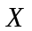 – must be clear it has been checked to be in both sets.

Question | Scheme | Marks | AOs
3(a) | 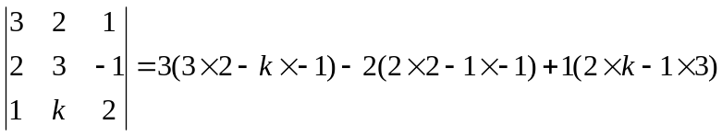 | M1 | 1.1b
3(a) | 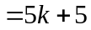 | A1 | 1.1b
3(a) |  | (2)
(b) | (i) 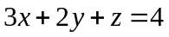 | B1 | 1.1b
(b) | (ii) EITHER 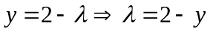  OR 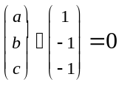 and 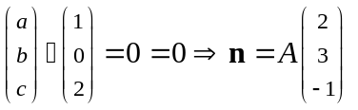 | M1 | 1.1b
(b) | EITHER  OR 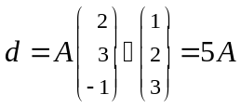 | M1 | 1.1b
(b) | 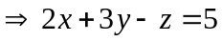 | A1 | 1.1b
(b) |  | (4)
(c) | The planes meet when all three equations are satisfied, so we can find where they meet by solving 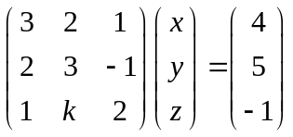 | B1 | 3.1a
(c) | If the planes form a sheaf, then they must share a common line. But if 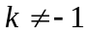 the determinant of the matrix is non-zero, so the equation has unique solution and hence the planes would meet in a single point. Therefore, we must have 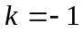. | B1 | 2.3
(c) |  | (4)
(8 marks)
Notes:
(a)
M1: Attempts determinant. Correct 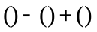 structure, but allow up to two slips in entries.
A1: Determinant is 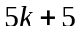.
(b)(i)
B1: Correct equation. (Accept multiples.)
(ii)
M1: Eliminates or  from Cartesian equations OR attempts to find a vector normal to both direction vectors using scalar product (or cross product may be used).
M1: Eliminates the other variable from their equations OR uses the scalar product with 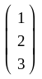 and their normal to find d.
A1: Correct equation. (Accept multiples.)
(c)
B1: Makes the link between the Cartesian equations and the matrix in (a).
B1: Identifies a sheaf cannot be formed if the solution is unique and so the matrix must be singular to form a sheaf, and hence .

Question | Scheme | Marks | AOs
4(a) | 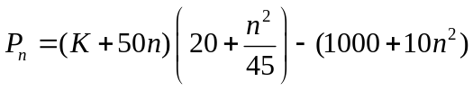 where 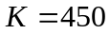 or 500 | M1 | 2.1
4(a) | 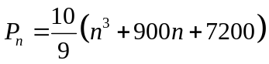* | A1* | 1.1b
4(a) |  | (2)
(b) | 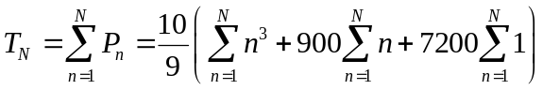
(b) | 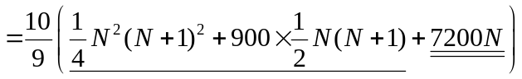 | M1A1  B1 | 1.1a  1.1b  1.1b
(b) | 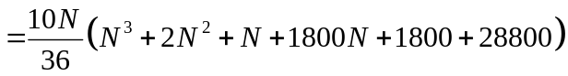 | M1 | 2.1
(b) | 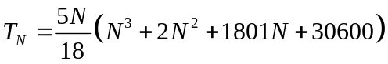 | A1 | 1.1b
(b) |  | (5)
(c) | Total profit is 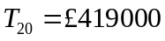 | M1 | 3.4
(c) | E.g. The predicted value is much less than the actual value, and so the model seems to be underestimating the profit by some way, so not a good model. | A1ft | 3.5a
(c) |  | (2)
(9 marks)
Notes:
(a)
M1: Attempts forming (number of units sold) (profit per unit) − production cost. Allow 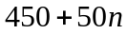 or 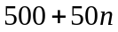.
A1*: cso. All work must be correct with the clear statement of how the formula arises.
(b)
M1: Substitutes for one of the standard formulae for 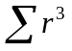 or 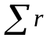 into the expression.
A1: Both formulae correctly applied.
B1: For 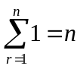 used.
M1: Expanding inside the bracket and factorising out the 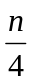.
A1: Correct expression found.
(c)
M1: Evaluates the total profit after 20 years - through use of their formula or via summing 20 terms from (a).
A1ft: Makes a comparison with the known profit and draws appropriate conclusion. Accept any well reasoned response for either accepting or rejecting the model, but it must include some comparison of values. Follow through their result of sum, so, for example, if evaluated close to 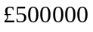 they should conclude the model is appropriate.

Question | Scheme |  | Marks | AOs
5 | 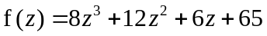 ; root 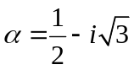
(a) | 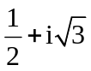 |  | B1 | 1.2
(a) |  |  | (1)
(b) | Attempts quadratic factor: 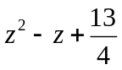 or 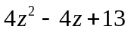 |  | M1 | 1.1b
(b) | So 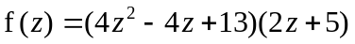 (oe) |  | M1 | 1.1b
(b) | So roots are 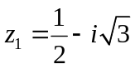, 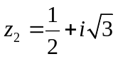 and 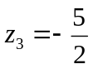 |  | A1 | 1.1b
(b) |  |  | (3)
(c) | 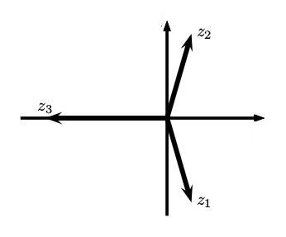 | Correct complex roots | B1 | 1.1b
(c) |  | Correct real root | B1ft | 1.1b
(c) |  |  | (2)
(d) | E.g. 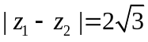, 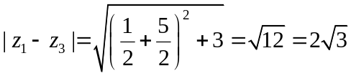 and 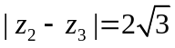 by symmetry.  OR 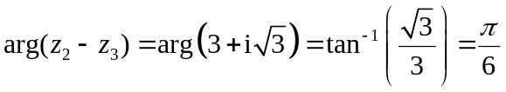, so (by symmetry) angle at 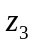 is 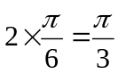, and since by symmetry the angles at 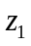 and 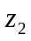 are equal, they must also each be  (so all add to ). |  | M1 | 3.1a
(d) | All three sides of the triangle are the same length, and so the vertices form an equilateral triangle.  OR All three angles are and so the triangle formed by the vertices is equilateral. |  | A1 | 2.1
(d) |  |  | (2)
(8 marks)
Notes:
(a)
B1: Correct conjugate root.
(b)
M1: Attempts quadratic factor 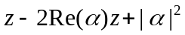 or 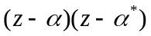. As a minimum accept an attempt at the product of roots.
M1: Attempts to find the linear term, e.g. by factorisation or dividing by quadratic term or use of product of roots being 65.
A1: Correct solutions. All three must be stated. Ignore labelling. Answers only score zero marks in (b). Algebra must be used.
(c)
B1: Correct placement of complex roots, symmetric about real axis, in first and fourth quadrants, closer to imaginary axis than real axis. Lines/arrows not needed, just points.
B1ft: Correct placement for real root. If root is correct then on real axis further from origin than other roots, but follow through if a positive root found in (b).
(d)
M1: A complete method to find either all three sides or all three angles of the triangle.
A1: Sides/angles all correct from correct work/reasoning and conclusion made to draw the argument together.

Question | Scheme | Marks | AOs
6(a) | For 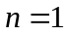: 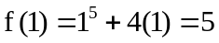. So the statement is true for | B1 | 2.2a
6(a) | Assume true for 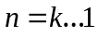, so 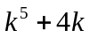 is divisible by 5 | M1 | 2.4
6(a) |  | M1 | 2.1
6(a) |  | A1 | 1.1b
6(a) | 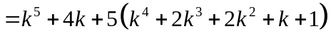  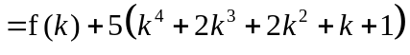 | A1 | 1.1b
6(a) | Hence the result is true for 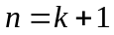. Since it is true for , and if true for 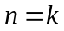 then true for , thus by mathematical induction the result holds for all 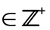 | A1cso | 2.4
6(a) |  | (6)
(b) | For any , * | B1* | 2.5
(b) |  | (1)
(c) | We know from (a) that 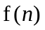 is divisible 5 for all positive integers, and since by (b) for negative we have 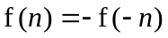 is divisible by 5 (as is a positive integer). | M1 | 2.1
(c) | Since 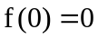 is also divisible by 5, so is divisible by 5 for all integers . | A1 | 2.4
(c) |  | (2)
(9 marks)
Notes:
(a)
B1: Shows the statement is true for .
M1: Makes the inductive assumption, assume true for .
M1: Attempts to expand 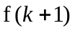 or 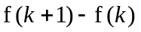 using the binomial theorem.
A1: Correct expansion.
A1: Correct expression for with common factor 5 made clear.
A1: Completes the inductive argument conveying all three underlined points or equivalent at some point in their argument.
(b)
B1*: Correct proof with each of the un-bracketed expressions shown in the scheme.
(c)
M1: Reasons that result holds for negative integers by results of (a) and (b).
A1t: Considers the 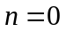 case and concludes true for all integers. Note: if case was used as the inductive base in (a), the reasoning here must clearly refer to all integers for the mark to be awarded.

Question | Scheme | Marks | AOs
7(a) | Explains that there are 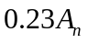 new juveniles from births AND 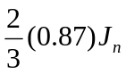 surviving juveniles staying juveniles | B1 | 2.4
7(a) | 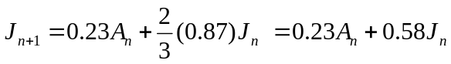 | B1 | 1.1b
7(a) |  | (2)
(b) | p = 0.30 | B1 | 3.3
(b) | 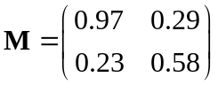 | B1ft  B1 | 3.3  3.3
(b) |  | (3)
(c)(i) | 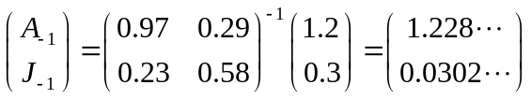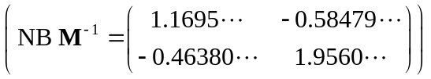 | M1 | 3.4
(c)(i) | Hence total population is 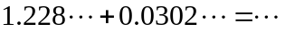 | M1 | 1.1b
(c)(i) | 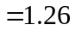 million | A1 | 2.2b
(c)(i) |  | (3)
(c)(ii) | 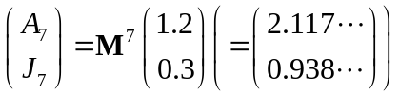 | M1 | 3.4
(c)(ii) | So the juvenile population on 1st January 2025 is expected to be 0.938 million (or 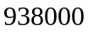) | A1 | 1.1b
(c)(ii) |  | (2)
(d) | For attempting to include 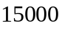 juvenile being exported by adding (or subtracting) a suitable vector, ie. 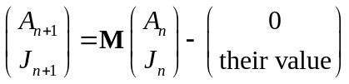 | M1 | 3.5c
(d) | 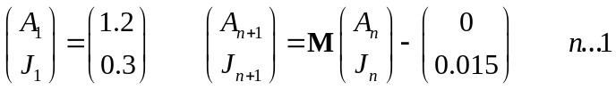 | A1ft | 3.3
(d) |  | (2)
(e) | E.g. The exportation may have an effect on the proportion of juveniles becoming adults/proportion who become adults each year may fluctuate/birth rates and death rates may change over time/two sub-populations may not sufficiently reflect the population. | B1 | 3.5b
(e) |  | (1)
(13 marks)
Notes:
(a)
B1: Explains the two components of the equation with reference to surviving juveniles remaining juveniles and that new juveniles arise through birth.
B1: Correct equation.
(b)
B1: Correct value for p.
B1ft: One row or column correct, follow through their equation in (a) on second row.
B1: Completely correct matrix.
(c)(i)
M1: Uses the model to find the population for 2017, ie 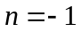, using their and initial vector. May see used, or the correct answer can imply the method
M1: Adds the two components of their vector to give the total population.
A1: awrt 1.26 million.
(c)(ii)
M1: Uses a calculator to evaluate 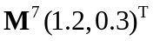, or multiplies by seven times oe. Awrt 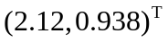, or just awrt 0.938 is sufficient for this mark.
A1: Concludes juvenile population is 0.938 million, or 938000.
(d)
M1: For incorporating the exportation into the model by subtracting (or adding if a negative entry is used) a vector with top entry zero and bottom entry an attempt at the 15 000 exported. So allow if an incorrect value of e.g. 15 000 or 0.15 is used as the value for this mark.
A1ft: Sets up the new system in full with correct vector subtracted (or added), but follow through on their  and . Allow if the range on is omitted.
(e)
B1: Any valid limitation of the model - allow for limitations of the new model or original model. Some examples are given above but accept any sensible limitation.

Question | Scheme | Marks | AOs
8(a) | Vol 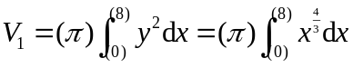 | B1 | 1.1b
8(a) | 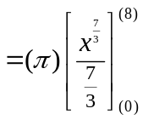 | M1 | 1.1b
8(a) | 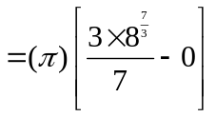 | M1 | 1.1b
8(a) | 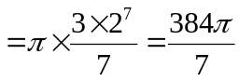* | A1* | 2.1
8(a) |  | (4)
(b) | Attempts to find the ratio of volume of 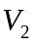 to total volume, using 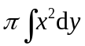 to get . | M1 | 3.1a
(b) | Vol 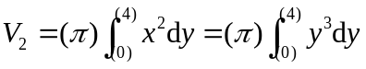 | B1 | 1.1b
(b) | So Vol 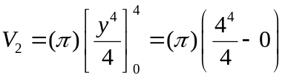 | M1 | 1.1b
(b) | 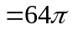 | A1 | 1.1b
(b) | So probability selected in a single trial is 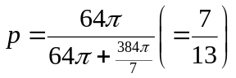 | M1 | 1.1b
(b) | Identifies binomial distribution needed, 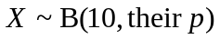. | M1 | 3.1a
(b) | 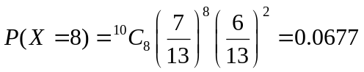 (4 d.p.) | A1 | 1.1b
(b) |  | (7)
(11 marks)
Notes:
(a)
B1: Correct integral with 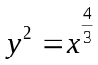. No need for or limits for this mark.
M1: Attempts the integration (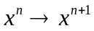).
M1: Applies limits 0 and 8, subtracts correct way. The lower limit of zero may be missing for this mark.
A1*: Simplifies to correct answer, no errors. Evidence of the lower limit being correctly applied should be seen for this mark.
(b)
M1: A full method to find the ratio 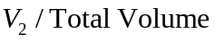 to establish the probability is drawn in a single trial.
B1: Correct integral, need not have or limits at this stage.
M1: Attempts the integration and applies limits of 4 and 0.
A1: Correct volume for
M1: Combines result of (a) and their second integral to find the probability is drawn in a single trial, ie 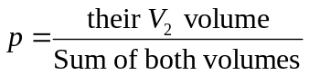 or ratio 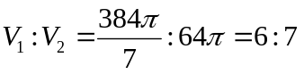, so 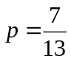
M1: Demonstrates awareness of the binomial distribution being needed. This may be implied by a correct value (from calculator) if a correct has been seen, or may be evidenced by writing out the distribution as shown in scheme.
A1: Correct answer to 4 decimal places.

Question | Scheme | Marks | AOs
9(a) | Forms a correct strategy to find the minimum distance between the comet and 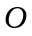. Way 1 Attempts dot product of 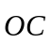 and the direction to form an equation in , then uses to find min distance or its square.  Way 2 Attempts distance formula for in terms of , then completes the square in to find min distance or its square.  Way 3 Attempts dot product to find angle, between the line and 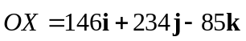 and use a trigonometric approach to find the minimum distance within a right angle triangle. | M1 | 3.1a
9(a) | Way 1 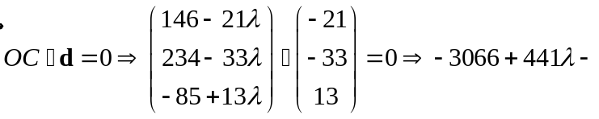  Way 2 Min distance, , given by  Way 3 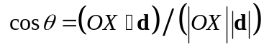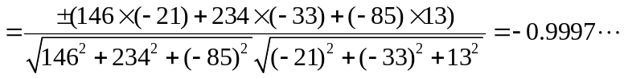 | M1 | 1.1b
9(a) | Way 1 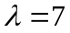 Way 2 So 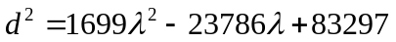  Way 3 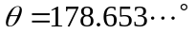 or 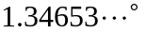 (oe) or 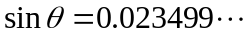 | A1 | 1.1b
9(a) | Way 1 So distance is  Way 2 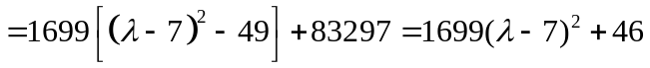,  so 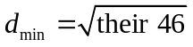 or 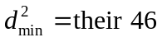  Way 3 So | M1 | 1.1b
9(a) | Interprets situation correctly and compares their minimum distance with the radius of the planet with correct units, e.g. 6500km compared with 6782km or 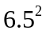 with 46. | M1 | 3.1b
9(a) | The closest distance of the comet to the planet is more than a radius away from the centre, so comet (just) misses planet. | A1 | 3.2a
9(a) |  | (6)
(b) | 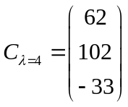, so need 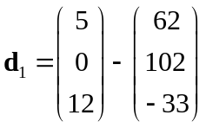 and 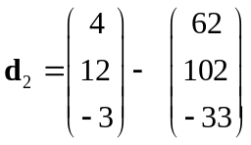 | M1 | 3.1a
(b) | 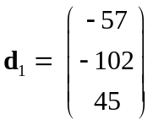 and 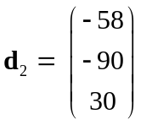 | A1 | 1.1b
(b) | 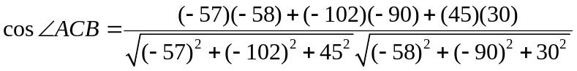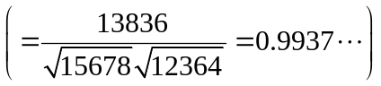 | M1 | 1.1b
(b) | 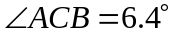 (awrt) (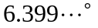) | A1 | 1.1b
(b) |  | (4)
(c) | The comet may not follow a straight line course, (as e.g. gravity when nearing the planet will affect it). | B1 | 3.2b
(c) |  | (1)
(11 marks)
Notes:
(a)
M1: Demonstration of a correct overall strategy to find the minimum distance, or its square, between the comet and O. See examples in scheme. There are other variations, e.g. via differentiating an expression for 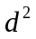 which follow a similar pattern.
M1: See scheme. A correct starting method, setting up an equation to find λ, or an expression for the square of distance, or correct equation to find an angle in an appropriate triangle.
A1: Correct λ (Way 1) or quadratic in λ (Way 2) or angle or its sine (Way 3). Equivalents in radians are 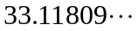 or 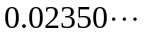.
M1: A correct attempt to find the minimum distance or the square of the minimum distance.
M1: Translates the information about the planet into the context of the question to draw an appropriate comparison between the minimum distance, d, between comet and O with the radius, or compares with the square of the radius. Units must match (ie both in km or in thousands of km).
A1: Correct conclusion drawn, following a correct minimum distance found.
(b)
M1: Identifies the correct direction vectors required to find the angle.
A1: Correct two vectors found. Any (non-zero) multiples of these are fine.
M1: Applies dot product formula with their direction vectors.
A1: Correct angle.
(c)
B1: See scheme. Accept any other reasonable comment, e.g. comet may lose mass as it travels, and this may affect its motion, satellites may not be in exactly the same positions and so on.

