Questions
Q1.
Given that –2 + 3i is a root of the equation
z² + pz + q = 0
where p and q are real constants,
(a) write down the other root of the equation.
(1)
(b) Find the value of p and the value of q.
(3)

(Total for question = 4 marks)

Q2.
z = 3 + 2i, w = 1 − i

Find in the form a + bi, where a and b are real constants,
(a) zw
(2)
(b) , showing clearly how you obtained your answer.
(3)
Given that

|z + k| = √53, where k is a real constant

(c) find the possible values of k.
(4)

(Total for question = 9 marks)

Q3.
Given that z₁ = –3 – 4i and z₂ = 4 – 3i
(a) show, on an Argand diagram, the point P representing z₁ and the point Q representing z₂
(2)
(b) Given that O is the origin, show that OP is perpendicular to OQ.
(2)
(c) Show the point R on your diagram, where R represents z₁+ z₂
(1)
(d) Prove that OPRQ is a square.
(2)

(Total for question = 7 marks)

Q4.
Given that z₁ = 1 − i,
(a) find arg(z₁).
(2)
Given that also z2 = 3 + 4i, find, in the form a + ib, a,b ∈ &#8477;
(b) z₁ z₂,
(2)
(c)
(3)
In part (b) and part (c) you must show all your working clearly.

(Total 7 marks)

Q5.
A = 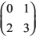
(a) Show that A is non-singular.
(2)
(b) Find B such that BA² = A.
(4)

(Total 6 marks)

Q6.
A right angled triangle T has vertices A(1, 1), B(2, 1) and C(2, 4). When T is transformed by the matrix P = 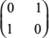, the image is T '.
(a) Find the coordinates of the vertices of T '.
(2)
(b) Describe fully the transformation represented by P.
(2)
The matrices Q = 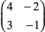 and R = 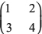 represent two transformations. When T is transformed by the matrix QR, the image is T ''.
(c) Find QR.
(2)
(d) Find the determinant of QR.
(2)
(e) Using your answer to part (d), find the area of T ''.
(3)

(Total 11 marks)

Q7.
Given that X = 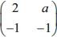, where a is a constant, and a ≠ 2,
(a) find X⁻¹ in terms of a.
(3)
Given that X + X⁻¹ = I, where I is the 2×2 identity matrix,
(b) find the value of a.
(3)
(Total 6 marks)

Mark Scheme
Q1.
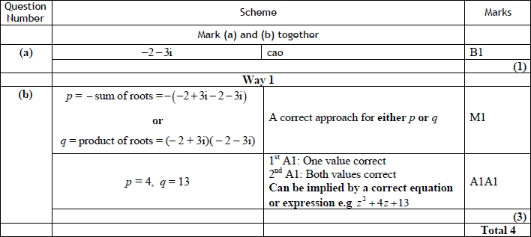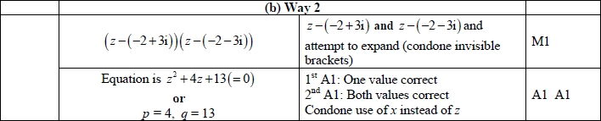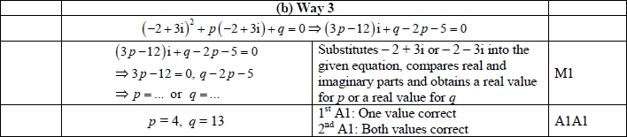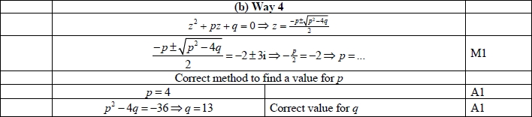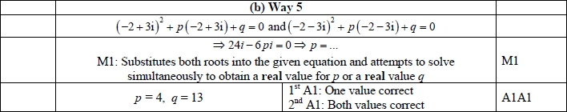

Q2.
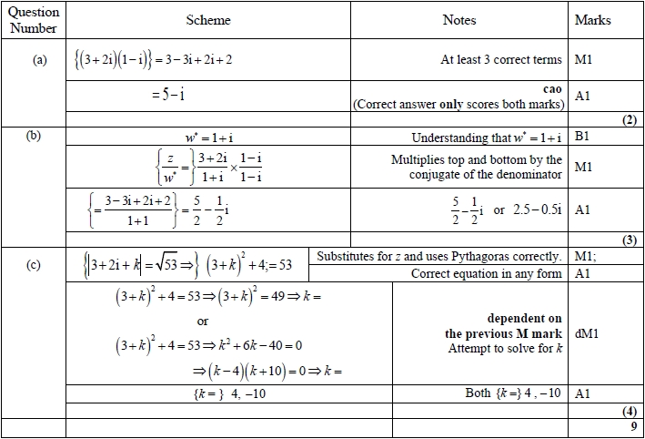
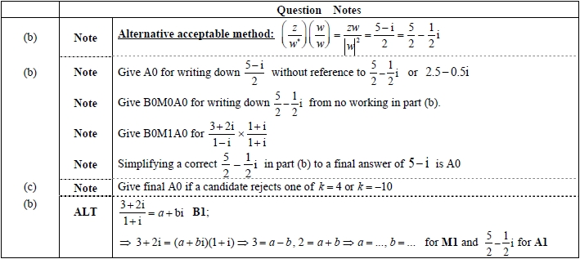

Q3.
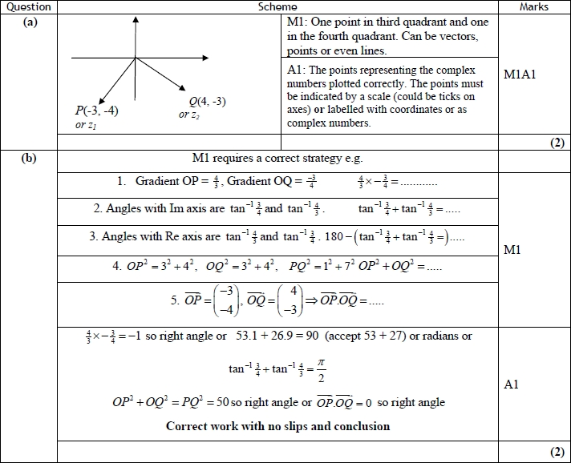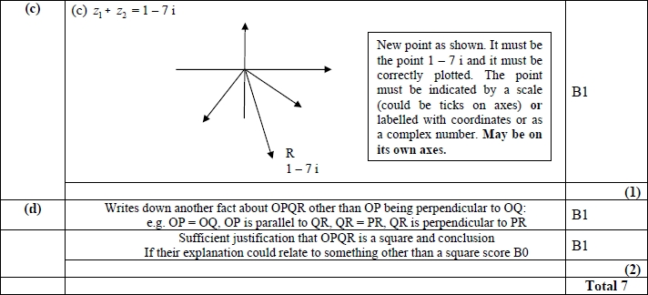

Q4.
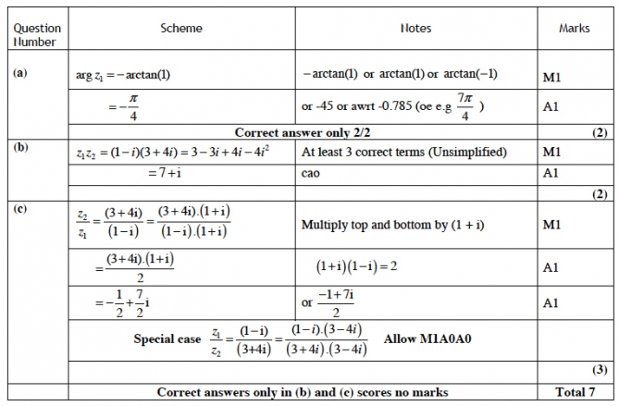

Q5.
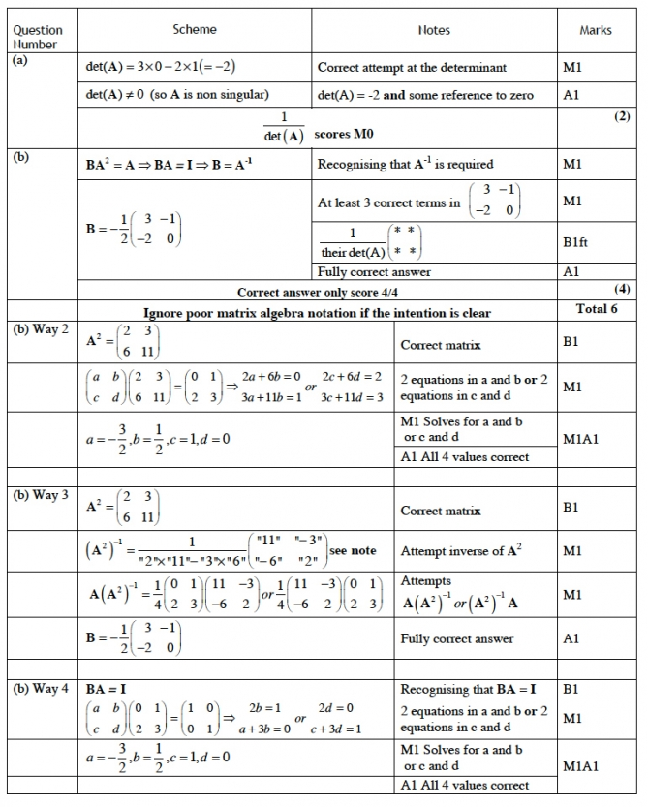
Extra Notes
(b) Way 3
Attempting inverse of A² needs to be recognisable as an attempt at an inverse
E.g. (A²)⁻¹ = 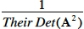 (A changed A²)

Q6.
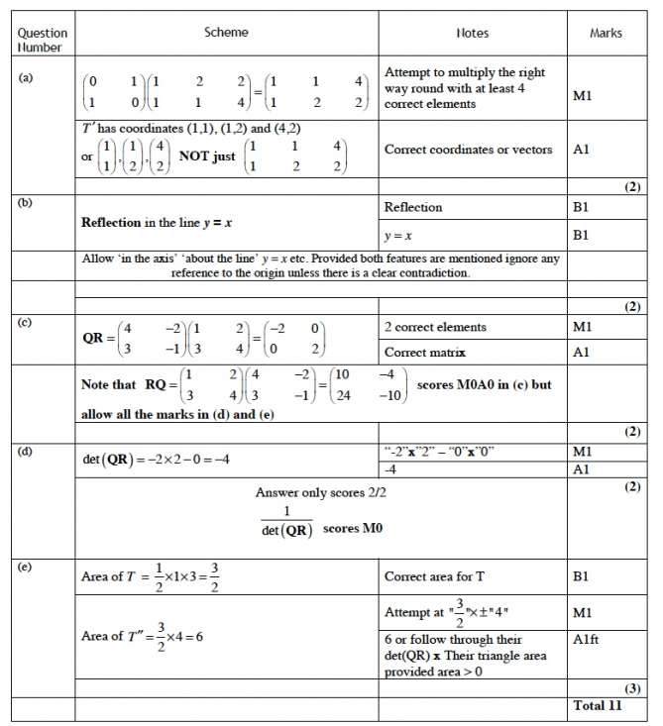

Q7.
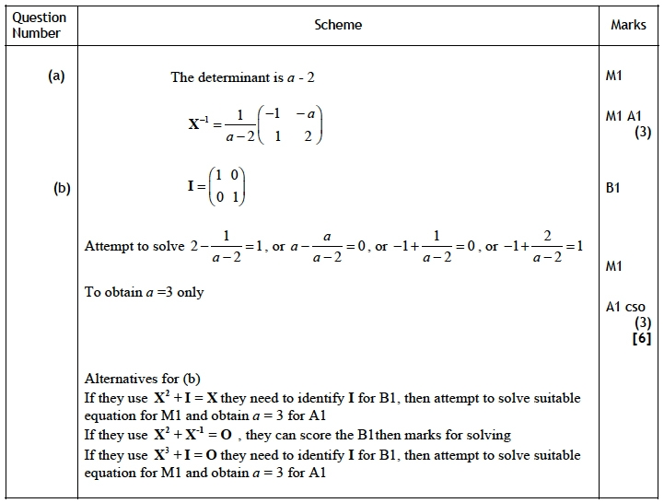
Notes:
(a) Attempt ad-bc for first M1
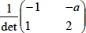 for second M1
(b) Final A1 for correct solution only

