|  |
| --- |
| Name: _______________________________________________ |
|  |
|  |
|  |
|  |
| **A-level Maths Settling In** |
| **Follow-up Questions** |
| **Date:** |
|  |
|  |
|  |
|  |
| **Time:** 1 minute |
|  |
| **Total marks available:** 68 |
|  |
| **Total marks achieved:** ______ |
|  |
|  |
|  |
|  |
|  |
|  |
|  |
|  |
|  |
|  |
|  |
|  |
|  |
|  |
|  |
|  |
|  |
|  |
|  |
|  |
|  |
| Here is another version of the "settling in" assessment, designed to check whether you have the required skills to access the a-level maths course. |
|  |
|  |
| **FUO** |
|  |

**Questions**

**Q1.**

**\*** Viv wants to invest £2000 for 2 years in the same bank.

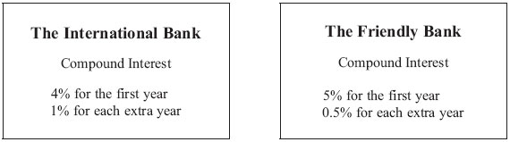

  At the end of 2 years, Viv wants to have as much money as possible.

  Which bank should she invest her £2000 in?

**(Total for Question is 4 marks)**

**Q2.**

*ABCD* is a trapezium.

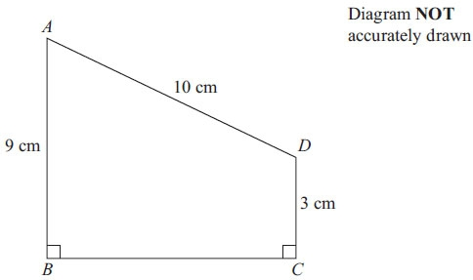

*AD* = 10 cm  
*AB* = 9 cm  
*DC* = 3 cm  
 Angle *ABC* = angle *BCD* = 90°

Calculate the length of *AC*.  
 Give your answer correct to 3 significant figures.

      ..............................................................................................................................................

**(Total for Question is 5 marks)**

**Q3.**

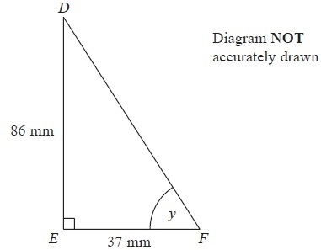

*DEF* is a right-angled triangle.

*DE* = 86 mm

*EF* = 37 mm

Calculate the size of the angle marked *y*.

Give your answer correct to 1 decimal place.

...........................................................°

**(Total for Question is 3 marks)**

**Q4.**

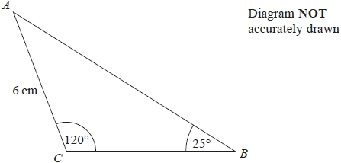

In triangle *ABC*,   
*AC* = 6 cm   
Angle *ACB* = 120°   
Angle *ABC* = 25°

Work out the area of triangle *ABC*.   
Give your answer correct to 1 decimal place.   
You must show all your working.

........................................................... cm2

**(Total for question = 4 marks)**

**Q5.**

The graph shows information about the velocity, *v* m/s, of a parachutist *t* seconds after leaving a plane.

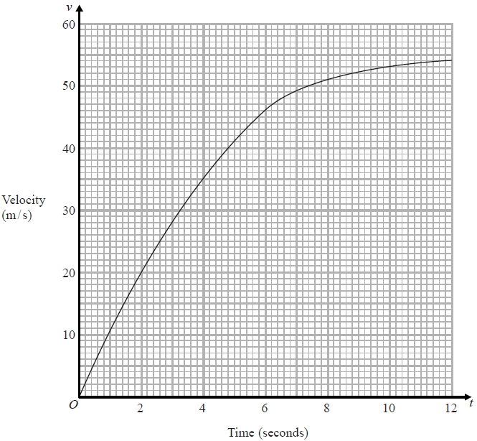

(a)  Work out an estimate for the acceleration of the parachutist at *t* = 6

........................................................... m/s2

**(2)**

(b)  Work out an estimate for the distance fallen by the parachutist in the first   
12 seconds after leaving the plane.   
Use 3 strips of equal width.

........................................................... m

**(3)**

**(Total for question is 5 marks)**

**Q6.**

**\*** 225 grams of flour are needed to make 9 cakes.

   Marian wants to make 20 of these cakes.  
    She has 475 grams of flour.

   Does Marian have enough flour to make 20 cakes?  
    You must show all your working.

**(Total for Question is 3 marks)**

**Q7.**

The functions f and g are such that

f(*x*) = 1 − 5*x*      and      g(*x*) = 1 + 5*x*

(a) Show that gf(1) = − 19

**(2)**

(b)  Prove that f−1(*x*) + g−1(*x*) = 0 for all values of *x*.

**(3)**

**(Total for question = 5 marks)**

**Q8.**

Make *a* the subject of       

...........................................................

**(Total for question = 3 marks)**

**Q9.**

The product of two consecutive positive integers is added to the larger of the two   
integers.

Prove that the result is always a square number.

**(Total for question = 3 marks)**

**Q10.**

Solve the simultaneous equations

3*x* + 10*y* = 7  
*x* – 4*y* = 6

*x* = . . . . . . . . . . . . . . . . . . . . . . .

*y* = . . . . . . . . . . . . . . . . . . . . . . .

**(Total for Question is 3 marks)**

**Q11.**

(a) Rationalise the denominator of 

      ..............................................................................................................................................

**(2)**

(1 + √3)2 can be written in the form *a* + *b*√3, where *a* and *b* are integers.

(b) Work out the value of *a* and the value of *b*.

*a* = . . . . . . . . . . . . . . . . . . . . . .

*b* = . . . . . . . . . . . . . . . . . . . . . .

**(2)**

**(Total for Question is 4 marks)**

**Q12.**

**∗**

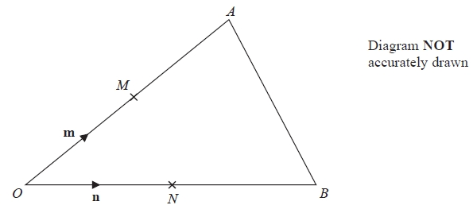

*OAB* is a triangle.   
*M* is the midpoint of *OA*.   
*N* is the midpoint of *OB*.

 = **m**

 = **n**

Show that *AB* is parallel to *MN*.

**(Total for Question is 3 marks)**

**Q13.**

(a) Write down an equation of a straight line that is parallel to the straight line *y* = 3*x* – 5

      ..............................................................................................................................................

**(1)**

A straight line, L, is perpendicular to the straight line *y* = 3*x* – 5 and passes through the point (6, 5)

(b) Find an equation of L.

      ..............................................................................................................................................

**(3)**

**(Total for Question is 4 marks)**

**Q14.**

The graph of *y* = f(*x*) is shown on the grid.

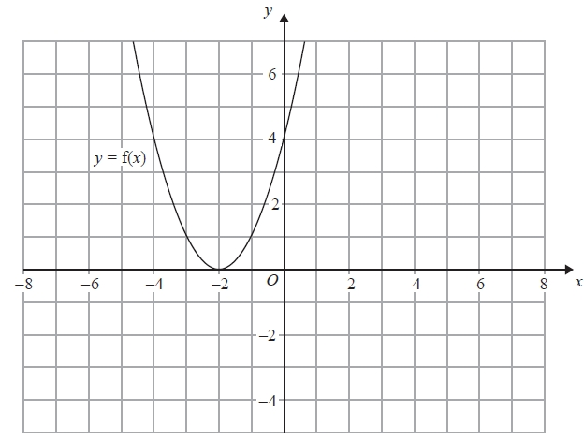

(a)  On the grid above, sketch the graph of *y* = f(*x* + 3)

**(2)**

The graph of *y* = g(*x*) is shown below.

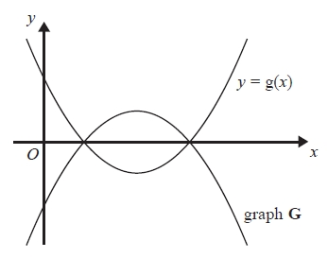

The graph **G** is the reflection of *y* = g(*x*) in the *x*-axis.

(b)  Write down an equation of graph **G**.

...........................................................

**(1)**

**(Total for question = 3 marks)**

**Q15.**

(a) (i) Factorise    *x*2 – 12*x* + 27

      ..............................................................................................................................................

     (ii) Solve the equation *x*2 – 12*x* + 27 = 0

      ..............................................................................................................................................

**(3)**

(b) Factorise    *y*2 – 100

      ..............................................................................................................................................

**(1)**

**(Total for Question is 4 marks)**

**Q16.**

Solve  = 3

*x* = ...........................................................

**(Total for question is 3 marks)**

**Q17.**

(a)  Write down the value of

(i)  70

...........................................................

(ii)  5−2

...........................................................

(iii)  

...........................................................

**(3)**

(b)  Simplify fully 

...........................................................

**(2)**

**(Total for question = 5 marks)**

**Q18.**

(a)  Write down the reciprocal of 5

...........................................................

**(1)**

(b)  Evaluate 3−2

...........................................................

**(1)**

(c)  Calculate 9×104×3×103

Give your answer in standard form.

...........................................................

**(2)**

**(Total for Question is 4 marks)**

**Mark Scheme**

Q1.

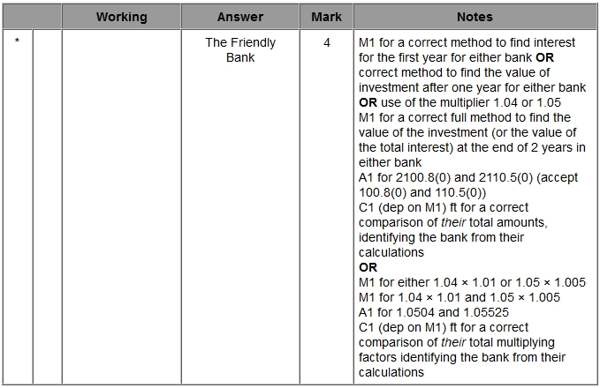

**Q2.**

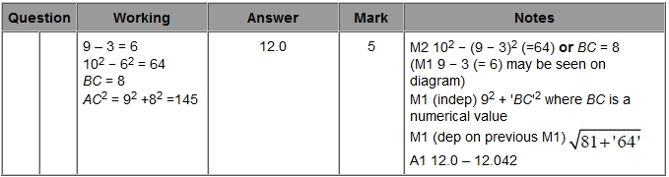

**Q3.**

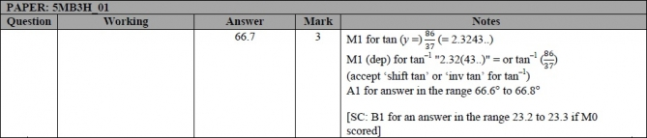

**Q4.**

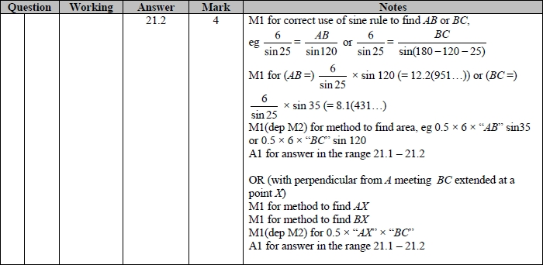

**Q5.**

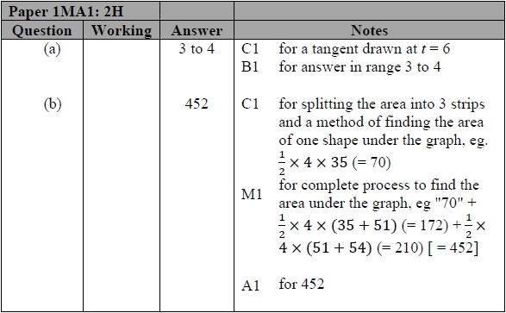

**Q6.**

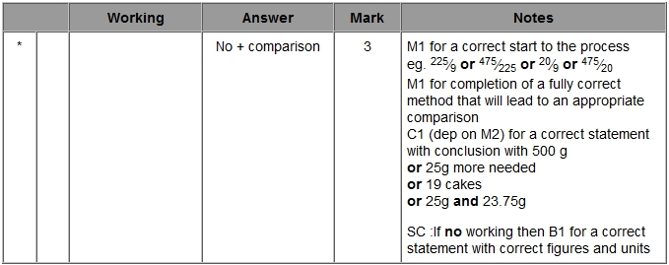

**Q7.**

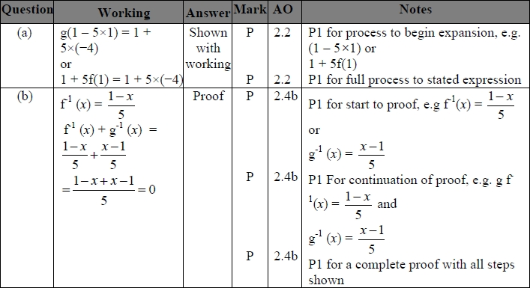

**Q8.**

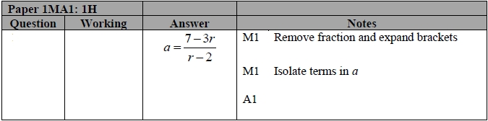

**Q9.**

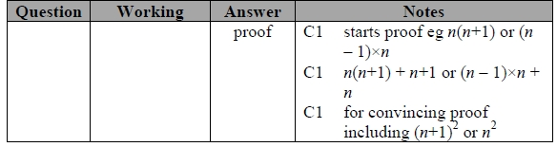

**Q10.**

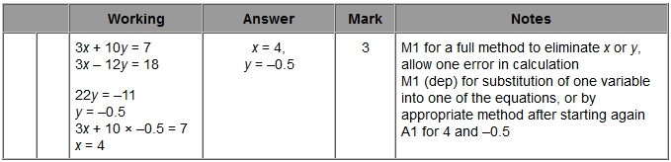

**Q11.**

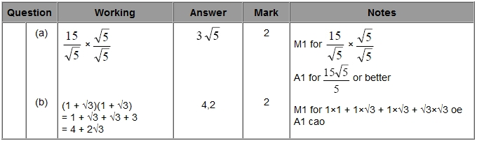

**Q12.**

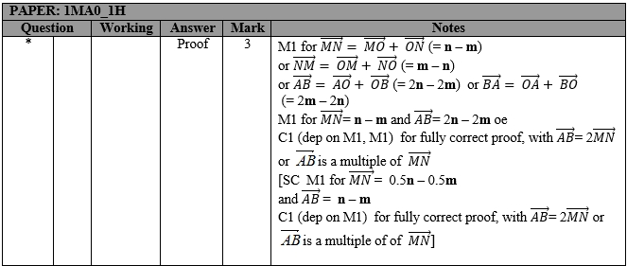

**Q13.**

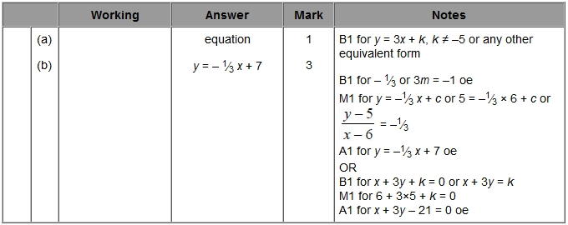

**Q14.**

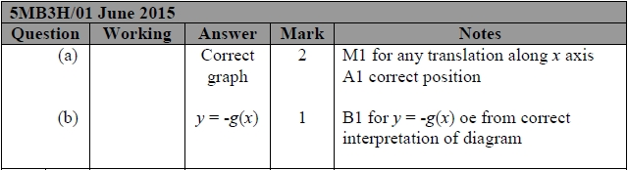

**Q15.**

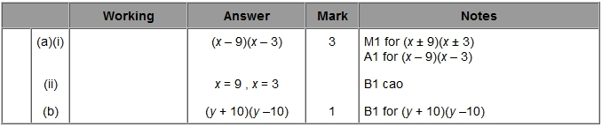

**Q16.**

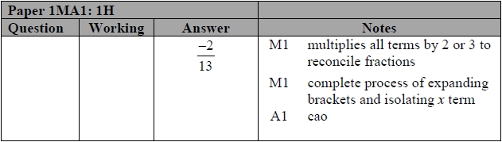

**Q17.**

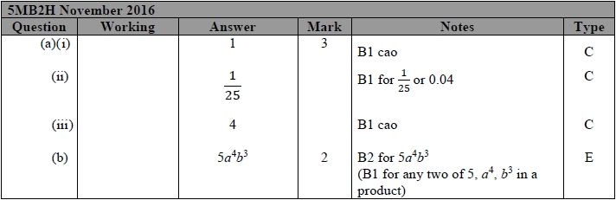

**Q18.**

