|  |
| --- |
| Name: _______________________________________________ |
|  |
|  |
|  |
|  |
| **A-level Maths Settling In** |
| **Sample Assessment** |
| **Date:** |
|  |
|  |
|  |
|  |
| **Time:** 1 hour |
|  |
| **Total marks available:** 68 |
|  |
| **Total marks achieved:** ______ |
|  |
|  |
|  |
|  |
|  |
|  |
|  |
|  |
|  |
|  |
|  |
|  |
|  |
|  |
|  |
|  |
|  |
|  |
|  |
|  |
|  |
| You will be sitting a similar paper in the first week of your A-level course. The expectation is that you have the skills to answer these questions successfully in order to access the a-level course. |
|  |
|  |
| **FUO** |
|  |

**Q1.**

*  Peter has £20 000 to invest in a savings account for 2 years.

He finds information about two savings accounts.

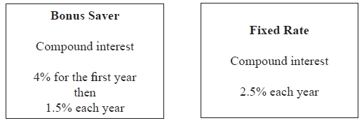

Peter wants to have as much money as possible in his savings account at the end of 2 years.

Which of these savings accounts should he choose?

**(Total for question = 4 marks)**

**Q2.**

* Here is part of a field.

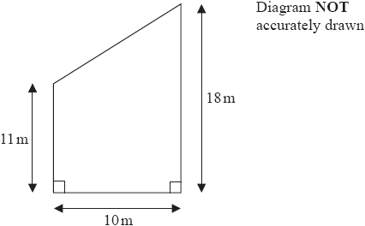

This part of the field is in the shape of a trapezium.   
A farmer wants to put a fence all the way around the edge of this part of the field.

The farmer has 50m of fence.

Does he have enough fence?   
You must show all your working.

**(Total for question = 5 marks)**

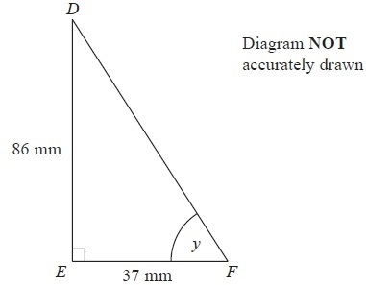**Q3.** 

*DEF* is a right-angled triangle.

*DE* = 86 mm

*EF* = 37 mm

Calculate the size of the angle marked *y*.

Give your answer correct to 1 decimal place.

...........................................................°

**(Total for Question is 3 marks)**

**Q4.**

(a)  Sketch the graph of *y* = cos *x*º for 0 *x* 360

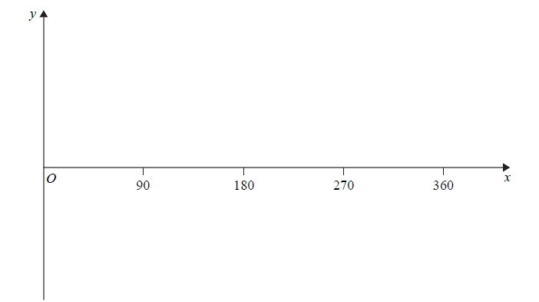

**(2)**

(b)  The graph of *y* = f(*x*) is shown on both grids below.

(i)  On this grid, draw the graph of *y* = 2f(*x*)

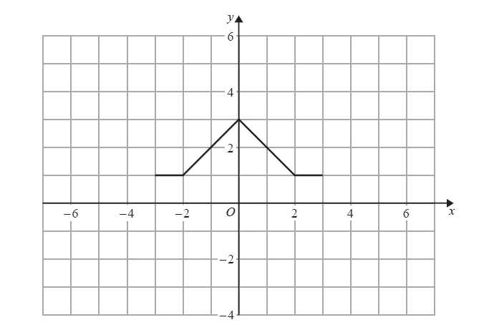

(ii)  On the grid below, draw the graph of *y* = f(*x* – 3)

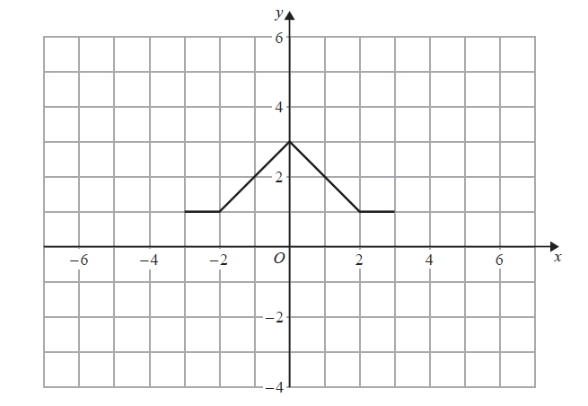

**(2)**

**(Total for question = 4 marks)**

**Q5.**

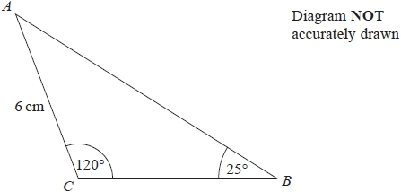

In triangle *ABC*,   
*AC* = 6 cm   
Angle *ACB* = 120°   
Angle *ABC* = 25°

Work out the area of triangle *ABC*.   
Give your answer correct to 1 decimal place.   
You must show all your working.

........................................................... cm2

**(Total for question = 4 marks)**

**Q6.**

The function f is such that

f(*x*) = 4*x* − 1

(a)  Find f−1(x)

f−1(*x*) = ...........................................................

**(2)**

The function g is such that

g(*x*) = *kx*2 where *k* is a constant.

Given that fg(2) = 12

(b)  work out the value of *k*

*k* = ...........................................................

**(2)**

**(Total for question = 4 marks)**

**Q7.**

Prove that

(2*n* + 3)2 – (2*n* – 3)2 is a multiple of 8

for all positive integer values of *n*.

**(Total for Question is 3 marks)**

**Q8.**

Here is a speed-time graph for a car.

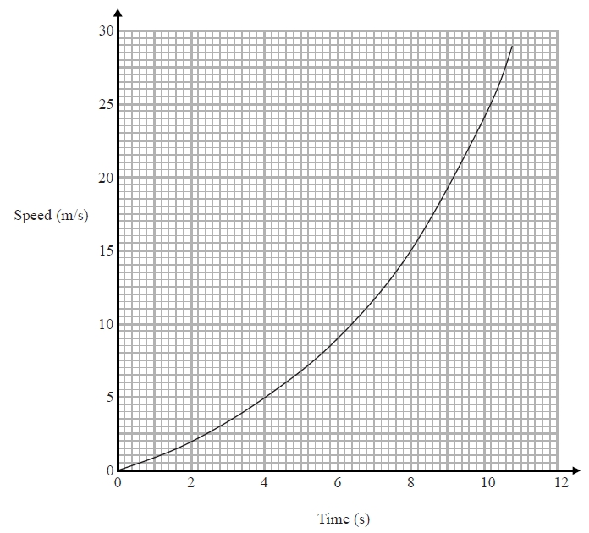

(a)  Work out an estimate for the distance the car travelled in the first 10 seconds.   
       Use 5 strips of equal width.

........................................................... m

**(3)**

(b)  Is your answer to (a) an underestimate or an overestimate of the actual distance?   
      Give a reason for your answer.

**(1)**

**(Total for question = 4 marks)**

**Q9.**

(a) Factorise      6 + 9*x*

      ..............................................................................................................................................

**(1)**

(b) Factorise      *y*2 – 16

      ..............................................................................................................................................

**(1)**

(c) Factorise      2*p*2 – *p* – 10

      ..............................................................................................................................................

**(2)**

**(Total for Question is 4 marks)**

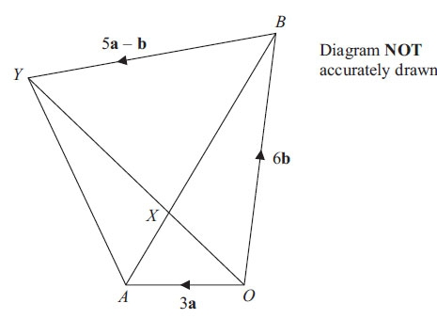**Q10.**

*OAYB* is a quadrilateral.

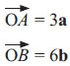

(a) Express  in terms of **a** and **b**.

      ..............................................................................................................................................

**(1)**

*X* is the point on *AB* such that *AX* : *XB* = 1 : 2

and  = 5**a** – **b**

*(b) Prove that 

**(4)**

**(Total for Question is 5 marks)**

**Q11.**

The straight line **L** has equation *y* = 2*x* − 5

Find an equation of the straight line perpendicular to **L** which passes through (−2, 3).

...........................................................

**(Total for Question is 3 marks)**

**Q12.**

Make *t* the subject of the formula



      ..............................................................................................................................................

**(Total for Question is 4 marks)**

**Q13.**

Solve 

*x* = . . . . . . . . . . . . . . . . . . . . . .

**(Total for Question is 3 marks)**

**Q14.**

Solve the simultaneous equations

4*x* + *y* = 25   
*x* − 3*y* = 16

*x* =...........................................................

*y* =...........................................................

**(Total for Question is 3 marks)**

**Q15.**

Harry has a cable.   
The cable has a length of 16 metres.

Harry cuts the cable into two parts, part *A* and part *B*.

The length of part *A* is 5 metres.   
The weight of part *A* is 8 kg.

Work out the weight of part *B*.

...........................................................kg

**(Total for question = 3 marks)**

**Q16.**

(a) Rationalise the denominator of 

...........................................................

**(2)**

(b) Work out the value of (√2 + √8)2

...........................................................

**(2)**

**(Total for Question is 4 marks)**

**Q17.**

(a) Simplify *m*5 ÷ *m*3

      ..............................................................................................................................................

**(1)**

(b) Simplify 5*x*4*y*3 × *x*2*y*

      ..............................................................................................................................................

**(2)**

**(Total for Question is 3 marks)**

**Q18.**

(a)  Find the value of      

...........................................................

**(1)**

(b)  Find the value of      

...........................................................

**(2)**

(c)  Solve      32*x* = 

*x* = ...........................................................

**(2)**

**(Total for question = 5 marks)**

**Mark Scheme**

Q1.

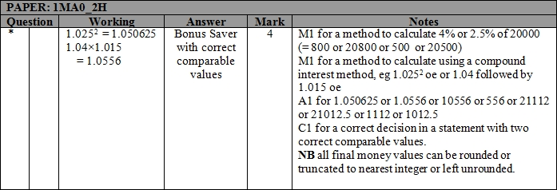

**Q2.**

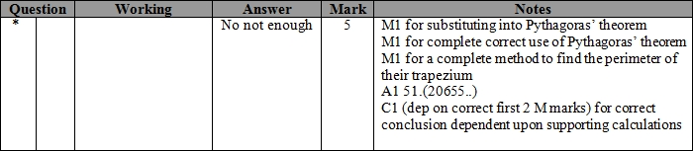

**Q3.**

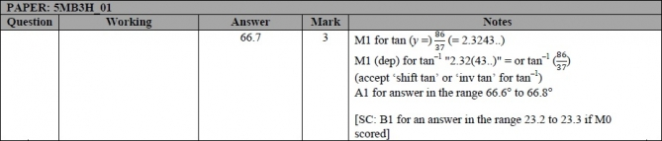

**Q4.**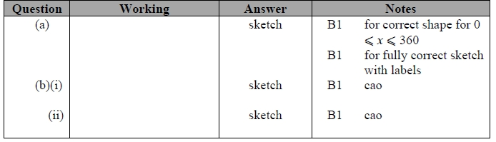

**Q5.**

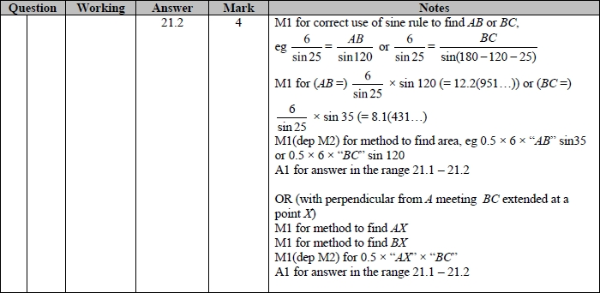

**Q6.**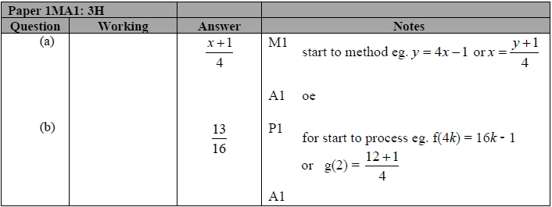

**Q7.**

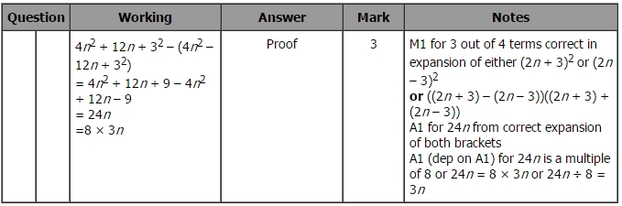

**Q8.**

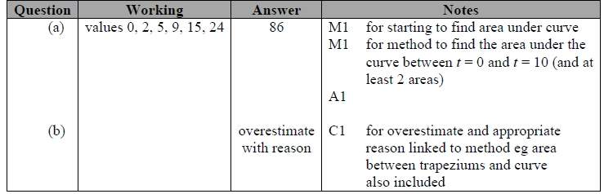

**Q9.**

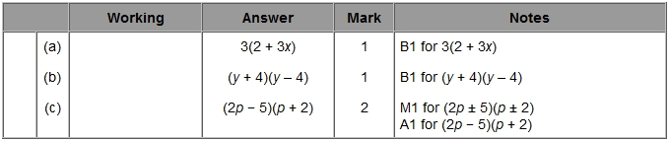

**Q10.**

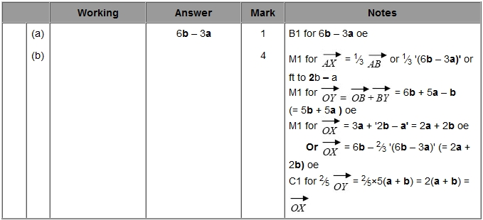

**Q11.**

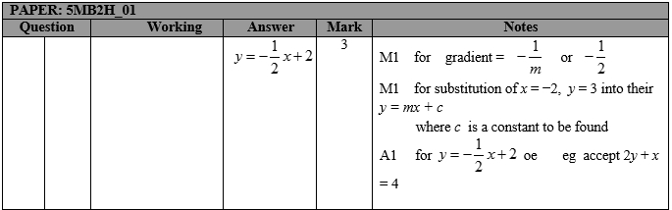

**Q12.**

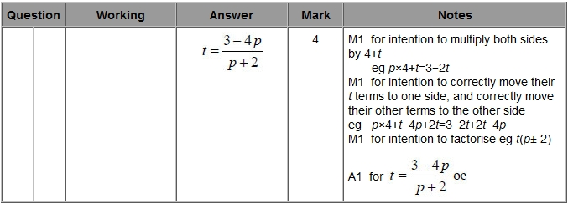

**Q13.**

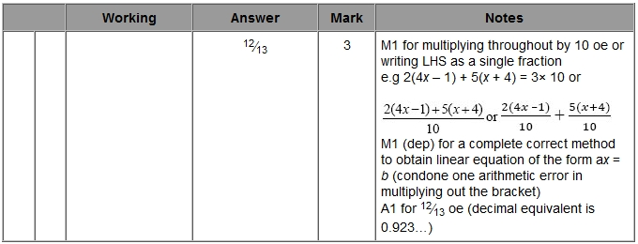

**Q14.**

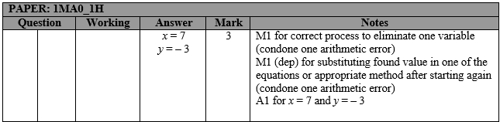

**Q15.**

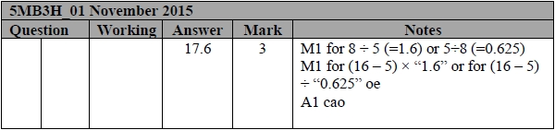

**Q16.**

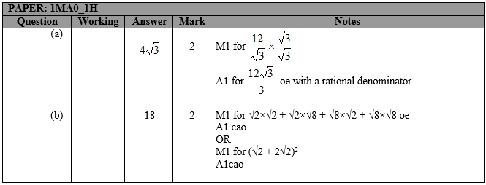

**Q17.**

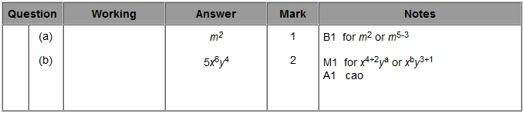

**Q18.**

