Rangley App | Version 2.0.0 Update Summary
Prepared for App Store Review
Date: October 2025
This document provides a structured overview of the major updates and fixes included in Rangley version 2.0.0.
It is intended to assist the App Review team in understanding new features, navigation changes, and recent improvements within the app.
All new features are fully functional within this build and have been verified in production configuration.

Index of Sections
- Home Map and Dock Navigation - Overview of updated dock layout and new Profile icon.
- Meet Groups - New feature allowing creation and reuse of participant groups.
- Meet Creation Flow - Streamlined step-by-step process for creating meets.
- Create Group Meets - Group-based meet invitations and participant management.
- Inbox and Friends System - Consolidated notifications and friend management updates.
- Profile and Account Settings - Relocated settings within the profile view.
- Fixes and Improvements - Summary of resolved issues and performance enhancements.
- Future Enhancements - Planned upcoming features and development roadmap.

- Home Map and Dock Navigation
  - Rangley opens directly to the interactive map, the center of all user activity.
  - The floating dock provides navigation between My Meets, Groups, Inbox, Messenger, and now Profile.
Rangley Icon, messenger, and inbox (paper tray) are new to 2.0.0

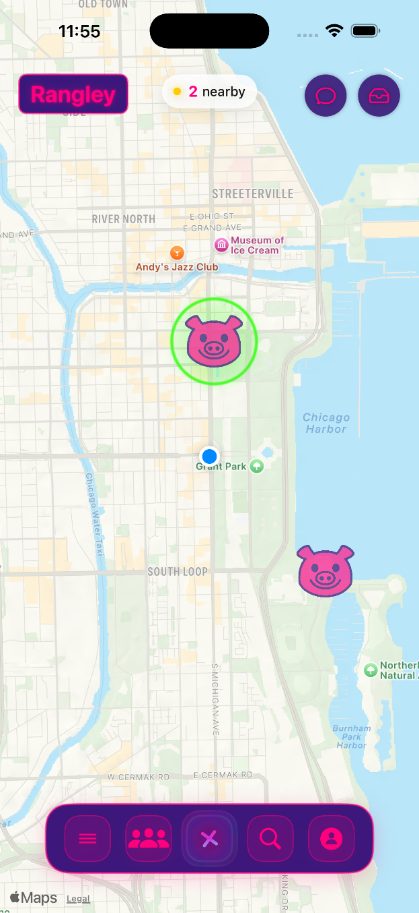

Profile Icon in the Right is new to dock in 2.0.0

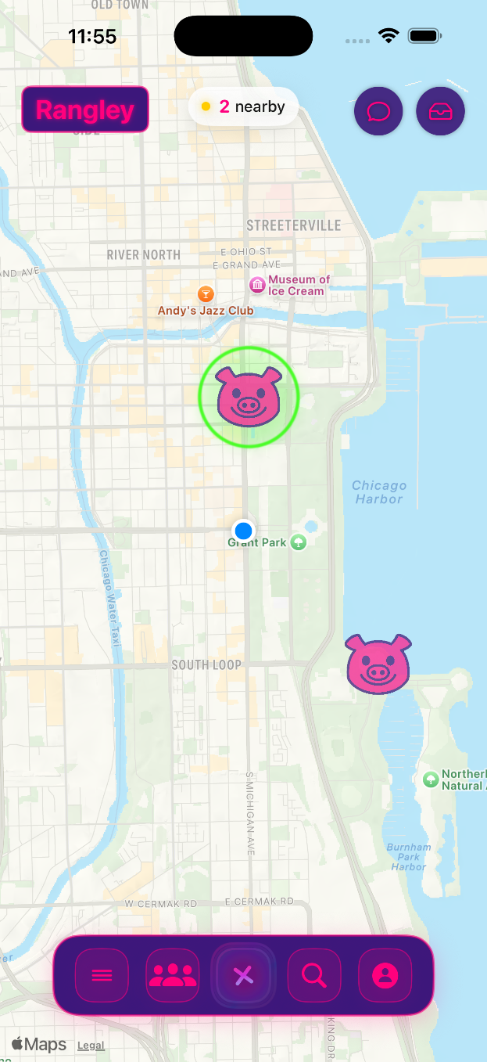

- Meet Groups
  - Users can create and manage Meet Groups.
  - Groups allow quick invitations during meet creation.
  - Each group can have a custom name and optional icon.
  - Intended for recurring or themed activities (e.g., friends, clubs, hobbies).

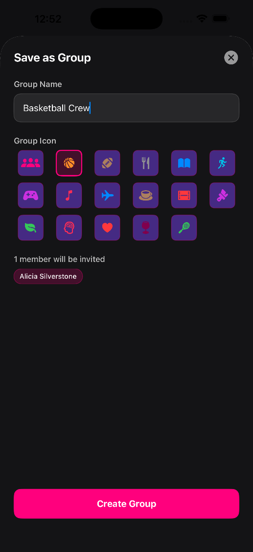
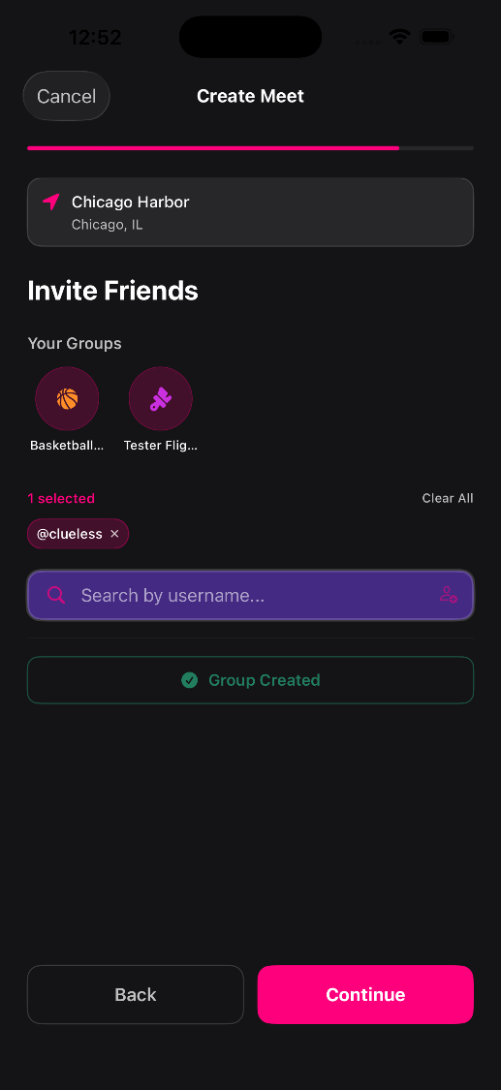
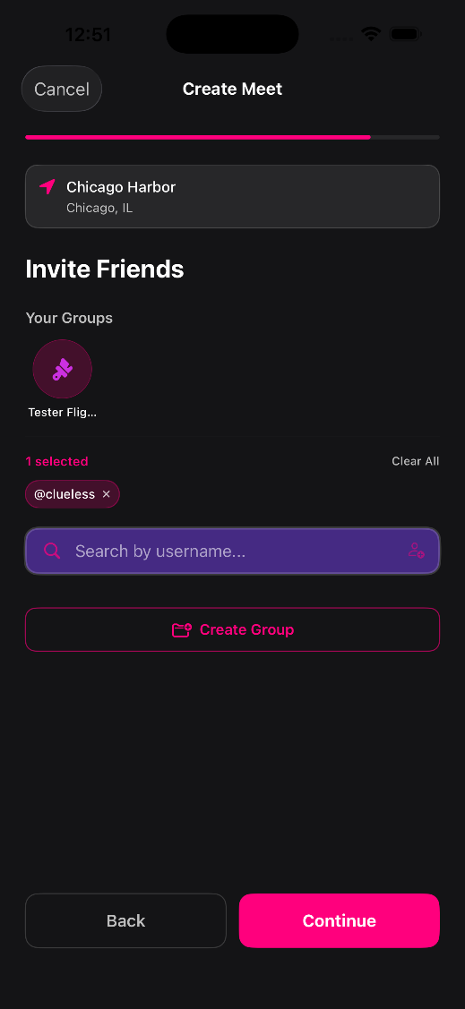

- Meet Creation Flow
  - Steps:
    - Tap on map to select location (selects the exact coordinate you tapped).
    - Enter meet name, and optionally description + category (default category is activity).
    - Set start and end time.
    - Invite friends or groups.
    - Review all details.
    - Confirm and create meet.
  - The full sheet UI with prev and next buttons improves clarity and reduces user error during creation.
  - Invite Friends and Groups
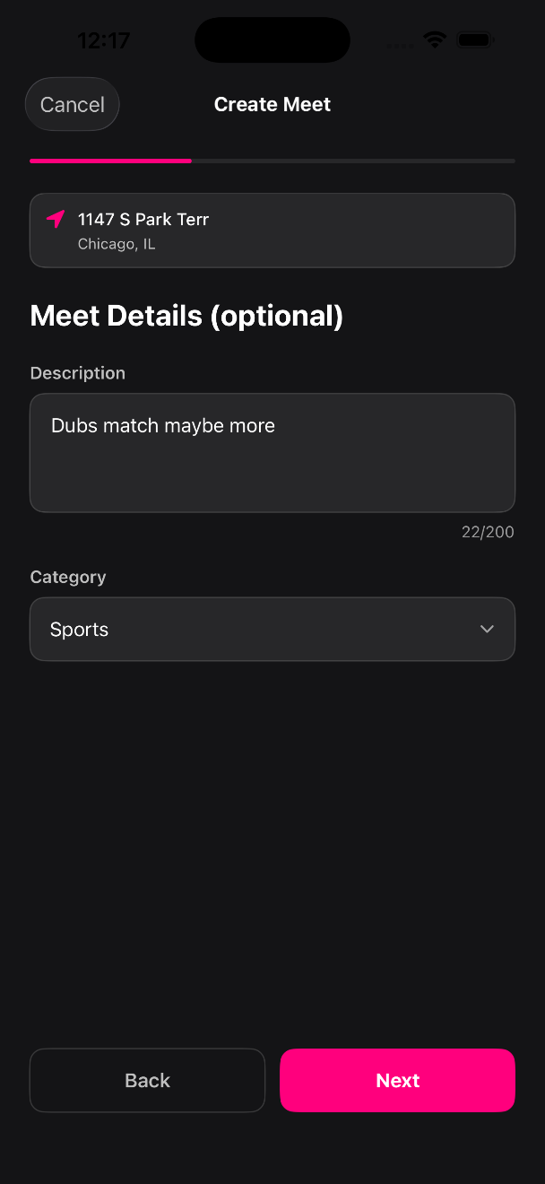
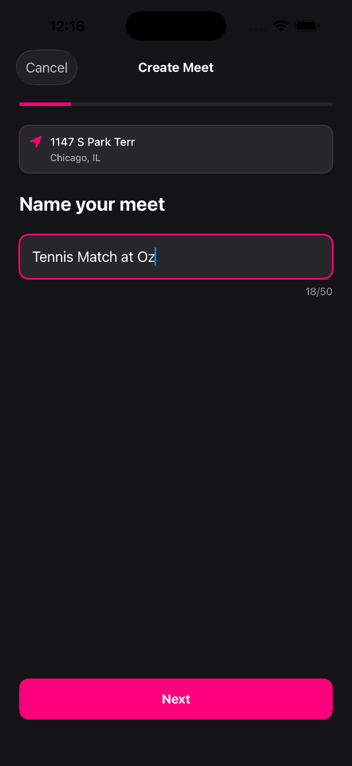

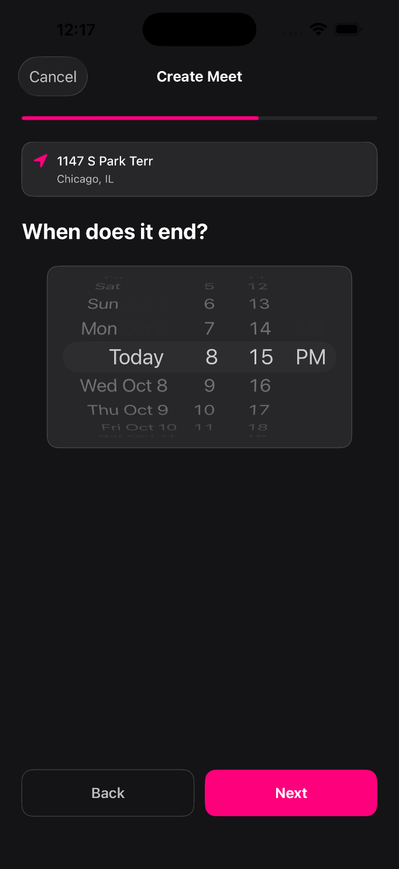
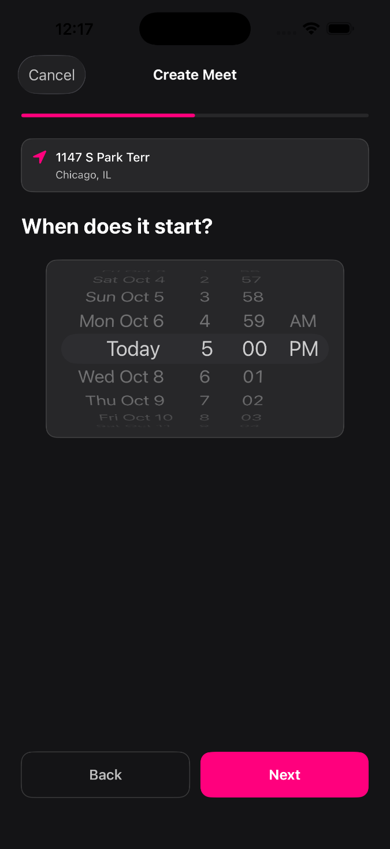

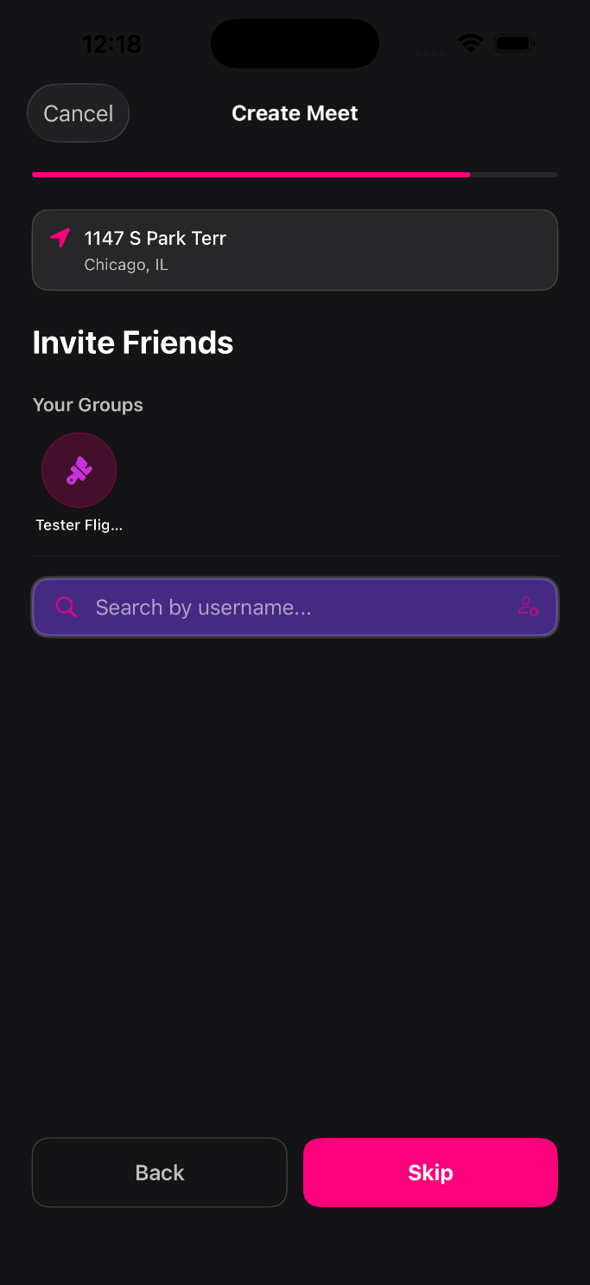
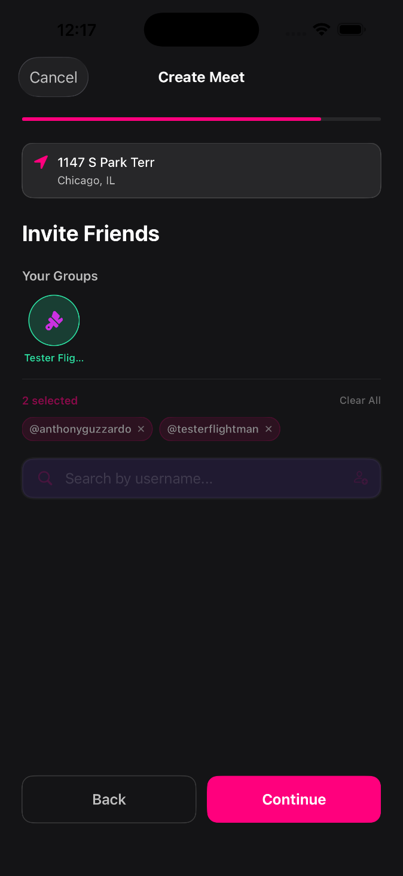

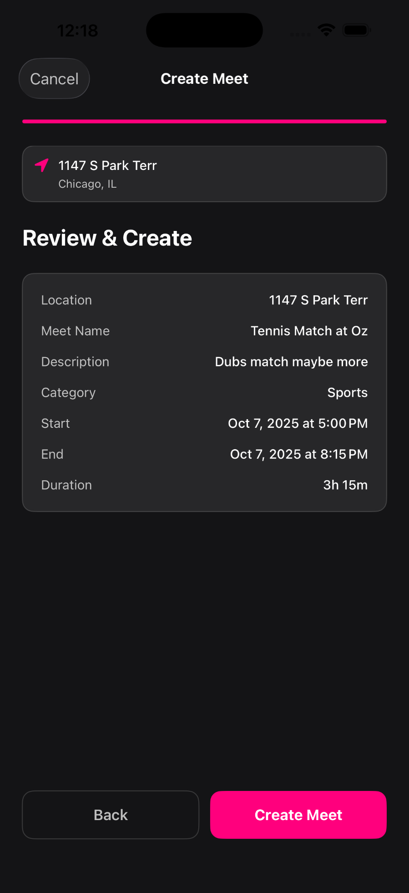

- Create Group Meets
  - Users can invite full groups.
  - Group invites simplify reusing participant lists.
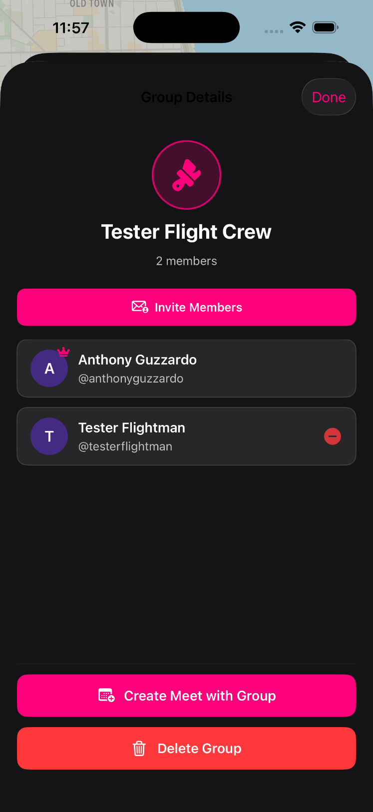

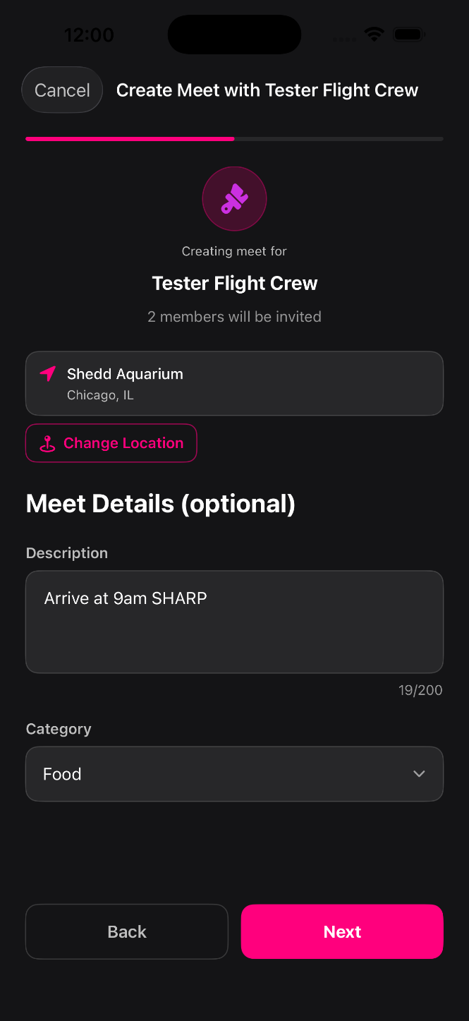
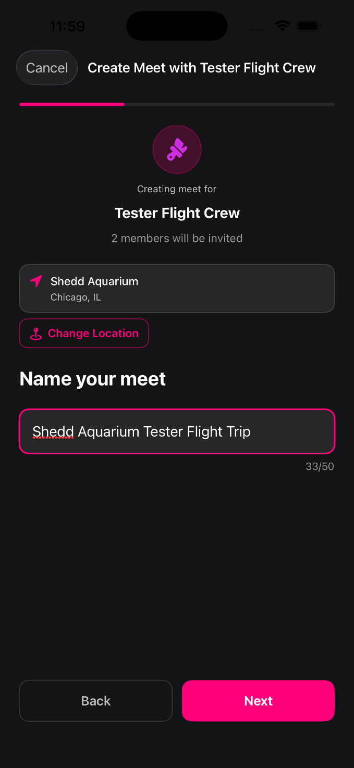

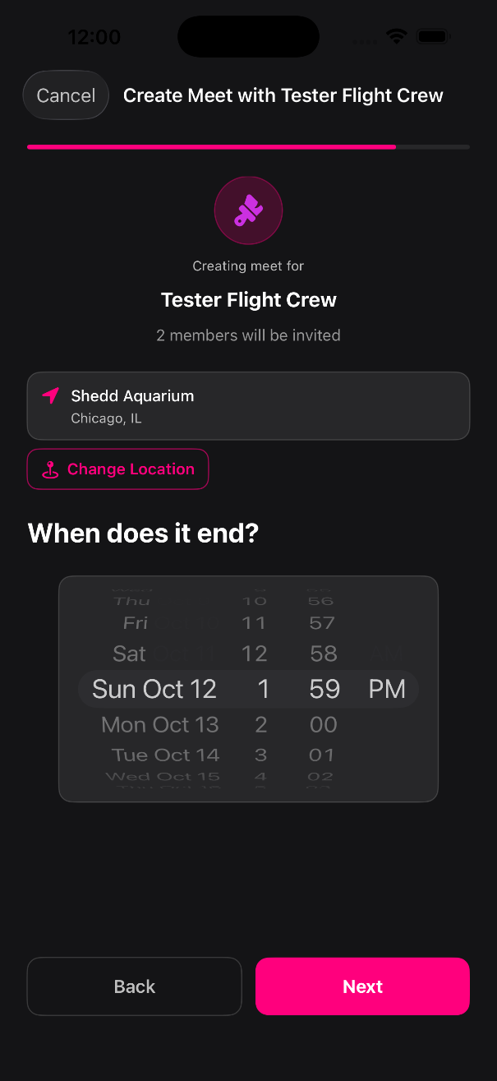
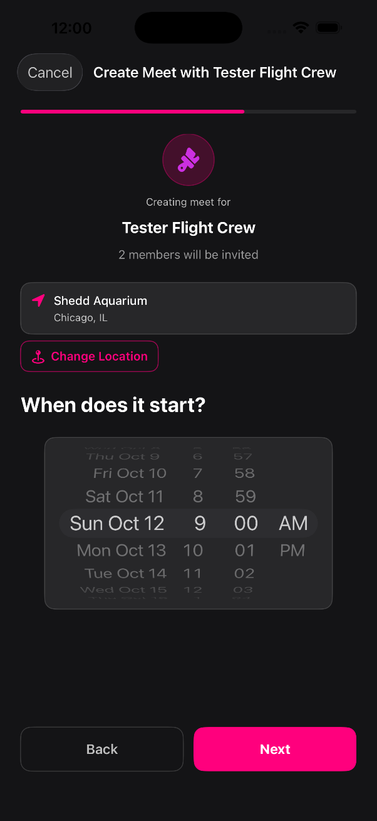

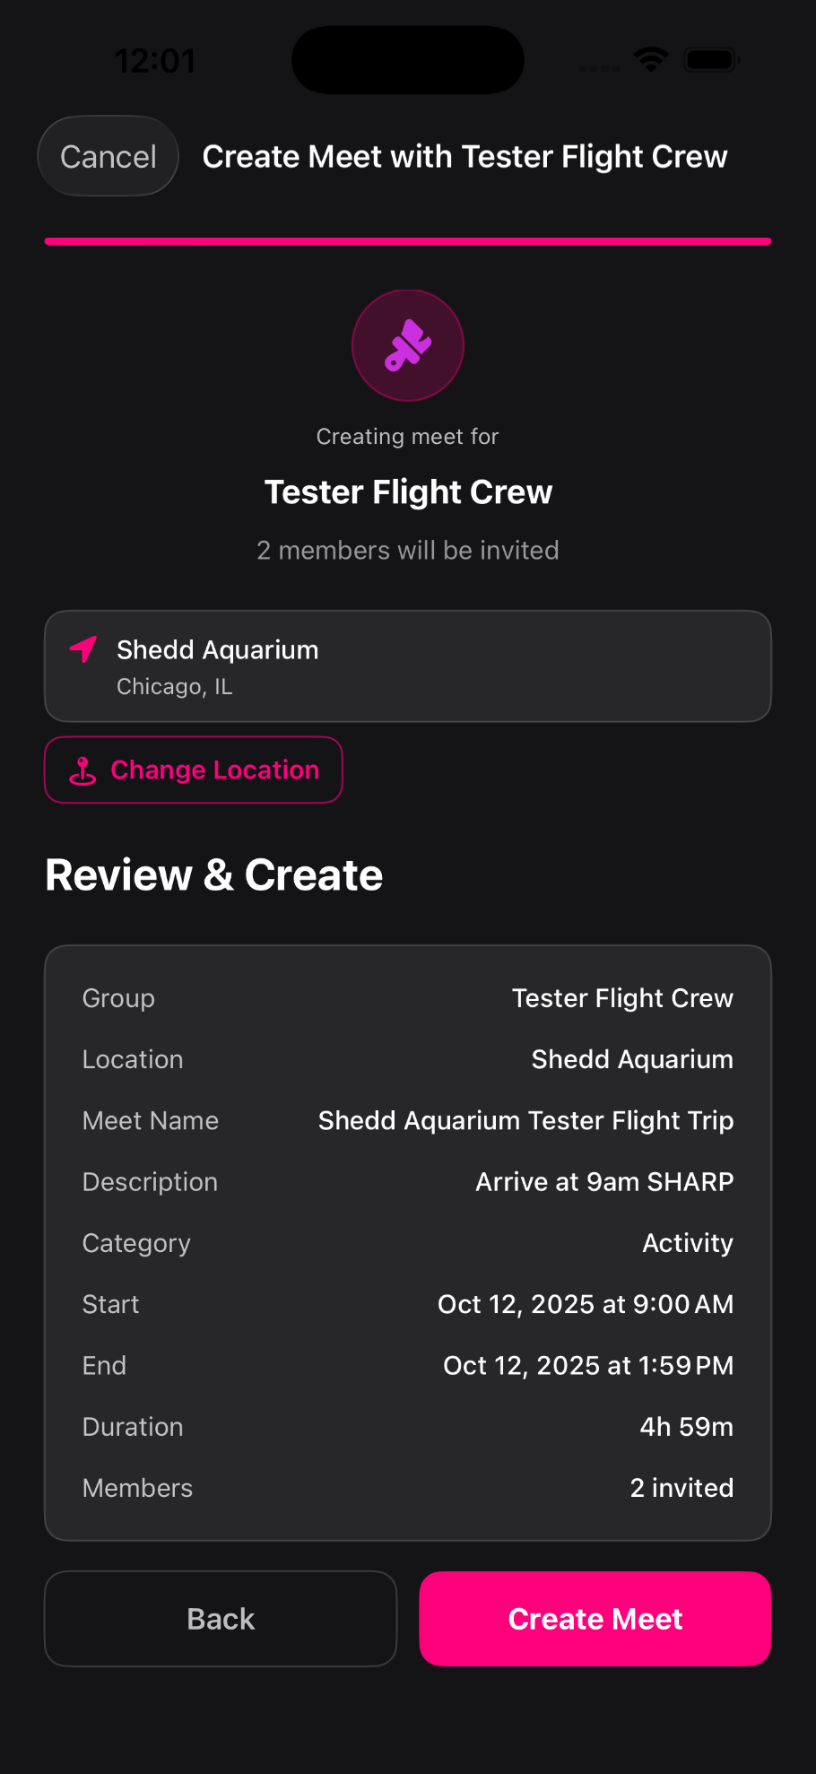

- Inbox and Friends System
  - Inbox consolidates all requests and notifications:
    - Friend requests
    - Meet invitations
    - Status notifications
  - Users can accept or decline friend requests directly.
  - Friend management includes search, view, and status indicators.
  - Status types include “is friend,” “pending invite,” and “declined.”

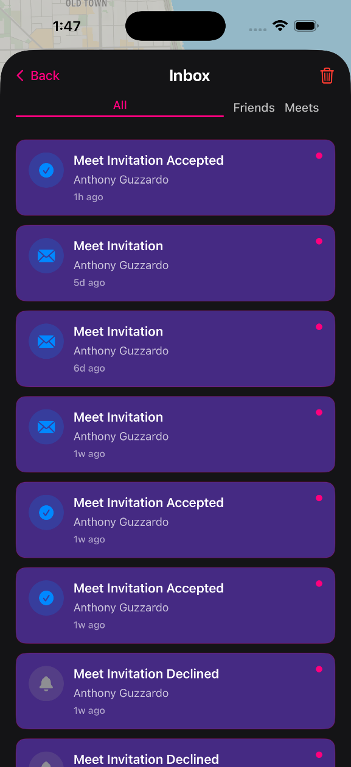
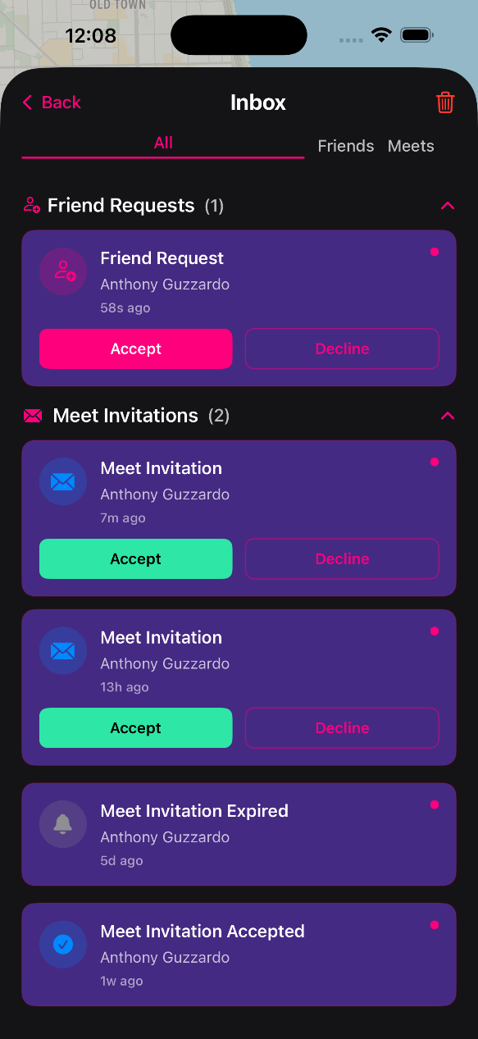

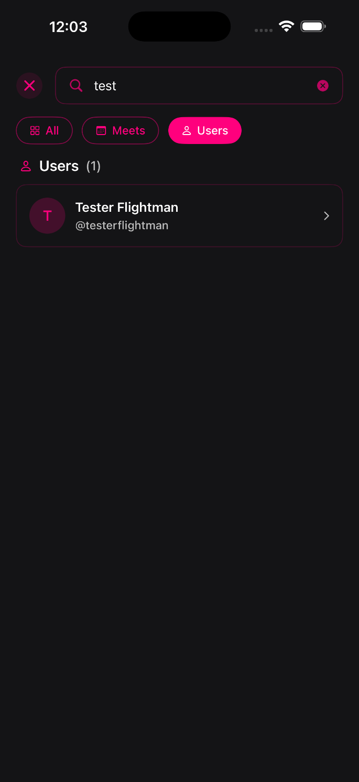
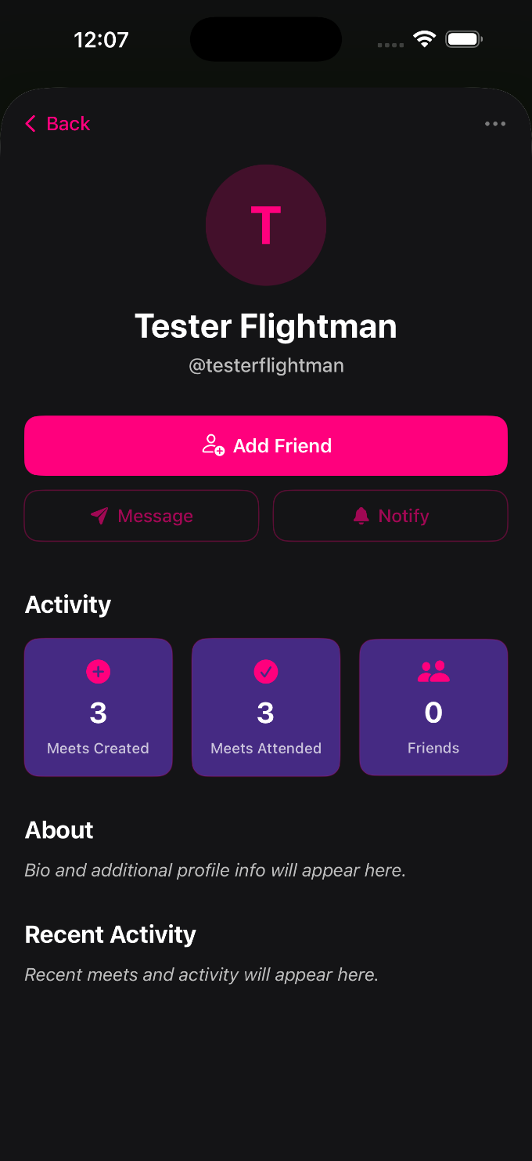

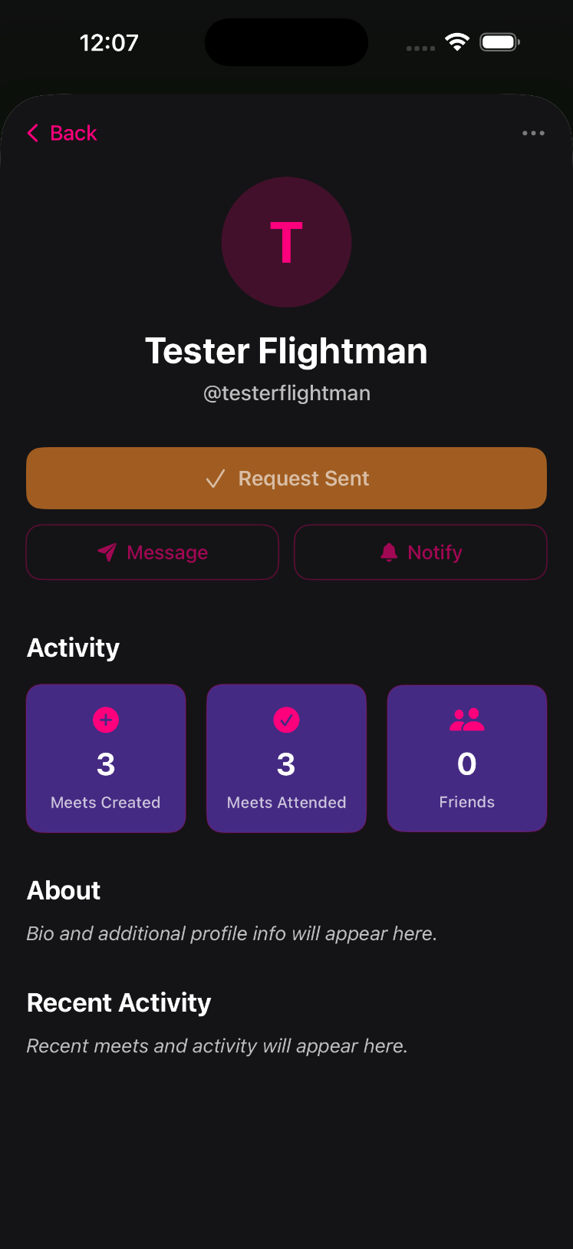
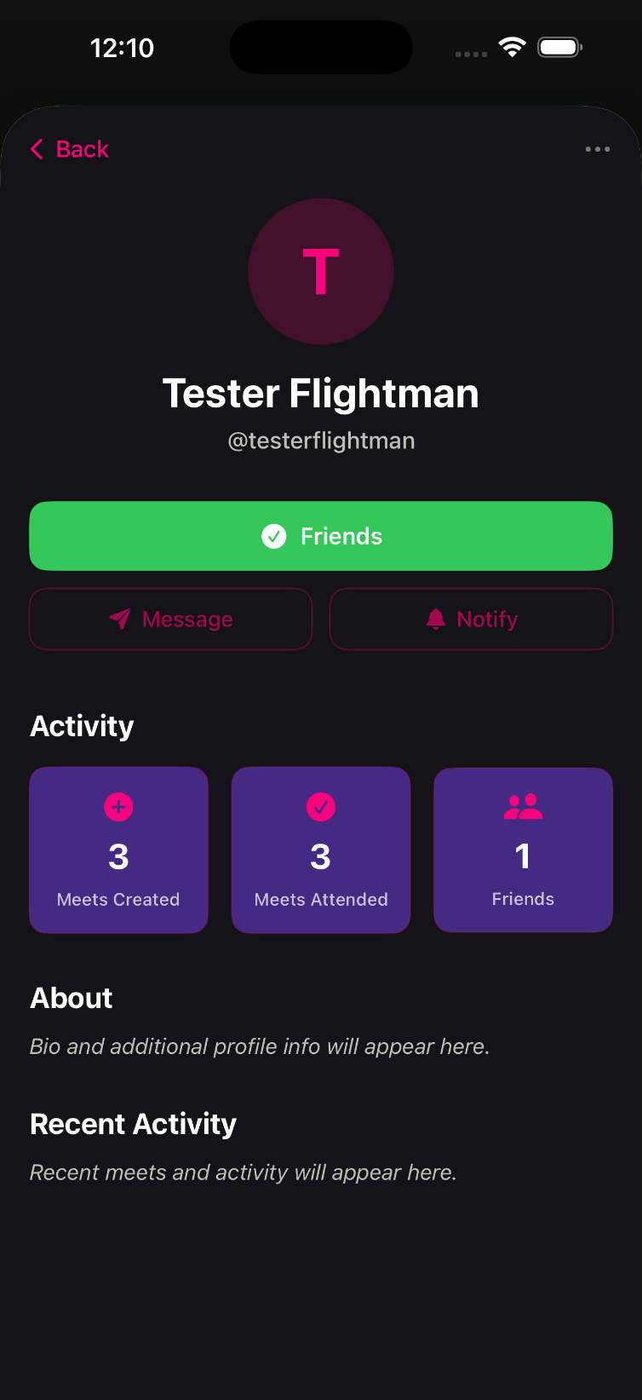

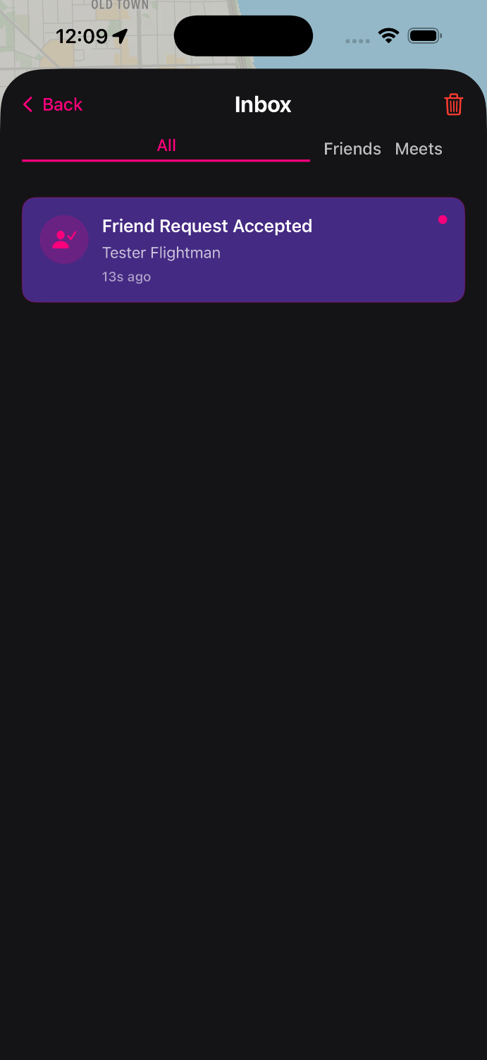
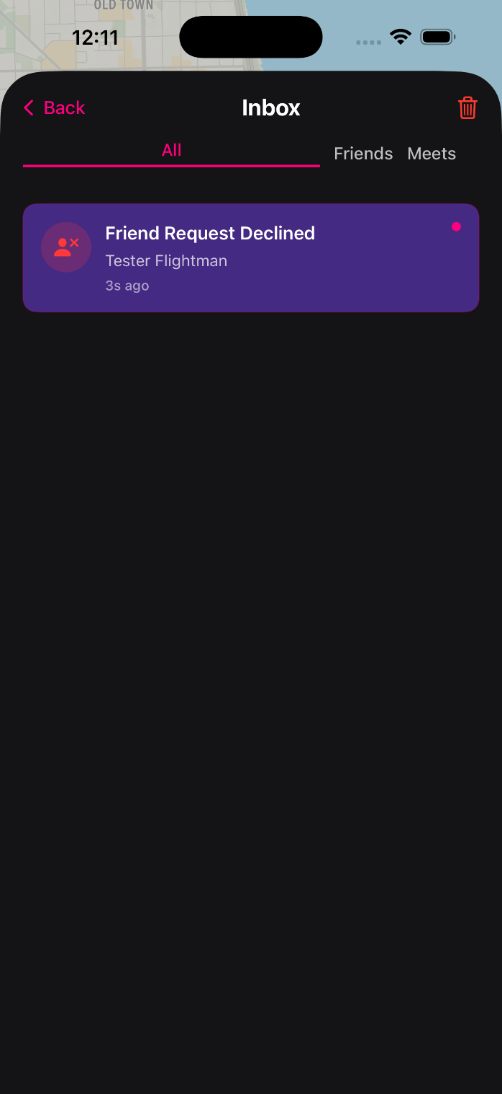

- Profile and Account Settings
  - Profile and account settings moved into the User Profile section.
  - Accessible via bottom-right dock icon.
  - Users can update details, change passwords, or delete accounts.
  - Consolidation improves discoverability and consistency.

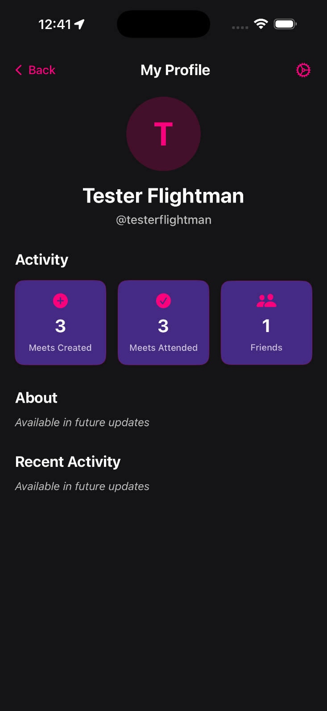

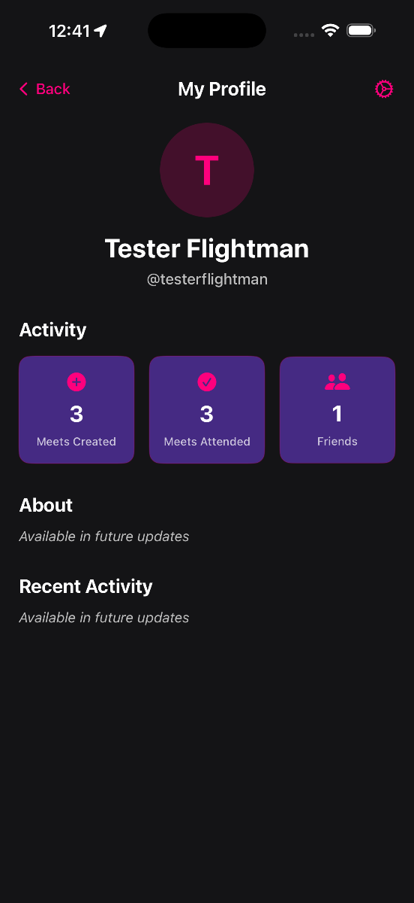
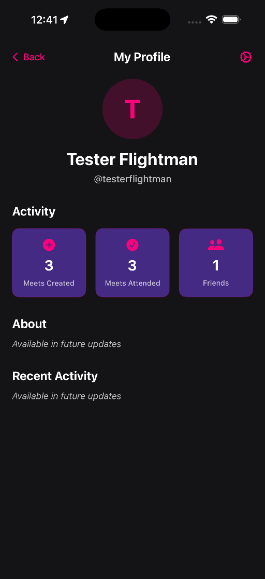
Tap on the gear in the users profile to view account settings such as Change Password and delete account. Tap on the friends button to view friends list. The number there is possibly different now if a user unfriended them.

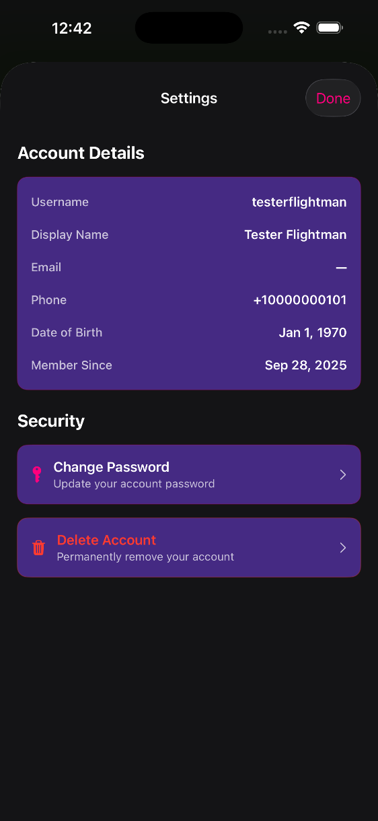
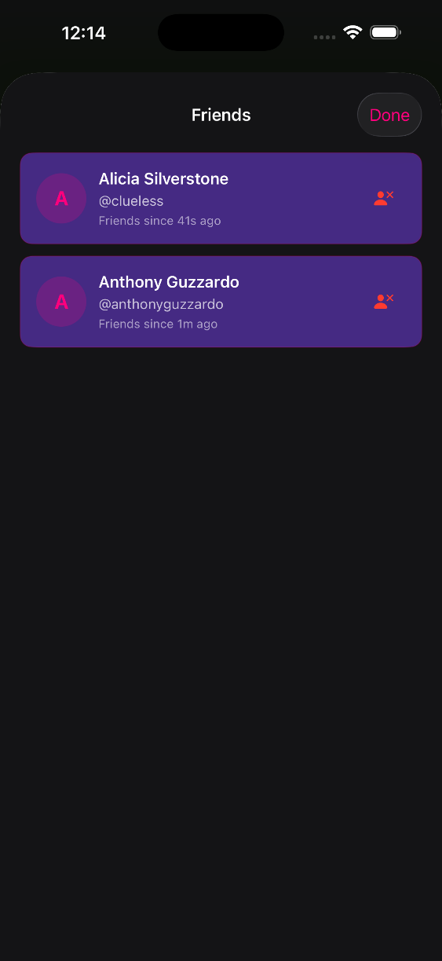

- Fixes and Improvements
  - Fixed date-of-birth error caused by UTC conversion.
  - Fixed update page routing issue that led to empty screens.
  - Improved state management between meet and group flows.
  - Enforced color consistency and layout hierarchy.
- Future Enhancements
  - Messenger tab currently serves as a placeholder.
  - Planned updates include:
    - Direct and group messaging
    - Real-time meet reminders
    - Push notifications
