*Ryan Schapiro, Gideon Sweijd, Corey Lee, Andrew Mangle, Dylan Friedman, Jayden Moore and Nathan Wells*

*Open Funds FO*

*Revolutionizing Student funding through open Payment Systems*

INTERLEDGER FINTECH HACKATHON 2024

**TABLE OF CONTENTS** Page

1. Background 2-3

1.1 NSFAS Objectives 2-3

1. Problem Section

2.1 Delayed and Non-Payments 3   
2.2 Exorbitant Bank Charges 3

2.3 System Inefficiencies 3

2.4 Debt Recovery 3

2.5 Administration Concerns 3

      3. Target Users and Market Selection 4  
 3.1 Target Users 4   
 3.2 Market Analysis 4

         3.3 Competitive Landscape 4

 4. Benefits of Open Payments 5-6

5. Prototype and Demo 6-9

      6. Future Opportunities and Expansion 9-10

      7. Conclusion 10

Background:

Student financial aid schemes are crucial for ensuring that higher education is accessible to all, regardless of financial background. Originating in the mid-20th century, these programs were established to promote educational equity and economic growth. Aid can be need-based, helping those from low-income families, or merit-based, rewarding academic or extracurricular achievements.

Governments, educational institutions, and private organizations provide various forms of aid, including grants, scholarships, and loans. The rising cost of education has made these schemes increasingly important, as they help mitigate financial barriers and support students in achieving their academic goals.

The National Student Financial Aid Scheme (NSFAS) is a South African government student financial aid program that provides loans and bursaries to eligible students at public universities and Technical and Vocational Education and Training (TVET) colleges. Established in 1996 under the National Student Financial Aid Scheme Act (No. 56 of 1999), NSFAS aims to provide financial assistance to students from poor and working-class families who would otherwise be unable to afford tertiary education.

NSFAS Objectives

**Promoting Access to Higher Education**

1. **Boosts Economic Growth and Productivity**: Education leads to higher income, creating a more skilled labour force. This, in turn, increases innovation and technological advancement, contributing to a dynamic economy.
2. **Reduces Socio-Economic Inequality**: By providing financial aid to disadvantaged students, NSFAS promotes a more equitable and inclusive society, allowing for upward social mobility and breaking the poverty cycle.
3. **Fosters Social Cohesion**: Improving access to higher education enhances the quality of social relationships, trust, mutual obligations, and respect within communities.

**Redressing Past Inequalities**

1. **Broadens Economic Base**: Historically, non-whites have been underrepresented in higher education. NSFAS aid helps rectify this imbalance, allowing more people to contribute to and benefit from economic activities.
2. **Improves Social Mobility**: Access to higher education promotes upward social mobility, facilitating changes in socio-economic status either in relation to parents (intergenerational mobility) or throughout an individual's lifetime (intra-generational mobility).

**Poverty Reduction**: By breaking the poverty cycle, NSFAS enables students who previously could not afford higher education to attend, contributing to long-term economic development.

Problem Section:

**Delayed and Non-Payments**

1. **Administrative Inefficiencies and Technical Glitches**: Current NSFAS platforms are inefficient and unreliable, leading to payment delays.
2. **Budget Constraints**: Financial limitations exacerbate payment issues, disrupting academic activities due to lack of essentials like food, rent, and textbooks.
3. **Financial Stress**: Students face uncertainty about their financial support, leading to increased stress and higher dropout risks due to untenable living situations.
4. **Loss of Trust**: Students lose faith in the government and its agencies due to poor service delivery.

**Exorbitant Bank Charges**

1. **Previous NSFAS Bank Accounts**: Past attempts to implement NSFAS bank accounts incurred high charges while still experiencing delays, leading to the system being scrapped.

**System Inefficiencies**

1. **User-Unfriendly Systems**: The current online systems are difficult to navigate, hindering students from applying and viewing their funding status.
2. **Corruption**: Mismanagement of funds, nepotism, and bureaucracy contribute to the inefficiency.
3. **Poor Communication**: Queries often go unanswered, making it impossible to resolve issues with late or non-payments.

**Debt Recovery**

1. **Challenges in Reclaiming Loans**: High unemployment rates and dropout rates make it difficult to maintain sustainable funding through loan recovery.
2. **Insufficient Support Systems**: Overworked call centres and help desks are unable to adequately assist students.

**Administration Concerns**

1. **Risk of Collapse**: Without immediate rework, NSFAS administration is at risk of failing.

Target Users and Market Selection:

**Target Users**

1. **NSFAS Beneficiaries**: Primary users include undergraduate students in public universities and TVET colleges, postgraduate students receiving NSFAS support, and prospective students applying for funding.
2. **Educational Institutions**: Universities and TVET colleges interact with NSFAS for disbursing funds and managing student accounts.
3. **Parents and Guardians**: Family members who monitor and manage the financial aid received by students.
4. **NSFAS Administrators**: Officials responsible for allocating and distributing financial aid and monitoring fund usage.

**Market Analysis**

1. **Total Addressable Market (TAM)**: Approximately 1.3 million students enrolled in higher education institutions, including those eligible for NSFAS and those seeking other financial aid.
2. **Serviceable Available Market (SAM)**: Around 700,000 students annually, including educational institutions and administrators managing NSFAS funds.
3. **Serviceable Obtainable Market (SOM)**: Initially targeting 30-40% of the SAM, equating to approximately 210,000 to 280,000 students.

**Competitive Landscape**

**Existing Financial Aid Systems**

1. **Traditional Banks**: Major South African banks offering student banking products and services.
2. **Fintech Startups**: Companies like Capitec Bank and TymeBank providing innovative financial services targeted at students.
3. **EduTech Platforms**: Providers like Fundi offering comprehensive financial services tailored for students and educational institutions.

**Competitive Advantage**

1. **Integration with NSFAS**: Streamlines fund disbursement and management processes.
2. **User-Friendly Interface**: Mobile-first, intuitive application.
3. **Real-Time Tracking**: Real-time tracking and notification of fund disbursements, expenditures, and balances.
4. **Financial Literacy Tools**: In-app resources to help students manage their finances effectively.

Benefits of Open Payments:

**Transparency and Fraud Reduction** Digital financial aid systems provide real-time visibility of transactions, ensuring every financial movement can be tracked and audited. This level of transparency helps identify and address any discrepancies immediately, significantly reducing the potential for fraud. By having an electronic trail, it becomes easier to monitor and verify the legitimacy of disbursements and expenditures, ensuring funds are used as intended and enhancing overall trust in the system.

**Streamlined Processes and Speed** Automated processes in digital financial aid systems reduce delays typically associated with manual handling. By automating the application, approval, and disbursement processes, errors are minimized, and administrative overhead is reduced. This leads to faster processing times, enabling students to receive their financial aid more promptly, which is crucial for covering immediate educational expenses such as tuition, books, and living costs.

**Lower Costs** Digital systems often incur lower transaction fees and administrative costs compared to traditional paper-based or manual systems. These savings allow organizations like the National Student Financial Aid Scheme (NSFAS) to allocate a larger portion of their budget directly to beneficiaries rather than spending it on operational costs. This efficiency means more students can benefit from financial aid without requiring additional funding.

**Scalable** One of the significant advantages of digital systems is their scalability. They can accommodate an increasing number of students without necessitating a proportional increase in infrastructure or resources. This scalability ensures that as the demand for financial aid grows, the system can handle the load without compromising on efficiency or service quality.

**Integration** Digital financial aid systems can easily integrate with other educational and financial systems, creating a seamless flow of information. This integration allows for better coordination between various departments and organizations, such as universities, banks, and government bodies. It ensures that data is consistently updated and accessible, improving the overall management and effectiveness of financial aid programs.

**Convenience and Access** Digital platforms provide greater convenience and accessibility for students, particularly those who struggle with traditional banking systems. Through mobile and web applications, students can easily apply for, manage, and receive their funds. This accessibility is especially beneficial for students in remote or underserved areas who may not have easy access to physical banking institutions.

**Debt Recovery** Digital financial aid systems facilitate easier tracking of loans and repayments. By maintaining detailed and up-to-date records of disbursements and outstanding debts, these systems improve the efficiency of debt recovery processes. Automated reminders and online payment options can encourage timely repayments, ensuring that funds are replenished and available for future students. Improved debt recovery rates also contribute to the long-term sustainability of financial aid programs.

Prototype and Demo:

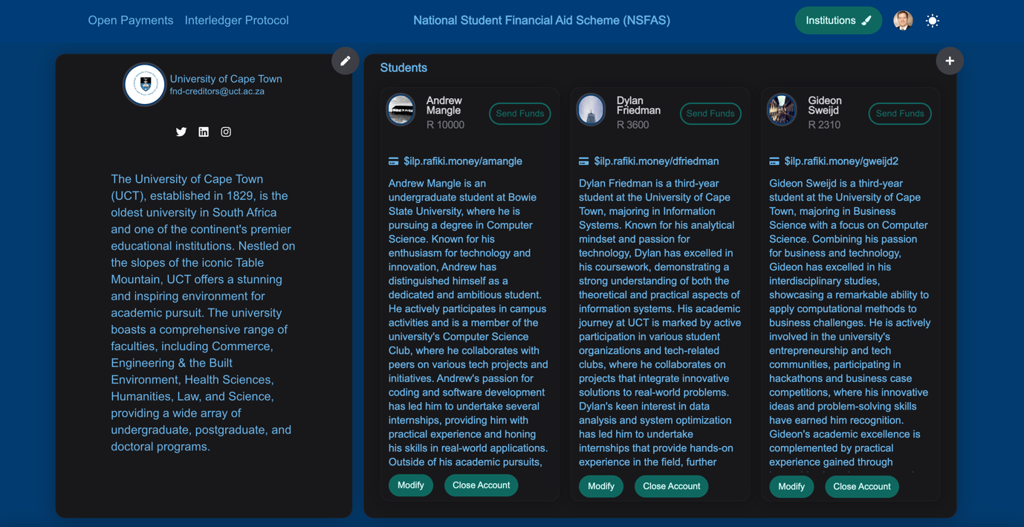

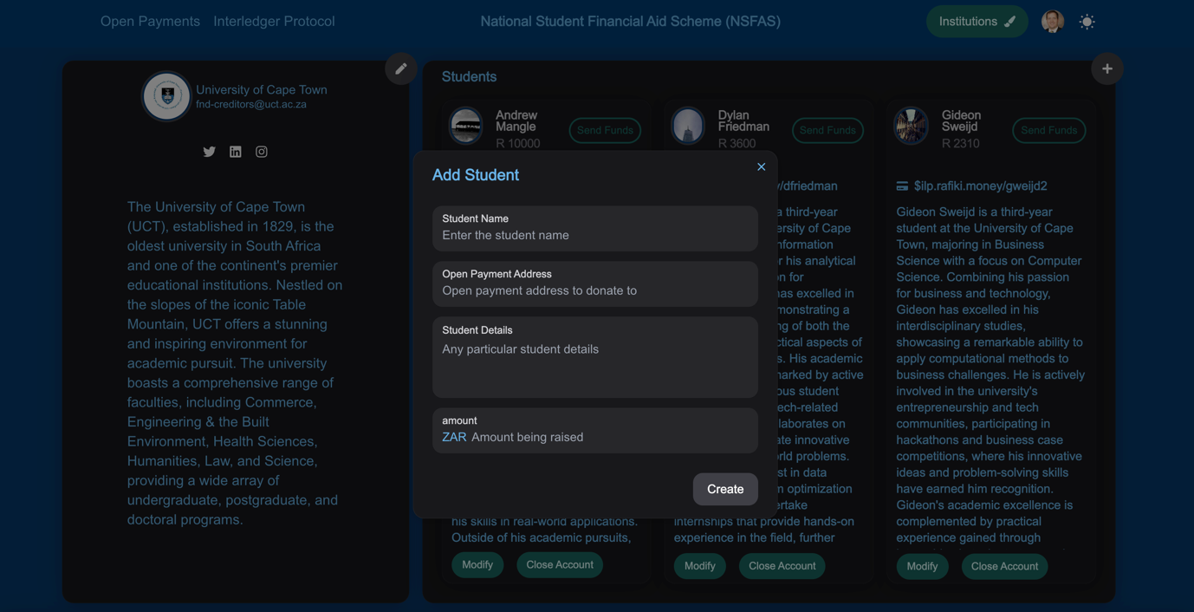

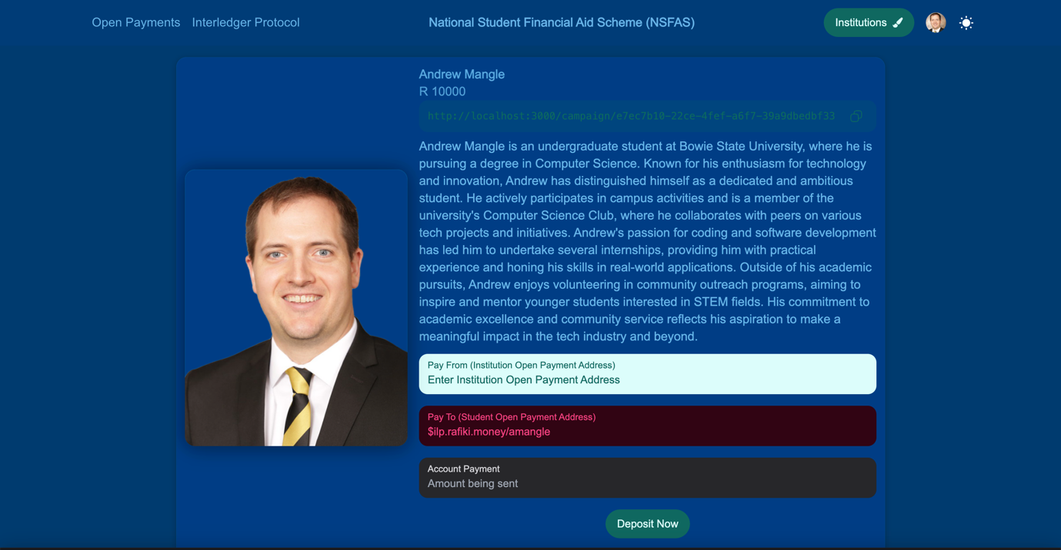

**(Mention how UCT and NSFAS will work together and UCT and NSFAS will setup the account for the student.)**

Future Opportunities and Expansion:

The web application is designed to provide a secure and efficient platform for managing student financial aid. Access to the application is restricted to authorized employees, ensuring that only they can view and manage students' wallet addresses, thus safeguarding financial information and transactions.

Currently, the application allows employees to deposit funds directly into students' wallets in a safe and secure manner leveraging open payments. When students apply for financial aid at the start of their academic journey or reapply after passing the academic year, their information is submitted to the system. Eligible students are then added to the application's database using institution-specific student identification numbers as their wallet address.

This streamlined process ensures accurate and efficient management of student information and funding. Additionally, the system's design supports future enhancements, such as crowd funding. Student representative councils at institutions can request the wallet addresses of students being supported by NSFAS and publish it along with the students story which can result in donors directly contributing to students' education and accommodation expenses, potentially increasing the amount of financial support available to students.

By leveraging this web application, financial aid organizations can better manage and distribute aid, ensuring more students receive the necessary funding for their educational pursuits.

Conclusion:

The implementation of the web application marks a significant advancement in the management of student financial aid. By providing a secure platform for authorized employees to handle wallet addresses and deposits, the system ensures the safety and accuracy of financial transactions. The integration of institution-specific student identification numbers streamlines the application and reapplication processes, enhancing efficiency. Additionally, the potential for future crowdfunding through wallet addresses opens new avenues for increasing financial support. This application not only optimizes current operations but also sets the stage for scalable and innovative funding solutions for students.