Using SharePoint for Assignments

**Contents**

Setup 3

Teams 3

SharePoint 3

List 4

Create 4

Modify 5

Permissions 5

List Columns 6

Add Pupils 8

Document Library 9

Create 9

Modify 10

Columns 10

Permissions 10

Power Automate – Create & Share 11

Create Flow 11

Main Code 12

When Power Apps calls a flow (V2) 12

Get Items 12

Apply to each 13

Create new folder 13

Grant access to an item or a folder 13

Optional Code 14

Apply to each sub folder 14

Create SDD folder 14

Run the Flow 15

Power Automate – Remove access – All Pupils 16

Duplicate Flow 16

Edit Flow 16

Send an HTTP request to SharePoint 17

Turn on and Run 17

Power Automate – Grant access – All Pupils 18

Duplicate Flow 18

Edit Flow 18

Turn on and Run 18

Power Automate – Remove access – Individual Pupil 19

Main Code 19

When Power Apps calls a flow (V2) 19

Send an HTTP request to SharePoint 19

Run the Flow 20

Power Automate – Grant access – Individual Pupil 21

Main Code 21

When Power Apps calls a flow (V2) 21

Condition 22

Run the Flow 22

Power Apps 23

Create App 23

Add Flows 24

Add Data 26

Format App 27

Modify slider 28

Code 28

Share All 28

Unshare All 29

Label 29

Test the slider 29

Share One 30

Unshare One 30

Higher 31

Save 31

# Setup

## Teams

Create a new class team. This one is called **Test**.

## SharePoint

In the SharePoint site of the class team, create a list and a document library.

SharePoint can be accessed via the **General** channel and the **Files** tab of the class team. It can take a few minutes after the team is created for the site to be accessible.

Access the **Site contents**.

### List

#### Create

Create a new list.

The list is called **Data**. It is used to hold the details of the pupils.

#### Modify

##### Permissions

Access the site contents to edit the settings of the list.

Stop inheriting permissions.

Remove non-owners.

##### List Columns

Show the **ID** column.

Add a *Person* column.

This one is called **Pupil**.

#### Add Pupils

Add the required pupils.

Glow email addresses can be used.

Update *Title* to match *ID*.

### Document Library

#### Create

Create a document library using the same steps for creating a list.

The document library is called **Assignment**. It is used to hold the pupils’ files.

#### Modify

##### Columns

Show the **ID** column.

##### Permissions

Modify the permissions and remove non-owners using the same steps for the list.

# Power Automate – Create & Share

Power Automate will require the site address of the SharePoint site:

The address will be shown in various drop-down lists.

## Create Flow

Create a flow.

This one is called **Test Create & Share**.

## Main Code

### When Power Apps calls a flow (V2)

### Get Items

### Apply to each

### Create new folder

### Grant access to an item or a folder

## Optional Code

This code can be used to create subfolder.

### Apply to each sub folder

Use the **Apply to each** block.

### Create SDD folder

Create as many as appropriate. Use the **Create new folder** block.

## Run the Flow

Save the flow. Ignore the *Get Items* warning. Run the flow

Check the result.

# Power Automate – Remove access – All Pupils

## Duplicate Flow

This one is called **Test Unshare**.

## Edit Flow

Delete any unnecessary blocks. Change the *Apply to each* block:

### Send an HTTP request to SharePoint

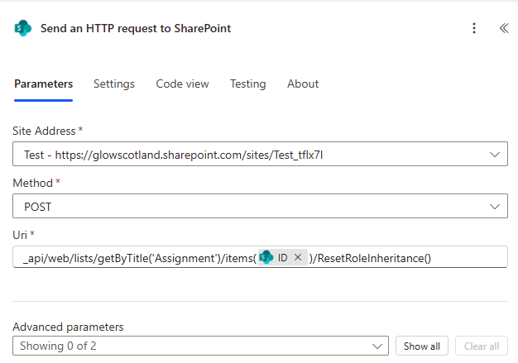

Uri:

_api/web/lists/getByTitle('Assignment')/items(@{items('Apply_to_each')?['ID']})/ResetRoleInheritance()

## Turn on and Run

Turn on the flow.

Run the flow.

Check the result.

# Power Automate – Grant access – All Pupils

## Duplicate Flow

This one is called **Test Share**.

## Edit Flow

Delete any unnecessary blocks. Change the *Apply to each* block:

## Turn on and Run

Turn on and run the flow. Check the result.

# Power Automate – Remove access – Individual Pupil

This one is called **Test Individual Unshare**.

## Main Code

### When Power Apps calls a flow (V2)

Add an input of type *Number*.

### Send an HTTP request to SharePoint

Uri:

_api/web/lists/getByTitle('Assignment')/items(@{triggerBody()?['number']})/ResetRoleInheritance()

## Run the Flow

Check the result.

# Power Automate – Grant access – Individual Pupil

This one is called **Test Individual Share**.

## Main Code

### When Power Apps calls a flow (V2)

Add an input of type *Number*.

### Condition

## Run the Flow

Check the result.

# Power Apps

## Create App

Create a new app.

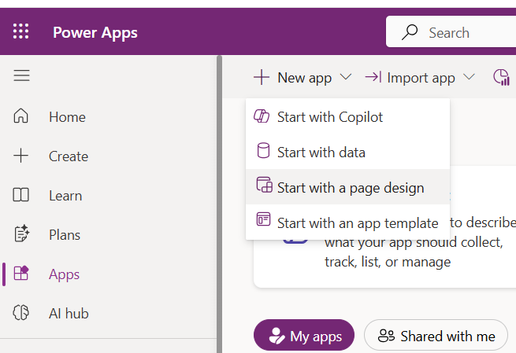

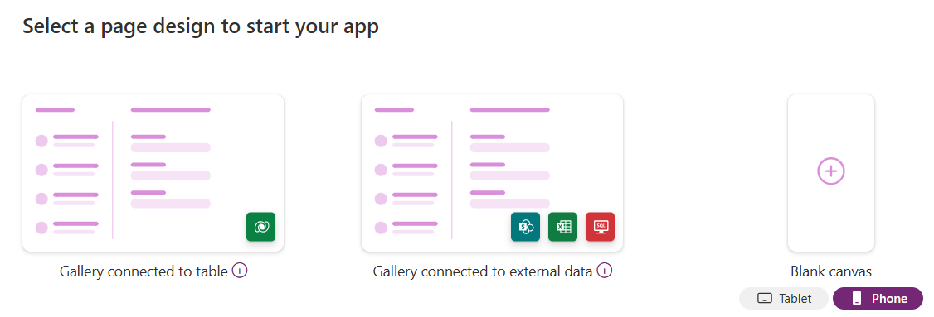

Add additional screens, as required.

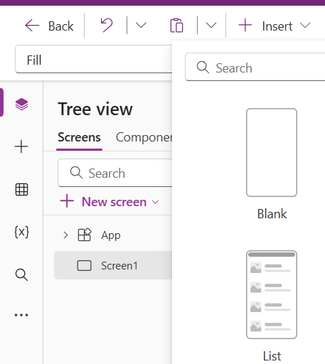

### Add Flows

Add Power Automate flows. Repeat as required.

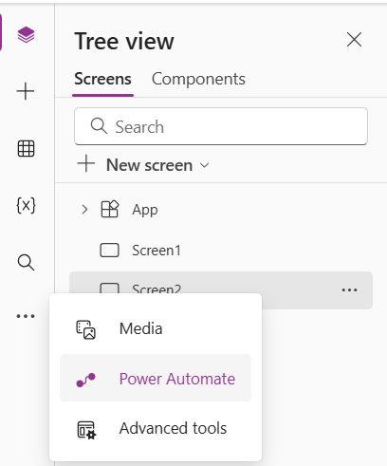

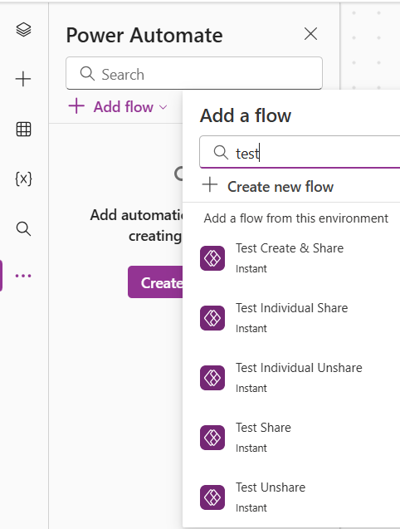

Name(s) without spaces will be used when coding.

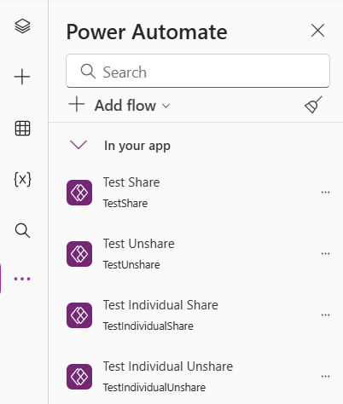

Insert the required items.

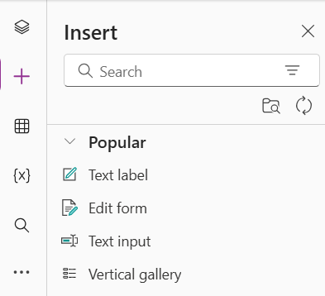

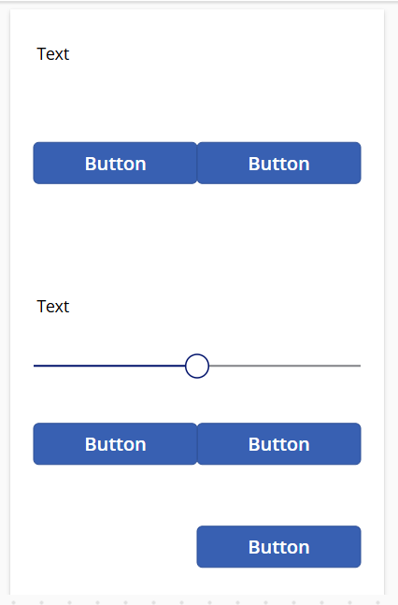

### Add Data

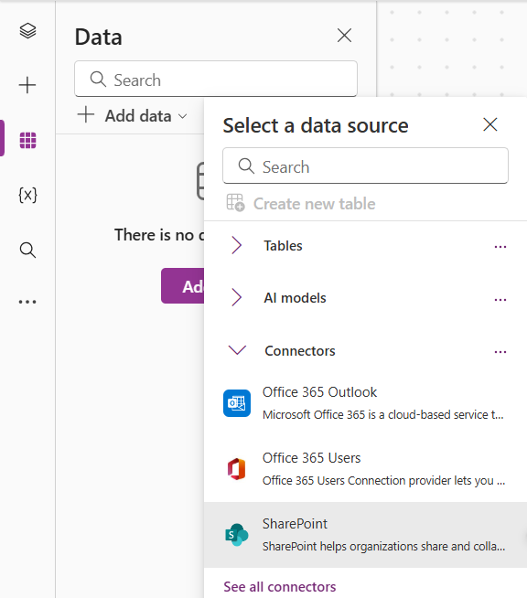

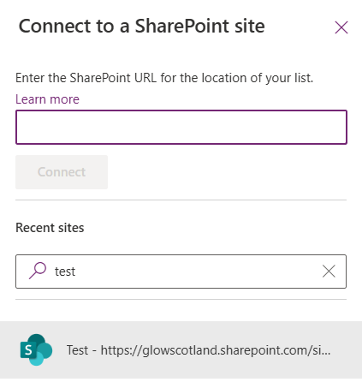

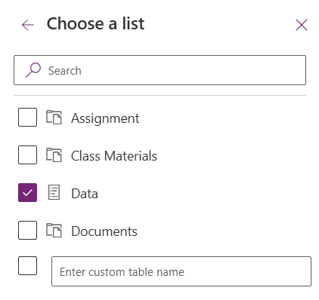

### Format App

Format as required.

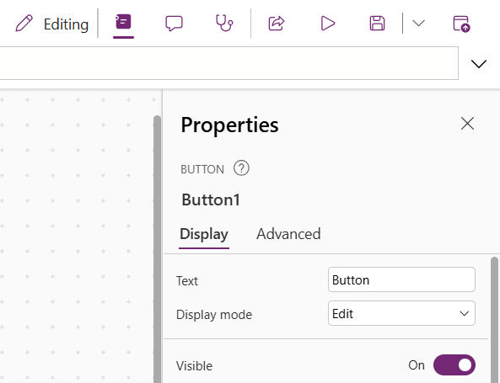

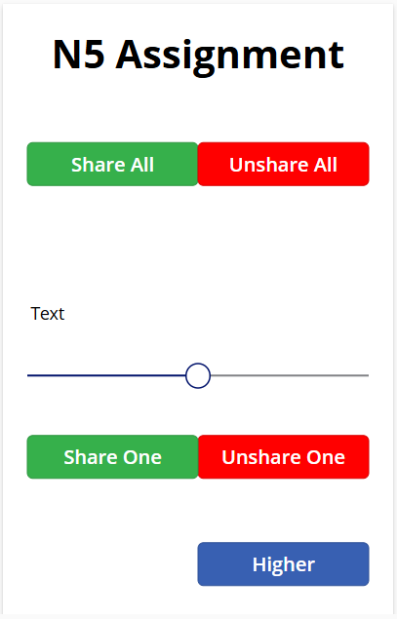

### Modify slider

Rename and set min and max values. These values are the ID values from the SharePoint list.

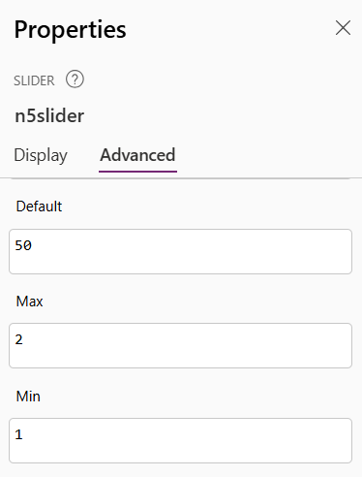

## Code

### Share All

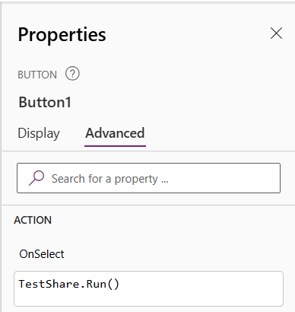

Code:

TestShare.Run()

### Unshare All

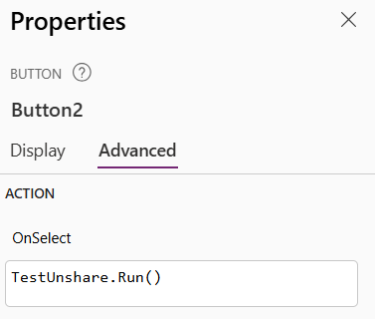

Code:

TestUnshare.Run()

### Label

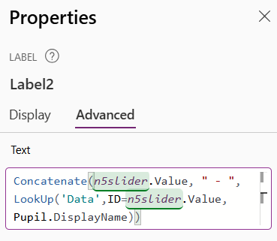

Code:

Concatenate(n5slider.Value, " - ", LookUp('Data',ID=n5slider.Value, Pupil.DisplayName))

#### Test the slider

Press and hold the *Alt* key. Drag the slider to see if the text changes.

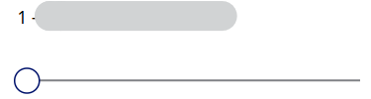 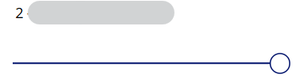

### Share One

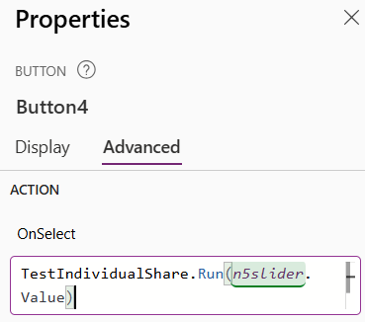

Code:

TestIndividualShare.Run(n5slider.Value)

### Unshare One

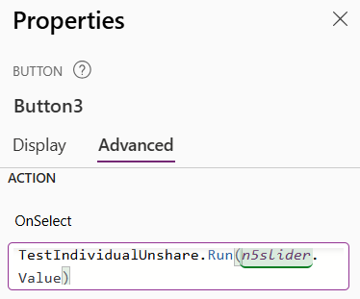

Code:

TestIndividualUnshare.Run(n5slider.Value)

### Higher

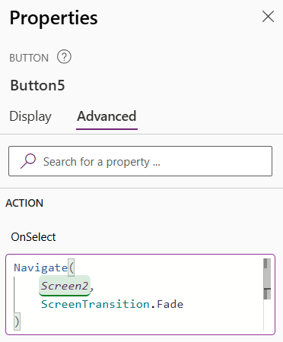

Code:

Navigate(Screen2, ScreenTransition.Fade)

## Save

Save the app!