# Judo “the gentle way” (post #1)

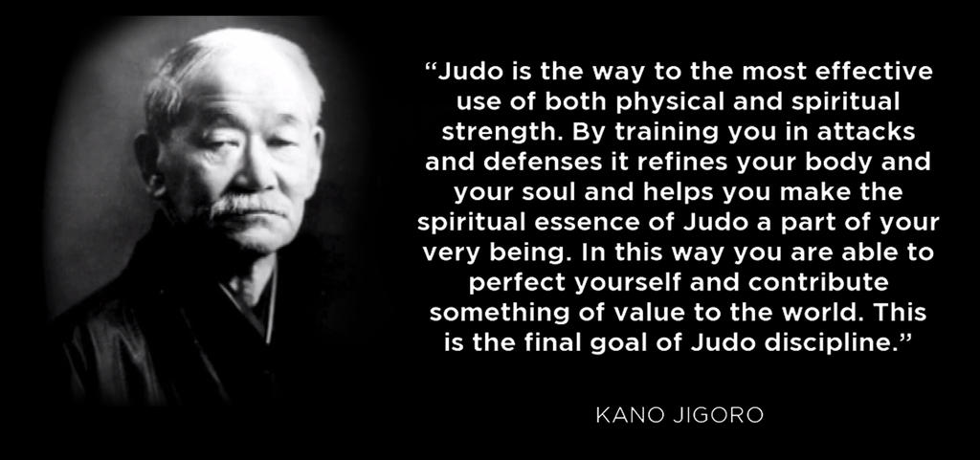

## Judo history

Judo is a Japanese martial art based upon the ancient techniques of jiujitsu. Dr Jigoro kano, president of the university of education in Tokyo, developed judo in 1882. Dr Kano, who had studied jujitsu in his youth, incorporated the best of these ancient techniques into the new art of judo. Dr Kano subsequently founded the Kodokan in Tokyo, japan as a place to teach his new art.

## Judo techniques

Judo is known for its spectacular throwing techniques but also includes numerous techniques for controlling an opponent while on the ground. Judo is often compared to freestyle wrestling and while the two share many techniques, judo retains many self-defence manoeuvres. A good judoka, one who practices judo, will first use timing and leverage to bring their opponent off balance and execute a throw. Once the judoka has thrown their opponent to the ground, they will use hold-down techniques, chokes, strangleholds, and arm locks to control and subdue the opponent. A judoka first learns "ukemi", the art of falling properly to avoid injury. All judo practitioners wear a judogi and a belt. Judo is practiced on mats for safety.

## Judo philosophy

The main principles of judo are "maximum efficiency" and "mutual welfare and benefit." The goal of maximum efficiency teaches the judoka to use the least amount of physical strength necessary to throw an opponent. This is accomplished by proper use of technique and timing. The goal of mutual welfare and benefit was an extension of Dr Kano's belief that judo could help the individual become a better member of society. Dr Kano felt that the personal discipline that judo taught would extend beyond the dojo into daily life and could allow the judoka to become a more productive member of society.

## Judo as a sport

In 1964, judo became the first martial art to be sanctioned as a medal sport in the Olympic games. Judo competitions are also held throughout the world. Points are awarded for throwing an opponent, holding an opponent on his back while on the mat for a designated amount of time, or forcing an opponent to submit via "tapping out" to an arm lock or choke. A match is won with a "perfect throw" called an ippon, two near perfect throws called wazari, holding an opponent on his back on the mat for 20 seconds, a combination of one wazari and holding an opponent down for 15 seconds, or submitting an opponent with a choke or armlock. However, arm locks and strangles are not permitted for juniors (under 14). Members of an Irish Judo Association judo club are offered frequent opportunities to compete. However, competition is not necessary for membership in the club.