# Judo equipment, Hygiene & Etiquette (post #5)

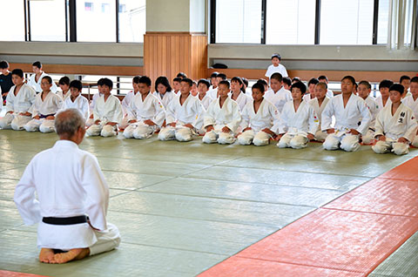

Judo is a contact sport so always ensure that

1. You and your suit (gi) are clean before your judo lesson
2. Keep your finger and toenails short and clean to prevent injury/scratches
3. Always have a pair of flip-flops or crocs on your feet are off the mat (especially the toilet)
4. Always bow to the teacher (sensei) and your opponent or before leaving the mat
5. Pay close attention to the teacher says at all times and follow instructions for safety
6. Kneel at the side of the mat (do not lie down) when not involved in play to avoid injury
7. Be humble in victory and gracious in defeat showing respect to your opponent at all times

And remember to enjoy the lesson and your new friends!

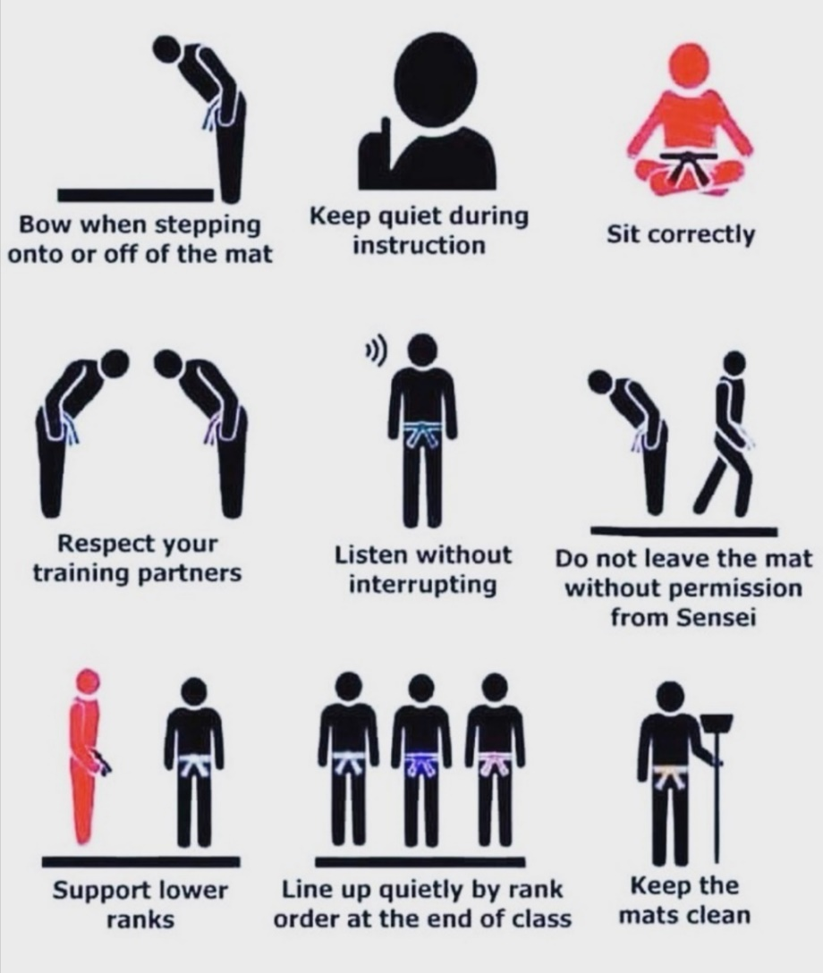

**Judo Etiquette Visual Guide**