------------------Sensor1 Content goes here------------------ ------------------Sensor1 Content goes here-------

------------------Sensor1 Content goes here------------------

------------------Sensor1 Content goes here------------------ ------------------Sensor1 Content goes here-------------------------Sensor1 Content goes here------------------

------------------Sensor1 Content goes here------------------

------------------Sensor1 Content goes here------------------

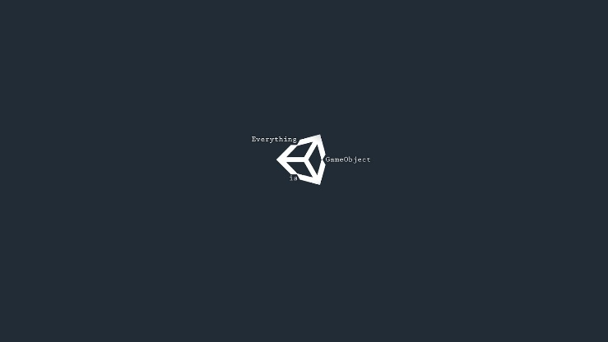

------------------Sensor1 Content goes here------------------

------------------Sensor1 Content goes here------------------ ------------------Sensor1 Content goes here------------------------------------Sensor1 Content goes here------------------ ------------------Sensor1 Content goes here------------------