Heroes of Pymoli Data Analysis - Written Description

1. The vast majority of players in Heroes of Pymoli are male, and therefore it is logical that males also constitute the highest purchase count and greatest total purchase value. Interestingly, however, they also have the lowest average purchase price and the lowest total purchase amount per person. This could suggest that males as a group either make fewer purchases per person, or that their purchases are of lower-priced items. Both seem to be the case here.
2. Players of age range 20-24 constitute the largest percentage of players when grouped by age (nearly 45% of all players), with the number of players being reduced for the age bins in either direction (younger or older than 20-24). As a group, players in the 20-24 age range also collectively made the largest number of purchases and spent the most money. Indeed, 4 of the 5 top spenders fall into the 20-24 age bucket (see image below).

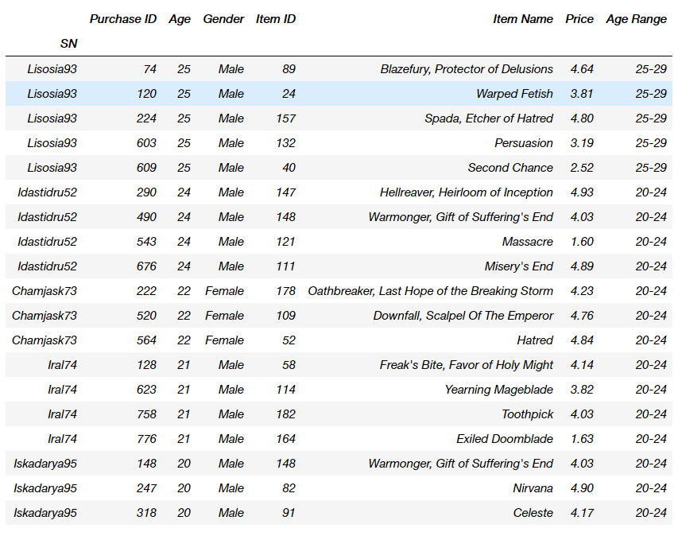

Similar to the gender demographics, however, this age group did not have the highest average purchase price or the highest average total purchase value per person, an honor that goes to the players in <10 age bin. It is surprising that the youngest players appear to be spending the most amount of money per capita.

1. The most popular items (by number of purchases) also tend the be the most profitable (by total purchase value). However, this is not strictly the case, as some items are profitable simply because they are more expensive even though other items are more popular. Assuming that in this digital game world all items cost the same for the game developer to “make”, profits margins can be driven up by increasing the sales on higher priced items. Another interesting observation is that the most popular item, Final Critic, also happens to be the most expensive of the top 5 most popular items. Thus the higher price of the item is not deterring players from purchasing it, and their decision to buy may instead be largely influenced by other properties of that item.