Libraries Revisited

Placing reusable code in libraries is one technique to code modularly. Libraries refer to physical *.py files that contain code, in particular functions, that other programs can use. The course has used the following libraries: math, tkinter, random and time. Let us revisit the time library.

Details of the time library can be found at https://docs.python.org/3/library/time.html
(This is an example of the online reference material for Python. Note the “3” in the address which indicates Python 3. And make sure the drop box in the upper left shows the correct version of Python is displayed.)

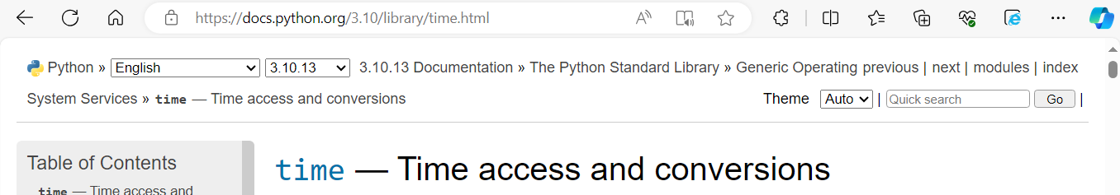

Time is an important concept with many different aspects to it. For example, there is elapsed time (quantitative measure) (recall time.sleep (n) where n was an elapsed time of n seconds), and calendar time (today’s date is “Dec 01, 2010”). And with calendar time, there is “which day of the month” (01), “which month” (Dec), “which month as a number” (12), “which day of the week” (Wednesday), etc.
The focus with this lesson will be on calendar time.

In computer science, time starts counting from a specific calendar time, then stored as seconds from that moment. Eg for Windows operating systems, time starts counting from January 01, 1970 00:00:00.

In programming languages, since time has many aspects, it is often maintained as a complex data type, and specific function or commands are used to pull specific values from it. Search for time.struct_time which detaills this data type.

Use this code below to see how the time.localtime () command uses the data structure. Calling this command/function returns a complex data structure from which different time aspects can then be further referenced. The table in the appendix shows how to use the results from time.localtime ().

Try (ignore the line numbers “01:” etc and leading blanks)

01: import time

02: curr_time = time.localtime() # Local date/time as of when this statement executes

03: curr_info = curr_time.tm_hour #note tm_hour is treated like a variable containing
#the current hour

04: print (“The current hour is “, curr_info, “ o’clock”)

05: curr_info = curr_time.tm_mon
06: print (“The current month number is “, curr_info)

07: #Format time using time.strftime( format types , time.localtime ())

Line 01 imports the library time and all its functions to the current *.py

Line 02 uses the “locatime()” function and stores the result in variable “curr_time”. It does not return a simple data type but rather a more complicated complex data type that contains detailed data about the current time. Note the dot-operator used to reference the time library (“time.”).

Line 3 also uses the dot-operator to pick out a specific simple data type data from the complex data stored in “curr_info”. From the appendix “tm_hour” contains the hour of the current time.

Line 4 prints out the current hour in a print message.

Lines 5 and 6 repeat lines 3 and 4 but works with the current month data.

strftime ()

A useful function to print time in nice formats is the strftime () function. Similar to the string format specifiers, it uses specifiers or directives to give programmers more control over how time can be displayed. See the appendix for a partial list of the directives, or the online documentation for the full list.

Try import time

time_str = time.strftime (“Today’s date is %d %b %Y”, time.localtime ())
print (time_str)

Writing a library

A library (also called a module in Python) is simply a physical *.py that contains function definitions (and other things) that another application can use. ie It only has “def”s and no main code.
Example : A source file, say my_library.py would just contrain the following:
Note there are no executable statements starting at the far left

def func_1 ():
block

def func_2 ():
block
Note that the main *.py file and the library *.py file should be in the same folder other wise, when the main program is run, a “module not found” message appears. There are methods for a program to find a library located elsewhere but that is beyond this course.

Libraries Revisted Exercises

- Write a program that prompts the user to select “day” or “month” and which then prints today’s day or month. The month will be in an English word format (eg Feb or February)

- Write a library that contains the following functions that may be helpful to students:
- A function that receives a purchase cost (float) and a tax rate (as a decimal), and calculates and returns the total cost plus tax
extended: modify the function so that it also has an optional discount parameter – if nothing is provided, no discount is calculated (the discount rate is received as a decimal)
- A function with the washrooms hard-coded into the function, and which will indicate which of the libraries are open. (This can be done randomly with a 50/50 change of being open or closed). The function returns the names of the open washrooms or “None” in a list
- A function that checks the current time (using the time library) and determines if it is past 3:15pm. It return True if the current time is past 3:15pm
- Advanced: A function that allows a user to enter a date (in separate prompts for day of month, month and year) for the due date of an assignment, and returns the number of days to work on it.

Write in a separate file, student_life.py, a main() program to help students with important things in a student’s life. student_life presents to the user the functions from the library above.
Remember that student_life.py must be physically in the same folder as your main student *.py file. If you are not using the IDLE such as replit.com, you may have to be careful.

Appendix

The localtime () values (variables/attributes):
Ignore “Index” column. Use “Attribute” column like a variable.
Advanced users might be able to make use of “Index” with knowledge of struct.

Index | Attribute | Values
0 | tm_year | (for example, 1993)
1 | tm_mon | range [1, 12]
2 | tm_mday | range [1, 31]
3 | tm_hour | range [0, 23]
4 | tm_min | range [0, 59]
5 | tm_sec | range [0, 61]; see (2) in strftime() description
6 | tm_wday | range [0, 6], Monday is 0
7 | tm_yday | range [1, 366]
8 | tm_isdst | 0, 1 or -1; see below

Some directives for strftime ()

Directive | Meaning | Notes
%a | Locale’s abbreviated weekday name.
%A | Locale’s full weekday name.
%b | Locale’s abbreviated month name.
%B | Locale’s full month name.
%c | Locale’s appropriate date and time representation.
%d | Day of the month as a decimal number [01,31].
%H | Hour (24-hour clock) as a decimal number [00,23].
%I | Hour (12-hour clock) as a decimal number [01,12].
%j | Day of the year as a decimal number [001,366].
%m | Month as a decimal number [01,12].

