03_01b Curves and Custom Colours

Curves

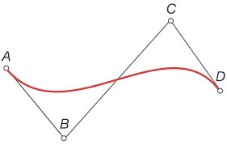
In computer graphics bezier curves are used to create smooth curves, which scale (ie look the same how close or how far you zoom). They are created using two anchor points, for where the curve starts and ends, and intermediate control points which bend the curve. The control points can be thought of as pulling on the curve towards them.

In the illustration to the right, points A and D are the anchor points, and B and C are the control points. Notice how the curve pulls towards B and C, which caused the wave like shape.

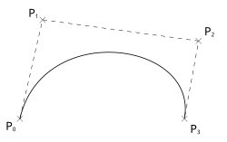
The tkinter command is
create_line (x₁, y₁, p₁, q₁, …x₂, x₂, smooth= " true" )
where x, y refer to the anchor points and p, q refer to the control points.
smooth = “true” starts a computational technique to draw curves called Bezier curves, which uses math to smooth out the line between the anchor points
There can be 1 to many (limit is unknown) control points.

Custom Colours

However, you can use custom colours too. Custom colour definitions will require using hexadecimal numbers, which can be found at this useful webite: https://www.color-hex.com.

You can pull up the colours using the down arrow, then use the visual tools to choose a colour. The hexadecimal number describing the selected colour appears in the drop list window.
In the example, the hexadecimal number is #E01B4C. The number refers to the Red-Green-Blue colour model. The first two hex digits (E0) refer to the decimal number 224, meaning 224 of Red, out of a scale running to 255. Similarly, 1B means 27 of Green, and 4C means 76 of Blue.

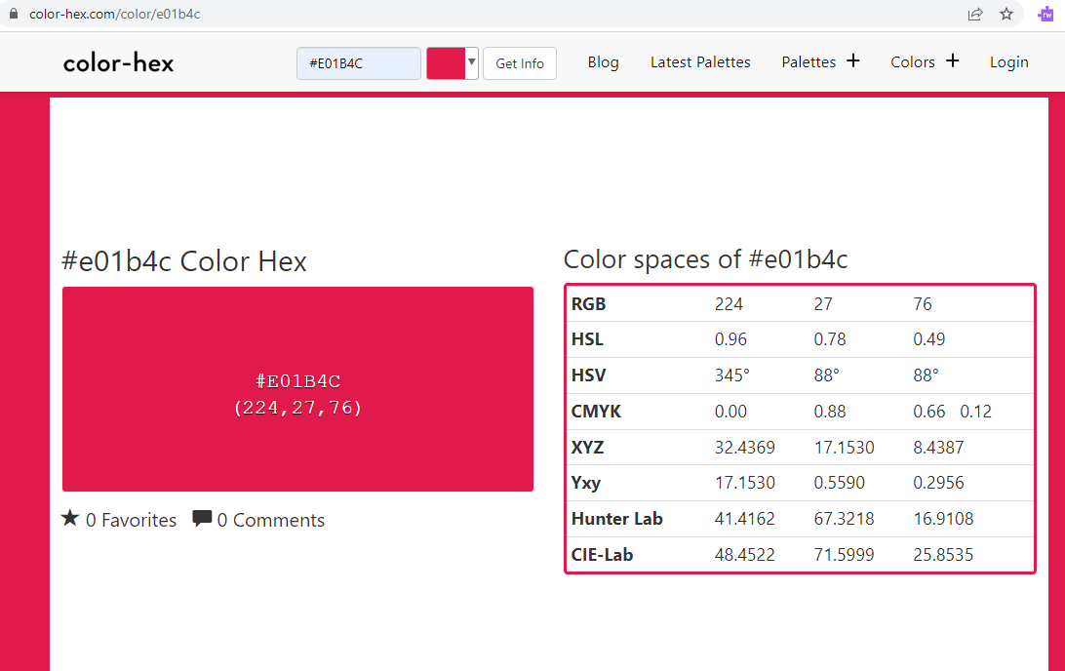
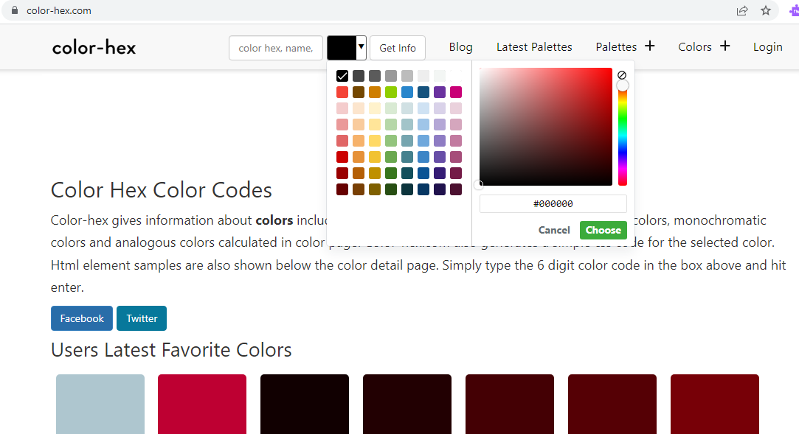

To use in Python:
- Define the colour as a string
- Use the string like a default colour

For example,

DARK_ROSE = “#E01B4C”
:
…(…, bg = DARK_ROSE) #This sets the background to DARK_ROSE; more on “bg” later

Curves and Custom Colours

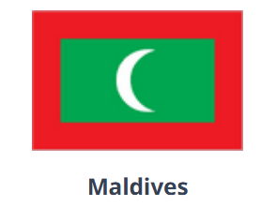
06.01b.01
Find a flag of the world that has simple geometric shapes and write a program to draw it, trying to match the colours.
Eg Bangladesh Guyana Maldives
Kiribati (focus on the waves – just do simple rough shapes for the top images)

06.01b.02
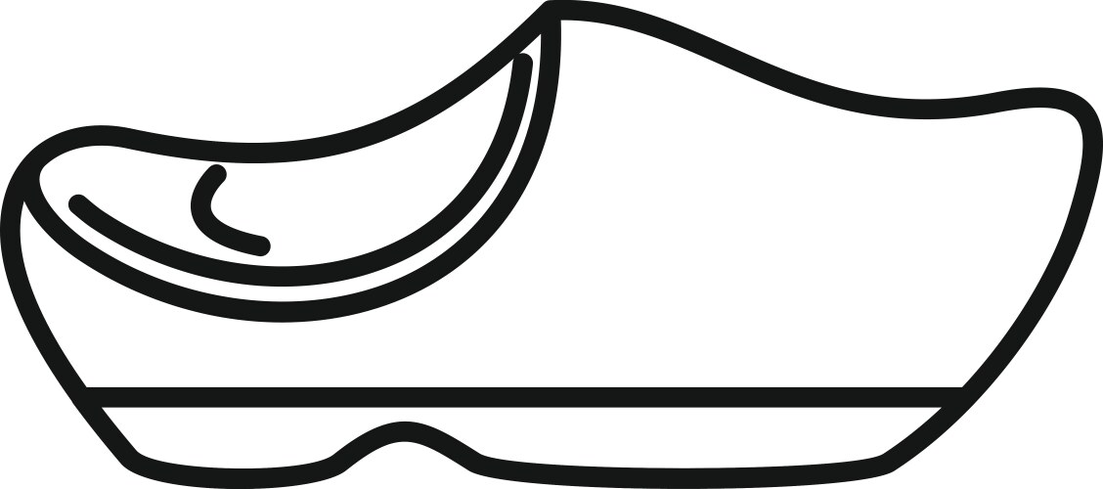
Write a program to draw the outline of a Dutch wooden shoe. You can choose how many curves to use.

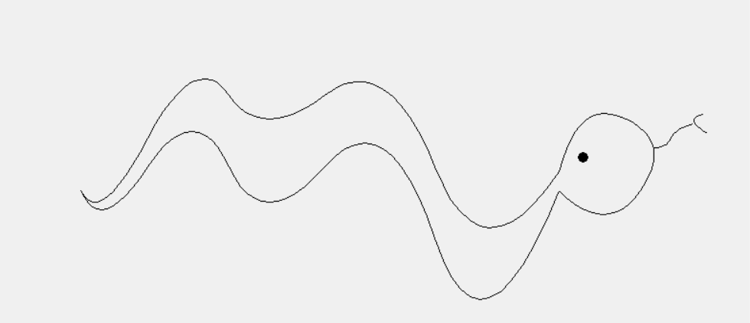
06.01b.03
Write a program to draw a snake with at least 4 curves in its body.
Similar to the picture below.

06.01b.04
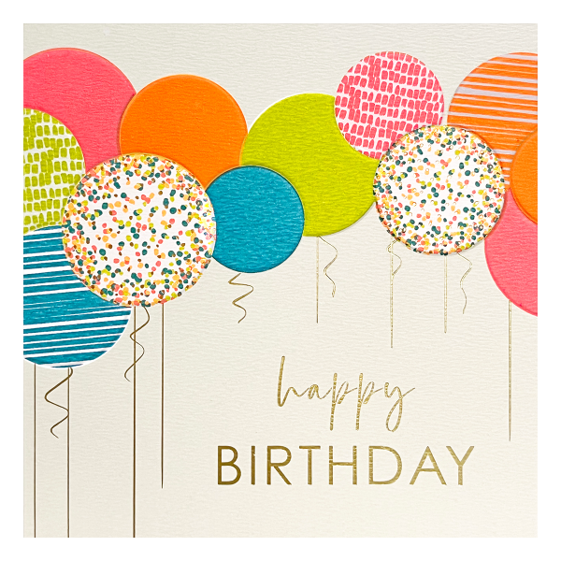
Write a program that draws a birthday card similar to the one illustrated. Draw it with
- 4 balloons of different sizes
- colour each with different custom colour
- add some decoration to one balloon
- add strings, some straight, some curly

