Introduction to working with Files

Back at the start of the course, a computer was defined as having 4 capabilities: receive input, produce output, process data, and store data in memory.
INPUT
PROCESSING
OUTPUT
MEMORY

Memory is categorized as volatile (primary) and non-volatile (secondary). When programs are running and using variables and performing calculations the data is kept in volatile memory or RAM. When a program is done, or if the program is interrupted unexpectedly, that data is lost.

To be saved permanently, data is stored in non-volatile memory – permanently means stored after the program ends, or if the program is interrupted unexpectedly. A basic way of storing data permanently in files – and these files can be stored locally on your computer on a hard drive or USB drive, or somewhere on a network drive or over the internet in a cloud drive (often just referred to as “the cloud”).

Advanced note: In computer science permanence of data is also referred to as “persistence”.

Opening, closing and file modes

By default, Python (and other languages) look for files in the same folder where the program is. This course will use the same default. Further, the course will use text files ie files will end with *.txt, and contain only text characters. It means when creating test files, notepad or some other text based editor should be used, not a word processor like Word or Google Docs.

A program must indicate that the file will be opened. When opening a file, the program needs to indicate if the file is to be opened in read, write, or append mode.
- “read” means the file can only be read from.
- “write” means the file is only being written to – any pre-existing file with that name will be deleted.
- “append” means the file is being written to - existing data will retained and new data is appended to the end. Files can also be both read and written/appended to.

Finally, after a file is done with, it must be closed.

For this introduction, the programs will work with text files, meaning the files have *.txt extensions. The characters are stored in UNICODE, which are the default for many programs. Recall that files can be stored using different proprietary formats or encoding, like *.doc for MS Windows. A program trying to read a *.doc file would need to know how the data was encoded.

The example program, “06_02_example_a.py” opens two files, counts the number of lines in one file (by reading the line), then writes the total to another file. Both files are then closed. The source code is as follows:

line 1: counter = 0

line 2: file_in_name = "test_input.txt" #name of file to input data
line 3: file_out_name = "test_output.txt" #name of file to receive output data
#notice the “txt” extensions

line 4: input_file = open (file_in_name, "r") #opens files for reading in
line 5: output_file = open (file_out_name, "w") #appropriate modes

#Attempt to read first line from file
#If there is no file, we have an empty string
line 6: line_read = input_file.readline()

line 7: while line_read != "": #validates for an empty string
line 8: counter += 1
line 9: line_read = input_file.readline ()

line 10 result_message = "Number of lines read is " + str(counter)
line 11: output_file.write(result_message) #write is like print but to a file
#and not to the console

line 12: input_file.close() #cleans up memory usage
line 13: output_file.close()

line 1: The program counts the number of lines in a file. The counter variable is initialized here.
lines 2, 3: The input and output files’ names are stored in variables. Note that the file extension must be given.

line 4: The open function’s first parameter is the name of the file to open. The second parameter indicates the mode - how the file is to be used by the program. Here, “r” means the file “text_input.txt” will only be read from. The program cannot write to it.
If the input file does not exist, then a runtime error will occur.

line 5: Similar to line 4 but the second parameter, “w” indicates the file can be written to. However, it cannot be read from. The file “text_output.txt” does not need to exist – the program will create the file. If the file does already exist, it will be deleted first before the program starts to write new things to it.

line 6: Once a file is open, the program reads a first line using readline(). This command reads an entire line until the end-of-line character. Recall in past programs we could explicitly print to the UI “\n” which causes a new line to print out. When working with files, the program needs to know that files end with this invisible character and deal with it accordingly.
Note there are other commands which read from (and write to) files, but they behave differently.

lines 7 – 9: This is the heart of the processing algorithm – counting the number of lines in a file.
A separate readline() before the loop (ie line 6) performs an initial read of the contents of the file; subsequent reads are in the loop itself. This approach is similar to past programs which read input directly from the console.
When the file is finished, the last readline() will read nothing, and stores an empty string in the variable ”line_read”. Line 7 checks for this as the condition to end the loop.

Lines 10, 11: The usually end of loop processing.

Lines 12, 13: When done, the program must call the close() function to close the file. A common mistake is to forget to close a file, which has some technical consequences. One consequence is the output file will not save the things written to it.

Note that many internet examples use the “with” command when working with files. By convention, the course does not allow it.

Reading a line

There are other methods of working with files and functions to read. Using the readline() and write() functions is a basic technique that works with each line read in the input file as 1 datum (singular for data). That is, a line is defined as one string until there is a newline character (\n”). Everything up to and including the newline character is one string.

For example, if the following 3 lines are the entire contents of a file, then a program needs to execute readline() 3 times to read all the contents (4th readline() will return an empty string which indicates the end of the file has been reached).
The quick brown fox jumped over the
Lazy
Calico cat

Newline characters

So far we have looked at processing whole lines. If we want to process the actual contents or value in the lines, we need to be aware of the invisible newline character. When reading a file that contains lines, for example,

one
two
three

the first two lines end with a newline character “\n”. A user will not see the character, but it is the last character in the string read by readline() and must be coded for.

For example, the first readline() executed means we are dealing with
one\n <-- the “\n” is invisible to people but not to the computer
and not just
one

But we would rather code to work with “one” rather than “one\n”. To do so, we can remove the newline character using the *.strip() function/method.

For example,
line_read = input_file.readline()
line_read = line_read.strip(“\n”)

This code reads in the line which includes the newline character, then immediately removes the newline character.

Since most programs will want to work with the contents of the lines, rather than just count lines, this function will probably be needed for most programs.

String input

After stripping the newline char, the program then has a string input that it now can process just like console programs that read input using input(). In other words, data type conversion will be necessary as appropriate.
See “06_02_example_b.py” for an example.

Parsing (lines with more than 1 item)

Earlier the idea of parsing was introduced with dealing with console input, via the “input” command, which sees everything on the console command line as 1 string. Then the *.split() command was used to parse individual items into a list. Since readline () also brings input into the program as 1 string *.split () can also be used to parse lines read from a file.

Two templates are provided:
06_02_template_strip.py
06_02_template_split.py

The first uses *.strip(), for situations where the details of a line do not matter.
The second uses *.split () for situations where individual words of a line matter.
06_02 Files Exercises

Can skip validations, but do look for modularity for practice, where possible.

06_02_01
Modify the example program “06_02_example_a.py” and:
- change the “w” parameter to “a” (this will append new output to an existing file)
Execute the program on the same input file “test_input.text” 4 times.
Look at the contents of the output file “test_output.txt”.
- modify the program in i) to print a newline character at the end of the line:
ie. result_message = “Number…”
Delete the output file “test_output.txt”.
Execute the program on the same input file “test_input.text” 4 times.
Compare the contents of the output file from i) and ii)

06_02_02
Create an input file with a colour (or some other set of items, like sports teams) on each line, repeating colours, for example,
red
blue
blue
red
white
yellow
blue
Write a program that loops through the file. For each colour that is not “red”, print out a statement similar to
“Blue is not red”, etc,

Keep a count of the number of time “red” is in the file, and the number of times any other colour than “red” is in the file. When the loop finishes, print out a summary of the counts.
For example, “Red appeared 2 times, while colours other than red appeared 5 times”
Do not worry about repeats of the non-red colours.

06_02_03
Write a progam to read a file which contains a score out of 100, one score on each line. When the file is completely read, calculate the average of the scores and write in a file, using “w”. The program does not know how many scores are contained in the file. The input file should look like:
56
23
2
:

06_02_04
Write a program that
- reads all the words contained in a file
- there is one word per line in the file
- once the file is read, the program will prompt the user for a number
- the program will then form phrases from the words by concatenating words together
- the number of words concatenated will be the number entered by the user
- if the last phrase cannot be fully formed, print out what was possible, along with a message indicating there were not enough words
- output is to another file

06_02_05
Write a program that will read the data from the file “06_02_05_max_min.txt”. There are two columns of numbers in the file. The program should find the maximum number from the first column, and the minimum from the second. An appropriate message should be printed at the end.

Appendix : More on file location

Location of files

The course will deal with locating files on the local computer, using the file system used on the hard drive. A file system is a method by which an operating system organizes and manages the files on the computer’s drives. (Reminder that this course focuses on computers using the Windows operating system).

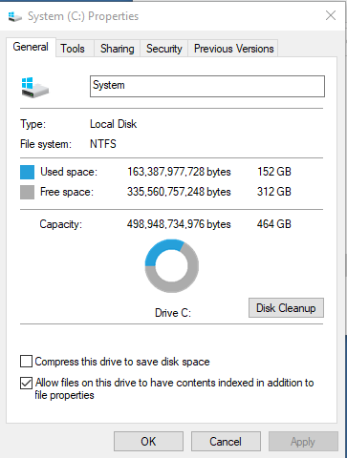
Advanced note: There are two basic file systems, FAT32 (File Allocation Table 32 (bit) ) and NTFS (NT File System). You can check which system your computer is using by pulling up the File Explorer, displaying the C: drive, and viewing the Properties of the C:. The FAT23 is the older and simpler system; the NTFS allows for additional features such as more control over file permissions and can manage larger files and manage the disk mor efficiently.

Network drives are conceptually similar to local file systems. But internet (cloud) file and document management is very different and is not part of the course.

There are a couple of things to understand about working with files. A program must know the name of the files being used. And a program must know where that file is located on the computer system.

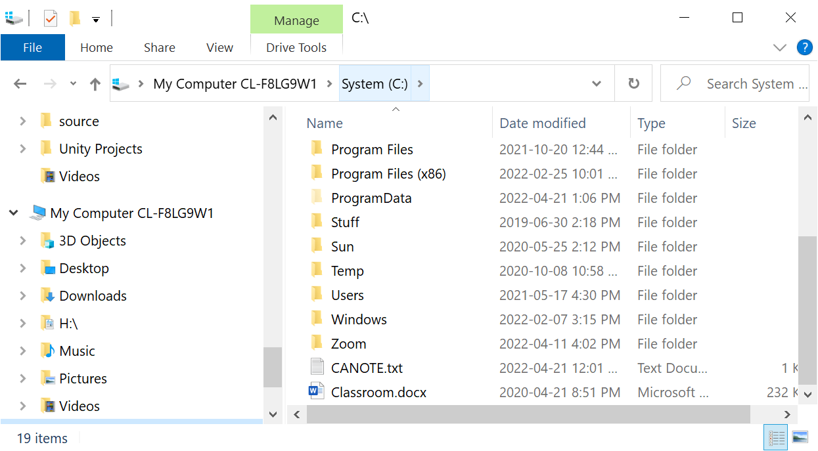

(The picture shows how my C: drive looks like with folders and some files)

By default, a program looks in the folder where the program itself resides for files.

For example, the program first_example.py, which is in the folder C:\User Programs\Python programs will look in C:\User Programs\Python programs for files to work on. If first_example.py works with data_file.txt, then the files should be places like this:

C:\User Programs\Python programs\first_example.py
C:\User Programs\Python programs\data_file.txt

For cloud-based users, it will depend on the editor. For replit.com, the source code itself is written exactly as we will describe. However, the external data files (ie the *.txt files) are created using a Add File button (1) on the replit.com itself. It appears in the file list on the left (2). Clicking on that file allows you to work on that file in the edit pane (3).

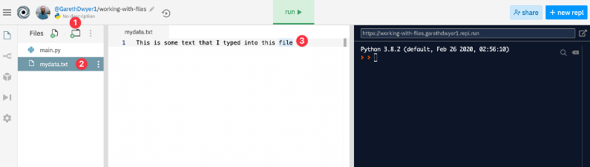

Programs can be written to look elsewhere for files to work with but that is beyond the scope of this course. This course will strictly work with files located in the same folder as the *.py file.

When you open the file explorer to look at the file structure, you will see something different at home and at school. At home, on personal computers and laptops, you generally will work with folders directly off the root folder C:. eg C:\Timmy\
By contrast, on school computers, since many people use a single computer, the folders are often organized under a user’s folder, then student ID. Eg C:\Users\1234567.

When using a USB drive, the drive is given another driver letter, like D: or E:.

Optional: See the end of this lesson for a little more information about locating files.

In general, when a program searches for a file, if a specific directory is not specified, the default search plan is to search in the folder where the program resides.
If the file is not found there, then the program will use the operating system environment variable PATH to locate the file. You can see what is stored in PATH by:
1) clicking on the “Search Windows” icon on the lower left corner of Windows
2) enter CMD
3) execute CMD to get to a console window
4) enter PATH


Below to the right is an example of the contents of PATH. It contains many directory paths – the program will search each of these directory paths to find the file.

