**Software Requirements Specification**

**for**

**Ultra Air**

**Version 1.0 approved**

**Prepared by:**

**Ivanov Timofey**

**Zarudko Ignat**

**Parhomenko Heorhi**

**BSU, MMF**

**17.05.2020**

**Minsk 2020**

**Contents**

**1. General information** 3

**2. Application purposes** 3

**3. Types of users and subsystem functions** 3

**System users** 3

**4. Users and their description** 4

**4.2 Use case diagram** 4

**4.2 Use cases** 4

*A. Guest* 4

*B. Client* 7

*C. Admin* 12

**5. Application Layouts:** 15

**5.1 Application Login Page** 15

**5.2 Application Home** 15

**5.3 Filling in information when buying a ticket** 16

**5.4 Confirm ticket page** 17

**5.5 Manage flights page** 18

**6. System description** 19

**6.1 Backend class diagram** 19

**6.2 Frontend class diagram** 19

**7. Deadlines and execution plan** 20

1. **General information**

Application "**Ultra Air**" - a service that provides the opportunity to buy tickets for the flight you need.

This site is intended for people who value their time and want to buy tickets for the aircraft of interest to them with maximum comfort.

  Having bought a ticket, you will instantly receive it by e-mail, and you can also add it to your electronic wallet and you will not waste time searching for it in the future.

1. **Application purposes**

The application provides the following features:

1. Authorization and registration;
2. View all available tickets;
3. Selecting the ticket, you are interested in;
4. Online payment for tickets.
5. **Types of users and subsystem functions**

## **System users**

|  |  |  |
| --- | --- | --- |
| № | User | Description |
| 1. | Guest(unregistered user) | Can view available tickets, but can’t buy them, can also register or login |
| 2. | Client | Can view and order tickets |
| 3. | Administrator | Сan do all what Client does and also has the ability to control flights (add, delete). |

# **4. Users and their description**

## **4.2 Use case diagram**

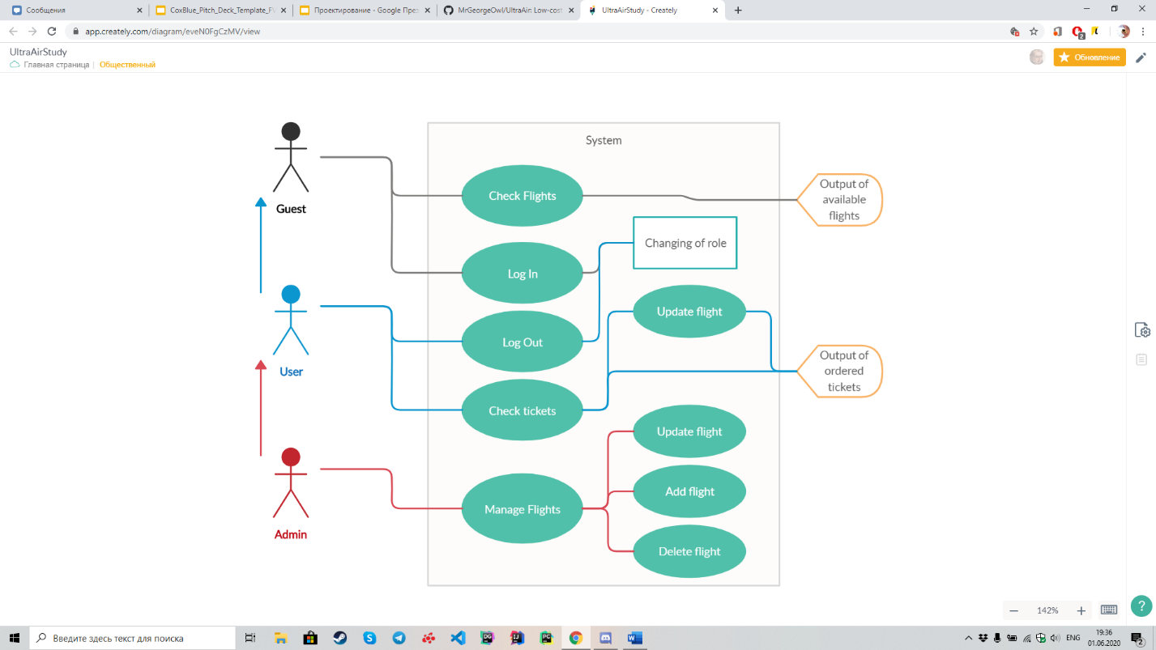

Pic. 4.1 Use case diagram

## **4.2 Use cases**

### *A. Guest*

*Use Case – Register (Guest)*

**Briefly**

|  |  |
| --- | --- |
| **Property** | **Description** |
| Actor | Guest |
| Goal in context | Register in system |
| Trigger event | Need to register |
| Pre-condition | - |
| Success | New User is Registered |
| Fail | Refusal to register with reasons |

**Main scenario**

|  |  |  |
| --- | --- | --- |
| **Step** | **Actor** | **Description** |
| 1 | Guest | Presses the “Register” button |
| 2 | System | Gives a registration form |
| 3 | Guest | Fills in the fields: |
|  |  | 1. Login |
|  |  | 2. E-mail |
|  |  | 3. Password |
|  |  | 4. Repeat password |
|  |  | Press the “Submit” button |
| 4 | System | Validating fields. If success, new user is registered |
| 5 | System | Sends confirmation email |

**Extension**

|  |  |  |
| --- | --- | --- |
| **№** | **Variations** | **Possible variations** |
| 3.1 | Required fields are empty | Application highlights empty fields, asks to fill them |
| 3.2 | Fields are filled incorrectly | Application highlights incorrect fields, offers to fix: |
|  |  | a. Such login already exists |
|  |  | b. This email doesn’t exist/is already taken |
|  |  | c. The re-password doesn’t match the password itself |

*Use case – View air tickets (Guest)*

**Briefly**

|  |  |
| --- | --- |
| **Property** | **Description** |
| Actor | Guest |
| Goal in context | Choose a suitable ticket |
| Trigger event | View available tickets |
| Pre-condition | - |
| Success | Ticket found |
| Fail | Ticket not found |

**Main scenario**

|  |  |  |
| --- | --- | --- |
| **Step** | **Actor** | **Description** |
| 1 | Guest | Presses the “Catalog” button |
| 2 | System | Redirects to a catalog page |
| 3 | Guest | Chooses a ticket |
| 4 | System | Redirects to a Login/Register page (only authorized user can order tickets) |

### *B. Client*

*Use Case – Login (Client)*

**Briefly**

|  |  |
| --- | --- |
| **Property** | **Description** |
| Actor | Client |
| Goal in context | Login to the system |
| Trigger event | Need to login |
| Pre-condition | Need to book a ticket/View booked |
| Success | Client is authorized |
| Fail | Refusal to login with reasons |

**Main scenario**

|  |  |  |
| --- | --- | --- |
| **Step** | **Actor** | **Description** |
| 1 | Client | Presses the “Login” button |
| 2 | System | Gives a login form |
| 3 | Client | Fills in the fields: |
|  |  | 1. Login or E-mail |
|  |  | 2. Password |
|  |  | Press the “Login” button |
| 4 | System | Validating fields. If success, Client is authorized |

**Extension**

|  |  |  |
| --- | --- | --- |
| **№** | **Variations** | **Possible variations** |
| 3.1 | Required fields are empty | Application highlights empty fields, asks to fill them |
| 3.2 | Fields are filled incorrectly | Application highlights incorrect fields, offers to fix: |
|  |  | a. Login or E-mail and/or Password are incorrect |

*Use Case – View air tickets (Client)*

**Briefly**

|  |  |
| --- | --- |
| **Property** | **Description** |
| Actor | Client |
| Goal in context | Choose a suitable ticket |
| Trigger event | View available tickets |
| Pre-condition | - |
| Success | Ticket found |
| Fail | Ticket not found |

**Main scenario**

|  |  |  |
| --- | --- | --- |
| **Step** | **Actor** | **Description** |
| 1 | Client | Presses the “Catalog” button |
| 2 | System | Redirects to a catalog page |
| 3 | Client | Chooses a ticket |
| 4 | System | Redirects to a ticketing page |

*Use Case – Ticketing (Client)*

**Briefly**

|  |  |
| --- | --- |
| **Property** | **Description** |
| Actor | Client |
| Goal in context | Order a ticket |
| Trigger event | Need to order a ticket |
| Pre-condition | Client is authorized |
| Success | Ticket is booked |
| Fail | Refusal of order with reasons/Cancelled by client |

**Main scenario**

|  |  |  |
| --- | --- | --- |
| **Step** | **Actor** | **Description** |
| 1 | Client | Presses the “Order” button on concrete ticket |
| 2 | System | Gives a form with info about ticket |
| 3 | Client | Fills in the fields: |
|  |  | 1. If client want to be first on registration, sitting |
| 5 | System | Calculates ticket’s price based on entered data |
| 4 | Client | Presses the “Order” or “Cancel” button |
| 5 | System | Confirms/Cancels booking |

*Use Case – View ordered tickets (Client)*

**Briefly**

|  |  |
| --- | --- |
| **Property** | **Description** |
| Actor | Client |
| Goal in context | View ordered tickets |
| Trigger event | Need to view ordered tickets |
| Pre-condition | Client is authorized |
| Success | Displaying ordered tickets |
| Fail | Error |

**Main scenario**

|  |  |  |
| --- | --- | --- |
| **Step** | **Actor** | **Description** |
| 1 | Client | Presses the “My tickets” button at his profile page |
| 2 | System | Returns a list of ordered tickets |

**Extension**

|  |  |  |
| --- | --- | --- |
| **№** | **Variations** | **Possible variations** |
| 3.1 | Ticket list is empty | Application returns a message “Empty list” instead of list itself |

*Use Case – Logout (Client)*

**Briefly**

|  |  |
| --- | --- |
| **Property** | **Description** |
| Actor | Client |
| Goal in context | Client becomes a Guest |
| Trigger event | Need to logout |
| Pre-condition | Client is authorized |
| Success | Client is logged out |
| Fail | Error |

**Main scenario**

|  |  |  |
| --- | --- | --- |
| **Step** | **Actor** | **Description** |
| 1 | Client | Presses the “Logout” button at his profile page |
| 2 | System | Authorizes Client as a Guest |

### *C. Admin*

*Use Case – Login (Admin)*

**Briefly**

|  |  |
| --- | --- |
| **Property** | **Description** |
| Actor | Client |
| Goal in context | Login to the system |
| Trigger event | Need to login |
| Pre-condition | Need to User abilities + flight management (Add, Delete, Edit) |
| Success | Admin is authorized |
| Fail | Refusal to login with reasons |

**Main scenario**

|  |  |  |
| --- | --- | --- |
| **Step** | **Actor** | **Description** |
| 1 | Admin | Presses the “Login” button |
| 2 | System | Gives a login form |
| 3 | Guest | Fills in the fields: |
|  |  | 1. Login or E-mail |
|  |  | 2. Password |
|  |  | Press the “Login” button |
| 4 | System | Validating fields. If success, Admin is authorized |

**Extension**

|  |  |  |
| --- | --- | --- |
| **№** | **Variations** | **Possible variations** |
| 3.1 | Required fields are empty | Application highlights empty fields, asks to fill them |
| 3.2 | Fields are filled incorrectly | Application highlights incorrect fields, offers to fix: |
|  |  | a. Login or E-mail and/or Password are incorrect |

*Use Case – Flight Management (Admin)*

**Briefly**

|  |  |
| --- | --- |
| **Property** | **Description** |
| Actor | Admin |
| Goal in context | Go to the flight management menu |
| Trigger event | Need to manage flights |
| Pre-condition | Admin is authorized |
| Success | Redirecting to Flight management page |
| Fail | Error |

**Main scenario**

|  |  |  |
| --- | --- | --- |
| **Step** | **Actor** | **Description** |
| 1 | Admin | Presses the “Manage Flights” button |
| 2 | System | Returns flights list with buttons “delete” for each flight, and button “Add flight” at the end |
| **3. Adding** |  |  |
| 3.1 | Admin | Presses “Add Flight” button |
| 3.2 | System | Returns adding flight form |
| 3.3 | Admin | Fills in the fields: |
|  |  | a. Departure city |
|  |  | b. Arrival city |
|  |  | c. Departure date |
|  |  | d. Arrival date |
| 3.4 |  | Presses “Add” button |
|  |  |  |
| **4. Delete** |  |  |
| 4.1 | Admin | Presses “Delete Flight” on certain flight |
| 4.2 | System | Deletes certain flight |
| **5. Edit** |  |  |
| 5.1 | Admin | Presses “Edit Flight” on certain flight |
| 5.2 | System | Transforms “Add flight” form into “Edit flight” form, fulfills fields with info about current flight |
| 5.3 | Admin | Edits fields |
| 5.4 | Admin | Presses “Edit” button |
| 5.5 | System | Edit certain flight |

**Extension**

|  |  |  |
| --- | --- | --- |
| **№** | **Variations** | **Possible variations** |
| 3.1/5.1 | Required fields are empty | Application highlights empty fields, asks to fill them |
| 3.2/5.2 | Fields are filled incorrectly | Application highlights incorrect fields, offers to fix: |
|  |  | a. City in unavailable for flights |

# **5. Application Layouts:**

## **5.1 Application Login Page**

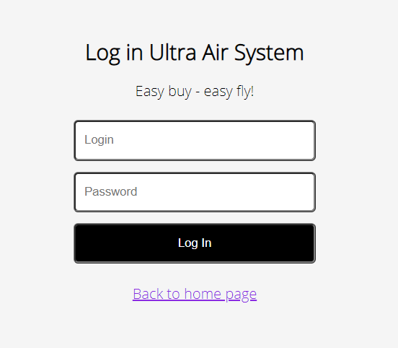

Pic. 5.1

## **5.2 Application Home**

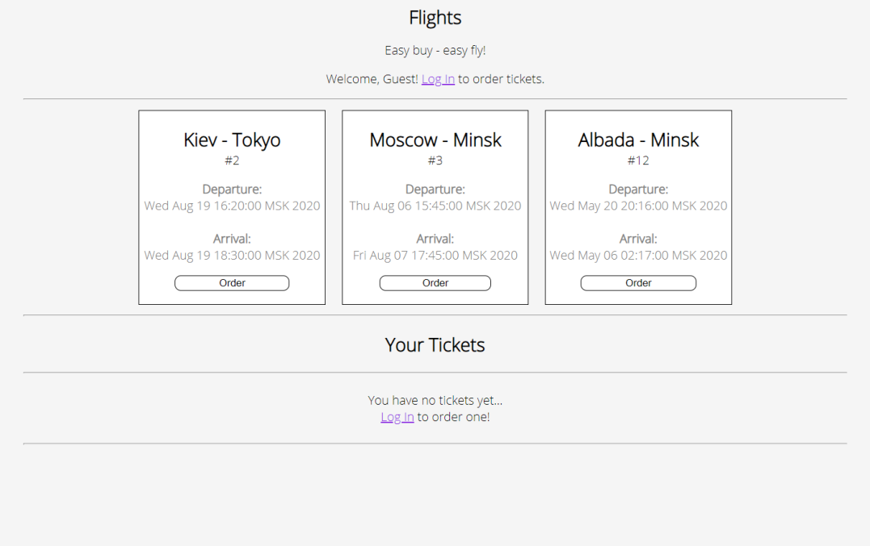

Pic. 5.2

## https://media.discordapp.net/attachments/687968972607455389/717089262335688824/unknown.png?width=541&height=676**5.3 Filling in information when buying a ticket**

Pic. 5.3

## **5.4 Confirm ticket page**

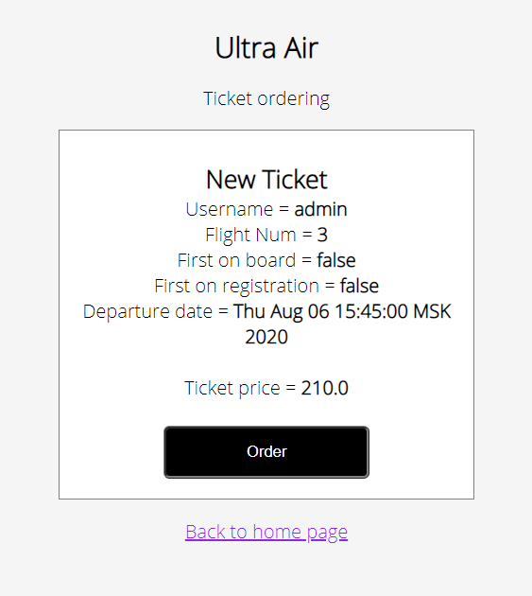

Pic. 5.4

## **5.5 Manage flights page**

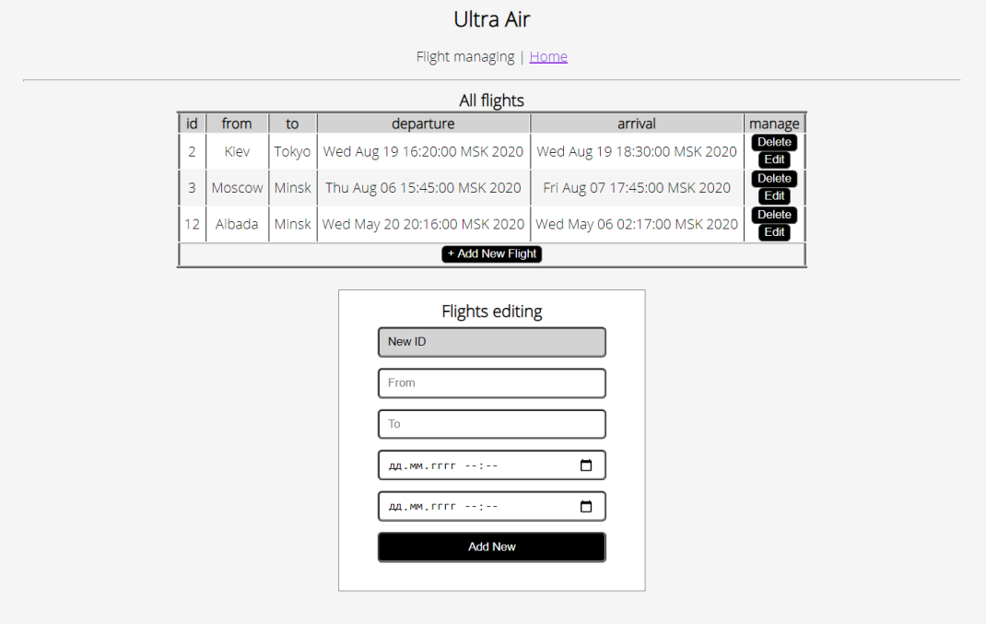

Pic. 5.5

**6. System description**

**6.1 Backend class diagram**

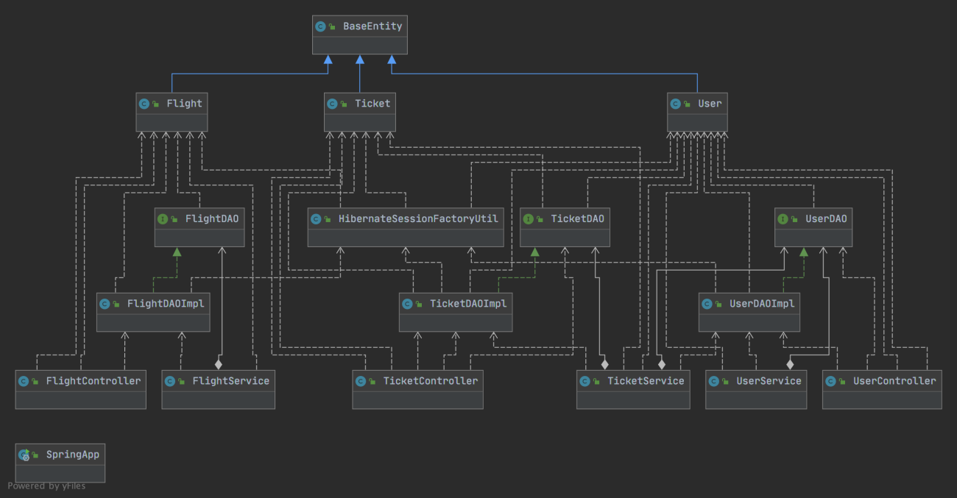

Pic. 6.1

**6.2 Frontend class diagram**

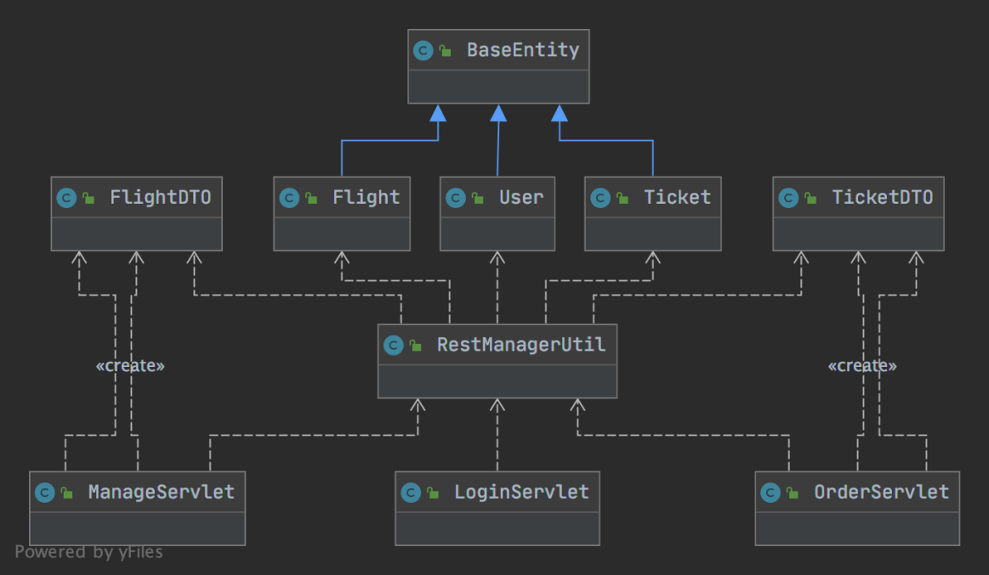

Pic. 6.2

**7. Deadlines and execution plan**

|  |  |
| --- | --- |
| **Development stage** | **Deadline** |
| Basis | 29.03.2020 |
| Diagram | 12.04.2020 |
| Use Stories | 12.04.2020 |
| CI | 19.04.2020 |
| Unit Testing | 19.04.2020 |
| Design | 26.04.2020 |
| Clean Code | 26.04.2020 |
| UML | 17.05.2020 |
| Presentation | 17.05.2020 |
| Docs | 17.05.2020 |