**Part B: Epipolar geometry and 3D reconstruction**

1. Example "house":

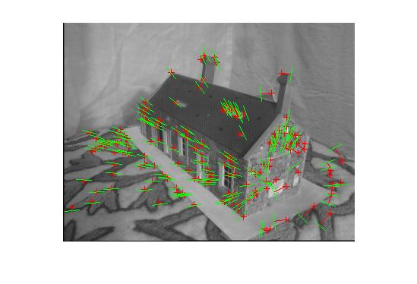

+ Matched points in both images

__ Epipolar lines

__ Distance between matched point and epipolar line

Residual: 3.0342

2. Example "house" perspective 1:

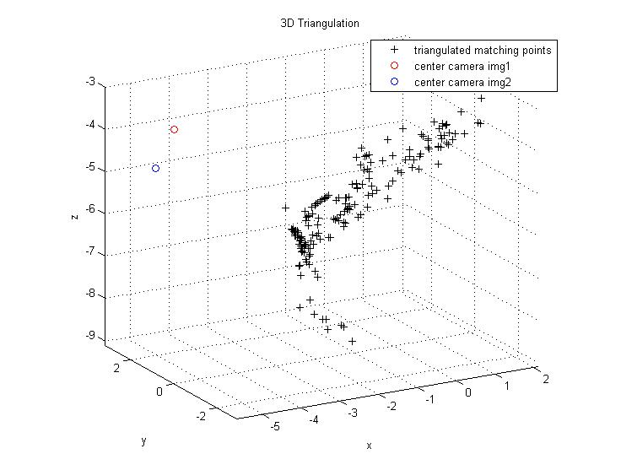

2. Example "house" perspective 2:

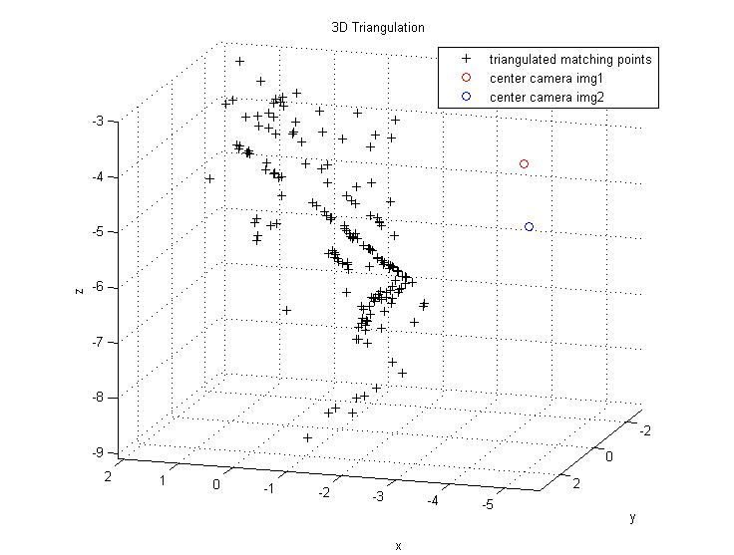

1. Example "library":

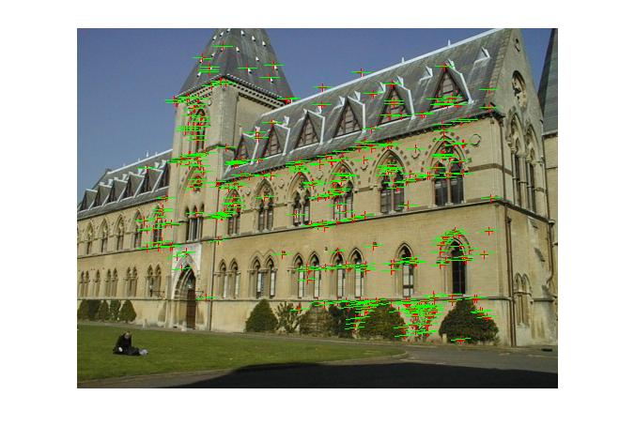

+ Matched points in both images

__ Epipolar lines

__ Distance between matched point and epipolar line

Residual: 0.3385

2. Example "library" perspective 1:

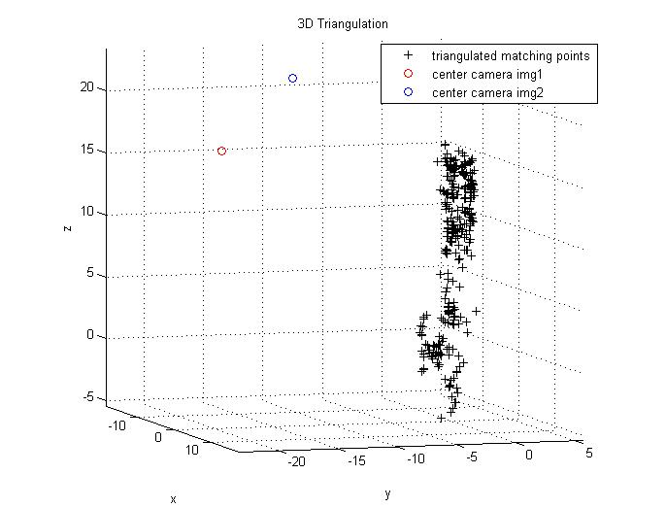

2. Example "library" perspective 2:

