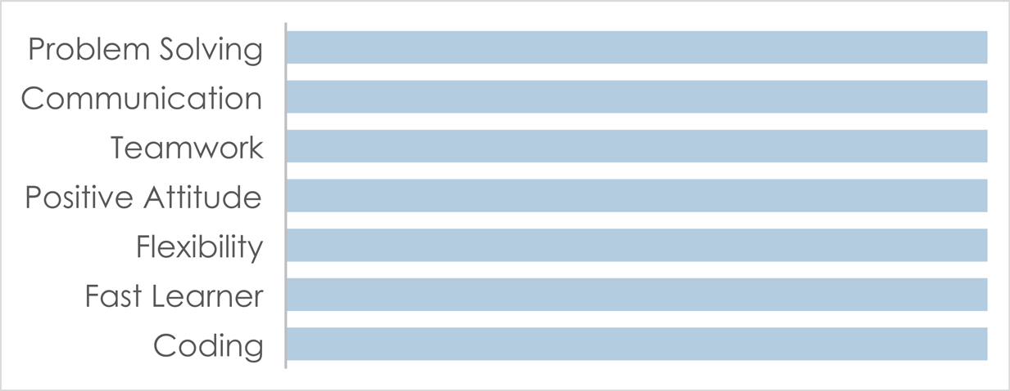

# PROFILE

Enthusiastic Software Engineer eager to contribute to team success through hard work, attention to detail and excellent organizational skills. Clear understanding of Programming and Coding. Motivated to learn, grow and excel in the field of Software Engineering.

# DATE & PLACE OF BIRTH:

**04/09/1998 – Irbid, Jordan**

# NATIONALITY: Jordanian CONTACT

PHONE:

+962789336602

EMAIL:

[m.banifawaz@outlook.com](mailto:m.banifawaz@outlook.com)

# LANGUAGES

English German Arabic

# SOFTWARE SKILLS

C#

Unreal Engine

Unity

Linux

Kali Linux

Ubuntu

Manjaro

Node.js

Laravel

React

Frappe

Jinja

ERPNext

Java HTML PHP CSS

.NET

Python C++

ASP.net JavaScript SQL / MySql

Ajax jQuery

Visual Basic Visual Studio VP

VB

**[GitHub Profile](https://github.com/MrGiveItAway-TPK)**

Work Experience in Next Pages

VBS

BAT

MUNES BANI FAWAZ

Software Engineer

# EDUCATION

## Philadelphia University of Jordan (Amman, Jordan)

10/2017 – 02/2021

Bachelor’s Degree in software engineering with an average of 77.6% and a rate of Very Good which in GPA is equal to 3.1 out of 4.

## First Secondary School of Abha (Abha, Saudi Arabia)

2013 – 2016

High School Diploma with an average of 96.03% which by the Jordan Equivalency Certificate is equivalent to 80.08% and certified by the Jordan Ministry of Education.

## Mecca Intermediate School (Abha, Saudi Arabia)

2010 – 2013

## Anjara Elementary School (Ajlun, Jordan)

2009 – 2010

## Robert-Koch Realshule (Stuttgart, Germany / Elementary School)

2008 – 2009

## Pfaffenwald-Shule (Stuttgart, Germany / Elementary School)

2004 – 2008

## Kinderhaus Uni-Kids (Stuttgart, Germany / Kindergarten)

2001 – 2004

# ACCOMPLISHMENTS

* Collaborated with one associate in the development of Philadelphia University Forms Project.
* Developed an interactive website for Mecca School - Abha, KSA that resulted in an increase in the human resources section of the school in matters of weeks of launch.
* Worked on many platforms and found solutions to many issues through testing and solving problems reported by individuals.
* Made various useful tools throughout the time in my university years that helped during the study a good number of individuals.

# SKILLS

**Company: Extensya**

**Title: System Development Officer**

**Experience Time: June 2021 – March 2022 (10 Months)**

-**Developer in the following:**

* PHP
* HTML
* CSS
* JavaScript
* Ajax
* jQuery
* SQL / MYSQL
* Creating Custom API’s

**-Using the following:**

* Joomla (Content Management System for publishing web content)
* FileZilla (FTP application for accessing Server)
* Navicat (Database Management and Development Software)

**-Mainly my duties in the company (Description):**

I have extensive experience working with internal systems and projects at Extensya. One of my primary responsibilities was to create and maintain web forms for quality evaluations and call logging used by clients, which included edit and password reset forms. I also edited a significant number of quality evaluation forms, working with around 40 clients on a regular basis.

In addition, I worked on various internal systems, such as the ECT system for employee announcements and feedback, online and English assessments, Extensya's chat tool for internal communication, Extensya's help desk for live agent support, and OMS as the core system that I used daily. I even led multiple projects based in the OMS System, including Headcount and DQMS Library.

For the Headcount project, I created a tool to automate the process of adding people to the company's employee database. This tool was built based on getting data from a Talent Acquisition Tool and Training Tool, and I added two new forms for adding company internal emails from the Technical IT Department and Badge Number IDs from the Human Resources Department. A third department reviewed the data before entering it into the company's database, with access to all company records to edit and change people's statuses accordingly.

For the DQMS Library project, I built a digital library for employees to access and added an uploader that worked like a file manager for adding and deleting files and folders. It also had a tree view that showed files in their respective folders for browsing content online. The tool could view PDF files, videos, images, and text files in the browser and supported formats for Google Chrome and similar browsers, and excel files could be downloaded for viewing.

I also created a custom API for retrieving data from Zendesk, which included retrieving data in the form of data object arrays and converting the data object array into JSON format, then converting the JSON data to CSV and XLS to preserve special characters and Arabic language. The data file was then sent as an Excel Sheet to the parties that needed it using PHPMAILER.

Additionally, I developed many tools and scripts to save time and effort on company-related work, such as fixing, editing, updating, debugging, and testing many things in the fields of the company's IT development process. One of the projects I led was the Procurement Tool, which aimed to manage purchases and orders for the company, replacing the paper-based system. The tool worked by creating an internal request via employees, which then went through several processes to get approved by multiple personnel. After that, it was converted into a procurement request and then a purchase order that was sent to the vendor with digital signatures. Finally, we received the delivered purchase via a vendor that was evaluated via a Receiving Form filled by the requester. The project included aspects such as email notifications, reminder emails, personnel validations, attachments to be uploaded, and prices with discounts and taxes calculation.

**Company: Nixpend**

**Title: ERP Full Stack Developer**

**Acting Role: ERP Trainer + Release Manager + Team Helper**

**Experience Time: September 2022 – December 2023 (1 Year And 4 Months)**

-**Developer in the following:**

* Frappe Framework (JS/Python)
* Python
* JavaScript
* ERPNext
* JINJA
* HTML
* CSS
* Ajax
* jQuery
* SQL / MYSQL

**-Using the following:**

* Gitlab
* VS Code
* Everything Via VS Code Command Line (Frappe, Frappe DB, Bench, Git, Linux, Python Console) – Commands

**-Mainly my duties in the company (Description):**

Almost after I started in the company for three months in getting to now healthcare solutions and pushing to become a professional, I’ve reached the following so far, I have an in-depth understanding of building, updating, and maintaining various modules and applications using ERP-NEXT/Frappe-Framework. At Nixpend, I have contributed significantly to the organization by building custom doctypes and modules with related reports and functionalities. I have also worked on building modules concerned with human resources, appointment bookings, procedures, and accounting doctypes and dimensions enhancements such as sales invoices and journal entry customization using Python and JS.

One of my notable achievements at Nixpend was building a revenue sharing module that efficiently distributes revenue amounts via invoices to healthcare practitioners sharing revenue. I have also fully upgraded our ERP/Frappe System from Version-13 to Version-14, performing necessary patches and migrations.

I have demonstrated my ability to work with various tools and technologies by creating custom APIs and integrating the system with another system called medical. I have also worked with hooks and created them using webhooks.

Furthermore, I have supervised the training of three new hires, providing them with the necessary knowledge to become self-dependent. In addition, I have created various Bash and Python scripts to streamline our work environment. These scripts include resetting Docker containers, generating SSH keys configuration, cleaning branches, managing Git push, pull, and commits, and validating any action before pushing to remote branches on Gitlab.

I’m also responsible for overseeing the process of distributing tickets and supervising the execution of updates and releases weekly. This includes reviewing and making merge requests and overseeing any open tickets from planning till production release.

Also, I have fully integrated the system with cloud services to store files with frappe/erpnext on Scaleway S3, Oracle Object Storage OCI, Google Cloud Files S3. And many more…

**Company: Syarah**

**Title: MID - ERP Full Stack Developer**

**Acting Role: ERP Trainer + DevOps Engineer + Acting Team Lead Role**

**Experience Time: December 2023 – Currently**

-**Developer in the following:**

* Frappe Framework (JS/Python)
* Python
* JavaScript
* Vue JS
* Vuetify
* ERPNext
* JINJA
* HTML
* CSS
* Ajax
* jQuery
* SQL / MYSQL
* Ubuntu
* Cloudflare
* NGINX
* AWS Cloud

**-Using the following:**

* Bitbucket
* Ubuntu
* WSL
* VS Code
* Everything Via VS Code Command Line (Frappe, Frappe DB, Bench, Git, Linux, Python Console) – Commands

**-Mainly my duties in the company (Description):**

* Giving Frappe/ERP And Python/JS Training Sessions
* Implementing Separate Vue JS Application And Supervised The Moving And Refactoring
* DevOps Services (Managing/Building/Creating Servers And Environments)
* Acting Team Lead Role In Absence Of Team Lead
* Implement Solutions Like Cloud Data Migration With Frappe/ERPNext Services
* Issues / Problem Solving
* Code Audit And Review
* Fully Upgrading Frappe/ERPNext System As Scratch From V13 to V14 to V15 + Seperating Built In Vue App
* Creating Bash Scripts To Auto Unattended Initialize A Frappe/ERPNext Clean Instance On WSL Or Ubuntu With Ability To Choose Version From Menu And Another One To Ease Developer Operations