Sequence Diagram
This diagram illustrates the interaction flow between the user and analytics components.
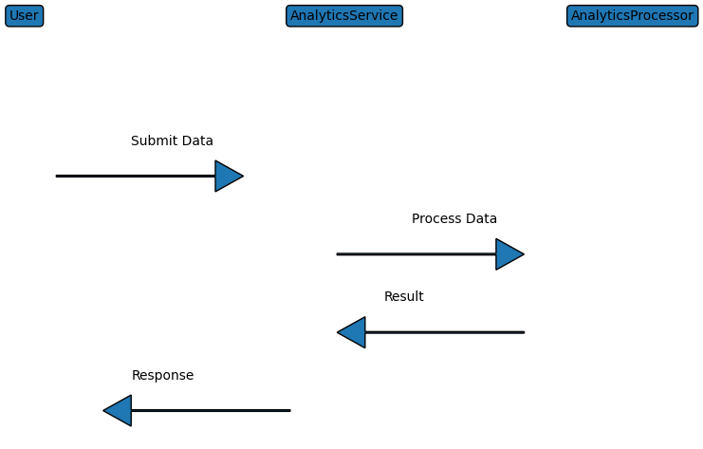

Activity Diagram
This diagram represents the workflow of analytical data processing.
