ONE-PAGE BOARD OF DIRECTORS (BOD) EXECUTIVE SUMMARY
Assignment Template:
The One-Page BoD Executive Summary
Section & Team Name: Team C (Firm C)
Student Names AND the StratSim round(s) each is presenting: Member A (C1-C2), Member B (C3), Member C (C4), Member D (C5-C6)

- the StratSim Results
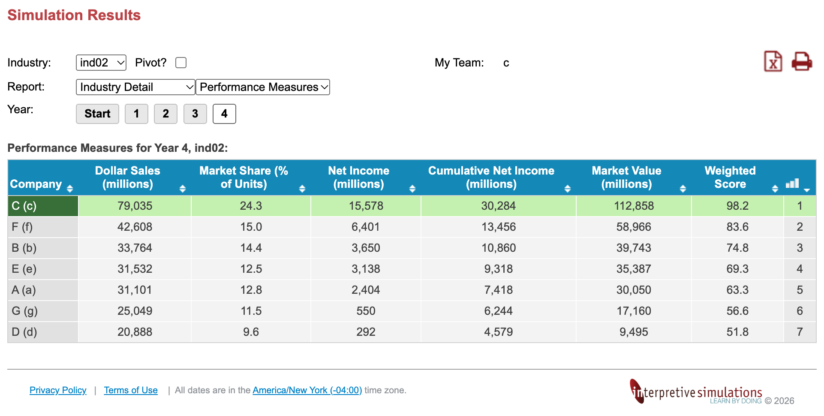
- Strategy for Exec. Summary
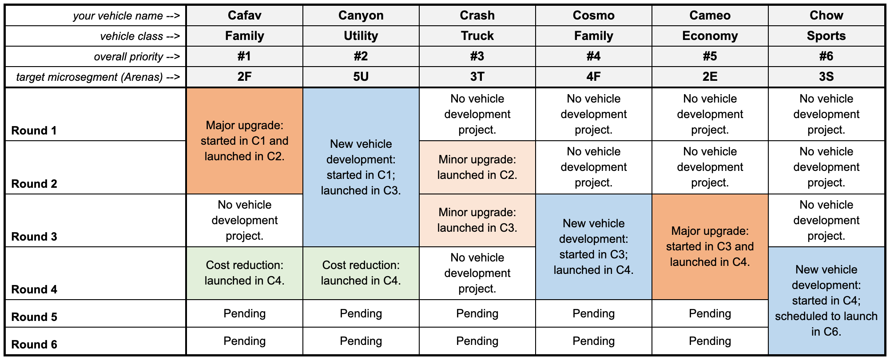
- Summary of Financial Results
