|  |
| --- |
| МИНОБРНАУКИ РОССИИ |
| Федеральное государственное бюджетное образовательное учреждение высшего образования **«МИРЭА − Российский технологический университет»**  **РТУ МИРЭА** |

**Институт информационных технологий (ИИТ)**

**Кафедра практической и прикладной информатики (ППИ)**

**ОТЧЕТ ПО ПРАКТИЧЕСКОЙ РАБОТЕ**

по дисциплине «Разработка баз данных»

**Практическое задание № 1**

|  |  |  |  |
| --- | --- | --- | --- |
| Студент группы ИНБО-01-17 | ИКБО-20-21 Савельев С.А. | (подпись) | |
| Преподаватель |  | (подпись) | |
| Отчет представлен | «23» сентября 2023 г. | |  | |

Москва 2023 г.

**Отчёт**

**Цель**: создание базы данных и таблицы в ней по теме «Каршеринг», на основе разработанных моделей.

**Результат работы:**

Разработанная модель в нотации IDEF1X представлена на рисунке 1.

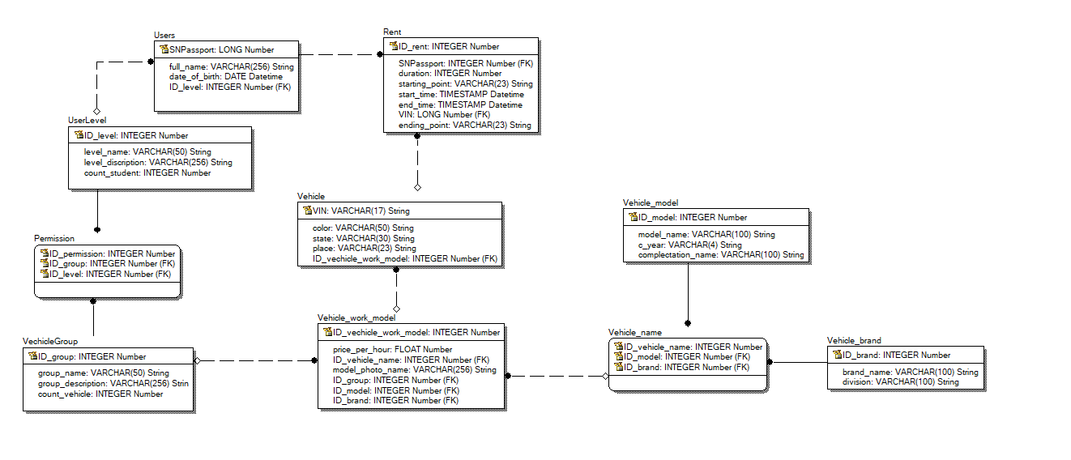

Рисунок 1 – Разработанная модель в нотации IDEF1X

Для реализации базы данных использовалась СУБД MySQL. Все последующие команды были выполнены в MySQL command line. С помощью команд была создана база данных “carsharing” и таблицы в ней, процесс создания представлен на рисунках 2-6.

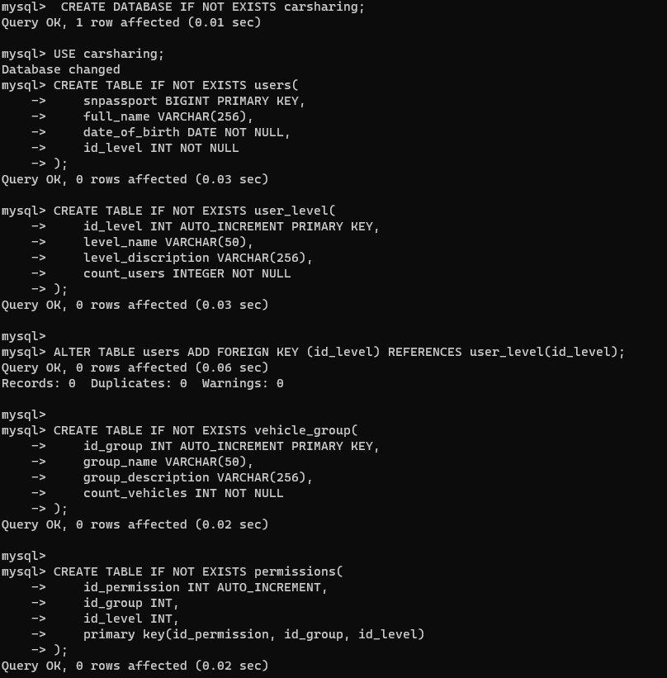

Рисунок 2 – Создание базы данных и создание части таблиц

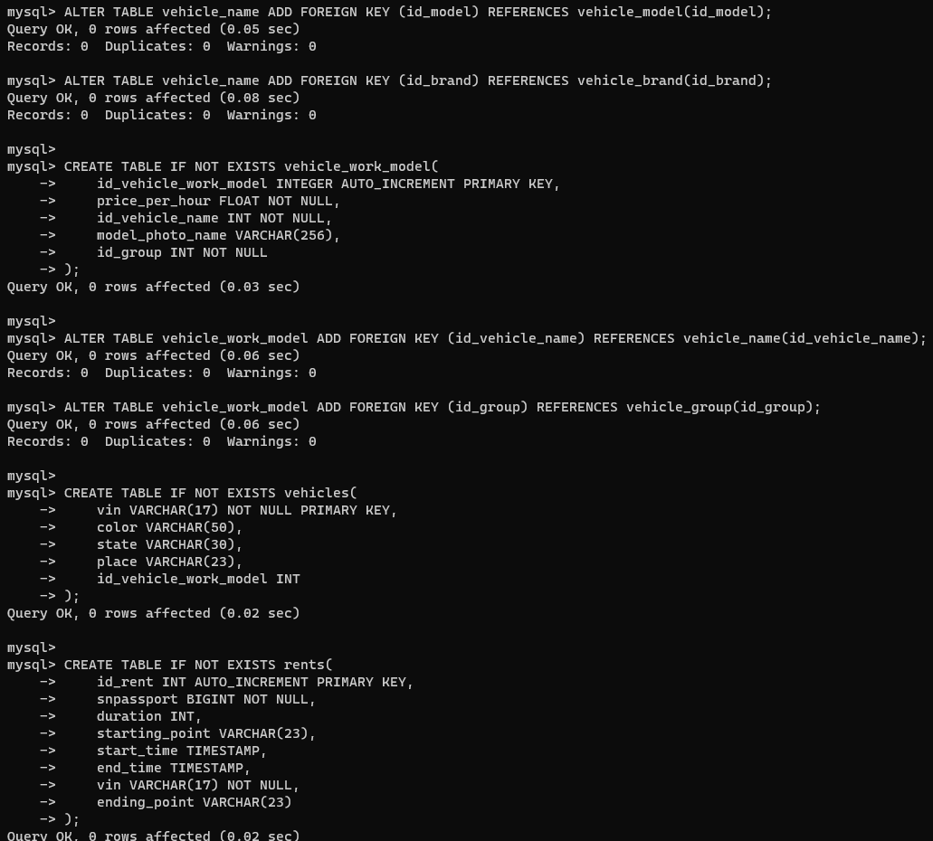

Рисунок 3 – Создание таблиц в базе данных “carsharing”

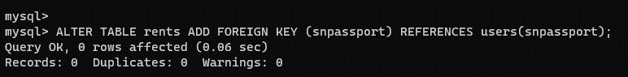

Рисунок 4 – Добавление внешнего ключа к таблицам базы данных “carsharing”

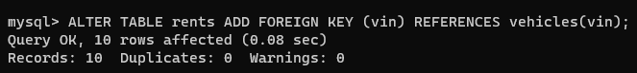

Рисунок 5 – Добавление внешнего ключа к таблицам базы данных “carsharing”



Рисунок 6 – Добавление внешнего ключа к таблицам базы данных “carsharing”

Результаты создания таблиц представлены на рисунках 7 – 9.

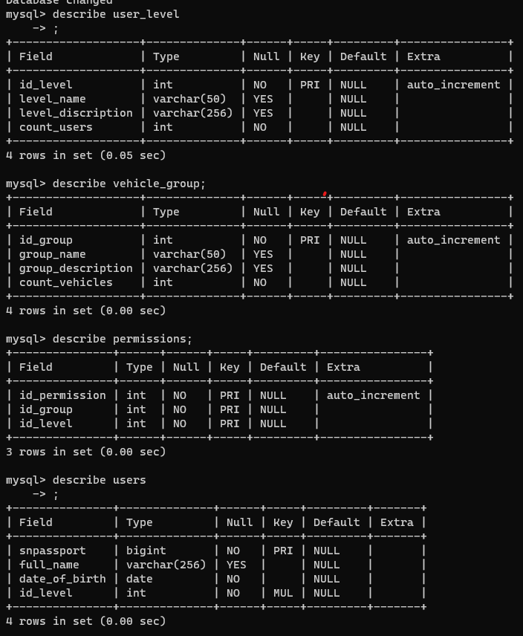

Рисунок 6 – Структура некоторых таблиц базы данных “carsharing”

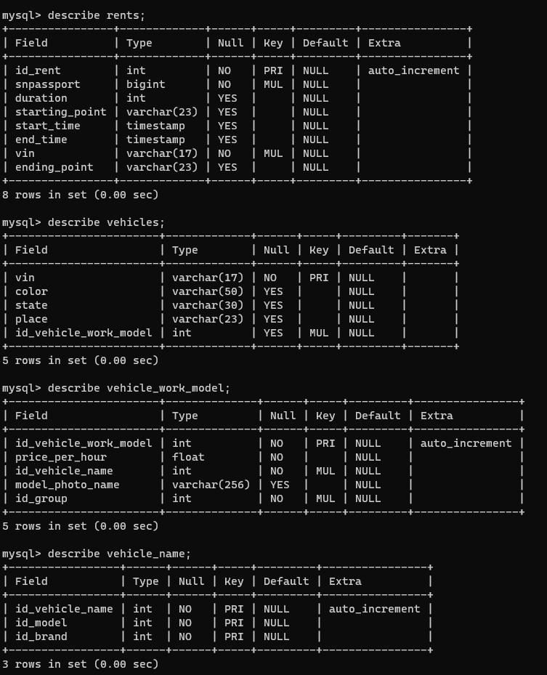

Рисунок 7 - Структура некоторых таблиц базы данных “carsharing”

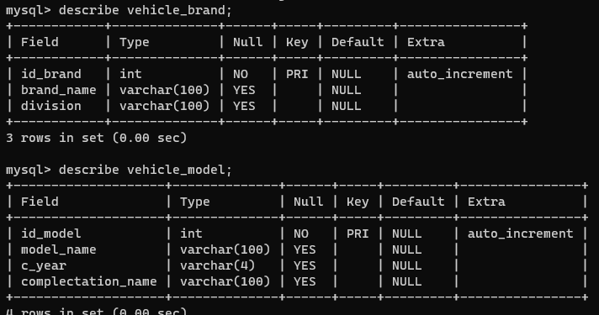

Рисунок 8 - Структура некоторых таблиц базы данных “carsharing”

Также с помощью MySQL Workbench была сгенерирована диаграмма по уже созданной базе данных (рис.10).

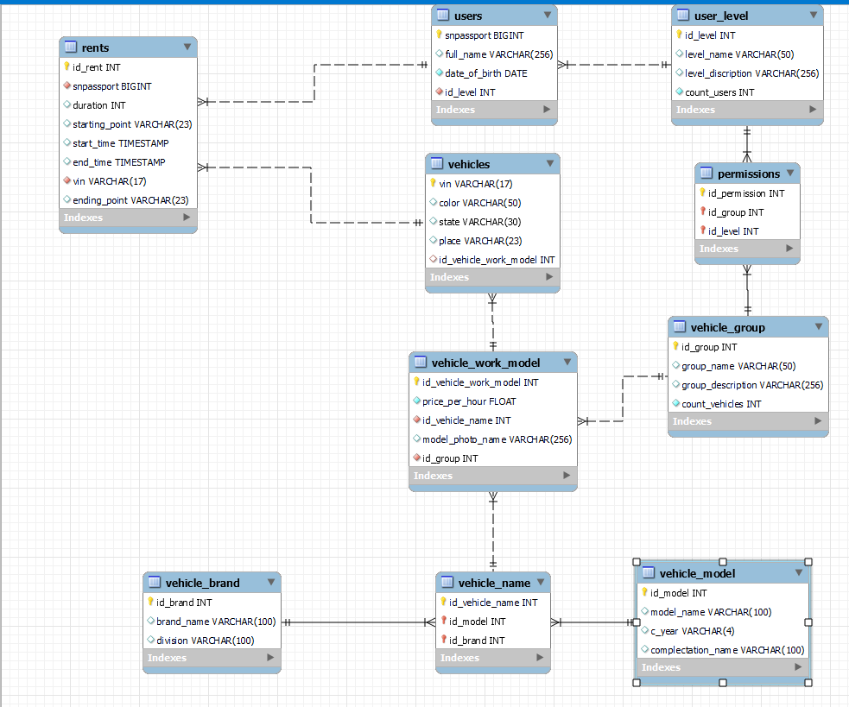

Рисунок 10 – Сгенерированная модель базы данных

Для создания базы данных использовался код представленный в листинге 1.

Листинг 1 – Создание базы данных.

 CREATE DATABASE IF NOT EXISTS carsharing;

 USE carsharing;

 CREATE TABLE IF NOT EXISTS users(

    snpassport BIGINT PRIMARY KEY,

    full_name VARCHAR(256),

    date_of_birth DATE NOT NULL,

    id_level INT NOT NULL

);

CREATE TABLE IF NOT EXISTS user_level(

    id_level INT AUTO_INCREMENT PRIMARY KEY,

    level_name VARCHAR(50),

    level_discription VARCHAR(256),

    count_users INTEGER NOT NULL

);

ALTER TABLE users ADD FOREIGN KEY (id_level) REFERENCES user_level(id_level);

Продолжение листинга 1

CREATE TABLE IF NOT EXISTS vehicle_group(

    id_group INT AUTO_INCREMENT PRIMARY KEY,

    group_name VARCHAR(50),

    group_description VARCHAR(256),

    count_vehicles INT NOT NULL

);

CREATE TABLE IF NOT EXISTS permissions(

    id_permission INT AUTO_INCREMENT,

    id_group INT,

    id_level INT,

    primary key(id_permission, id_group, id_level)

);

ALTER TABLE permissions ADD FOREIGN KEY (id_group) REFERENCES user_level(id_level);

ALTER TABLE permissions ADD FOREIGN KEY (id_level) REFERENCES vehicle_group(id_group);

CREATE TABLE IF NOT EXISTS vehicle_model(

    id_model INTEGER AUTO_INCREMENT PRIMARY KEY,

    model_name VARCHAR(100),

    c_year VARCHAR(4),

    complectation_name VARCHAR(100)

);

CREATE TABLE IF NOT EXISTS vehicle_brand(

    id_brand INTEGER AUTO_INCREMENT PRIMARY KEY,

    brand_name VARCHAR(100),

    division VARCHAR(100)

);

CREATE TABLE IF NOT EXISTS vehicle_name(

    id_vehicle_name INTEGER AUTO_INCREMENT,

    id_model INT,

    id_brand INT,

    PRIMARY KEY (id_vehicle_name, id_model, id_brand)

);

ALTER TABLE vehicle_name ADD FOREIGN KEY (id_model) REFERENCES vehicle_model(id_model);

ALTER TABLE vehicle_name ADD FOREIGN KEY (id_brand) REFERENCES vehicle_brand(id_brand);

CREATE TABLE IF NOT EXISTS vehicle_work_model(

    id_vehicle_work_model INTEGER AUTO_INCREMENT PRIMARY KEY,

    price_per_hour FLOAT NOT NULL,

    id_vehicle_name INT NOT NULL,

    model_photo_name VARCHAR(256),

Продолжение листинга 1

id_group INT NOT NULL

);

ALTER TABLE vehicle_work_model ADD FOREIGN KEY (id_vehicle_name) REFERENCES vehicle_name(id_vehicle_name);

ALTER TABLE vehicle_work_model ADD FOREIGN KEY (id_group) REFERENCES vehicle_group(id_group);

CREATE TABLE IF NOT EXISTS vehicles(

    vin VARCHAR(17) NOT NULL PRIMARY KEY,

    color VARCHAR(50),

    state VARCHAR(30),

    place VARCHAR(23),

    id_vehicle_work_model INT

);

CREATE TABLE IF NOT EXISTS rents(

    id_rent INT AUTO_INCREMENT PRIMARY KEY,

    snpassport BIGINT NOT NULL,

    duration INT,

    starting_point VARCHAR(23),

    start_time TIMESTAMP,

    end_time TIMESTAMP,

    vin VARCHAR(17) NOT NULL,

    ending_point VARCHAR(23)

);

ALTER TABLE rents ADD FOREIGN KEY (snpassport) REFERENCES users(snpassport);

ALTER TABLE rents ADD FOREIGN KEY (vin) REFERENCES vehicles(vin);

ALTER TABLE vahicles ADD FOREIGN KEY (id_vehicle_work_model) REFERENCES vehicle_work_model(id_vehicle_work_model);

После создания базы данных было произведено заполнение полей базы с помощью команды INSERT, процесс представлен на рисунках 11 – 20.

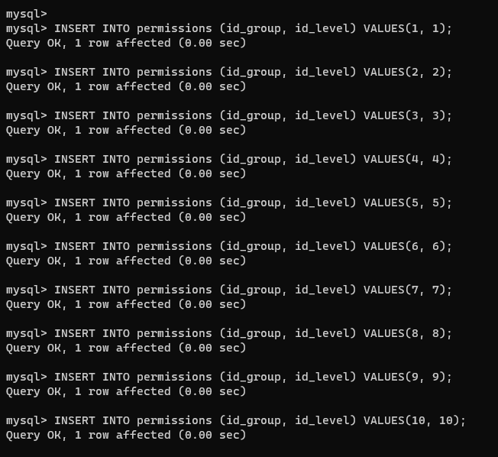

Рисунок 11 – Заполнение таблицы “permissions”

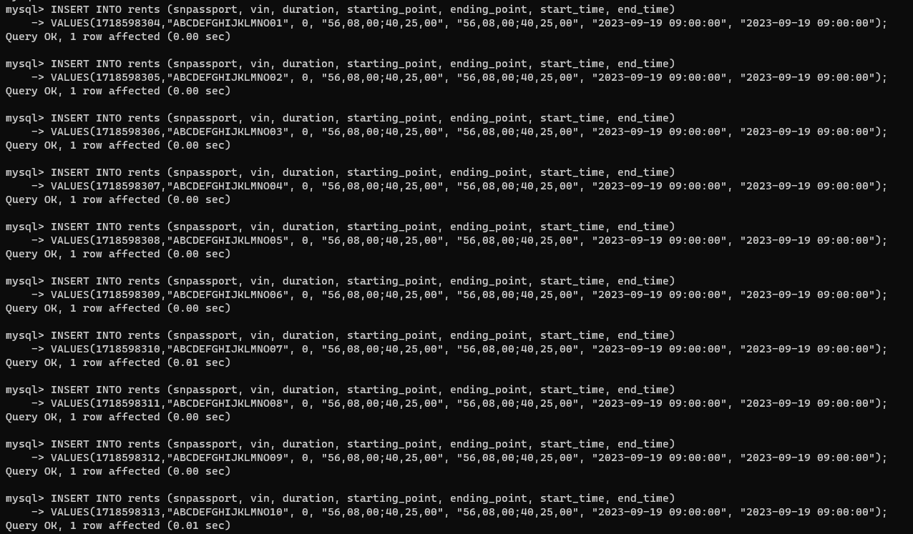

Рисунок 12 – Заполнение таблицы “rents”

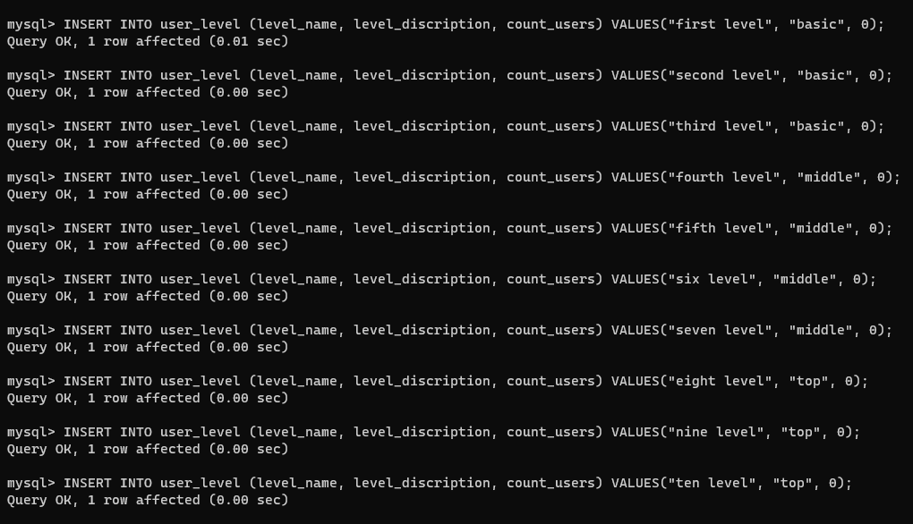

Рисунок 13 – Заполнение таблицы “user_level”

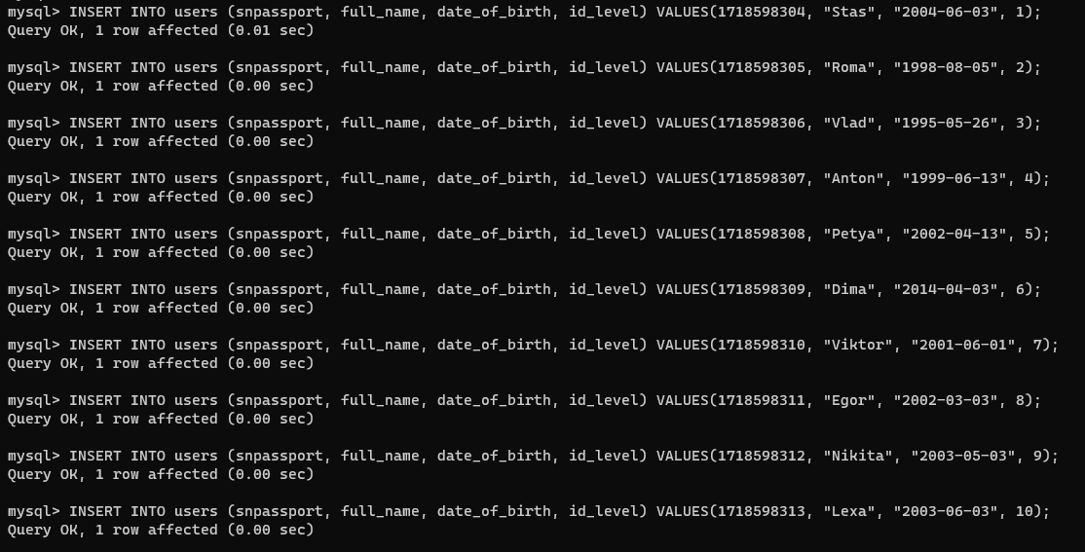

Рисунок 14 – Заполнение таблицы “users”

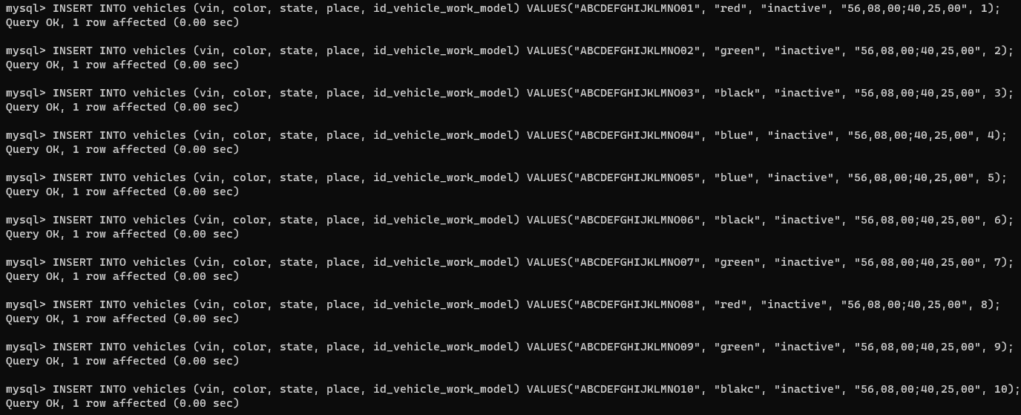

Рисунок 15 – Заполнение таблицы “vehicles”

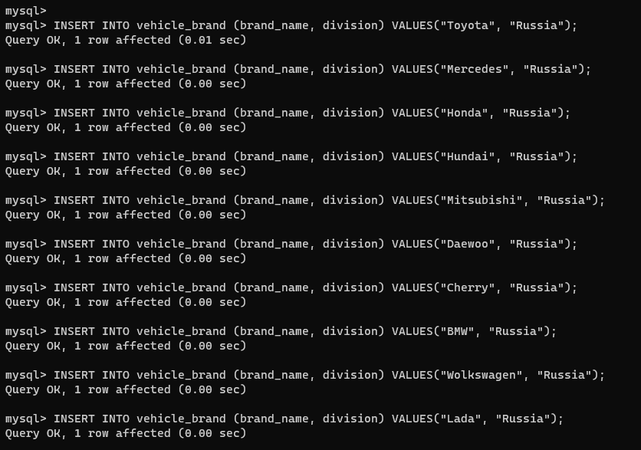

Рисунок 16 – Заполнение таблицы “vehicle_brand”

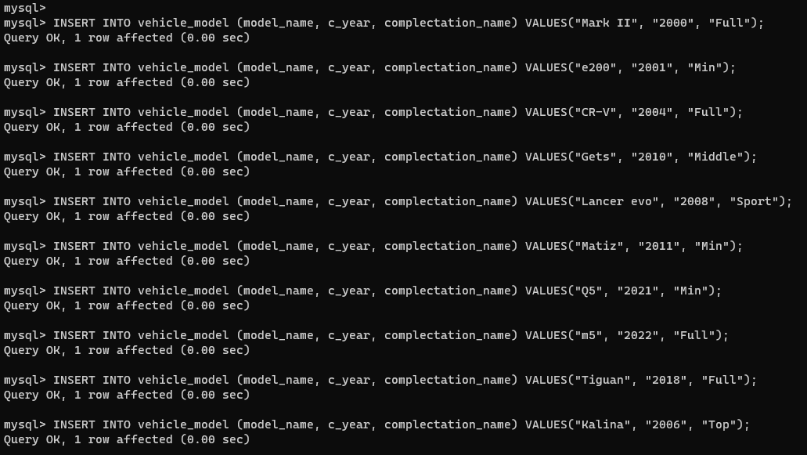

Рисунок 17 – Заполнение таблицы “vehicle_model”

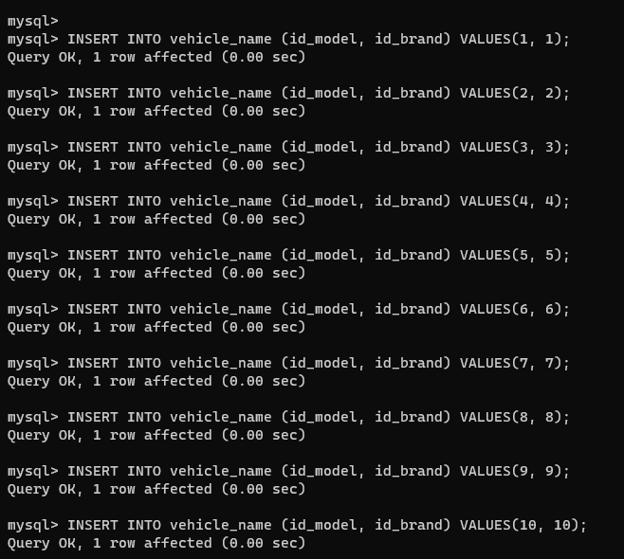

Рисунок 18 – Заполнение таблицы ‘vehicle_name’

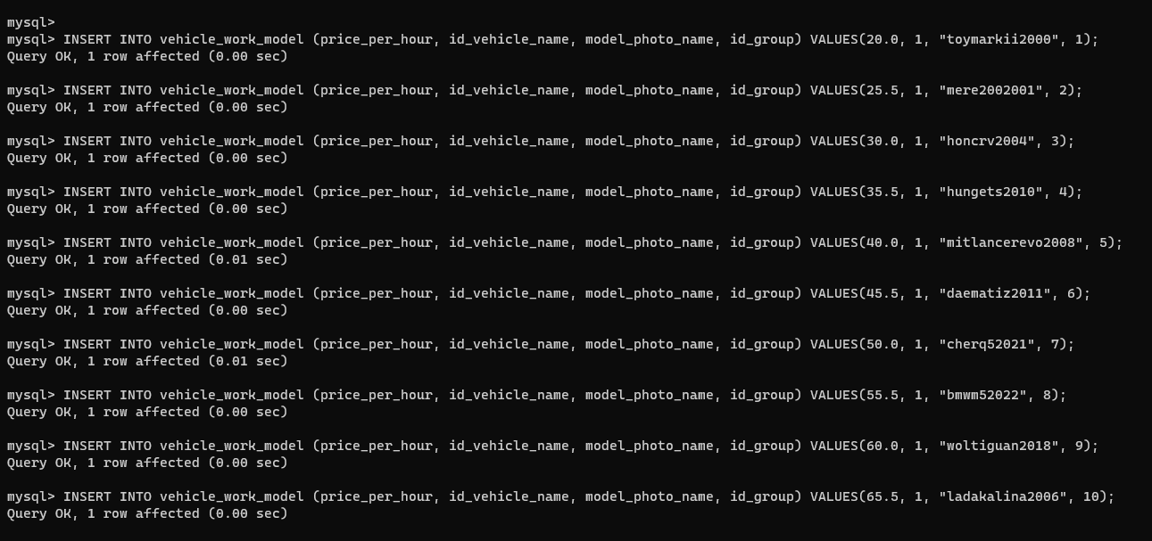

Рисунок 19 – Заполнение таблицы “vehicle_work_model”

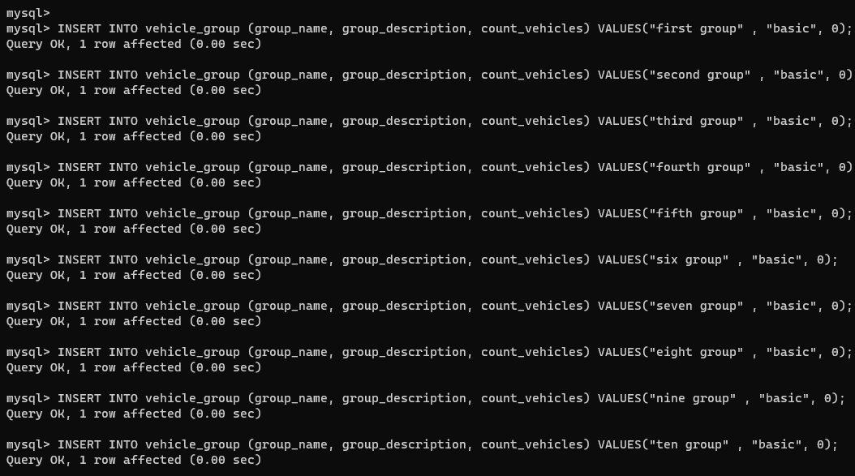

Рисунок 20 – Заполнение таблицы “vehicle_group”

Результат заполнения представлен на рисунках 21 – 24.

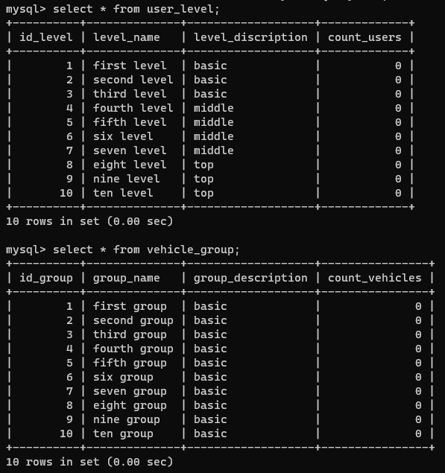

Рисунок 21 – Содержимое части таблиц

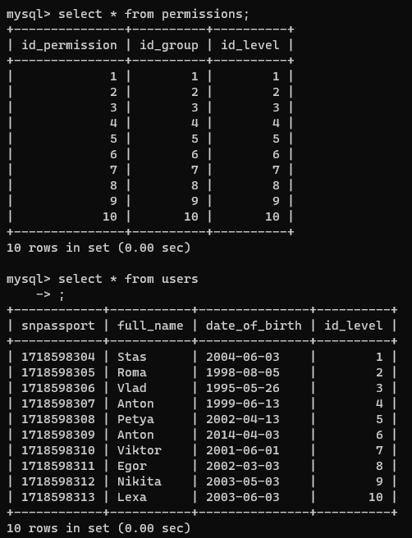

Рисунок 22 – Содержимое части таблиц



Рисунок 23 – Содержимое части таблиц

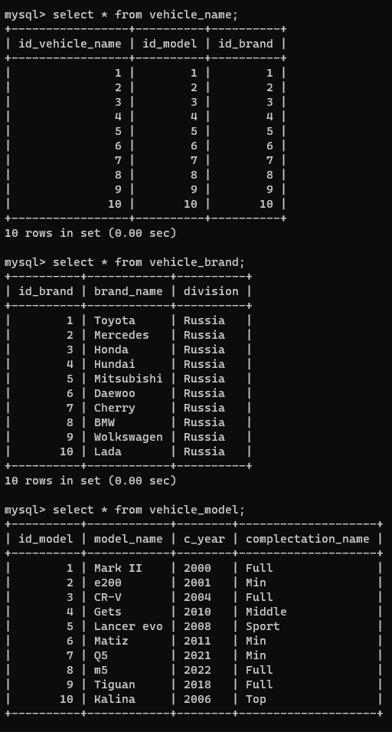

Рисунок 24 – Содержимое части таблиц

Для заполнения таблиц использовался код, представленный в листинге 2.

Листинг 2 – Код заполнения таблиц базы данных.

USE carsharing;

INSERT INTO user_level (level_name, level_discription, count_users) VALUES("first level", "basic", 0);

INSERT INTO user_level (level_name, level_discription, count_users) VALUES("second level", "basic", 0);

INSERT INTO user_level (level_name, level_discription, count_users) VALUES("third level", "basic", 0);

INSERT INTO user_level (level_name, level_discription, count_users) VALUES("fourth level", "middle", 0);

Продолжение листинга 2.

INSERT INTO user_level (level_name, level_discription, count_users) VALUES("fifth level", "middle", 0);

INSERT INTO user_level (level_name, level_discription, count_users) VALUES("six level", "middle", 0);

INSERT INTO user_level (level_name, level_discription, count_users) VALUES("seven level", "middle", 0);

INSERT INTO user_level (level_name, level_discription, count_users) VALUES("eight level", "top", 0);

INSERT INTO user_level (level_name, level_discription, count_users) VALUES("nine level", "top", 0);

INSERT INTO user_level (level_name, level_discription, count_users) VALUES("ten level", "top", 0);

INSERT INTO vehicle_group (group_name, group_description, count_vehicles) VALUES("first group" , "basic", 0);

INSERT INTO vehicle_group (group_name, group_description, count_vehicles) VALUES("second group" , "basic", 0);

INSERT INTO vehicle_group (group_name, group_description, count_vehicles) VALUES("third group" , "basic", 0);

INSERT INTO vehicle_group (group_name, group_description, count_vehicles) VALUES("fourth group" , "basic", 0);

INSERT INTO vehicle_group (group_name, group_description, count_vehicles) VALUES("fifth group" , "basic", 0);

INSERT INTO vehicle_group (group_name, group_description, count_vehicles) VALUES("six group" , "basic", 0);

INSERT INTO vehicle_group (group_name, group_description, count_vehicles) VALUES("seven group" , "basic", 0);

INSERT INTO vehicle_group (group_name, group_description, count_vehicles) VALUES("eight group" , "basic", 0);

INSERT INTO vehicle_group (group_name, group_description, count_vehicles) VALUES("nine group" , "basic", 0);

INSERT INTO vehicle_group (group_name, group_description, count_vehicles) VALUES("ten group" , "basic", 0);

INSERT INTO permissions (id_group, id_level) VALUES(1, 1);

INSERT INTO permissions (id_group, id_level) VALUES(2, 2);

INSERT INTO permissions (id_group, id_level) VALUES(3, 3);

INSERT INTO permissions (id_group, id_level) VALUES(4, 4);

INSERT INTO permissions (id_group, id_level) VALUES(5, 5);

INSERT INTO permissions (id_group, id_level) VALUES(6, 6);

INSERT INTO permissions (id_group, id_level) VALUES(7, 7);

INSERT INTO permissions (id_group, id_level) VALUES(8, 8);

INSERT INTO permissions (id_group, id_level) VALUES(9, 9);

INSERT INTO permissions (id_group, id_level) VALUES(10, 10);

INSERT INTO vehicle_model (model_name, c_year, complectation_name) VALUES("Mark II", "2000", "Full");

INSERT INTO vehicle_model (model_name, c_year, complectation_name) VALUES("e200", "2001", "Min");

Продолжение листинга 2.

INSERT INTO vehicle_model (model_name, c_year, complectation_name) VALUES("CR-V", "2004", "Full");

INSERT INTO vehicle_model (model_name, c_year, complectation_name) VALUES("Gets", "2010", "Middle");

INSERT INTO vehicle_model (model_name, c_year, complectation_name) VALUES("Lancer evo", "2008", "Sport");

INSERT INTO vehicle_model (model_name, c_year, complectation_name) VALUES("Matiz", "2011", "Min");

INSERT INTO vehicle_model (model_name, c_year, complectation_name) VALUES("Q5", "2021", "Min");

INSERT INTO vehicle_model (model_name, c_year, complectation_name) VALUES("m5", "2022", "Full");

INSERT INTO vehicle_model (model_name, c_year, complectation_name) VALUES("Tiguan", "2018", "Full");

INSERT INTO vehicle_model (model_name, c_year, complectation_name) VALUES("Kalina", "2006", "Top");

INSERT INTO vehicle_brand (brand_name, division) VALUES("Toyota", "Russia");

INSERT INTO vehicle_brand (brand_name, division) VALUES("Mercedes", "Russia");

INSERT INTO vehicle_brand (brand_name, division) VALUES("Honda", "Russia");

INSERT INTO vehicle_brand (brand_name, division) VALUES("Hundai", "Russia");

INSERT INTO vehicle_brand (brand_name, division) VALUES("Mitsubishi", "Russia");

INSERT INTO vehicle_brand (brand_name, division) VALUES("Daewoo", "Russia");

INSERT INTO vehicle_brand (brand_name, division) VALUES("Cherry", "Russia");

INSERT INTO vehicle_brand (brand_name, division) VALUES("BMW", "Russia");

INSERT INTO vehicle_brand (brand_name, division) VALUES("Wolkswagen", "Russia");

INSERT INTO vehicle_brand (brand_name, division) VALUES("Lada", "Russia");

INSERT INTO vehicle_name (id_model, id_brand) VALUES(1, 1);

INSERT INTO vehicle_name (id_model, id_brand) VALUES(2, 2);

INSERT INTO vehicle_name (id_model, id_brand) VALUES(3, 3);

INSERT INTO vehicle_name (id_model, id_brand) VALUES(4, 4);

INSERT INTO vehicle_name (id_model, id_brand) VALUES(5, 5);

INSERT INTO vehicle_name (id_model, id_brand) VALUES(6, 6);

INSERT INTO vehicle_name (id_model, id_brand) VALUES(7, 7);

INSERT INTO vehicle_name (id_model, id_brand) VALUES(8, 8);

INSERT INTO vehicle_name (id_model, id_brand) VALUES(9, 9);

INSERT INTO vehicle_name (id_model, id_brand) VALUES(10, 10);

INSERT INTO vehicle_work_model (price_per_hour, id_vehicle_name, model_photo_name, id_group) VALUES(20.0, 1, "toymarkii2000", 1);

INSERT INTO vehicle_work_model (price_per_hour, id_vehicle_name, model_photo_name, id_group) VALUES(25.5, 1, "mere2002001", 2);

INSERT INTO vehicle_work_model (price_per_hour, id_vehicle_name, model_photo_name, id_group) VALUES(30.0, 1, "honcrv2004", 3);

INSERT INTO vehicle_work_model (price_per_hour, id_vehicle_name, model_photo_name, id_group) VALUES(35.5, 1, "hungets2010", 4);

INSERT INTO vehicle_work_model (price_per_hour, id_vehicle_name, model_photo_name, id_group) VALUES(40.0, 1, "mitlancerevo2008", 5);

Продолжение листинга 2.

INSERT INTO vehicle_work_model (price_per_hour, id_vehicle_name, model_photo_name, id_group) VALUES(45.5, 1, "daematiz2011", 6);

INSERT INTO vehicle_work_model (price_per_hour, id_vehicle_name, model_photo_name, id_group) VALUES(50.0, 1, "cherq52021", 7);

INSERT INTO vehicle_work_model (price_per_hour, id_vehicle_name, model_photo_name, id_group) VALUES(55.5, 1, "bmwm52022", 8);

INSERT INTO vehicle_work_model (price_per_hour, id_vehicle_name, model_photo_name, id_group) VALUES(60.0, 1, "woltiguan2018", 9);

INSERT INTO vehicle_work_model (price_per_hour, id_vehicle_name, model_photo_name, id_group) VALUES(65.5, 1, "ladakalina2006", 10);

INSERT INTO vehicles (vin, color, state, place, id_vehicle_work_model) VALUES("ABCDEFGHIJKLMNO01", "red", "inactive", "56,08,00;40,25,00", 1);

INSERT INTO vehicles (vin, color, state, place, id_vehicle_work_model) VALUES("ABCDEFGHIJKLMNO02", "green", "inactive", "56,08,00;40,25,00", 2);

INSERT INTO vehicles (vin, color, state, place, id_vehicle_work_model) VALUES("ABCDEFGHIJKLMNO03", "black", "inactive", "56,08,00;40,25,00", 3);

INSERT INTO vehicles (vin, color, state, place, id_vehicle_work_model) VALUES("ABCDEFGHIJKLMNO04", "blue", "inactive", "56,08,00;40,25,00", 4);

INSERT INTO vehicles (vin, color, state, place, id_vehicle_work_model) VALUES("ABCDEFGHIJKLMNO05", "blue", "inactive", "56,08,00;40,25,00", 5);

INSERT INTO vehicles (vin, color, state, place, id_vehicle_work_model) VALUES("ABCDEFGHIJKLMNO06", "black", "inactive", "56,08,00;40,25,00", 6);

INSERT INTO vehicles (vin, color, state, place, id_vehicle_work_model) VALUES("ABCDEFGHIJKLMNO07", "green", "inactive", "56,08,00;40,25,00", 7);

INSERT INTO vehicles (vin, color, state, place, id_vehicle_work_model) VALUES("ABCDEFGHIJKLMNO08", "red", "inactive", "56,08,00;40,25,00", 8);

INSERT INTO vehicles (vin, color, state, place, id_vehicle_work_model) VALUES("ABCDEFGHIJKLMNO09", "green", "inactive", "56,08,00;40,25,00", 9);

INSERT INTO vehicles (vin, color, state, place, id_vehicle_work_model) VALUES("ABCDEFGHIJKLMNO10", "blakc", "inactive", "56,08,00;40,25,00", 10);

INSERT INTO users (snpassport, full_name, date_of_birth, id_level) VALUES(1718598304, "Stas", "2004-06-03", 1);

INSERT INTO users (snpassport, full_name, date_of_birth, id_level) VALUES(1718598305, "Roma", "1998-08-05", 2);

INSERT INTO users (snpassport, full_name, date_of_birth, id_level) VALUES(1718598306, "Vlad", "1995-05-26", 3);

INSERT INTO users (snpassport, full_name, date_of_birth, id_level) VALUES(1718598307, "Anton", "1999-06-13", 4);

INSERT INTO users (snpassport, full_name, date_of_birth, id_level) VALUES(1718598308, "Petya", "2002-04-13", 5);

INSERT INTO users (snpassport, full_name, date_of_birth, id_level) VALUES(1718598309, "Dima", "2014-04-03", 6);

INSERT INTO users (snpassport, full_name, date_of_birth, id_level) VALUES(1718598310, "Viktor", "2001-06-01", 7);

INSERT INTO users (snpassport, full_name, date_of_birth, id_level) VALUES(1718598311, "Egor", "2002-03-03", 8);

Продолжение листинга 2.

INSERT INTO users (snpassport, full_name, date_of_birth, id_level) VALUES(1718598312, "Nikita", "2003-05-03", 9);

INSERT INTO users (snpassport, full_name, date_of_birth, id_level) VALUES(1718598313, "Lexa", "2003-06-03", 10);

INSERT INTO rents (snpassport, vin, duration, starting_point, ending_point, start_time, end_time)

VALUES(1718598304,"ABCDEFGHIJKLMNO01", 0, "56,08,00;40,25,00", "56,08,00;40,25,00", "2023-09-19 09:00:00", "2023-09-19 09:00:00");

INSERT INTO rents (snpassport, vin, duration, starting_point, ending_point, start_time, end_time)

VALUES(1718598305,"ABCDEFGHIJKLMNO02", 0, "56,08,00;40,25,00", "56,08,00;40,25,00", "2023-09-19 09:00:00", "2023-09-19 09:00:00");

INSERT INTO rents (snpassport, vin, duration, starting_point, ending_point, start_time, end_time)

VALUES(1718598306,"ABCDEFGHIJKLMNO03", 0, "56,08,00;40,25,00", "56,08,00;40,25,00", "2023-09-19 09:00:00", "2023-09-19 09:00:00");

INSERT INTO rents (snpassport, vin, duration, starting_point, ending_point, start_time, end_time)

VALUES(1718598307,"ABCDEFGHIJKLMNO04", 0, "56,08,00;40,25,00", "56,08,00;40,25,00", "2023-09-19 09:00:00", "2023-09-19 09:00:00");

INSERT INTO rents (snpassport, vin, duration, starting_point, ending_point, start_time, end_time)

VALUES(1718598308,"ABCDEFGHIJKLMNO05", 0, "56,08,00;40,25,00", "56,08,00;40,25,00", "2023-09-19 09:00:00", "2023-09-19 09:00:00");

INSERT INTO rents (snpassport, vin, duration, starting_point, ending_point, start_time, end_time)

VALUES(1718598309,"ABCDEFGHIJKLMNO06", 0, "56,08,00;40,25,00", "56,08,00;40,25,00", "2023-09-19 09:00:00", "2023-09-19 09:00:00");

INSERT INTO rents (snpassport, vin, duration, starting_point, ending_point, start_time, end_time)

VALUES(1718598310,"ABCDEFGHIJKLMNO07", 0, "56,08,00;40,25,00", "56,08,00;40,25,00", "2023-09-19 09:00:00", "2023-09-19 09:00:00");

INSERT INTO rents (snpassport, vin, duration, starting_point, ending_point, start_time, end_time)

VALUES(1718598311,"ABCDEFGHIJKLMNO08", 0, "56,08,00;40,25,00", "56,08,00;40,25,00", "2023-09-19 09:00:00", "2023-09-19 09:00:00");

INSERT INTO rents (snpassport, vin, duration, starting_point, ending_point, start_time, end_time)

VALUES(1718598312,"ABCDEFGHIJKLMNO09", 0, "56,08,00;40,25,00", "56,08,00;40,25,00", "2023-09-19 09:00:00", "2023-09-19 09:00:00");

INSERT INTO rents (snpassport, vin, duration, starting_point, ending_point, start_time, end_time)

VALUES(1718598313,"ABCDEFGHIJKLMNO10", 0, "56,08,00;40,25,00", "56,08,00;40,25,00", "2023-09-19 09:00:00", "2023-09-19 09:00:00");

Итоговый список таблиц представлен на рисунке 25.

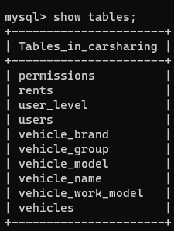

Рисунок 25 – Итоговый список таблиц

**Вывод:**

В результате данной практической работы была создана база данных, а также было произведено наполнение её тестовыми данными.