1

https://api.apilayer.com/currency_data/list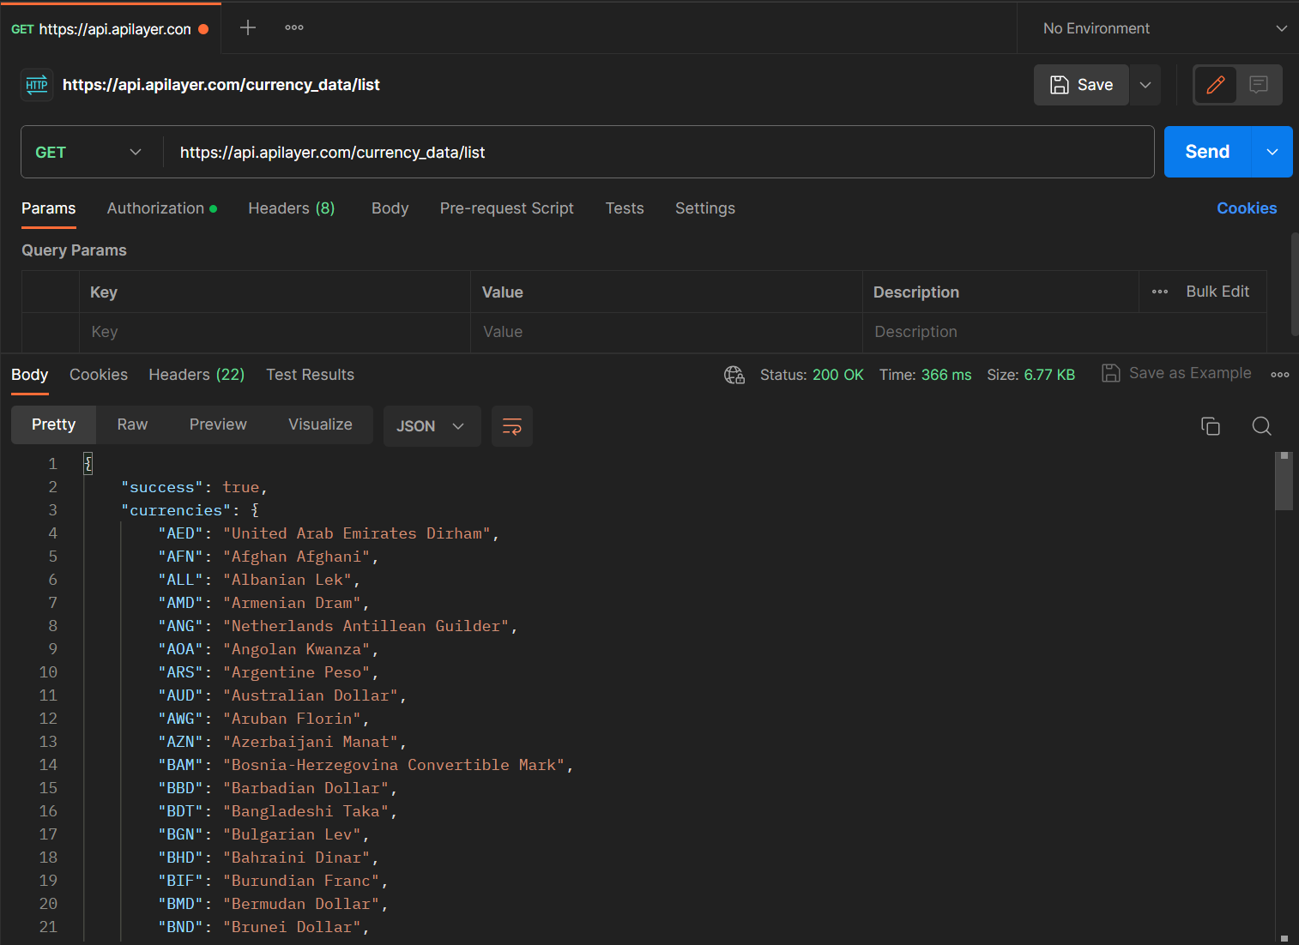

2

https://api.apilayer.com/currency_data/historical?date=2018-02-22&currencies=EUR,GBP,JPY&source=USD 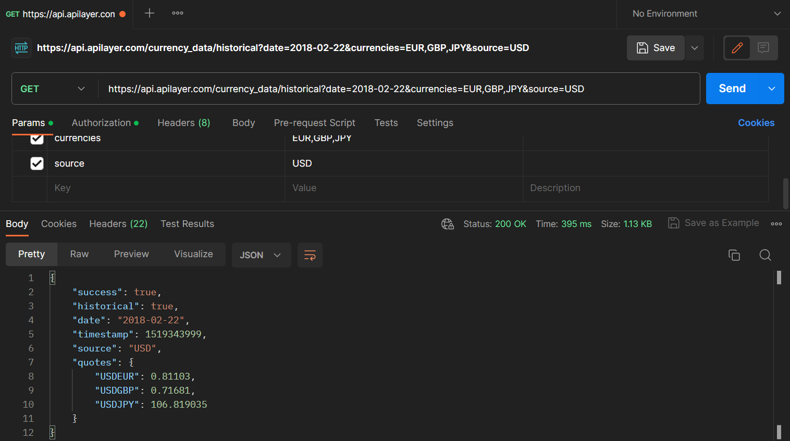

3

https://api.apilayer.com/currency_data/timeframe?start_date=2016-02-25&end_date=2017-02-21&currencies=EUR&source=USD

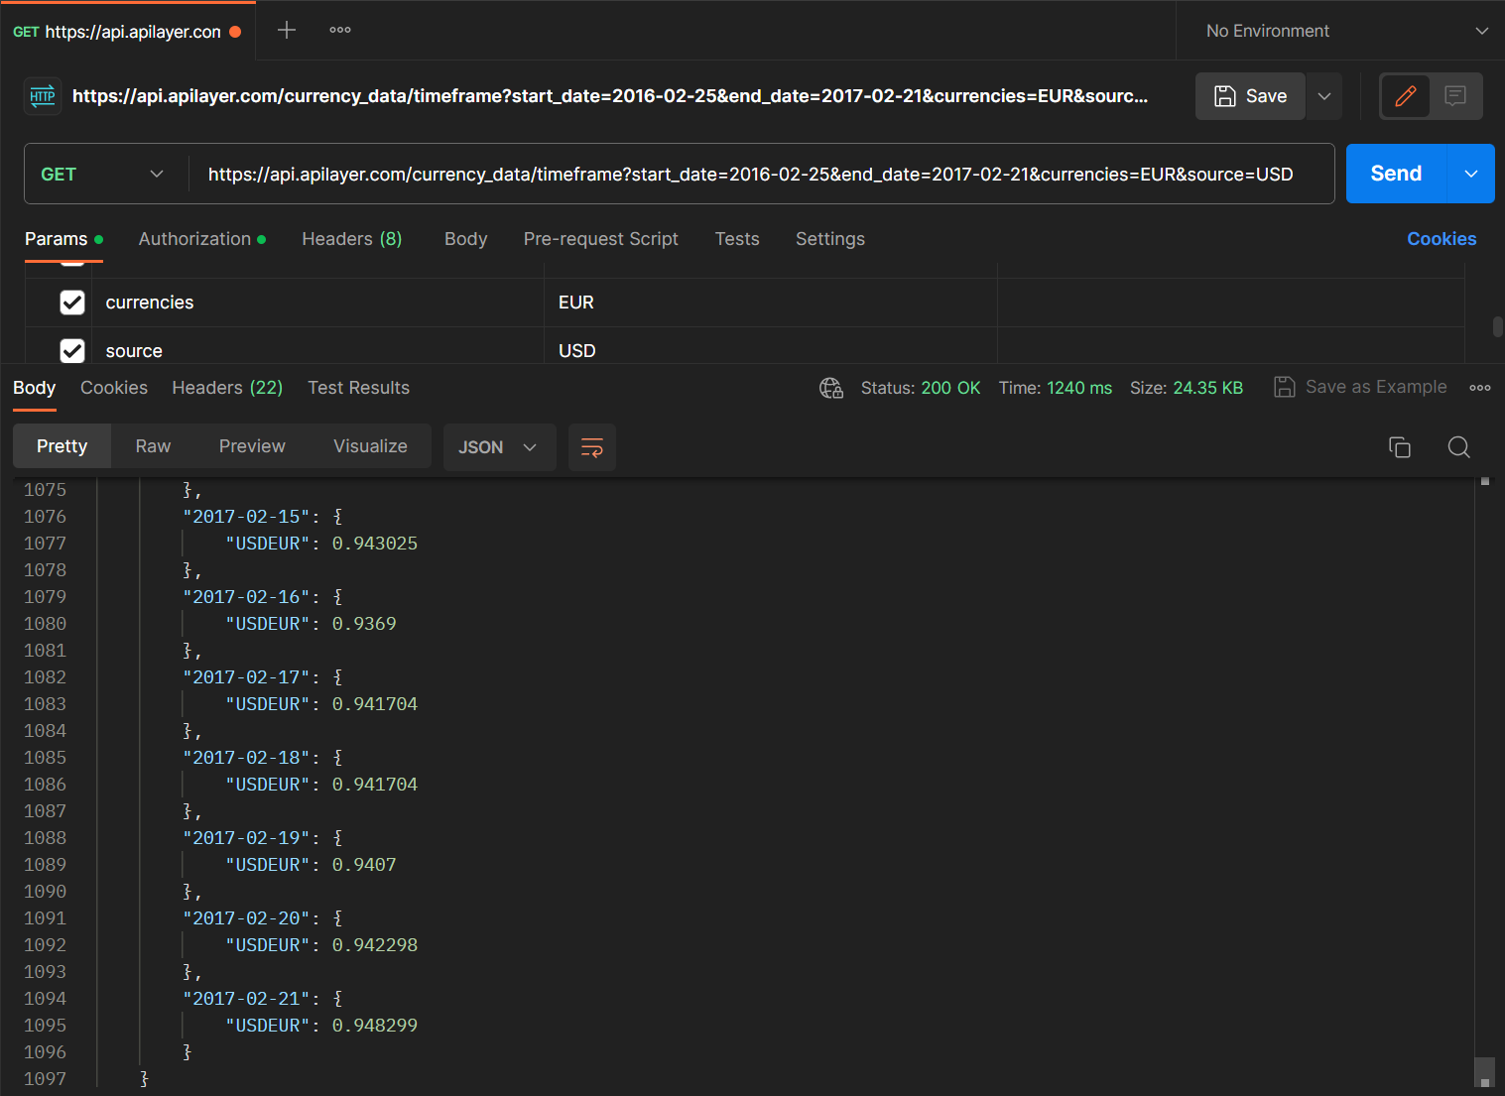

4.

