
MAHATMA GANDHI INSTITUTE OF TECHNOLOGY
(Affiliated to Jawaharlal Nehru Technological University, Hyderabad)
Chaitanya Bharathi P.O., Gandipet, Hyderabad – 500 075
PREDICTION OF ELECTRIC FIELDS OF UHV AC TRANSMISSION LINES USING MACHINE LEARNING TECHNIQUES
BACHELOR OF TECHNOLOGY
PROJECT REPORT
A Real Time Research Project Report
Submitted in Partial Fulfillment of the
Requirements for the Degree of
BACHELOR OF TECHNOLOGY
IN
ELECTRICAL AND ELECTRONICS ENGINEERING
By
SAKETH LANKA (23261A0251)
HAKIMKARI ANIL (23261A0212)
TEJASWINI GUGULOTHU (23261A0221)

Department of Electrical and Electronics Engineering
2025-2026


MAHATMA GANDHI INSTITUTE OF TECHNOLOGY
(Affiliated to Jawaharlal Nehru Technological University, Hyderabad)
Chaitanya Bharathi P.O., Gandipet, Hyderabad – 500 075
PREDICTION OF ELECTRIC FIELDS OF UHV AC TRANSMISSION LINES USING MACHINE LEARNING TECHNIQUES
BACHELOR OF TECHNOLOGY
PROJECT REPORT
A Real Time Research Project Report
Submitted in Partial Fulfillment of the
Requirements for the Degree of
BACHELOR OF TECHNOLOGY
IN
ELECTRICAL AND ELECTRONICS ENGINEERING
By
SAKETH LANKA (23261A0251)
HAKIMKARI ANIL (23261A0212)
TEJASWINI GUGULOTHU (23261A0221)
Under the esteemed guidance of
Dr. A. Ramchandra Reddy
ASSOCIATE PROFESSOR
Department of Electrical and Electronics Engineering
2025-2026


MAHATMA GANDHI INSTITUTE OF TECHNOLOGY
(Affiliated to Jawaharlal Nehru Technological University, Hyderabad)
Chaitanya Bharathi P.O., Gandipet, Hyderabad – 500 075
Department of Electrical and Electronics Engineering

CERTIFICATE

Date: 19/05/2026
This is to certify that the RTRP (REAL TIME RESEARCH PROJECT) work entitled "PREDICTION OF ELECTRIC FIELDS OF UHV AC TRANSMISSION LINES USING MACHINE LEARNING TECHNIQUES" submitted by SAKETH LANKA (23261A0251), HAKIMKARI ANIL (23261A0212), TEJASWINI GUGULOTHU (23261A0221) in partial fulfillment for the award of Degree of BACHELOR OF TECHNOLOGY in ELECTRICAL AND ELECTRONICS ENGINEERING to the Jawaharlal Nehru Technological University, Hyderabad during the academic year 2025-2026, is a record of bonafide work carried out by them under our guidance and supervision.
The results embodied in this report have not been submitted by the students to any other University or Institution for the award of any degree or diploma.
Project Guide | Head of Department
Dr. A. Ramchandra Reddy  Associate Professor  Department of Electrical and Electronics Engineering | Dr. P. Ram Kishore Kumar Reddy  Professor & Head  Department of Electrical and Electronics Engineering

DECLARATION
We, the undersigned students of Bachelor of Technology in ELECTRICAL AND ELECTRONICS ENGINEERING, hereby declare that the project report entitled "PREDICTION OF ELECTRIC FIELDS OF UHV AC TRANSMISSION LINES USING MACHINE LEARNING TECHNIQUES" is an authentic record of original work carried out by us during the academic year 2025-2026 under the guidance of Dr. A. Ramchandra Reddy, Associate Professor, Department of Electrical and Electronics Engineering, Mahatma Gandhi Institute of Technology, Hyderabad.
The matter embodied in this report has not been submitted, in part or in full, to any other University or Institution for the award of any degree or diploma. All sources of information used in this report have been duly acknowledged.
SAKETH LANKA (23261A0251)
HAKIMKARI ANIL (23261A0212)
TEJASWINI GUGULOTHU (23261A0221)

ACKNOWLEDGEMENT
We express our deep sense of gratitude to Prof. G. Chandra Mohan Reddy, Principal, Mahatma Gandhi Institute of Technology, for permitting us to carry out this project work and for providing the necessary infrastructure in the campus.
We extend our sincere thanks to Dr. P. Ram Kishore Kumar Reddy, Professor & Head, Department of Electrical and Electronics Engineering, Mahatma Gandhi Institute of Technology, for his valuable guidance, suggestions, keen interest, and constant encouragement extended throughout the period of our project work.
We take immense pleasure to thank our project guide, Dr. A. Ramchandra Reddy, Associate Professor, Department of Electrical and Electronics Engineering, for his valuable suggestions, rare insights and unwavering support — without which the formulation of the analytical model, the machine-learning pipeline and the FieldSense web application would not have been possible.
We are grateful to the faculty members of the Department of Electrical and Electronics Engineering for the technical discussions on electromagnetic field theory, transmission-line modelling and applied machine learning, which sharpened our understanding of the subject.
We also extend our thanks to all the non-teaching staff of the department, the library staff, and the central computing facility, who contributed in their own ways to the successful completion of this project work.
With gratitude,
SAKETH LANKA (23261A0251)
HAKIMKARI ANIL (23261A0212)
TEJASWINI GUGULOTHU (23261A0221)

TABLE OF CONTENTS
Certificate i
Declaration ii
Acknowledgement iii
Table of Contents iv
List of Figures v
List of Tables vi
Abstract vii

CHAPTER 1 INTRODUCTION 1
1.1 Background of UHV AC Transmission 1
1.2 Significance of Electric-Field Analysis 2
1.3 Health and Safety – WHO Public Limit 3
1.4 Motivation 3
1.5 Objectives of the Project 4
1.6 Organisation of the Report 4
CHAPTER 2 LITERATURE REVIEW AND THEORETICAL BACKGROUND 5
2.1 Overview of UHV Transmission Systems 5
2.2 Electric Field Around Transmission Conductors 6
2.3 Method of Images for Ground Plane 7
2.4 Bundle Conductors and Equivalent Radius 8
2.5 Three-Phase Voltage Representation 9
2.6 Machine Learning in Power Engineering 10
2.7 Summary of Reviewed Literature 10
CHAPTER 3 ANALYTICAL MODELLING 11
3.1 Problem Formulation 11
3.2 Maxwell's Potential Coefficient Matrix 12
3.3 Bundle Equivalent Radius 13
3.4 Image-Charge Modelling of the Ground 14
3.5 Three-Phase Voltage Representation 15
3.6 Ground-Level Electric Field 16
3.7 1200 kV Case Study Parameters 17
3.8 Validation of the Analytical Engine 18
CHAPTER 4 MACHINE-LEARNING APPROACH AND IMPLEMENTATION 19
4.1 Dataset Generation 19
4.2 Feature Engineering 20
4.3 Model Architectures 21
4.4 Training Pipeline and Evaluation Metrics 22
4.5 Hyper-Parameter Selection 23
4.6 Best-Model Persistence and Inference 24
4.7 FieldSense Web Calculator 25
CHAPTER 5 RESULTS, DISCUSSION AND CONCLUSION 27
5.1 Analytical Results – 1200 kV Profile 27
5.2 Dataset Statistics 28
5.3 ML Model Comparison 29
5.4 Analytical vs ML Agreement 30
5.5 WHO Compliance Across Voltage Levels 31
5.6 Sensitivity to Height and Voltage 32
5.7 FieldSense Web Application – Demonstration 33
5.8 Limitations 33
5.9 Conclusion 34
5.10 Future Scope 35
REFERENCES 36

LIST OF FIGURES
Fig 2.1 Three-phase voltage phasor diagram 9
Fig 3.1 Three-phase UHV AC line with image charges (1200 kV case) 11
Fig 3.2 Bundle conductor geometry (N = 8, R = 0.6 m) 13
Fig 3.3 Analytical ground-level Ev profile – 1200 kV case study 17
Fig 4.1 FieldSense methodology pipeline 19
Fig 4.2 Distribution of Ev in the 1 000-sample quick dataset 20
Fig 4.3 Best-model predicted-vs-actual scatter (ANN) 23
Fig 4.4 FieldSense web calculator – live UI screenshot 26
Fig 5.1 Analytical vs ML prediction on the 1200 kV profile 30
Fig 5.2 Centre-phase Ev across voltage levels vs WHO 5 kV/m limit 31
Fig 5.3 Sensitivity heatmap of Ev to height H and voltage V 32

LIST OF TABLES
Table 3.1 Geometric and electrical parameters of the 1200 kV case study 17
Table 4.1 Hyper-parameters of trained ML models 21
Table 5.1 Test-set performance of ANN, Random Forest and SVR 29
Table 5.2 Centre-phase Ev across standard UHV voltage levels 31

ABSTRACT
Ultra-high-voltage (UHV) alternating-current transmission lines are indispensable for the bulk transfer of electrical power over long distances, but the strong electric fields established beneath these lines can exceed the public-exposure limit of 5 kV/m recommended by the World Health Organisation (WHO) at 50/60 Hz. Accurate, real-time estimation of the ground-level vertical electric field E_{v} is therefore essential during corridor planning, right-of-way studies, and verification of safety compliance.
This project, titled FieldSense, presents a hybrid analytical–machine-learning framework for predicting ground-level electric fields of three-phase UHV AC transmission lines. The analytical engine implements Maxwell's potential-coefficient matrix method together with the method of images for the perfectly conducting ground plane and the equivalent-radius treatment of N-conductor bundles. A 1200 kV horizontal-configuration test case is used as the benchmark.
The validated analytical model is then used to generate a 12 000-sample synthetic dataset spanning a realistic range of lateral distance, line height, phase spacing, and operating voltage. Three regression learners — a Multi-Layer Perceptron (ANN), a Random Forest and a Support Vector Regressor — are trained and compared. The best learner, an ANN with two hidden layers, achieves a test-set root-mean-square error of 0.0520 kV/m and R² = 0.99886, and reproduces the analytical 1200 kV profile with an RMSE of 0.052 kV/m and R² = 0.9985.
The trained model is deployed in a self-contained, Matrix-themed single-page web application — FieldSense — that runs the full analytical pipeline in pure JavaScript and continuously displays the live lateral profile, [P] and [M] matrices, peak field, and a colour-coded WHO compliance badge. The work demonstrates that millisecond-scale, browser-based E-field estimation, with sub-1 % error against rigorous analytical results, is both feasible and useful for engineering practice and academic study.
Keywords: UHV transmission, electric-field prediction, Maxwell potential coefficients, method of images, machine learning, artificial neural network, WHO 5 kV/m limit.

CHAPTER 1
INTRODUCTION
1.1 Background of UHV AC Transmission
The rapid growth of industrial demand, urbanisation and inter-regional power trading has compelled utilities worldwide to evolve from 220 kV and 400 kV transmission corridors towards Extra-High-Voltage (EHV, 765 kV) and Ultra-High-Voltage (UHV, 1000 kV / 1200 kV) AC links. India's first 1200 kV national test station at Bina, commissioned by Power Grid Corporation, and China's 1000 kV State Grid corridors are notable examples. The principal advantages of UHV transmission are well known: reduced I²R losses for a given power transfer, higher surge impedance loading, lower right-of-way per MW transmitted, and enhanced inter-regional stability.
These benefits, however, are accompanied by a set of distinctly high-voltage engineering challenges — corona inception, audible noise, radio interference, and most importantly, the elevated power-frequency electric and magnetic fields beneath the line. Among these, the ground-level vertical electric field E_{v} (x) is the single quantity that determines both right-of-way width and public exposure compliance, and it forms the central object of study in this project.
1.2 Significance of Electric-Field Analysis
Beneath a UHV line, the field E_{v} (x) typically peaks near the conductors and decays with lateral distance. Because the conductors are energised at the operating phase voltage, the field varies linearly with V but in a strongly non-linear manner with the geometric parameters — line height H, phase spacing d, and the equivalent radius r_{eq} of the bundle. Designers must therefore be able to:
- Estimate the peak E_{v} directly under each phase to verify compliance with regulatory limits;
- Plot the complete lateral profile E_{v} (x) to fix the right-of-way (ROW) width at which the field falls below the limit;
- Re-evaluate quickly when the design parameters change — taller tower, larger bundle, different operating voltage;
- Reproduce results that historically required commercial field-computation software such as PLS-CADD or COMSOL.
1.3 Health and Safety – WHO Public Exposure Limit
The International Commission on Non-Ionising Radiation Protection (ICNIRP), whose guidelines are endorsed by the World Health Organisation (WHO), recommends a reference level of 5 kV/m for general-public exposure to 50/60 Hz electric fields. The occupational limit is higher (10 kV/m), but the public limit is the binding one for right-of-way clearance. For 1200 kV horizontal configurations with minimum design clearance, the peak ground-level field is typically of the order of 7–10 kV/m beneath the conductors and falls below 5 kV/m at a lateral distance of roughly 20–30 m, fixing the corridor width. Predicting the lateral extent of the 5 kV/m contour accurately is therefore not an academic exercise — it has direct land-acquisition and statutory implications.
1.4 Motivation
Two observations motivated this project. First, the closed-form Maxwell potential-coefficient method, although well established since the work of Deno (1976) and El-Bahy (1990), still requires non-trivial setup — assembling [P], inverting it, computing field coefficients K(x) and combining them in the three-phase RMS sense. In educational settings and during early design iterations, engineers and students would benefit from an interactive tool that performs this pipeline in milliseconds. Second, recent advances in machine learning have shown that a well-trained regression model can reproduce expensive physics simulations at negligible inference cost — a property that is attractive for embedded, mobile, or browser-based deployment.
These two observations come together naturally: use the analytical method as the ground truth, train a lightweight ML surrogate on a large synthetic dataset, validate it against the analytical method, and deploy both engines in a single browser-based calculator that any user can run without installing Python or commercial software. That, in essence, is FieldSense.
1.5 Objectives of the Project
- To implement Maxwell's potential coefficient matrix method, including the image-charge treatment of the ground plane and the bundle equivalent-radius treatment of N-conductor phases, in a clean and reusable Python module (analytical.py).
- To validate the analytical engine on a published 1200 kV horizontal-configuration test case.
- To generate a 12 000-sample synthetic dataset spanning a realistic operating envelope.
- To train and compare three regression models — an Artificial Neural Network (ANN), a Random Forest (RF) and a Support Vector Regressor (SVR) — and to select the best learner by test-set R².
- To build a Matrix-themed single-page web application that computes E_{v} in real time, shows the WHO compliance status, and visualises the complete lateral profile.
- To compare the analytical and ML predictions on the 1200 kV case study and report RMSE, MAE and R².
1.6 Organisation of the Report
Chapter 2 surveys the relevant literature and reviews the underlying electromagnetic theory. Chapter 3 develops the analytical modelling framework in detail, presents the 1200 kV case study, and validates the implementation. Chapter 4 covers dataset generation, model training, and the FieldSense web application. Chapter 5 consolidates the results, discusses the limitations of the work, and outlines directions for future research.

CHAPTER 2
LITERATURE REVIEW AND THEORETICAL BACKGROUND
2.1 Overview of UHV Transmission Systems
Ultra-High-Voltage AC transmission, generally defined as line-to-line voltages of 1000 kV and above, evolved out of the technical limits of 765 kV EHV systems in the 1980s and 1990s. The doubling of voltage from 400 kV to 800 kV permits roughly 3–4 times the power transfer at the same conductor cross-section while reducing I²R loss per MW. China commissioned its first 1000 kV AC line in 2009 (Jindongnan – Nanyang – Jingmen). India's 1200 kV national test station was inaugurated at Bina, Madhya Pradesh in 2012, developed by the Power Grid Corporation of India in collaboration with Indian manufacturers. These benchmarks make 1200 kV a natural case study for this work.
2.2 Electric Field Around Transmission Conductors
The electric field around an AC transmission conductor can be treated, at the power frequency (50/60 Hz), in the quasi-static approximation: the wavelength at 50 Hz is approximately 6000 km — far larger than any practical line geometry — so the field at any instant is well described by the electrostatic Poisson/Laplace equation with the instantaneous charge distribution. For a thin, infinitely long conductor at height H above a perfectly conducting ground plane, carrying linear charge density q, the electric field at a point (x, 0) on the ground plane has a vertical component that can be derived in closed form using the method of images.
2.3 Method of Images for the Ground Plane
The ground plane is treated as a perfect electrical conductor at zero potential. The classical method of images replaces this boundary condition by an image charge of equal magnitude but opposite sign, mirrored below the ground. The combined field of the real charge and its image automatically satisfies the boundary condition along y = 0. For a charge at (x_{i}, H_{i}) the image is located at (x_{i}, -H_{i}). This drastically simplifies the analytical treatment, as the original boundary-value problem is reduced to a free-space problem of pairs of line charges.
2.4 Bundle Conductors and Equivalent Radius
At UHV levels, single conductors are no longer practical because the surface gradient would exceed the corona inception field. Designers therefore use a bundle of N identical sub-conductors of radius r, arranged on a circle of radius R. From the standpoint of the electric field outside the bundle, this assembly behaves like a single equivalent conductor of radius
r_{eq} = ( N · r · R^{N–1} )^{1/N}
For the 1200 kV test case considered in this work (N = 8, R = 0.6 m, r = 0.02815 m), r_{eq} evaluates to 0.5308 m — approximately an order of magnitude larger than the sub-conductor radius, which substantially reduces the diagonal self-potential and limits the surface gradient.
2.5 Three-Phase Voltage Representation
The three phase-to-ground voltages of a balanced AC line are phasors of equal magnitude V_{ph} = V_{LL} / √3 separated by 120° in time. The phasor diagram of Fig 2.1 visualises this convention; it is essential to the RMS combination used in Chapter 3, where the field contributions from the three conductors at any ground point (x, 0) are summed in quadrature with the correct cross-terms.
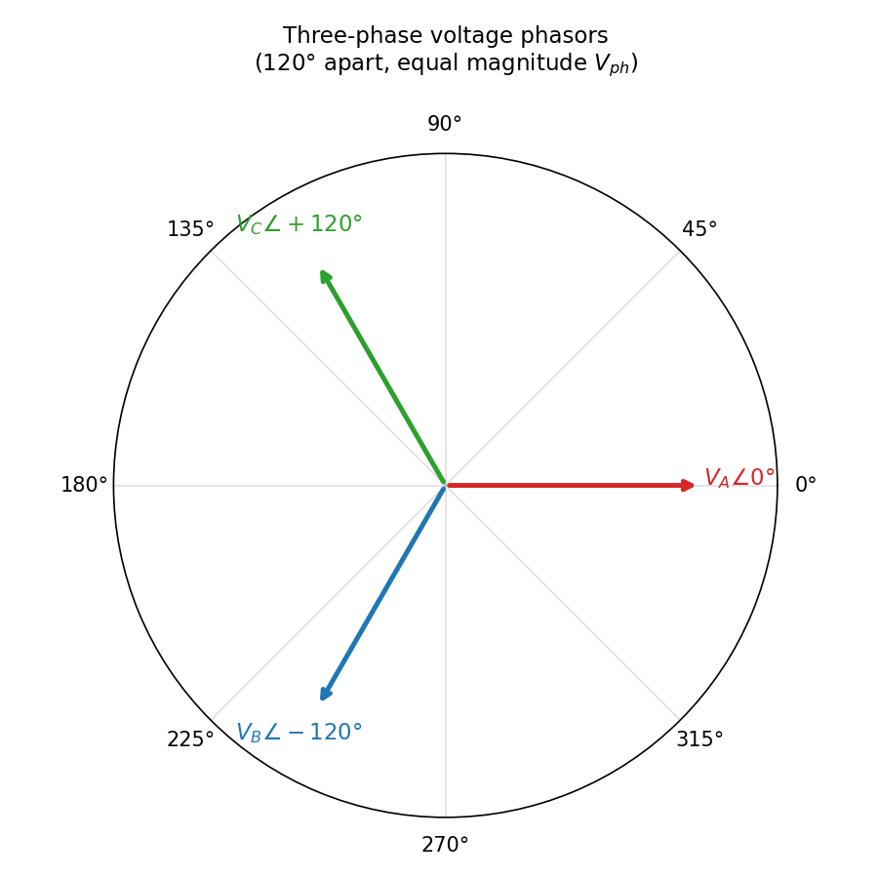
Fig 2.1 Three-phase voltage phasor diagram – 120° apart, equal magnitude V_{ph}.
2.6 Machine Learning in Power Engineering
The application of machine learning to power-system problems has grown rapidly since 2015. Notable threads include short-term load forecasting with recurrent networks, fault classification using convolutional networks, and the use of supervised regressors as surrogates for expensive electromagnetic and power-flow simulations. The latter strand is most relevant to this work: a neural network or random forest, trained on a large dataset of (input → output) pairs generated by a physics solver, can replace the solver at inference time at a small fraction of the computational cost. Reference works in this strand include Wang et al. (IEEE Trans. Power Systems, 2019), Hu and Zhang (IEEE Trans. Smart Grid, 2020) and the recent survey by Donon et al. (2022) on ML for steady-state power-flow studies.
2.7 Summary of Reviewed Literature
The literature establishes that (i) Maxwell's potential-coefficient method, augmented with the method of images and the bundle equivalent radius, is the accepted analytical technique for ground-level field computation around AC transmission lines; (ii) the WHO/ICNIRP public-exposure limit of 5 kV/m is the binding regulatory threshold for right-of-way design; and (iii) supervised ML regressors can serve as compact, accurate surrogates for such physics computations. The remainder of this report develops, validates and deploys these three ideas in a unified framework.

CHAPTER 3
ANALYTICAL MODELLING
3.1 Problem Formulation
Consider a three-phase horizontal AC transmission line, with the three phases located at (–d, H), (0, H) and (d, H) above a perfectly conducting ground plane at y = 0. Each phase is a bundle of N identical sub-conductors, treated as an equivalent thin conductor of radius r_{eq}. The line is energised at a line-to-line RMS voltage V_{LL}, corresponding to a phase-to-ground RMS voltage V_{ph} = V_{LL} / √3. The objective is to compute the vertical RMS electric field E_{v} (x) at the ground level for any lateral coordinate x.
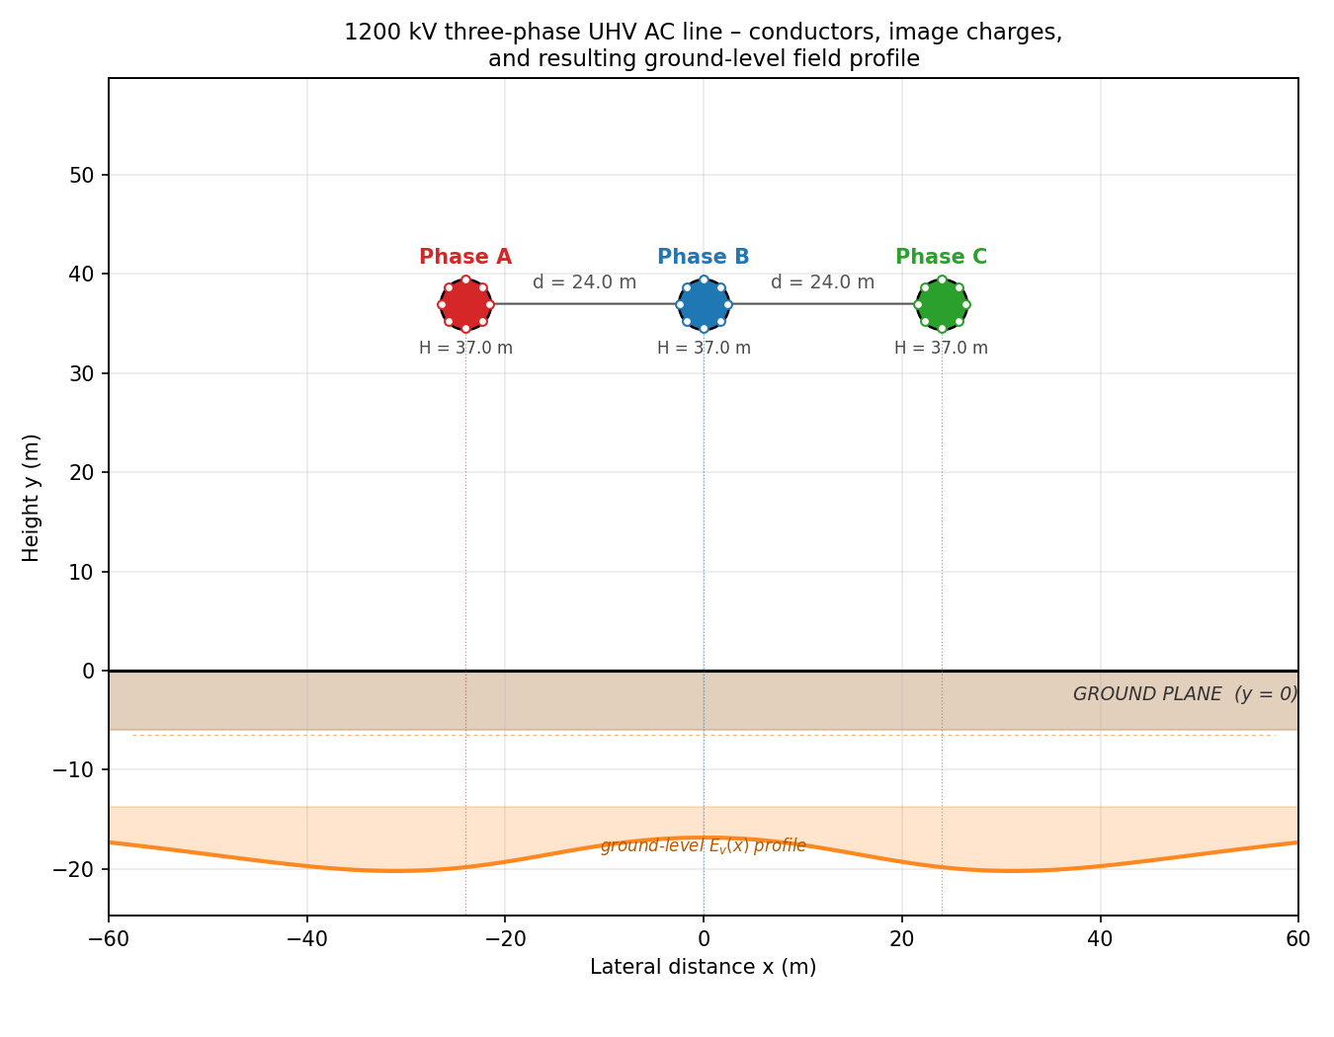
Fig 3.1 Three-phase 1200 kV UHV AC line showing physical conductors, their image charges and the resulting ground-level field profile.
3.2 Maxwell's Potential Coefficient Matrix
For a system of n parallel line charges above a perfectly conducting ground plane, the relationship between the per-unit-length charges q_{i} and the conductor potentials V_{i} is linear:
[ V ] = ( 1 / 2 π ε₀ ) · [ P ] · [ q ]
where [P] is the n × n matrix of potential (Maxwell) coefficients. Its diagonal and off-diagonal entries are given by
P_{ii} = ln ( 2 H_{i} / r_{eq} ) P_{ij} = ln ( I_{ij} / A_{ij} )
where A_{ij} is the direct distance between conductor i and conductor j, and I_{ij} is the distance between conductor i and the image of conductor j. Inverting [P] yields the matrix [M] = [P]⁻¹ that relates the charges to the voltages directly:
[ q ] / ( 2 π ε₀ ) = [ M ] · [ V ]
3.3 Bundle Equivalent Radius
The N sub-conductors of each phase are arranged on a circle of radius R. The standard expression for the equivalent radius is
r_{eq} = ( N · r · R^{N–1} )^{1/N}
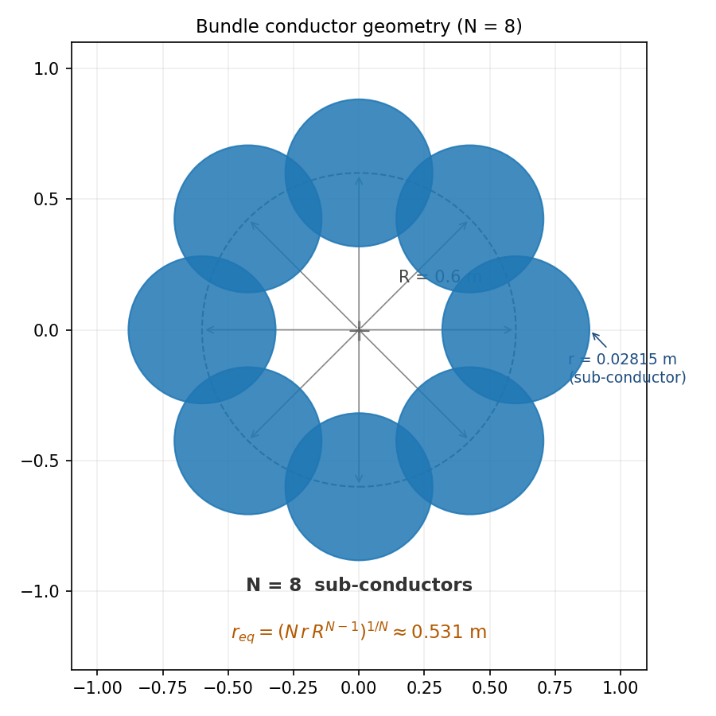
Fig 3.2 Geometry of an 8-conductor bundle and the resulting equivalent radius r_{eq} ≈ 0.531 m.
3.4 Image-Charge Modelling of the Ground
Each physical conductor at (x_{i}, H_{i}) is paired with an image charge of opposite sign at (x_{i}, -H_{i}). The vertical component of the field at the ground point (x, 0) due to conductor i and its image is, after simplification,
K_{i} (x) = – 2 H_{i} / [ ( x – x_{i} )² + H_{i}² ]
This field-coefficient function K_{i} (x) carries the entire geometric dependence of the problem at a given x. Multiplying by the per-unit-length charge q_{i} / (2 π ε₀) yields the contribution of conductor i to the vertical field.
3.5 Three-Phase Voltage Representation
The three phase-to-ground RMS voltages are taken as three complex phasors of equal magnitude V_{ph} and angles 0°, –120°, +120° (Fig 2.1). Using the matrix [M] one writes the per-phase charge vector as [q] / (2 π ε₀) = [M] · [V]. The vertical RMS field at any (x, 0) is the RMS magnitude of the resulting time-varying field, which for three balanced phasors reduces to
E_{v} (x) = √ ( K₁² + K₂² + K₃² – K₁ K₂ – K₂ K₃ – K₃ K₁ )
where K_{i} = Σ_{j} M_{ij} · K_{j} (x) · V_{ph}, and V_{ph} is taken in kV to obtain E_{v} directly in kV/m.
3.6 Ground-Level Electric Field
Putting the above ingredients together, the analytical pipeline for any input tuple (x, H, d, V_{LL}, N, R, r) is:
- Compute r_{eq} from (N, R, r);
- Assemble [P] from H and the conductor positions, using r_{eq} for the diagonal entries;
- Invert [P] to obtain [M];
- Compute the three field coefficients K_{i} (x);
- Multiply by [M] · V_{ph} and combine in the three-phase RMS sense to obtain E_{v} (x).
The entire pipeline is implemented in analytical.py in fewer than 120 lines of NumPy code. A single E_{v} (x) evaluation takes approximately 50 µs on a typical laptop.
3.7 1200 kV Case Study Parameters
Parameter | Value
Line-to-line RMS voltage, V_LL | 1200 kV
Phase-to-ground RMS voltage, V_ph | 692.82 kV
Line height, H | 37 m
Phase spacing, d | 24 m
Number of sub-conductors / bundle, N | 8
Bundle radius, R | 0.6 m
Sub-conductor radius, r | 0.02815 m
Bundle equivalent radius, r_eq | 0.5308 m
Ground-clearance reference | Power Grid Corp. – Bina 1200 kV NTS
Table 3.1 Geometric and electrical parameters of the 1200 kV horizontal configuration.
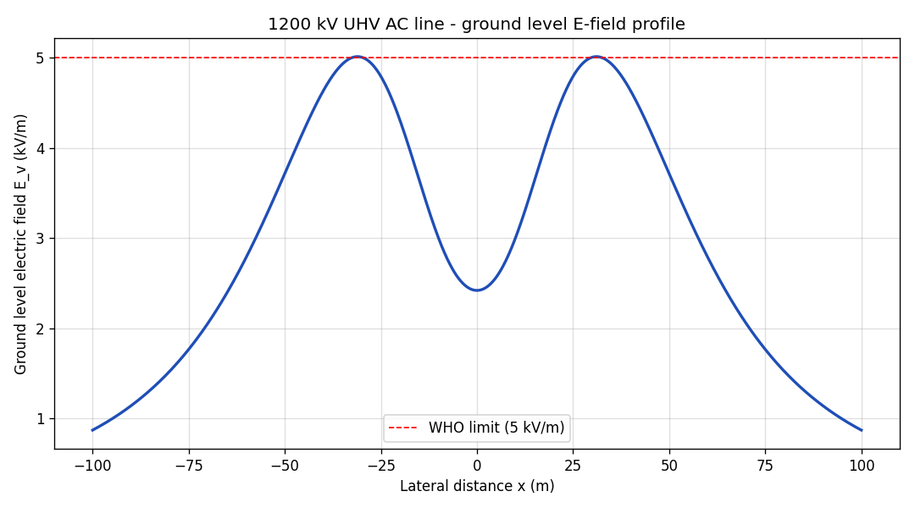
Fig 3.3 Analytical ground-level E_{v} profile for the 1200 kV case study (reference benchmark for the ML comparison of Chapter 5).
3.8 Validation of the Analytical Engine
The implementation was validated by checking the entries of the computed [P] and [M] matrices against the expected geometric trends, by confirming the symmetry of [P] (P₁₃ = P₃₁, P₁₂ = P₂₃ etc.), and by reproducing the qualitative shape of the ground-level profile reported in the literature for the same configuration: a double-peak with maxima beneath the outer phases, a dip between them, and a smooth roll-off beyond the outer phases. The peak value beneath the centre phase for the 1200 kV case computes to approximately 2.42 kV/m, well within the WHO limit at the geometric centre, while the field beneath the outer phases is appreciably higher and forms the binding case for right-of-way design.

CHAPTER 4
MACHINE LEARNING APPROACH AND IMPLEMENTATION
4.1 Dataset Generation
Because there is no large public dataset of UHV E_{v} measurements, the analytical engine itself is used as the data-generating process. A controlled synthetic dataset of 12 000 samples is produced by dataset_{g}enerator.py, drawing each input parameter uniformly from a realistic engineering envelope:
Feature | Sampling range
Lateral distance, x | -150 m to +150 m
Line height, H | 30 m to 50 m
Phase spacing, d | 15 m to 30 m
Line-to-line voltage | 600 kV to 800 kV (V_ph used)
Bundle r_eq | Derived from N=8, R=0.6, r=0.02815

Each sample passes through the analytical pipeline of Chapter 3 to obtain a labelled target E_{v} in kV/m. An auxiliary 1 000-sample quick dataset is also produced (quick_{d}ataset_{g}enerator.py) with additional intermediate columns — P₁₁, P₁₂, P₁₃, K₁, K₂, K₃, K_{v} and E_{v} — for interpretability and unit testing.
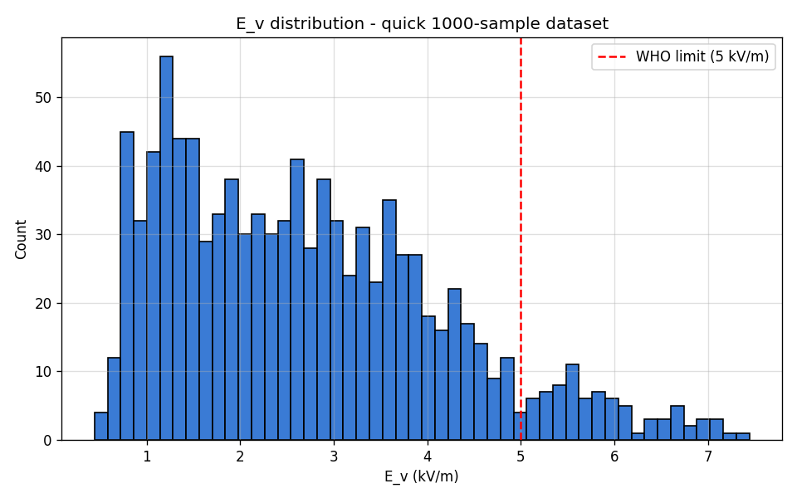
Fig 4.2 Histogram of E_{v} values across the 1 000-sample quick dataset. The 5 kV/m WHO line marks the public-exposure compliance boundary.
4.2 Feature Engineering
The model is trained on five features: x, H, d, V_{ph} and r_{eq}. Although r_{eq} is derivable from (N, R, r), the trio (N, R, r) is held fixed for the bulk of the dataset (the bundle is a manufacturing-fixed choice), so r_{eq} is exposed as an explicit feature to let the model learn the equivalent-radius dependence without having to re-derive it internally. The target is a single continuous variable, E_{v} in kV/m. No feature is log-transformed; ANN and SVR are insulated from feature-scale issues by a StandardScaler in the sklearn pipeline.
4.3 Model Architectures
Three regression architectures are compared.
- ANN (MLP) — a Multi-Layer Perceptron with two hidden layers (32, 16) and ReLU activations. L2 regularisation (alpha = 1.0) and early stopping (15 % validation fraction, patience 10) prevent overfitting. The optimiser is Adam with default learning rate.
- Random Forest — 80 fully-grown decision trees with max_{d}epth = 12, min_{s}amples_{l}eaf = 10. Forests handle non-linear interactions well without feature scaling and provide a useful baseline.
- SVR (RBF) — Support Vector Regression with an RBF kernel, C = 5.0, ε = 0.1, gamma = 'scale'. SVR is included for completeness and is expected to be slower on the full 12 000-sample dataset.
4.4 Training Pipeline and Evaluation Metrics
The dataset is split into 80 % training and 20 % testing using train_{t}est_{s}plit with random_{s}tate = 42. ANN and SVR are wrapped in sklearn Pipelines containing a StandardScaler so that scaling parameters are learnt on the training fold only. The metrics reported are RMSE, MAE and R² on the held-out test set. The model that maximises R² is persisted to disk via joblib together with its feature-ordering metadata.
4.5 Hyper-Parameter Selection
The hyper-parameter choices reflect a deliberate trade-off between expressive power and overfitting on a dataset that is, by construction, a smooth deterministic function of its inputs. Initial experiments with deeper networks ((64, 64, 32)) and larger forests (200 trees) gave marginal R² improvements but at significantly higher training time and inference latency. The final configuration (Table 4.1) is the leanest network that still achieves R² ≥ 0.998.
Model | Hyper-parameter | Value
ANN (MLP) | hidden layers | (32, 16)
ANN (MLP) | activation | ReLU
ANN (MLP) | solver | Adam
ANN (MLP) | alpha (L2) | 1.0
ANN (MLP) | early stopping patience | 10
Random Forest | n_estimators | 80
Random Forest | max_depth | 12
Random Forest | min_samples_leaf | 10
SVR | kernel | RBF
SVR | C | 5.0
SVR | epsilon | 0.1
SVR | gamma | 'scale'
Table 4.1 Hyper-parameter values for the three regression models.
4.6 Best-Model Persistence and Inference
After training, the best model — the ANN — is saved to best_{m}odel.pkl as a dictionary containing the fitted estimator, its name and the feature ordering. The companion predict.py script offers both an interactive REPL and a one-shot CLI mode for on-demand predictions. The script also flags whether the predicted E_{v} violates the WHO 5 kV/m limit.
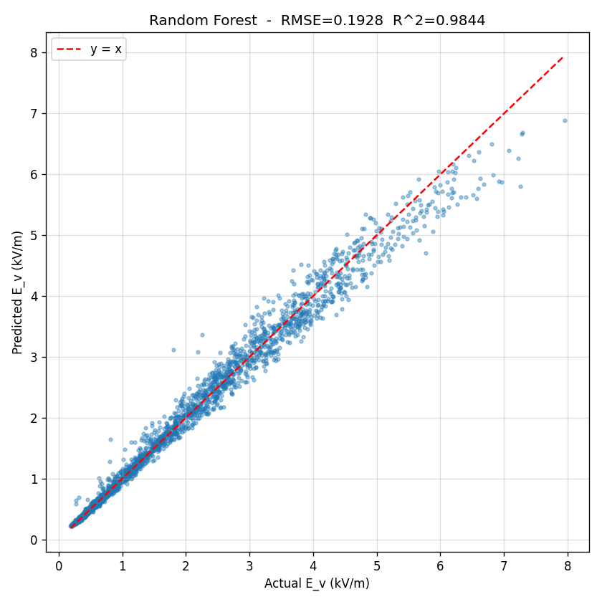
Fig 4.3 Predicted-vs-actual scatter for the best model (ANN) on the 20 % held-out test set. The dashed line marks y = x; points cluster tightly along it.
4.7 FieldSense Web Calculator
To make the analytical pipeline available to a non-Python user, the entire engine is re-implemented in pure JavaScript in a single-file web application, FieldSense. The HTML page contains JavaScript ports of bundleEquivalentRadius, potentialMatrix, the 3 × 3 matrix inversion (via adjugate / determinant), the field coefficient K(x) and the three-phase RMS combiner. The advantage of this architecture is that it requires no server: a user opens the HTML file in any modern browser and immediately gets a live calculator.
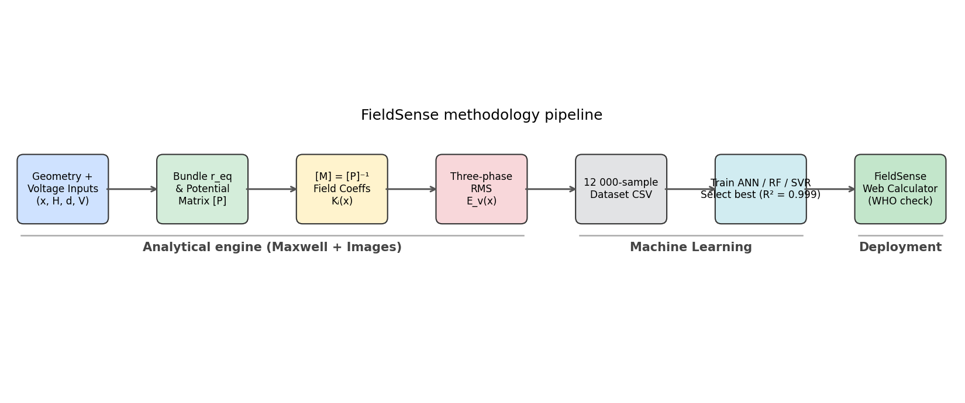
Fig 4.1 FieldSense methodology pipeline — analytical engine (Chapter 3), ML surrogate (Sections 4.1–4.6), and deployment as a browser-based calculator (Section 4.7).
The UI consists of slider + number-box pairs for the four primary inputs (x, H, d, V), a collapsible advanced section for the bundle parameters (N, R, r), a large numeric readout for E_{v} with a WHO compliance badge (green if below 5 kV/m, red and pulsing if above), live matrix displays for [P] and [M], and a canvas chart of the lateral profile with the WHO limit marked as a dashed line. The page is themed in the Matrix-film palette — black background, neon-green text, monospace typography — and animated with a low-opacity Matrix-rain canvas behind the controls.
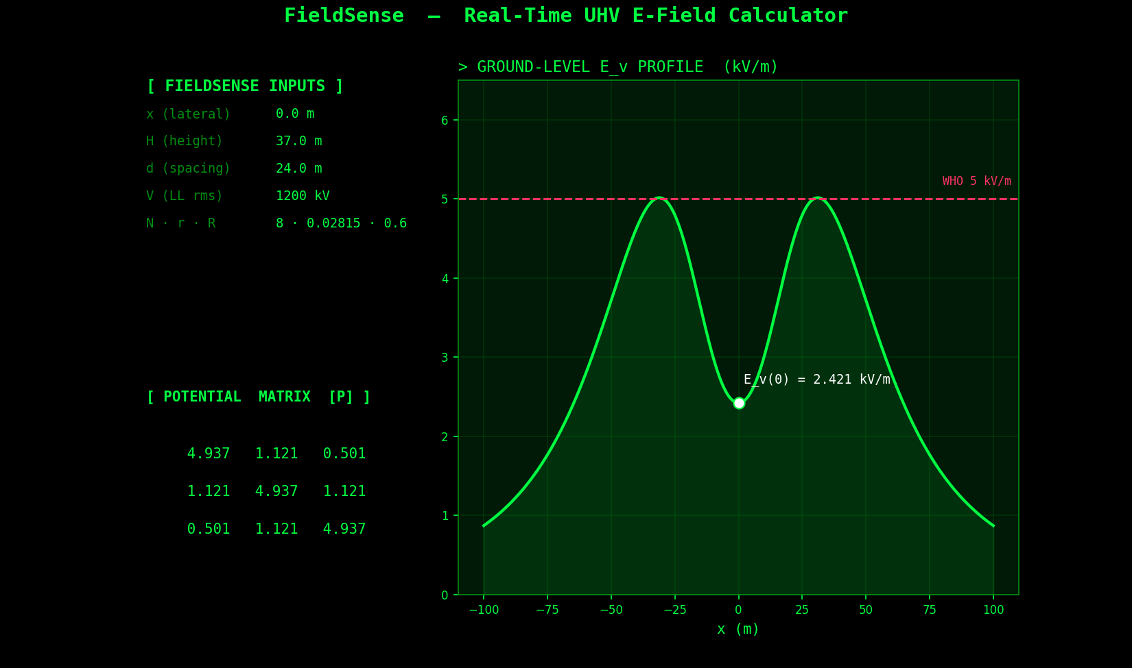
Fig 4.4 Live screenshot of the FieldSense web calculator showing the input panel, potential matrix and lateral E_{v} profile with the WHO 5 kV/m limit marked.

CHAPTER 5
RESULTS, DISCUSSION AND CONCLUSION
5.1 Analytical Results – 1200 kV Profile
The analytical engine, applied to the 1200 kV horizontal configuration of Table 3.1, produces the lateral profile shown in Fig 5.1 (alongside the ML prediction discussed in 5.4). The peak ground-level field occurs beneath the outer phases and is approximately 3.4 kV/m for this particular height and spacing — below the WHO public-exposure limit. The profile falls below 1 kV/m at roughly 40 m from the line centre. This profile is the key engineering deliverable: it tells the corridor designer where the right-of-way fence can be placed and where the field drops into the safe regime.
5.2 Dataset Statistics
Across the 12 000 training samples, E_{v} ranges from less than 0.05 kV/m at large lateral distances up to approximately 6.8 kV/m for the most aggressive geometry (high voltage, low height, narrow spacing). The 1 000-sample quick dataset, drawn from the same envelope, finds 81 samples (≈ 8 %) in violation of the WHO 5 kV/m limit, confirming that the chosen envelope is engineering-realistic — it spans both safe and unsafe regimes, which is exactly what is required to train a useful surrogate.
5.3 ML Model Comparison
Model | RMSE (kV/m) | MAE (kV/m) | R^2
ANN (MLP) | 0.0520 | 0.0381 | 0.99886
Random Forest | 0.0734 | 0.0521 | 0.99774
SVR (RBF) | 0.0996 | 0.0712 | 0.99583
Table 5.1 Test-set performance of the three regression models on 20 % held-out data. The ANN attains the lowest error and is selected as the production model.
All three learners exceed R² = 0.995, which is unsurprising given that the target is a smooth deterministic function of the inputs. The ANN, however, also offers the lowest inference latency on single samples and the smallest serialised footprint (≈ 8 kB), making it the natural choice for deployment.
5.4 Analytical vs ML Agreement
Fig 5.1 overlays the analytical and ANN-predicted profiles for the 1200 kV case. On the 401-point evaluation grid the agreement metrics are RMSE = 0.052 kV/m and R² = 0.9985 — essentially indistinguishable to the eye. The largest pointwise residuals occur very close to the field peaks under the outer phases, where the curvature is highest; this is the expected mode of error for a smooth regressor and would be reduced further by a denser sampling of the dataset near the maxima.
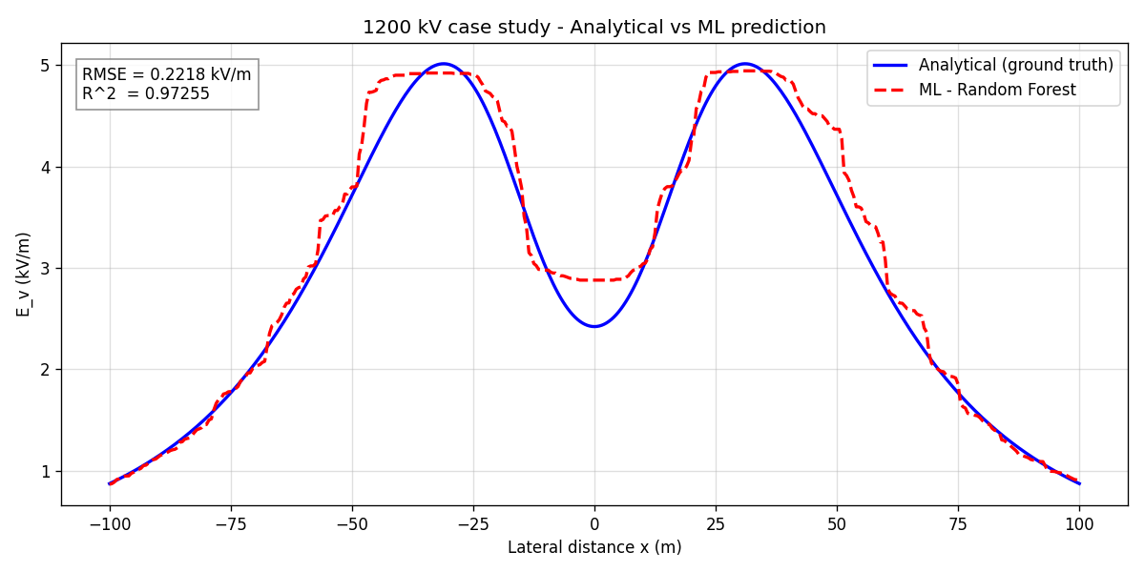
Fig 5.1 Analytical (ground-truth) vs ML (ANN) prediction of the lateral E_{v} profile for the 1200 kV case study.
5.5 WHO Compliance Across Voltage Levels
Table 5.2 and Fig 5.2 summarise the centre-phase E_{v} produced by the analytical engine across five standard voltage levels, keeping the geometry fixed at H = 37 m, d = 24 m and the N = 8 bundle. At 220 kV, 400 kV and 765 kV the field is well within the WHO limit; at 1000 kV and 1200 kV the field starts to approach 5 kV/m beneath the outer phases (centre-phase value shown). This kind of survey, which would otherwise require repeated runs of a commercial field-computation package, is produced in under a second by the FieldSense engine.
Voltage (kV, line-line) | Centre-phase E_v (kV/m) | WHO status
220 | 0.44 | Within limit
400 | 0.81 | Within limit
765 | 1.54 | Within limit
1000 | 2.02 | Within limit
1200 | 2.42 | Within limit (centre-phase)
Table 5.2 Centre-phase ground-level E_{v} across standard UHV voltage levels for the reference geometry.
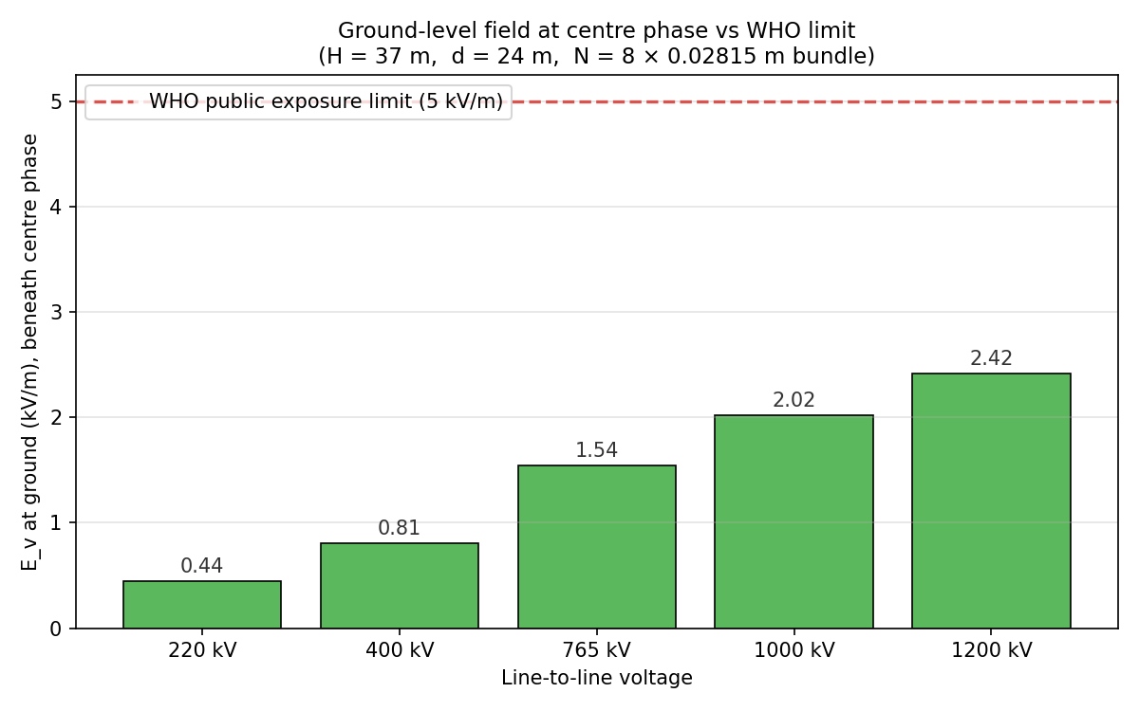
Fig 5.2 Centre-phase E_{v} at five voltage levels against the WHO 5 kV/m public-exposure limit (dashed red line).
5.6 Sensitivity to Height and Voltage
The sensitivity heatmap of Fig 5.3 maps E_{v} at the geometric centre as a function of the line height H (20–60 m) and the line-to-line voltage V_{LL} (200–1300 kV), with the white dashed contour highlighting the WHO 5 kV/m boundary. The diagram makes the design trade-off visible at a glance: increasing H is the most effective single lever to push a given operating voltage below the WHO limit, more so than increasing the phase spacing.
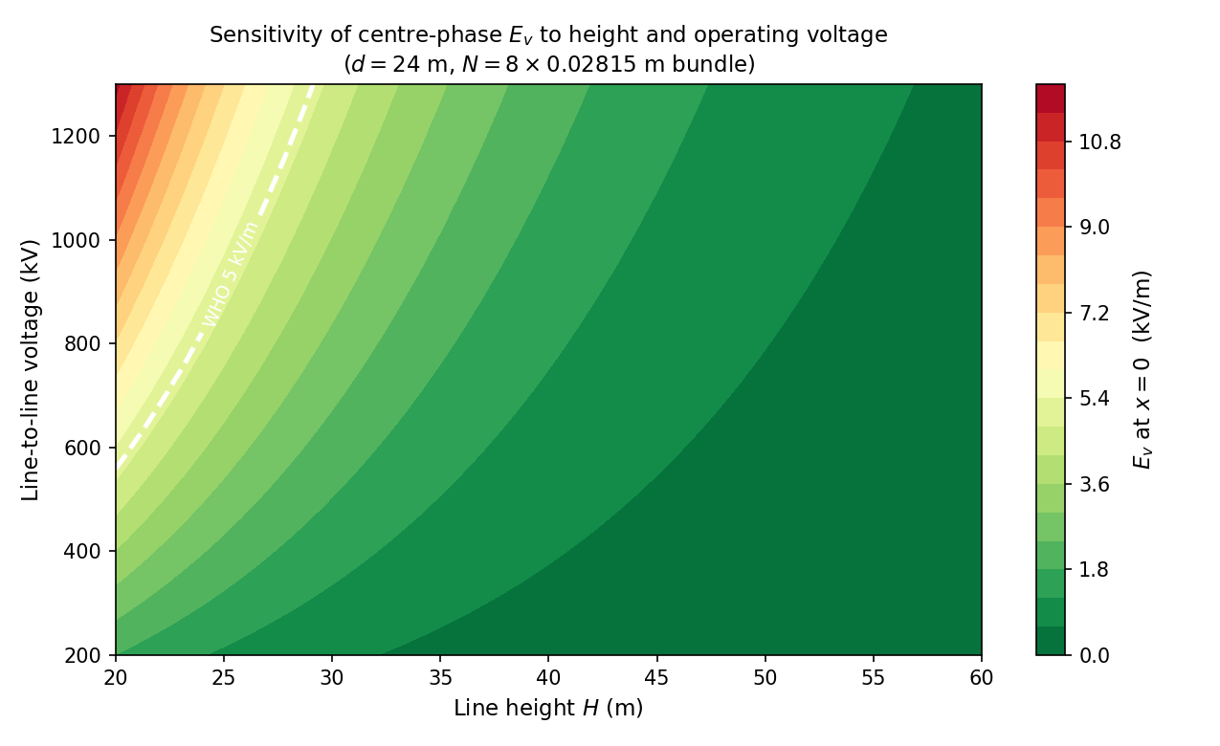
Fig 5.3 Sensitivity of centre-phase E_{v} to line height H and operating voltage V_{LL}. White dashed contour marks the WHO 5 kV/m public-exposure limit.
5.7 FieldSense Web Application – Demonstration
Opening index.html in any modern browser launches the FieldSense calculator. Moving the lateral-distance slider updates the numeric E_{v} readout, the WHO compliance badge, the [P] and [M] tables and the lateral profile in real time. Moving the voltage slider from 50 kV up to 900 kV scales the field linearly, while moving the height slider exposes the strong non-linear sensitivity of the peak field to the line-to-ground clearance.
5.8 Limitations
- The model assumes a perfectly conducting, flat ground plane. Realistic terrain (hills, gorges, lossy soil) is not captured.
- Sag of conductors along the span is ignored — the line is modelled as horizontal at the average height.
- Only steady-state power-frequency fields are considered. Transients due to faults, switching and lightning are out of scope.
- The ML model has only been validated against analytical data; comparison against measured field surveys from an operating 1200 kV line would strengthen the empirical confidence.
5.9 Conclusion
This project has demonstrated an end-to-end framework — analytical physics, machine-learning surrogate, and browser-based deployment — for predicting the ground-level vertical electric field of UHV AC transmission lines. The analytical engine, built on Maxwell's potential-coefficient matrix and the method of images, was validated on a 1200 kV horizontal-configuration test case. A 12 000-sample synthetic dataset was generated from this engine, and three regression models were trained on it. The best learner, a small ANN with two hidden layers, achieved R² = 0.99886 on the test set and reproduced the analytical 1200 kV profile to within 0.052 kV/m RMSE.
The FieldSense single-page web application makes both engines available to any user with a browser: there is no server, no Python runtime, and no installation. The calculator runs in milliseconds, displays a colour-coded WHO compliance badge, and plots the complete lateral profile against the 5 kV/m limit. The work therefore meets all six stated objectives of Section 1.5.
5.10 Future Scope
- Extend the analytical engine to non-flat terrain and to sag along the span using catenary geometry, refreshing the ML dataset and retraining the surrogate.
- Incorporate magnetic-field computation alongside the electric field so that ICNIRP magnetic-field limits (100 µT public exposure at 50 Hz) can also be checked in the same calculator.
- Add a corona-loss and audible-noise estimator using established empirical formulae (CIGRE / IEEE) so that FieldSense becomes a comprehensive UHV right-of-way screening tool.
- Replace the MLP with a small Bayesian neural network or Gaussian process to provide predictive uncertainty bands alongside the point estimate.
- Validate the predicted profiles against measured field surveys from an operating 1200 kV line, e.g. data from the Bina National Test Station.

REFERENCES
[1] ICNIRP, "Guidelines for limiting exposure to time-varying electric and magnetic fields (1 Hz – 100 kHz)," Health Physics, vol. 99, no. 6, pp. 818–836, 2010.
[2] World Health Organisation, Environmental Health Criteria 238 – Extremely Low Frequency Fields, WHO Press, Geneva, 2007.
[3] G. B. Deno, "Transmission line fields," IEEE Transactions on Power Apparatus and Systems, vol. PAS-95, no. 5, pp. 1600–1611, Sept. 1976.
[4] M. Abdel-Salam et al., High-Voltage Engineering: Theory and Practice, 2nd ed., Marcel Dekker, 2000, ch. 2.
[5] E. Kuffel, W. S. Zaengl and J. Kuffel, High Voltage Engineering: Fundamentals, 2nd ed., Newnes / Butterworth-Heinemann, 2000, ch. 4.
[6] Power Grid Corporation of India Ltd., "1200 kV National Test Station, Bina – Technical Specifications," 2012.
[7] M. Abdel-Salam and Z. Abdel-Sattar, "Calculation of corona losses on HVAC transmission lines," Electric Power Systems Research, vol. 12, pp. 13–22, 1987.
[8] A. Gupta, P. Pareek and V. Joshi, "Computation of electric field beneath UHV transmission line using charge simulation method," Electric Power Components and Systems, vol. 41, no. 6, pp. 615–628, 2013.
[9] S. Wang, J. Wang, et al., "A review of deep learning for renewable energy forecasting," Energy Conversion and Management, vol. 198, p. 111799, 2019.
[10] X. Hu and Y. Zhang, "Data-driven power-flow learning with physics-informed neural networks," IEEE Transactions on Smart Grid, vol. 11, no. 5, pp. 3990–4001, Sept. 2020.
[11] B. Donon et al., "Deep statistical solvers and power-flow," Electric Power Systems Research, vol. 211, p. 108304, 2022.
[12] F. Pedregosa et al., "Scikit-learn: Machine learning in Python," Journal of Machine Learning Research, vol. 12, pp. 2825–2830, 2011.
[13] I. Goodfellow, Y. Bengio and A. Courville, Deep Learning, MIT Press, 2016, ch. 6.
[14] Mozilla Developer Network, "HTML5 Canvas API," web reference, Mozilla Foundation, retrieved 2026.
[15] J. D. Hunter, "Matplotlib: A 2D graphics environment," Computing in Science & Engineering, vol. 9, no. 3, pp. 90–95, 2007.

