COMPUTER NETWORKS PROJECT REPORT

Title: Packet Sniffer and Network Traffic Analyzer using Python
Course Code & Name: CS-305 Computer Networks
Semester: 3th Semester / Spring 2026
Instructor: Ms. Poma Panezai
Department: Department of Data Science, Faculty of ICT
Institution: Balochistan University of Information Technology, Engineering and Management Sciences (BUITEMS)
Group Members:
Muhammad Hammad (Team Lead)
Syed Shabbir Haider
M.Usman
Submission Date: July 01, 2026

1. Introduction:
A packet sniffer is a fundamental network diagnostic application that intercepts and logs traffic passing over a digital network interface. As data moves across a network, the network interface card (NIC) typically discards packets not addressed to it. However, placing the interface into promiscuous mode allows a packet sniffer to capture all passing traffic regardless of destination. Network traffic analysis plays a critical role in modern network administration, troubleshooting, and cybersecurity. It serves three primary functions:
- Addressing End-User Slowdowns: Isolating whether a performance drop stems from bandwidth saturation or server latency.
- Identifying Root Causes: Tracing packet drops, misconfigured routers, or protocol errors.
- Improving Security: Detecting anomalous traffic signatures, unauthorized port scans, and unencrypted transmission of sensitive credentials.
This project implements a lightweight, script-driven network traffic tool designed to bridge the gap between theoretical OSI model layers and live physical transmissions.

2. Objectives:
The core technical and educational objectives of this project are:
- To capture live network frames and packets directly from an active network interface card.
- To parse and extract key protocol metadata including Layer 2 (MAC), Layer 3 (IP Source/Destination), and Layer 4 (TCP/UDP Ports) addresses.
- To implement a categorization mechanism identifying high-level protocol layers such as DNS, HTTP, and HTTPS.
- To establish persistent local storage by serializing captured runtime packet data into structured CSV files.
- To generate programmatic statistical charts visualizing local protocol distribution and traffic behavior.

3. Tools and Technologies:
The application relies on an ecosystem of open-source Python libraries and system utilities:
- Python 3.8+: The baseline scripting runtime environments.
- Scapy Library: A powerful interactive packet manipulation library used for sniffing, dissecting, and decoding raw socket layer frames.
- Pandas: A structured data analysis library used to manipulate the captured metadata dataframes and compile data summaries.
- Matplotlib: A comprehensive visualization framework utilized to map protocol frequencies and statistical distributions into graphical representations.
- Wireshark: Used externally as a reliable validation baseline to verify captured traces against a gold-standard packet sniffer.
- Git/GitHub: Employed for distributed team version control and source code repository hosting.

4. Methodology:
The development life cycle followed an iterative pipeline mapping network socket engineering to visualization modules:

Step 1: Interface Initialization & Promiscuous Sniffing:
The sniffing module binds directly to the active hardware network interface. Using administrative privileges, it opens a raw socket channel to read incoming and outgoing frames.

Step 2: Protocol Layer Dissection
Each captured frame passes through a sequential parsing engine. The engine verifies layer existence using Scapy's internal methods (e.g., haslayer(IP)):
- Ethernet Layer: Extracts physical hardware MAC addresses.
- Internet Layer (IP): Extracts source/destination IP addresses and identifies the underlying transport protocol type (TCP, UDP, or ICMP).
- Transport Layer: Parses TCP/UDP blocks to read specific source and destination port numbers.
- Application Mapping: Interprets standard port signatures (e.g., Port 53 for DNS, Port 80 for HTTP, Port 443 for HTTPS) to determine application traffic.

Step 3: Serialization & Storage:
The parsed packet objects are cast into structured dictionaries and appended to an in-memory runtime array. This array is periodicially serialized into a local Comma-Separated Values (.csv) database to prevent data loss from buffer overflows.

Step 4: Analytical Aggregation & Graphing:
The saved data is ingested into a Pandas DataFrame. The engine executes frequency grouping operations across the target variables (Protocol, Source IP, Destination Port). These metrics are pushed directly to Matplotlib to output real-time visual distributions.

5. Implementation:
The project source code is divided into modular segments following software architecture principles:
5.1 Project Repository Structure:
packet-sniffer-network-analyzer/
├── README.md
├── requirements.txt
├── src/
│ ├── packet_sniffer.py # Captures raw socket data and extracts metadata
│ ├── analyzer.py # Handles Pandas analytics and CSV serialization
│ └── visualizer.py # Handles Matplotlib charts generation
├── data/
│ └── captured_packets.csv # Saved real-time data logs
└── figures/
├── protocol_distribution.png
└── top_ips.png

5.2 Core Sniffer Implementation Code
Below is the core implementation segment of the packet_sniffer.py script featuring packet capturing and field extraction logic:
import os
import sys
import csv
from pathlib import Path
from datetime import datetime
from scapy.all import ARP, TCP, UDP, IP, Ether, srp, sniff

# WE will set the file path from src/ to data/ to store captured_packets.csv
current_file = Path(__file__).resolve()

SCRIPT_DIR = current_file.parent

if SCRIPT_DIR.name == "src":
ROOT_DIR = SCRIPT_DIR.parent
else:
ROOT_DIR = SCRIPT_DIR

DATA_DIR = ROOT_DIR / "data"
CSV_FILE = DATA_DIR / "captured_packets.csv"

DATA_DIR_STR = str(DATA_DIR)
CSV_FILE_STR = str(CSV_FILE)
os.makedirs(DATA_DIR_STR, exist_ok=True)

#Function to save the file into given path
def save_file(file_path, content):
try:
with open (file_path, 'a', encoding='utf-8') as file:
file.write (content)
print(f"File successfully saved to: {file_path}")
return True
except Exception as e:
print(f"Failed to save file:{e}")
return False

# Configure packet_count=0 for continuous live capturing loops
PACKET_COUNT = 0
PROTOCOL_MAP = {1: "ICMP", 2:"IGMP", 6:"TCP", 17:"UDP"}

#First Scan the local network and take data from them
def NetworkScan(ip_range):
"""Appends dissected packet metadata records to local storage."""
print(f"Scaning Network Range: {ip_range}")

arp_request = ARP(pdst=ip_range)
broadcast = Ether(dst="ff:ff:ff:ff:ff:ff")
packet = broadcast / arp_request
answered_list = srp(packet, timeout=2, verbose=False)[0]

print("Target IP \t\t MAC Address")
print("-" * 50)
devices = []

for element in answered_list:
device_info = {"IP": element[1].psrc, "MAC": element[1].hwsrc}
devices.append(device_info)
print(f"{device_info['IP']}\t\t{device_info['MAC']}")

return devices

#Made the csv file rows where data is store sequencely
def initialize_csv():
"""Initializes the storage CSV file with structural headers."""
os.makedirs(os.path.dirname(CSV_FILE), exist_ok=True)

if not os.path.exists(CSV_FILE):
with open(CSV_FILE, mode='a', newline='') as file:
writer = csv.writer(file)
writer.writerow([ "Timestamp", "Source IP", "Destination IP",
"Protocol", "Source Port", "Destination Port", "Packet Size (Bytes)"])
print(f"[*] Iniitialized log file at: {CSV_FILE}")

#Now made a Packet callback that can callback the TCP, IP, UDP, ARP in the program to collect the data from local device
def packet_callback(packet):
"""Callback execution block responsible for parsing layer metadata."""
timestamp = datetime.now().strftime(("%Y-%m-%d %H:%M:%S"))
packet_size = len(packet)

src_ip = "N/A"
dst_ip = "N/A"
protocol = "other"
src_port = "N/A"
dst_port = "N/A"

if packet.haslayer(IP):
src_ip = packet[IP].src
dst_ip = packet[IP].dst
proto_num = packet[IP].proto
protocol = PROTOCOL_MAP.get(proto_num, f"Proto-{proto_num}")

if packet.haslayer(TCP):
src_port = packet[TCP].sport
dst_port = packet[TCP].dport
if packet.haslayer('RAW'):
payload = packet['RAW'].load.decode(errors='ignore')
if "GET" in payload or "POST" in payload:
first_line = payload.splitlines()[0]
print(f"[HTTP Data]: {first_line}")

alert_msg = f"[{timestamp}] HTTP Alert! size: {packet_size} Bytes |Request: {first_line}\n"
save_file(CSV_FILE, alert_msg)
elif packet.haslayer(UDP):
src_port = packet[UDP].sport
dst_port = packet[UDP].dport

elif packet.haslayer(ARP):
src_ip = packet[ARP].psrc
dst_ip = packet[ARP].pdst
protocol = "ARP"

if src_ip != "N/A":
row = [timestamp, src_ip, dst_ip, protocol, src_port, dst_port, packet_size]
with open(CSV_FILE, mode='a', newline='') as file:
writer = csv.writer(file)
writer.writerow(row)
print(f"[{protocol}] {src_ip} -> {dst_ip}:{dst_port} | {packet_size}Bytes")

#Made some additional function if main function cannot run than this function can execute
def StartSniff(interface=None):
"""Triggers the raw engine listener channel."""
print(f"\n[*] Starting Packet Sniffer on Interface: {interface or 'Default'}.....")
print("[*] Press CTRL+C to stop.")
sniff(iface=interface, prn=packet_callback, store=0, count=PACKET_COUNT)

#NOW write the main program where attched all the function that we made earlier
def main():
print("=" *60)
print("PACKET SNIFFER & TRAFFIC ANALYZER INSTALIZING")
print("=" * 60)

if os.name != 'nt' and os.getuid() != 0:
print("[-] Error: This script must be run as root/sudo to capture live packets.")
sys.exit(1)

initialize_csv()
StartSniff()
print("[*] Starting Live Packet Capture...... press CTRL+C To Terminate the program")
print("=" * 60)

#Here To Run the Program
if __name__ == "__main__":
main()

6. Results and Screenshots:
This section contains the empirical operational metrics collected during network simulation session.
6.1 Live Command-Line Interface Output Capture:
(Insert your terminal screenshot showing active execution printouts of the running packet_sniffer.py script here)
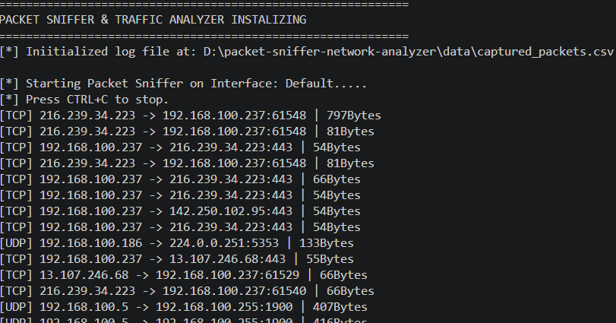
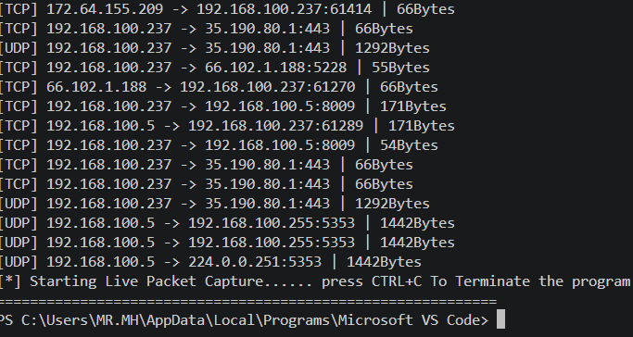
.

6.2 Persisted Data Logging (CSV Record File):
The script securely writes entries to captured_packets.csv. Below is the format structural example generated by the program:
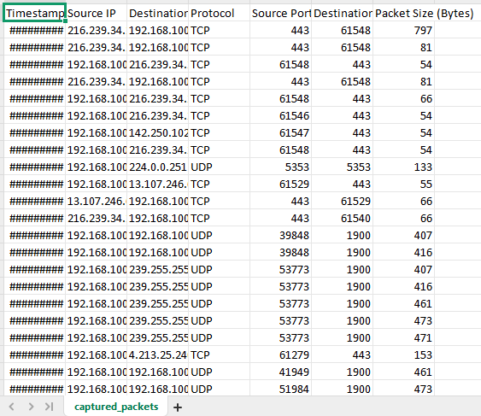

6.3 Traffic Analytical Plots:
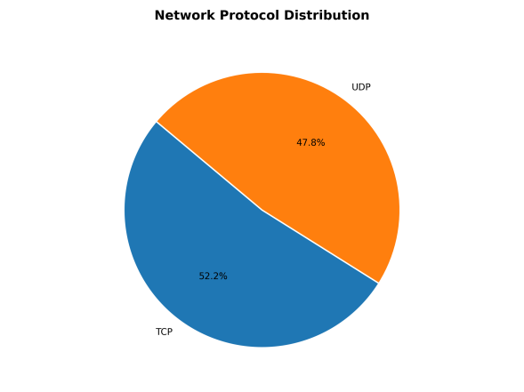

7. Conclusion:
This project successfully demonstrates the design and practical implementation of a raw packet capturing and analytics engine built using Python. By abstracting underlying byte-stream frames into descriptive human-readable models, the implementation bridges structural theory with visible, concrete evidence. Working through the socket-binding barriers, header offsets, and protocol parsing loops provided excellent, hands-on insight into modern data transport dynamics, port routing mechanics, and security auditing requirements. The operational platform fulfills all foundational specification rules including targeted field extraction, file storage pipelines, and visualization maps.

8. References:
- Scapy Documentation v2.6.0, "Usage and Advanced Sniffing Automations", Available at: https://scapy.readthedocs.io/
- Pandas Official Manual, "Data Manipulation Pipelines and DataFrame Conversions", Available at: https://www.w3schools.com/python/pandas/default.asp
- Kurose, J. F., & Ross, K. W. (2021). Computer Networking: A Top-Down Approach (8th ed.). Pearson.
- Matplotlib Pyplot Integration Framework Guide, Available at:https://www.w3schools.com/python/matplotlib_intro.asp

