Predicting Customer Loyalty
Clankers: Lexie Boyd, Lauren Dunbar, Kian Thomasbeer, Stephanie Tiede
STAT 4630
Dec. 9, 2025

Introduction
This project aims to answer the question of how to predict repeat purchases using UK retail data. Knowing the answer to this question allows companies to better target these customers with rewards and, on the other hand, better target those who will not be buying from them in the future. With this information, they can create a plan to fix their retention for those who will not be returning. From a company’s standpoint, being informed of the significant factors in customer churn allows for a better understanding of an accurate demand forecast. As a result, the inventory levels will likely be more accurate with less “out-of-stock” instances. Ultimately, being able to create as many consistent lifetime customers will be invaluable for any company due to the cost of new customers in comparison to lifetime customers. Cutting costs on marketing to those who will be less likely to become repeat customers will help a company’s profitability in the long run. Throughout the analysis, models are compared under different information regimes, ranging from first-purchase data to longitudinal customer history, reflecting how predictability evolves over the customer lifecycle.
Dataset Description
The dataset is the Online Retail II dataset from the UCI Machine Learning Repository. It contains all transactions occurring for a United Kingdom based and registered non-store online retail business between December 1, 2009 and December 9, 2011. The company sells unique all occasion giftware, and many customers are wholesalers. The dataset includes 1,067,371 transaction records and eight variables: Invoice, StockCode, Description, Quantity, InvoiceDate, Price, CustomerID, and Country. It is stored in XLSX format and represents actual transactional data. This dataset is interesting because it contains real world business transactions with both customer and product information. Ultimately, this project aims to build predictive models that generalize well using ridge regression, bagging, and neural network methods inspired from STAT4630 Statistical Machine Learning classwork.
Exploratory Data Analysis
The first step in cleaning the data is removing the records with missing Customer IDs and ensuring the integrity of our results by removing the transactions with unreasonable values like negative quantities. This results in 4304 unique customers – which gives us reason to believe a lot of our data is going to be repeat customers. To investigate the distribution of the response variable, we created a binary variable, repeat_purchase, which makes up 67% of the purchases. The recency of the purchase and total amount spent of purchases present to the viewer is a strong right skew no matter if it is a repeat purchase or not. Naturally, the country that the most repeat customers belong to is the UK. From looking at the means, we know that while the maximum number of purchases is 205, they mostly range from 1-5. Total spent ranges from 30 to 170 pounds with a maximum of 28120 pounds. In terms of multicollinearity, factors to consider are: repeat purchases and customer lifetime days as well as number of purchases and total spent.
Ridge Regression
This section evaluates how predictable customer repeat purchasing is using ridge-penalized logistic regression, and how that predictability changes as additional information becomes available. The modeling framework is held fixed to isolate how the timing and strength of predictive signals evolve as the information set expands. Ridge-penalized logistic regression is used because predictors such as spend, quantity, item counts, and customer averages are highly correlated. The objective is stable out-of-sample inference rather than aggressive in-sample fit. Ridge regularization constrains coefficient magnitudes, mitigating instability and retaining only signal that improves cross-validated performance.
The first model relies exclusively on information available at the customer’s first purchase. The outcome is a binary indicator of whether the customer ever makes a repeat purchase. Predictors include total basket spend, total quantity, number of distinct items, hour of purchase, day of week, and geographic region (constructed by grouping countries into broad regions). Continuous variables are standardized, categorical variables are one-hot encoded, and the data are split into stratified training and test sets. The ridge penalty is selected via cross-validation to minimize log loss.
Results show that first-purchase information contains little predictive signal. Cross-validation selects a very strong penalty (C = 0.001), indicating heavy shrinkage. Because AUC evaluates pairwise ranking rather than threshold accuracy, it is the most appropriate metric for assessing model usefulness under class imbalance. Test AUC is 0.537, barely above random. Test log loss is approximately 0.643, essentially identical to a baseline that predicts a constant repeat-purchase probability. At a 0.5 threshold, the model predicts nearly all customers as repeat purchasers, which produces high recall for repeat customers but zero recall for non-repeat customers. An accuracy of roughly two thirds reflects class imbalance rather than real discrimination. Initial basket characteristics, timing, and coarse geography are therefore weak predictors of long-run retention.
The second model uses the same outcome, preprocessing, data splits, and ridge-penalized logistic regression framework as the first, but augments the feature set with customer-level aggregates computed across all observed purchases: average price per item, average quantity per purchase, and an indicator for whether the customer ever returned an item. These variables capture behavioral information that accumulates over time rather than characteristics observed at acquisition.
Predictive performance improves meaningfully. The AUC increases to approximately 0.65, implying that the model correctly ranks a randomly chosen repeat customer above a non-repeat customer about 65% of the time. Test-set log loss declines to roughly 0.60 from a baseline near 0.64, indicating improved probability calibration and discrimination. Cross-validation selects a substantially weaker regularization penalty, suggesting that the added behavioral features provide stable, generalizable signal that survives ridge shrinkage. Despite this improvement, threshold-based classification remains skewed because of class imbalance. At a 0.5 probability threshold, the model exhibits very high sensitivity but low specificity, reflecting probability estimates centered near the base repeat rate rather than a lack of learned signal. Accordingly, the model is best interpreted as a ranking or prioritization tool rather than a binary classifier, as its probability estimates are more informative for relative ordering of customers than for threshold-based classification under class imbalance.
Overall, the results show that repeat purchasing is weakly predictable at acquisition but becomes meaningfully predictable once longitudinal behavioral patterns emerge. Early performance limitations reflect data constraints rather than model failure, and informative signals arise only after customers reveal persistent purchasing behavior over time.
Decision Trees
To classify our data at a slightly more complex level, we used decision trees to classify whether an individual is a repeat or non-repeat customer based on the variables in the data. We used both a regular decision tree and a random forest to classify our data and compared the accuracy rate between the methods. Our original dataset contained customer data based on individual purchases, and we used two variations of that dataset in our decision trees, same as the data used above with the ridge-penalized logistic regression. The first variation of the data included only the first purchase a customer made, and the other variation included aggregated customer data. We removed variables that measured the same thing as whether a customer made a repeat purchase, which included the number of purchases a customer made from the company, the total amount of money spent on the company, and how long the customer has been involved with the company.
Using the first purchase dataset, we first created a classification decision tree that classified customers as ‘Yes’ or ‘No’ depending on whether they had made any repeat purchases from the company. We used the variables measuring the amount spent, the amount of items, average item price, maximum item price, purchase hour, purchase day of the week, and the region the customer is based in to classify whether a customer made any repeat purchases. In the original dataset, the country each customer is based in is recorded, but in R, the tree() functions cannot handle variables with more than a certain amount of levels. To circumvent this, we organized customers by region rather than country which may lead to a loss in information, but it allows us to use the tree() function to create a decision tree. With these variables, a single node decision tree was created, meaning none of the above variables could be used to effectively classify the customers. To find our model’s accuracy rate, we created a training set that included half of the original data, created a tree using our training data with a 50/50 split, compared the classification with our test set, and made a confusion matrix of its classification decisions. The overall accuracy of the first purchase decision tree was approximately 65.44%, but the sensitivity was 100% and the specificity was 0%. This model simply classified all the customers as a repeat customer both because our class imbalance leans towards a majority of ‘yes’ classes, which is similar to the classification preference in the ridge regression above, and because the other variables were not influential on the classification decision.
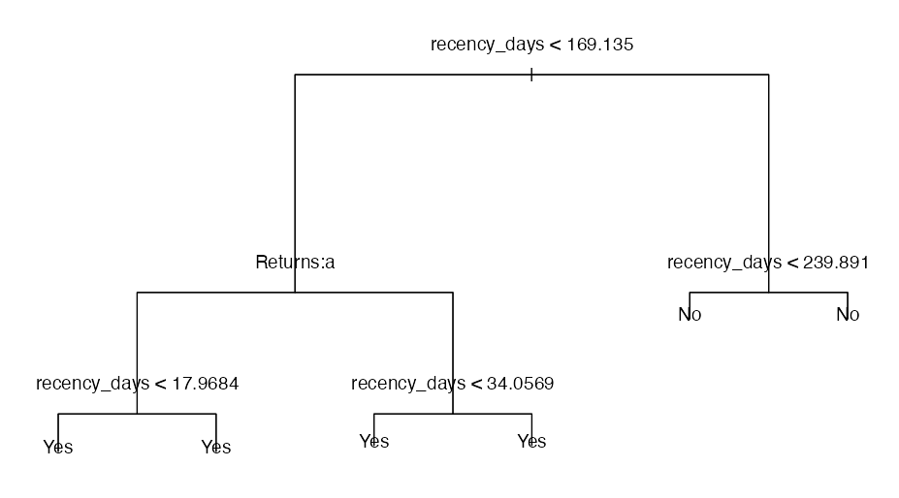
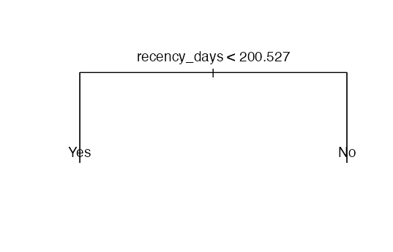
Next, we tried the same decision tree method with the aggregated customer data that includes all purchase information for a customer. The predictor variables in this model included average money amount spent per purchase, date of first and last purchase from the company, amount of days since the last purchase, average amount of items purchased per order, whether the customer ever returned an item, and the region the customer is based in. Variables that measured the same thing as whether the customer ordered from the company more than once were removed from the dataset, and they included the number of purchases made, the total amount of money spent on the company, and the customer lifetime. The decision tree created from aggregated customer data had 6 terminal nodes, with the amount of days since the last purchase variable and whether the customer ever returned an item variable being used in tree construction. These variables may have some predictive power for classifying whether a customer has any repeat purchases because the more recent a customer has purchased from the company, the more likely it may be that they have already bought something before. The accuracy of the aggregated customer decision tree was approximately 74.16%, the sensitivity was 93.19%, and the specificity was 37.48%. Pruning the tree did not change these rates, but did reveal that recency had a strong classification power over returns, and customers are more likely to be classified as having made a repeat purchase if they had purchased something within the last 200.53 days. Overall, the model is not very useful as the specificity is low, meaning the model contains many false positives or Type I errors. Based on this outcome, we can assume that aggregated customer data is more useful in classifying whether a customer made any repeat purchases from the company than just their first purchase information, but is still lacking in classification power overall.
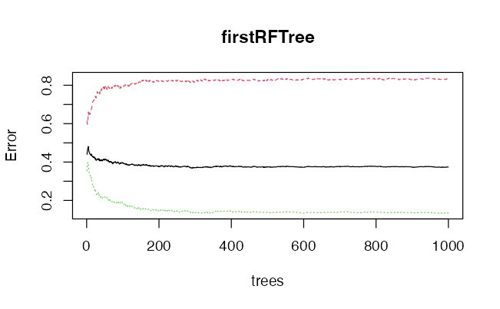
Once we classified our data using decision trees, we wanted to see whether a random forest would produce a more accurate classification of customer repeat purchases through ensemble learning. Using the first purchase data, we created a random forest with the training set of our data, the same one used above, and set the number of predictors per model to 6 (our total predictor count was 8) and the number of trees to 1000. We compared the model between different numbers of predictors per model, and the OOB estimate of error rate was the lowest when we used 6 predictors. This gave us an accuracy rate of 62.61%, a sensitivity rate of 66.56%, and a specificity rate of 39.37%. Not every customer is being classified as ‘yes’ as opposed to the decision tree. Even so, the accuracy rates are relatively low and close to chance. When we looked at which variables were the most important in the random forest, the average item price had the highest mean decrease gini score while basket quantity (amount of items purchases) had the highest mean decrease accuracy score.
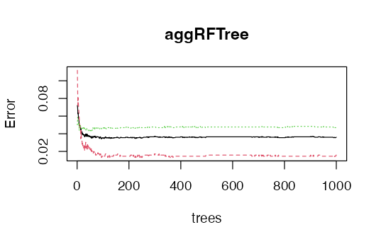
Next, we created a random forest using the aggregated customer data. We set the number of predictors per model to 6 and the number of trees to 1000, the same as the random forest for the first purchase data. This gave us an accuracy of 96.39%, sensitivity of 99.11%, and specificity of 91.86%. This model so far has been the most useful for classifying customers based on whether they made a repeat purchase from the company as we have the highest accuracy scores across true positives and true negatives. When looking at which variables were the most important in the model, the date of the first purchase had the highest mean decrease accuracy as well as the highest mean decrease gini score.
Based on the results of the decision trees and random forests for the first purchase data and the aggregated customer data, we can see that the random forest models for both data result in more variables being used to classify customers, but at the cost of interpretability of the decisions, for aggregated customer data performs the best with the highest accuracy rates but visually is less interpretable than the decision trees. The least useful model was the decision tree for the first purchase data, which classified all customers as ‘yes’ in terms of repeat purchases. From this, we can conclude that random forests are more effective in classifying data than decision trees, and that aggregated data is more useful than a customer's first purchase in classifying whether they made another purchase from the company.
FFNN
The final modeling approach applies a feedforward neural network (FFNN) to evaluate whether flexible, nonlinear function approximation can improve the prediction of repeat purchases beyond ridge regression and random forest. Neural networks are well suited for capturing interactions and nonlinear relationships that linear models and tree ensembles may only approximate.
Before constructing the network, we identified several variables in the customer level dataset that introduced information leakage. Features such as number of purchases, total spending, average spending per purchase, and customer lifetime days directly tell whether a customer returned. When included, these variables led to artificially perfect model performance because the network could infer the outcome perfectly instead of learning behavioral structure. These variables were removed to ensure that the FFNN learned patterns, rather than exploiting post outcome information.
After cleaning the feature set, the remaining predictors included continuous behavioral variables (recency, average quantity, return indicator) and a one-hot encoded representation of customer geography. All numeric predictors were standardized, and the data was split into training, validation, and test sets in a 60-20-20 ratio. The neural network architecture used two hidden layers of 64 units each, with ReLU activation, batch normalization, and dropout to stabilize optimization and reduce overfitting. The output layer consisted of a single linear unit, and predictions were obtained using a sigmoid transformation within the binary cross entropy with logits loss function. Training used the AdamW optimizer, which combines adaptive learning rates with weight decay regularization.
Early stopping on validation AUC was used to select the best model and prevent overfitting. Validation performance improved steadily across the first fifteen epochs, plateaued around an AUC of 0.81, and then began to deteriorate, leading to an early stopping at epoch 24. This training pattern indicates that the network benefited from regularization to avoid memorizing noise. On the held out test set, the FFNN achieved an AUC of 0.82 and an accuracy of 0.73, outperforming the ridge regression but not the random forest. The neural network demonstrated strong recall for repeat customers (0.78), while performance on non repeat customers was more modest (0.64).
Overall, the FFNN results highlight two key insights. First, once the leakage variables are removed, neural networks provide incremental but meaningful gains over simpler methods by capturing nonlinear structure in customer behavior. Second, the network’s ability to identify high probability repeat customers provides value for targeted marketing and retention strategies.
Concluding Thoughts
This project demonstrates that the predictability of customer repeat purchasing depends strongly on both the modeling approach and the amount of information available at the time of prediction. Using only first-purchase data, all methods perform near baseline, indicating that repeat behavior is weakly predictable at acquisition. Ridge-penalized logistic regression is particularly well suited in this setting because it provides stable estimates while accounting for collinearity and class imbalance. Furthermore, the observed performance differences across models reflect the bias-variance tradeoff: regularized linear models favor stability under weak signal, while tree-based ensembles reduce bias at the cost of higher variance when richer information is available.
As aggregated, longitudinal customer information becomes available, predictive performance improves substantially, especially for more flexible models such as tree-based ensembles and neural networks. This increase reflects the growing observability of behavioral patterns over time rather than strong inherent predictability at the point of entry. Accordingly, these models are best interpreted as tools for ranking or monitoring customers once purchase history exists, rather than as early-stage classifiers.
With respect to future work on this research question, more work can be done to investigate how diverse forms of retail or regions beyond the UK compare. The dataset is also more than ten years old, with advancements in marketing technology and online shopping, it would be beneficial to find more recent data.
Overall, the results highlight key trade-offs between interpretability, flexibility, and information dependence across statistical learning methods. Model performance cannot be evaluated independently of prediction timing or feature construction, and different approaches are appropriate at different stages of the customer lifecycle.

AI Use Statement
- Used ChatGPT to create comments on my code to explain work
- Used ChatGPT to give suggestions as to what I should look at in EDA
- Used ChatGPT to debug R and Python issues

