Installing the Caster Plugin (Windows)

- On the computer system running Plex Media Server (PMS), right-click on its tray icon, and select Open Plug-ins Folder:
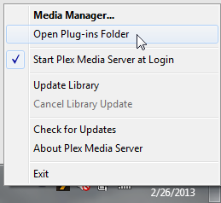

- Copy the entire Caster.bundle folder, to PMS's plug-in folder:
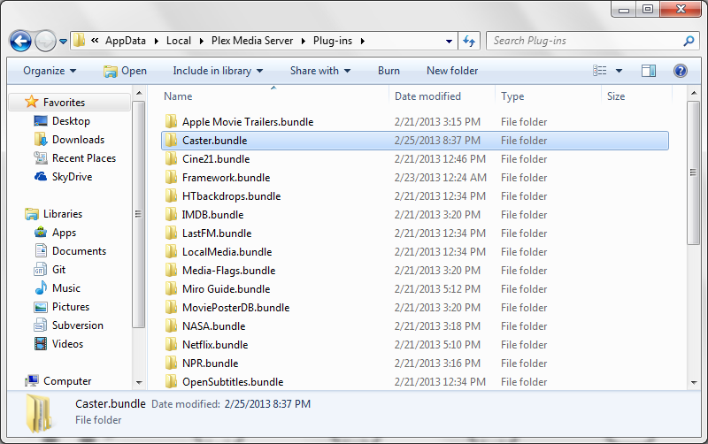

- After a bit, the plug-in should show up in the PMS's Media Manager (right-click the PMS tray icon, and select Media Manager...; if you already have it open, refresh the browser). If it doesn't appear after a few minutes, restart PMS (right-click the PMS tray icon, select Exit then, re-launch the PMS application).

