Lab 1: Your AWS Account, Identity, and Permissions

Overview
In this course you build real data systems in a real AWS account. Before you build anything, you need to know three things about that account: who you are in it, what you're allowed to do, and where your data will live. This lab answers all three. You find your way around the console, discover the identity AWS knows you by, test what that identity can and can't do, and create the S3 bucket you'll use for every lab after this one. Then you protect your raw data with a policy you write yourself, and recover a dataset someone overwrote. You also set up budget alerts that warn you long before you run out of money. Plan for about 60 minutes.
AWS Identity and Access Management (IAM) decides, for every request anyone or anything makes in AWS, whether to allow it. Data science work depends on it: it's what lets a training job read a dataset without anyone pasting a password into a notebook, and what stops a mistaken script from deleting the data a whole team relies on.
After completing this lab, you should be able to:
- Find your account name, account ID, and Region in the AWS Management Console
- Create AWS Budgets alerts that warn you as your spending grows.
- Explain the difference between an IAM user and a role, and why your session uses a role with temporary credentials.
- Read an IAM policy and identify its Effect, Action, Resource, and Condition.
- Predict whether AWS allows a request, including when an explicit deny overrides an allow.
- Create an S3 bucket with versioning and a bucket policy that protects raw data.
- Recover an overwritten file from an earlier version.

Working in your Learner Lab account
These rules apply to every lab in this course. Read them now; each later lab repeats them as a reminder.
- Your account persists. Everything you create stays in the account after your session ends, until you delete it. The bucket you create today is meant to last the whole course.
- Some resources bill even when your session is over. Your account has a fixed budget, shown on the Learner Lab page, and the budget alerts you create in Task 1 email you as you spend it. Servers, databases, and load balancers bill by the hour whether you're using them or not, so every lab ends with a cleanup task. If you exceed your lab budget, your account is disabled and all of your work is lost.
- You document your own work. Your work is graded from checkpoint screenshots and the output of verification scripts you run in AWS CloudShell. Every screenshot must show your account name (see What you will submit).
- Resources carry over between labs. Later labs build on earlier ones. Don't delete anything a lab tells you to keep.
- Never choose Reset. The Learner Lab page has a Reset button. It permanently deletes everything in your account, including your course bucket and all your work from earlier labs, and it can't be undone. It doesn't give back any budget you've spent. If something seems badly broken, ask the instructor or graduate assistant for help instead.

What you will submit
Item | Taken in | Shows
Screenshot 1 | Task 1 | Your Budgets list showing all three budgets
Screenshot 2 | Task 3 | The permissions probe output in CloudShell
Screenshot 3 | Task 5 | The error you get when trying to delete the raw sales file
Screenshot 4 | Task 6 | The file's versions after you restore the original
Screenshot 5 | Task 7 | The full verify-lab1.sh output, ending with the Result line
Reflection answers (optional) | End of lab | Your answers to the two reflection questions (optional)
Every screenshot must show your account name. Your account name appears in the upper-right corner of the AWS Management Console. Capture enough of the screen to include it in every screenshot, in this lab and every later lab. Screenshots without your account name will not receive credit.
Naming matters. The verification script looks for resources by name. Enter any value shown in code format exactly as written.

Lab at a glance
Every request in AWS, from you, a script, or an AWS service, goes through the same decision before anything happens. This lab has you test each path through it.
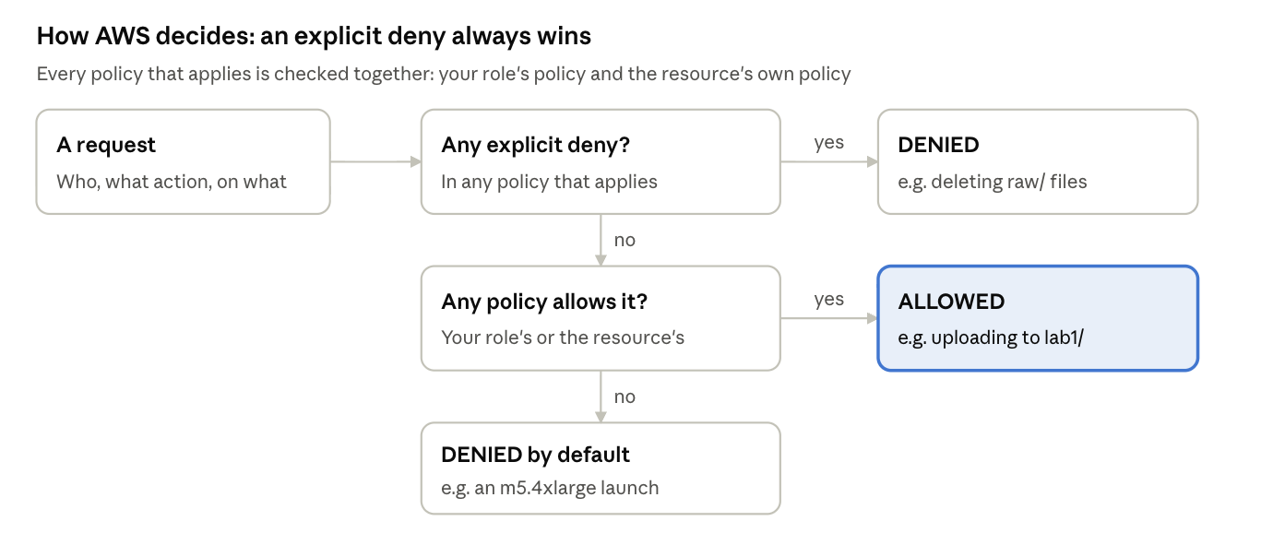
The order matters. AWS looks for a deny first, so a single deny overrides any number of allows. And if nothing mentions a request at all, the answer is still no. That's why your bucket policy can protect raw/ from you, even though your role is allowed to delete objects everywhere else.

Before you begin
- You should receive an invitation to join AWS Academy Learner Lab (housed in Canvas) during Monday of Week 1 of the course. If you did not receive an invitation, email the graduate assistant email address at dtsc_ga_620@eastern.edu.
- Open the Learner Lab page with the link in Brightspace and choose Start Lab. The first start can take a few minutes. Wait until the circle next to AWS turns green.
- Look at the top of the Learner Lab page for your budget, shown as Used $X of $Y. That's how much of your account's budget you've spent across the whole course. It updates a few times a day, not instantly, so a mistake can cost more than the number shows at first. Check it at the start of every lab.
- Also at the top of the Learner Lab page, a clock is counting down from 04:00. When the timer ends, AWS stops some resources, but nothing is deleted, and your next session picks up where you left off. If you need extra time during a session, hit Start Lab again, and you will get a fresh 4 hours.
- Download these five files from Brightspace (as a zip file; unzip them) and save them where you can find them.
File | What it's for
house-sales-2025.csv | 620 house sales in Riverbend, a fictional city. This is the raw dataset you protect.
house-sales-2025-overwritten.csv | The same file after a mistaken analysis saved over it
bucket-policy.json | The policy you apply to your bucket in Task 5
probe-permissions.sh | Tests what your identity can and can't do
verify-lab1.sh | The verification script for Task 7
The Learner Lab page also has an AWS Details button. It shows your session's remaining time and other details.

Task 1: Find your way around and set up your account
The AWS Management Console is the website where you manage everything in your account. You learn the four parts of it that come up in every lab, then set up two safeguards your account needs for the rest of the course: a default Region and budget alerts.
- On the Learner Lab page, choose the AWS link (next to the green dot). The console opens in a new browser tab. If nothing opens, allow pop-ups for the site and try again.
- The Region selector, in the top-right corner, shows where your resources are created. Choose it and select US East (N. Virginia) us-east-1. AWS runs separate data centers in many Regions around the world; Learner Lab lets you use only us-east-1 and us-west-2, and this course uses us-east-1. A resource created in another Region won't appear when us-east-1 is selected, which is the most common reason students think something vanished.
- The search box, at the top-left corner, finds any service. Type S3 and notice the result, then press Escape. You'll open services this way throughout the course. If you select the star next to the name of the service, the service will be pinned on the toolbar, which is very convenient!
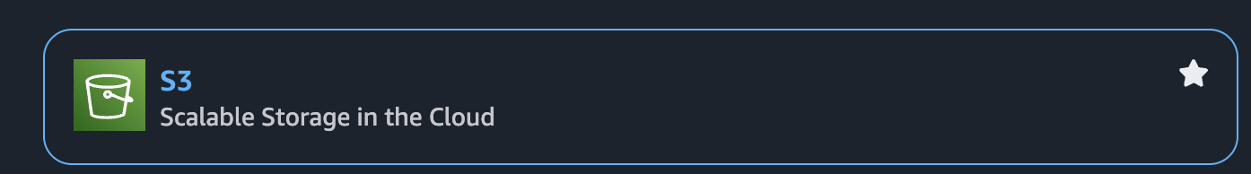

- The account menu is in the top-right corner, beside the Region. Choose it. It shows your account ID, a 12-digit number. Every resource you create belongs to this account. AWS uses it to identify your account in resource names and in the output of later scripts. Notice some features have “access denied”; that’s ok!
- Close the account menu. CloudShell is the terminal icon in the bar at the top of the console. You open it in Task 3; it's a Linux command line that's already signed in as you.

Learner Lab opens the console in us-east-1 for you, and its account settings are restricted, so there's no default Region to set. Still, glance at the Region selector at the start of every lab. If you switch Regions while exploring, the console stays in the new one until you switch back.

Create budget alerts
Your account has a budget of $50 for the whole term. The Learner Lab page shows how much you've used, but only if you look. AWS Budgets emails you when your spending crosses an amount you choose, so a forgotten server announces itself. You create three budgets:
Budget | Emails you when spending passes | What to do when it arrives
My Zero-Spend Budget | $0.01 | Nothing, usually: it confirms alerts reach you, and most labs spend a little.
Budget10 | $10 | Check that the last lab's cleanup ran and nothing is still running.
Budget_for_term | $45, which is 90% of your $50 | Stop. Run the last lab's cleanup script, check that nothing is running, and contact your instructor before doing more work.
Before you start, find the first and last dates of this 7-week term in your course schedule. You need them for Budget_for_term.
- In the console search box, search for and choose Billing and Cost Management. In the left navigation pane, choose Budgets, then Create budget.
- Create the zero-spend budget:
  - Budget setup: Use a template (simplified)
  - Templates: Zero spend budget
  - Budget name: keep My Zero-Spend Budget
  - Email recipients: your Eastern email address (include a personal email address, if you want)
  - Choose Create budget.
- Choose Create budget again and create Budget10. The wizard has five pages:
  - Choose budget type: under Budget setup, choose Customize (advanced). Leave Billing View - optional collapsed. Under Budget types, choose Cost budget - Recommended. Choose Next.
  - Set your budget: Budget name Budget10. Period Annually, with Budget renewal type Recurring budget. Budgeting method Fixed, with a budgeted amount of 10. Budget scope All AWS services. Choose Next.
  - Configure alerts: choose Add an alert threshold. Set Threshold to 100 and % of budgeted amount, Trigger to Actual, and Email recipients to your Eastern email address. Choose Next.
  - Attach actions: add nothing. Choose Next.
  - Review: check the settings and choose Create budget.
- Choose Create budget again and create Budget_for_term:
  - Choose budget type: Customize (advanced) and Cost budget - Recommended, as before. Choose Next.
  - Set your budget: Budget name Budget_for_term. Period Custom, with the Start date as today and the End date set to the last day of the term. Budgeting method Fixed, with a budgeted amount of 50. Budget scope All AWS services. Choose Next.
  - Configure alerts: choose Add an alert threshold. Set Threshold to 90 and % of budgeted amount, Trigger to Actual, and Email recipients to your Eastern email address. Choose Next.
  - Attach actions: add nothing. Choose Next.
  - Review: check the dates and amount, then choose Create budget.
- Check the Budgets list. It shows three budgets.
Checkpoint screenshot 1: Capture the Budgets list showing all three budgets (properly named), with your account name visible in the upper-right corner.
Budget_for_term measures exactly what Learner Lab measures: everything you spend from today’s date to the last day of the term, against your $50. Its alert comes at $45, leaving room to clean up before you reach the limit. Budget10 is an earlier, smaller warning that renews each year.
Budgets are a smoke alarm, not a circuit breaker. AWS updates billing data a few times a day, so an alert can arrive hours after the spending that caused it, and nothing stops your resources automatically. Cleaning up at the end of every lab is still what protects your account. Alert-only budgets like these don't add charges; don't add budget actions or reports, which can.

Task 2: Create your course bucket
Amazon S3 stores files, which S3 calls objects, in containers called buckets. You create one private bucket for the whole course. Datasets, code, models, and results will all live there, each lab in its own folder.
- In the console search box, search for and choose S3, then choose Create bucket.
- Configure:
  - AWS Region: US East (N. Virginia) us-east-1. If the form doesn't show a Region, confirm us-east-1 in the top-right corner.
  - Bucket type: General purpose
  - Bucket name: dtsc620-<firstname>-<lastname>-labs, using your own name in lowercase, for example dtsc620-jeff-eicher-labs
  - Object Ownership: keep ACLs disabled
  - Block Public Access settings for this bucket: keep Block all public access selected
  - Bucket Versioning: Enable
  - Keep the remaining defaults, including default encryption.
- Choose Create bucket.
Bucket names must be unique across every AWS account in the world, and can use only lowercase letters, numbers, and hyphens. If your name is taken, add a hyphen and the last four digits of your account ID, for example dtsc620-jeff-eicher-labs-4821.
Bucket Versioning keeps every version of every object. When someone saves over a file, the old version stays. It will be hidden but recoverable. You'll need it in Task 6.
- Choose your bucket's name to open it. Choose Create folder, enter raw, and choose Create folder. Create a second folder named lab1.
- Open raw/ and upload house-sales-2025.csv.
- Open lab1/ and upload house-sales-2025-overwritten.csv.
- Copy your exact bucket name into a note. You use it in CloudShell in Tasks 3, 6, and 7, and in every later lab.
The raw/ folder holds data exactly as it arrived, which no one should change. Later labs each get their own folder, such as lab2/. S3 has no real folders: an object's key is its full name, such as raw/house-sales-2025.csv, and the console shows the part before each slash as a folder.

Task 3: Find out who you are and what you can do
Every request to AWS comes from an identity, and IAM checks that identity's permissions before acting. You find out which identity you're using, then test a handful of requests to see which ones IAM allows.

Get the scripts into CloudShell
- In S3, open your bucket's lab1/ folder and upload probe-permissions.sh and verify-lab1.sh.
- Choose the CloudShell icon in the bar at the top of the console. It takes a minute to start the first time. Confirm the Region shown is us-east-1.
- Copy the two scripts from your bucket, replacing the bucket name with your own:
aws s3 cp s3://dtsc620-firstname-lastname-labs/lab1/probe-permissions.sh .
aws s3 cp s3://dtsc620-firstname-lastname-labs/lab1/verify-lab1.sh .
Be careful with these bash commands. They end with a space, then a period. I’ll highlight it here (and in future labs) so you don’t miss it.
When you paste multiple lines into CloudShell, a “safe paste” message will appear. This is a perfect time to remove -firstname-lastname and enter the name of your bucket.
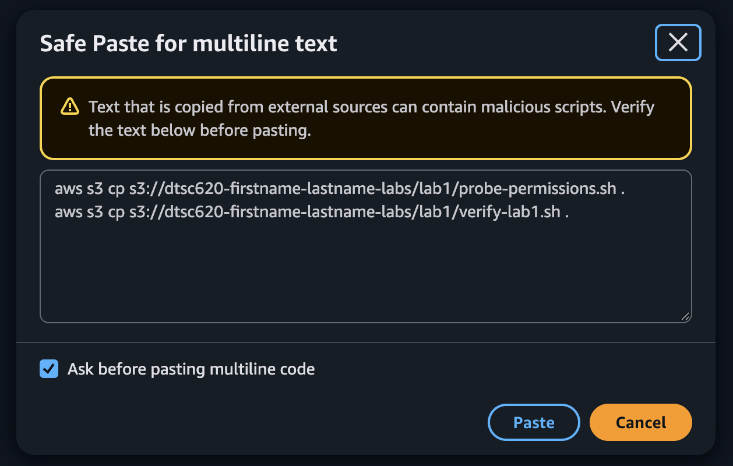
Every later lab gets its scripts the same way: you upload them to your bucket, then copy them into CloudShell.
Each line copies one file from your bucket into CloudShell. Read the first one in parts:
Part | Meaning
aws | The AWS command line tool, already installed and signed in as you in CloudShell
s3 cp | Use the S3 service to copy a file, like dragging it from one place to another
s3://dtsc620-firstname-lastname-labs/lab1/probe-permissions.sh | Where to copy from: your bucket's name, then the file's key, its folder and name
. | Where to copy to: a single period means "the folder I'm in right now," your CloudShell home folder
The files keep their names, so you now have probe-permissions.sh and verify-lab1.sh in CloudShell. Run ls to list them. CloudShell keeps your home folder between sessions, so you copy each file only once.
The console's Upload button puts files into S3, whereas aws s3 cp gets them out, onto whatever computer runs the command. Every later lab gets its scripts this way. You upload them to your bucket, then copy them into CloudShell. The same command, run on a server, is how your lab servers will fetch code and data.

Who are you?
- Ask AWS who you are:
aws sts get-caller-identity
The Arn field reads something like arn:aws:sts::123456789012:assumed-role/voclabs/user1234567=Your_Name. Read it in parts: your account ID, then assumed-role, then the role's name, voclabs, then a session name for you.
You are not an IAM user. An IAM user is a permanent identity with its own password or access keys that never expire. You're using a role: an identity anyone allowed can step into, receiving temporary credentials that expire. Learner Lab signs you in by giving you the voclabs role for the length of your session. Roles with temporary credentials are how AWS recommends people and programs work, because a leaked temporary key stops working on its own.

What can you do?
- We will clear the terminal, then run the permissions probe, giving it your bucket name so it can save a report:
clear
bash probe-permissions.sh dtsc620-firstname-lastname-labs
It tries eight requests and prints ALLOWED or DENIED for each. None of them creates anything that bills: the two instance launches are dry runs, which ask "would this be allowed?" without launching anything.
Checkpoint screenshot 2: Capture the probe's full output, with your account name visible in the upper-right corner.
- Compare your results with this table. Results for probes 4 and 5 can vary with Learner Lab's current settings; either answer teaches the same lesson.
Probe | Expected | What it shows
1, 2: list buckets, describe instances in us-east-1 | ALLOWED | Your role's policy allows everyday work in the course's Region.
3: describe instances in eu-west-1 | DENIED | A policy can limit where you act, not just what you do.
4, 5: read LabRole and its policies | ALLOWED, or DENIED | LabRole is a second role, made for AWS services such as EC2 and Lambda to use on your behalf in later labs.
6: create an IAM user | DENIED | Learner Lab's policy explicitly denies creating users, groups, and roles. That's why this course uses roles that already exist.
7: launch a t3.micro (dry run) | ALLOWED | Small instance types are permitted.
8: launch an m5.4xlarge (dry run) | DENIED | A policy condition limits instance size, protecting your budget. Same action as probe 7, different answer. An m5.4xlarge instance is about 75 times more expensive than t3.micro!
Probes 7 and 8 make the key point that permissions aren't just about which actions you can take. Conditions in a policy can allow an action in one situation and refuse it in another.

Task 4: Read a policy
Permissions are written as policies, which are JSON documents listing what's allowed or denied (JSON stands for “JavaScript Object Notation”). Before you apply one to your bucket, you read it.
- In S3, open your bucket's lab1/ folder and upload bucket-policy.json. Then select it and choose Open in the top right. The policy opens in a new browser tab; keep that tab open for Task 5. If your browser shows a formatted view with tabs, choose Raw Data to see the plain text. The policy has two statements. Here is the second:
{
"Sid": "ProtectRawData",
"Effect": "Deny",
"Principal": "*",
"Action": ["s3:DeleteObject", "s3:DeleteObjectVersion"],
"Resource": "arn:aws:s3:::BUCKET-NAME/raw/*"
}

Element | In this statement | Meaning
Sid | ProtectRawData | A label for people; AWS ignores it
Effect | Deny | Whether matching requests are allowed or denied
Principal | * | Who the statement applies to: here, everyone, including you
Action | s3:DeleteObject, s3:DeleteObjectVersion | Which requests it covers: deleting an object or one of its versions
Resource | arn:aws:s3:::BUCKET-NAME/raw/* | Which things it covers: every object under raw/ in your bucket
- Find the first statement, DenyInsecureConnections. It adds a fifth element, a Condition: it denies every action (s3:*) on the bucket when aws:SecureTransport is false, that is, when a request arrives over plain HTTP instead of encrypted HTTPS.
There are two kinds of policy here. Your voclabs role has an identity-based policy, attached to you, listing what you may do anywhere. This bucket policy is a resource-based policy, attached to the bucket, listing what anyone may do to it. AWS considers both for every request and follows three rules:
- Default deny: if no policy allows a request, it's denied.
- Allow: if a policy allows it and none denies it, it's allowed.
- Explicit deny wins: if any policy denies it, it's denied, no matter what else allows it.

- Using those rules, predict the result of each request after you apply this bucket policy. Write your predictions down; Tasks 5 and 6 test them.
Request | Your prediction
A. Delete raw/house-sales-2025.csv
B. List the bucket over plain HTTP
C. Upload a new file to lab1/
D. Save a different file over raw/house-sales-2025.csv
Request D is the subtle one. Look closely at which actions the policy denies.

Task 5: Protect the raw data with a bucket policy
You apply the policy, then test your predictions for requests A, B, and C.

Apply the policy
- In S3, open your bucket and choose the Permissions tab. Under Bucket policy, choose Edit.
- Copy the entire contents of bucket-policy.json and paste them into the policy editor. Don’t forget to include the braces!
- Replace BUCKET-NAME with your exact bucket name in all three places it appears. Leave everything else as it is.
- Choose Save changes. If the console reports an error, check that you replaced all three and kept every quotation mark and bracket.

Test request A: delete a raw file
- Open raw/, select house-sales-2025.csv, and choose Delete. Type delete to confirm, and choose Delete objects.
The console reports that the deletion failed, with an access-denied error. Your voclabs role is allowed to delete objects, but the bucket policy explicitly denies it for anything under raw/, and an explicit deny wins.
Checkpoint screenshot 3: Capture the failed-deletion message, the “failed to delete” information (showing the CSV) and make sure your account name is visible in the upper-right corner. Then choose Close.

Test request B: use plain HTTP
- In CloudShell, clear the previous commands and list your bucket over HTTPS, the normal way, then over plain HTTP, replacing the bucket name with your own:
clear
aws s3 ls s3://dtsc620-firstname-lastname-labs/raw/
aws s3 ls s3://dtsc620-firstname-lastname-labs/raw/ --endpoint-url http://s3.amazonaws.com
The first works. The second fails with AccessDenied: the same request, refused only because it wasn't encrypted. That's the Condition at work.

Test request C: upload outside raw/
- Upload a file to lab1/:
aws s3 cp verify-lab1.sh s3://dtsc620-firstname-lastname-labs/lab1/verify-lab1.sh
It works. The policy denies only what it names; everything else is still decided by your role's own permissions.
The policy doesn't stop you from changing or removing the policy itself. That's deliberate: a policy that denied policy changes could lock everyone out of the bucket for good. Keep this policy in place for the rest of the course; later labs work only in their own folders, and none of them delete anything under raw/.

Task 6: Recover from a mistake with versioning
A teammate filtered the sales file for one analysis and saved the result over the raw file, dropping a neighborhood and renaming a column. You reproduce the mistake, which tests request D, then undo it.

Make the mistake (request D)
- In CloudShell, copy the overwritten file on top of the raw one, replacing the bucket name in both places:
aws s3 cp s3://dtsc620-firstname-lastname-labs/lab1/house-sales-2025-overwritten.csv s3://dtsc620-firstname-lastname-labs/raw/house-sales-2025.csv
It works. The policy denies deleting raw files, not writing them, so saving over one is allowed. Did you predict that? Policies do exactly what they say, which isn't always what you meant.
- Look at the damage. The first command shows the header; the second counts lines:
aws s3 cp s3://dtsc620-firstname-lastname-labs/raw/house-sales-2025.csv - | head -2
aws s3 cp s3://dtsc620-firstname-lastname-labs/raw/house-sales-2025.csv - | wc -l
The header now says price where it used to say sale_price, and the file has 472 lines instead of 621. Every Maple Park sale is gone.

Find the original
If you open raw/ in the S3 console now, you see only one house-sales-2025.csv: the damaged one, with today's time and a smaller size. The original hasn't been deleted, but the console's normal view shows just the latest version of each object and hides the rest. Older versions appear only when you turn on Show versions, which you do in step 6. To restore the original, you need its version ID, so you list the versions in CloudShell.
- List the file's versions:
aws s3api list-object-versions --bucket dtsc620-firstname-lastname-labs --prefix raw/house-sales-2025.csv --query 'Versions[].[VersionId,LastModified,Size,IsLatest]' --output table
There are two versions. The current one (IsLatest True) is 31,171 bytes; the original is 41,205 bytes and older. Copy the original's VersionId, a long string of letters and numbers.

Restore it
- Copy the original version back on top, replacing the bucket name in both places and pasting the version ID:
aws s3api copy-object --bucket dtsc620-firstname-lastname-labs --key raw/house-sales-2025.csv --copy-source "dtsc620-firstname-lastname-labs/raw/house-sales-2025.csv?versionId=PASTE-VERSION-ID"
- Check it: run the two commands from step 2 again. The header says sale_price again, and the file has 621 lines.
- In the S3 console, open raw/ and turn on Show versions. The file now has three versions: the original, the mistake, and the restored copy on top.
Checkpoint screenshot 4: Capture the three versions with Show versions on, with your account name visible in the upper-right corner.
You restored by copying the old version forward rather than deleting the bad one. You had to do it this way, because the policy denies deleting versions under raw/. The result is a full history: anyone can see that the file was overwritten and when, which matters when a model's results suddenly change and someone asks whether the training data did.

Task 7: Verify your work with CloudShell
Every lab in this course ends with a verification script that checks your work and prints PASS or FAIL for each requirement. This one checks 19.
- In CloudShell, clear the previous output and run the script you copied in Task 3:
clear
bash verify-lab1.sh
- Every line should start with PASS, and the last line should read Result: 19 passed, 0 failed.
- If any line shows FAIL, its message says what was expected and what was found. Fix that item, then run bash verify-lab1.sh again.
The script checks | Set in
A zero-spend budget, Budget10 at $10, and Budget_for_term at $50 over a custom period of 60 days or less with an 90% alert, each budget with an email alert | Task 1
Your bucket exists in us-east-1 with the course naming pattern, Block all public access on, and versioning enabled | Task 2
The probe ran as an assumed role, creating an IAM user and using eu-west-1 were denied, and a t3.micro dry run was allowed | Task 3
The bucket policy denies plain-HTTP requests and deletions under raw/ | Task 5
raw/house-sales-2025.csv has at least three versions, and the current one matches the original upload | Task 6
lab1/ holds the overwritten file, and no EC2 instances are running | Tasks 2 and 6
Checkpoint screenshot 5: Capture the full script output, from the header line with your account ID through the Result line. Include the console's top bar so your account name in the upper-right corner shows.

Task 8: End your session
Most labs end with a cleanup task that deletes billable resources. This lab created nothing that bills by the hour: the bucket and its few files cost a fraction of a cent a month, and you keep them for the course.
- Close CloudShell.
- On the Learner Lab page, choose End Lab and confirm.
Ending the lab ends your session: your temporary credentials expire, and the console stops working until you choose Start Lab again. Your bucket, its files, and its policy stay exactly as you left them.

Reflection questions (optional)
Answer each in one or two paragraphs, referring to what you did in this lab.
1. Least privilege for a data team. Riverbend's data team has three kinds of people: data engineers, who load new raw data each month; analysts, who read raw data and write cleaned datasets; and a dashboard, which only reads cleaned data. Using the elements you learned (Effect, Action, Resource, and Condition), describe what each should be allowed to do with the raw/ folder and with a clean/ folder. Then explain why your Task 6 mistake could still happen under your policy, and name one change, to the policy or to the team's habits, that would prevent it.
2. Keys versus roles. Developers sometimes paste long-term access keys into a notebook or script so it can read data from S3, and those notebooks sometimes end up in public code repositories. Compare that with the temporary role credentials you used today. What happens in each case if the credentials leak? Why will the later labs in this course, which run code on servers and in AWS Lambda, give that code a role instead of a key?

