Reports: A Student
The SCoR Hub · How-to guide · v0.6.0
Purpose
This guide tells you how to view the result history and the progress of one student.
Before you start
• Sign in to the app. See "Access the App and Sign In".
• Open Reports and find the student. See "Reports: Class and Cohort".
Open a student
1. On the Reports table, click the name of the student.
2. Wait for the student page. The title is the name of the student.
Read the page
• The line under the name shows the grade, program, school, homeroom, and IPP status.
• Click "Reading" or "Writing" to change the subject.
• "Assessment history" - a table with one row for each result (Cycle, Date, Level, Δ, Achievement).
• "Reading level over time" or "Writing average over time" - a chart of the progress.
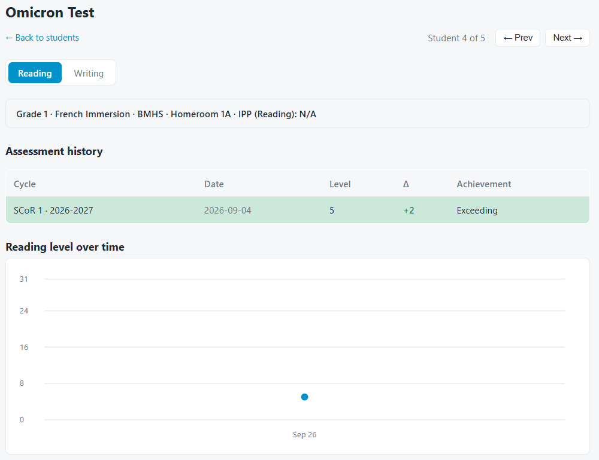
Move to another student
• Click "Next →" to open the next student.
• Click "→ Prev" to open the previous student.
• Click "→ Back to students" to return to the group.
Note: If the student has a confirmed IPP, the app does not show an achievement band. The app tracks the student for personal progress.

