Access the App and Sign In
Short Cycles of Response App

Purpose
This guide tells you how to open the Short Cycles of Response app. It also tells you how to sign in with your TCRCE Microsoft account.

Before you start
- Use a supported web browser. For example, use Google Chrome, or Firefox.
- Get your TCRCE Microsoft account (Entra ID) and Multi-Factor Authentication app/device ready.

Sign in
- Open your web browser.
- Go to https://data.tcrce.ca.
- Click "Sign in" at the top right.
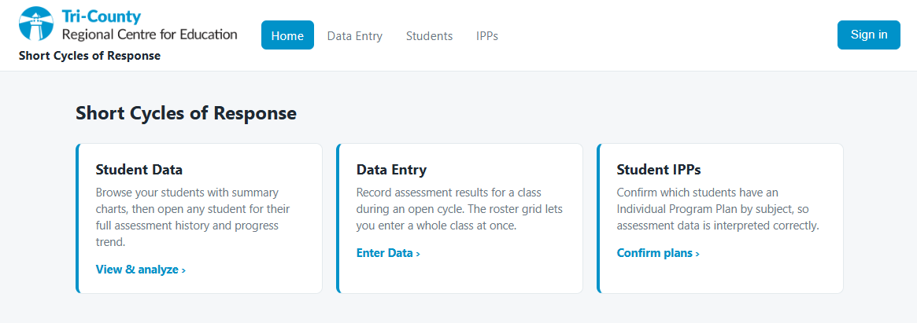
- If your browser is already signed in, you should just be logged in, if not:
  - Wait for the Microsoft sign-in page.
  - Type your TCRCE email address.
  - Click "Next".
  - Type your password.
  - Click "Sign in".
  - If the system asks, approve the sign-in request on your phone.
  - Wait for the app home page.
- Make sure the page shows "Welcome back" and your name.
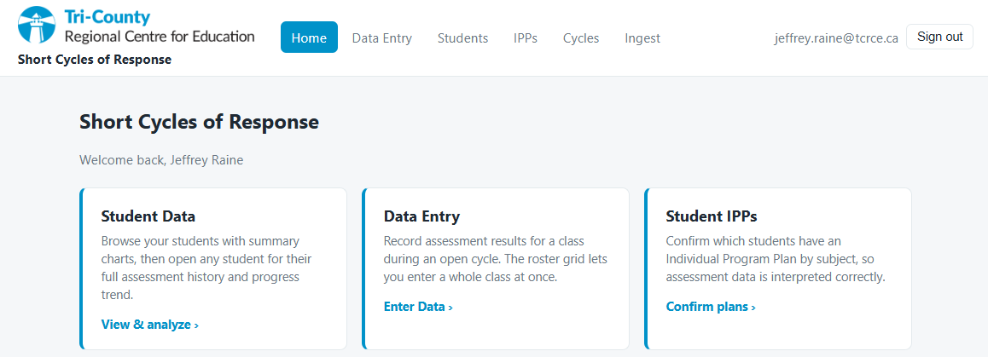

The home page menu
The home page shows one card for each task. Click a card to start the task.
- "Student Data" — view your students and their data.
- "Data Entry" — record results for a class.
- "Student IPPs" — confirm which students have an Individual Program Plan.
Note: You do not see every card. The app shows only the cards for your role.

Sign out
- To sign out, Find your name at the top right.
- Click "Sign out".

