Enter Writing Data

Purpose
This guide tells you how to record writing scores for a class in a writing cycle.

Before you start
- Sign in to the app. See the "Access the App and Sign In" handout.

Open the class roster
- Click "Data Entry" in the top menu.
- Find the "Writing" section.
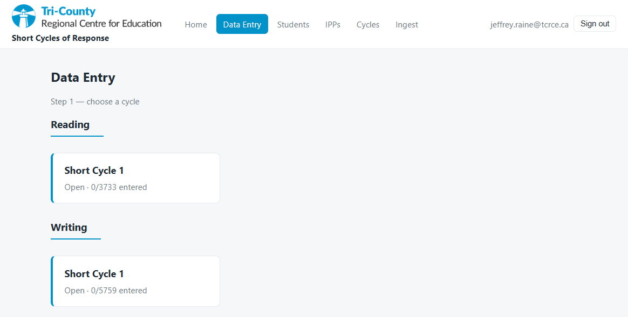
- Click the writing cycle card for your class.
- Look at "Step 2 — choose a group".
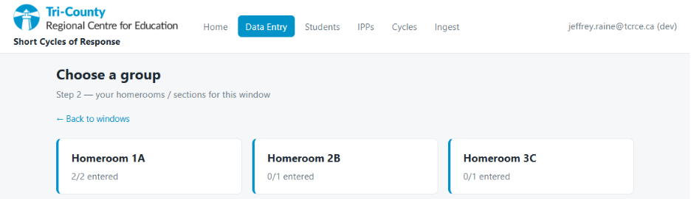
- Click the card for your homeroom or section.
- Wait for the roster grid.

Show a small group (optional)
You can show only the students in the small group that you pulled aside. This step is optional.

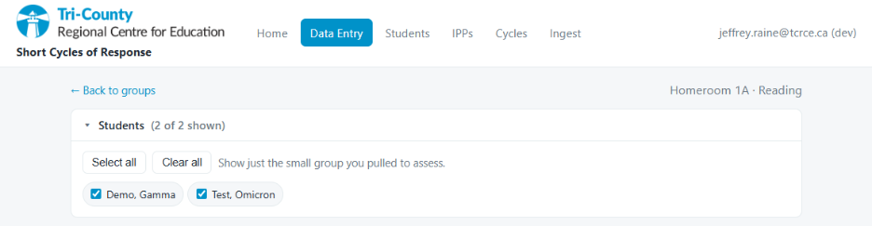
- Click "Students (N of M shown)" above the grid.
- Click "Clear all".
- Select the checkbox for each student that you want to show.
- Click "Students" again to close the list.
Note: The app keeps your entries for hidden students. Hidden students still save.

The four traits
A writing result has four traits. You must give a score from 1 to 4 for each trait.
- "Ideas"
- "Org." — Organization
- "Lang." — Language
- "Conv." — Conventions

Enter and save writing scores
- Find the student row.
- In the "Ideas" column, open the dropdown.
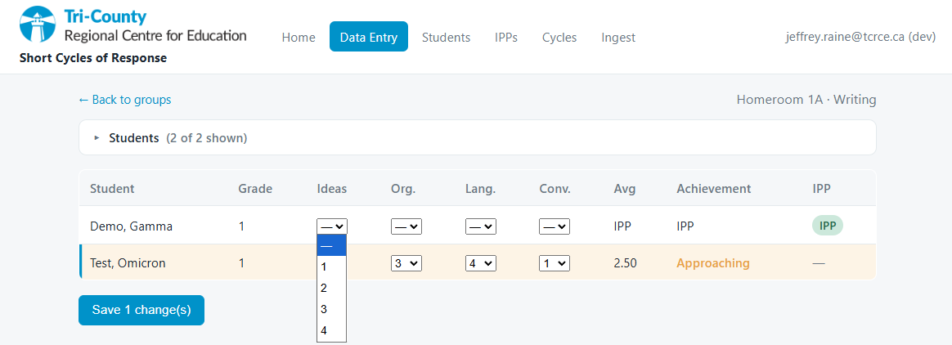
- Select a score from 1 to 4.
- Do the same for the "Org.", "Lang.", and "Conv." columns.
- Look at the "Avg" column. It shows the average of the four scores.
- Look at the "Achievement" column. It shows the band.
- Do the same for each student.
- Click "Save N changes" at the bottom.
- Wait for the message "Saved N".
Note: You must give all four scores for a student. If one score is empty, the app does not save that row. The app shows "All four traits required — not saved".

