View Cohort Student Data

Purpose
This guide tells you how to view your students as a group. You can filter the group, view charts, and select specific students to view their individual data.

Before you start
- Sign in to the app. See the "Access the App and Sign In" handout.

Open the cohort page
- Click "Students" in the top menu.
- Look at the page title "Student Data".
- Click "Reading" or "Writing" to choose the subject.

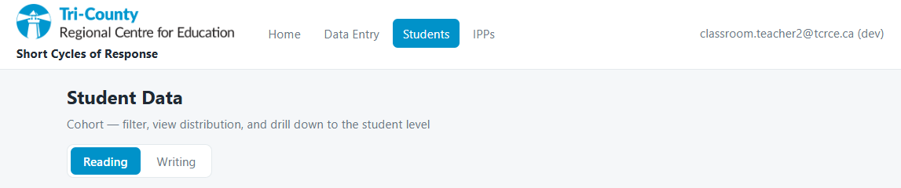

Filter the group
- Click "Show filters".
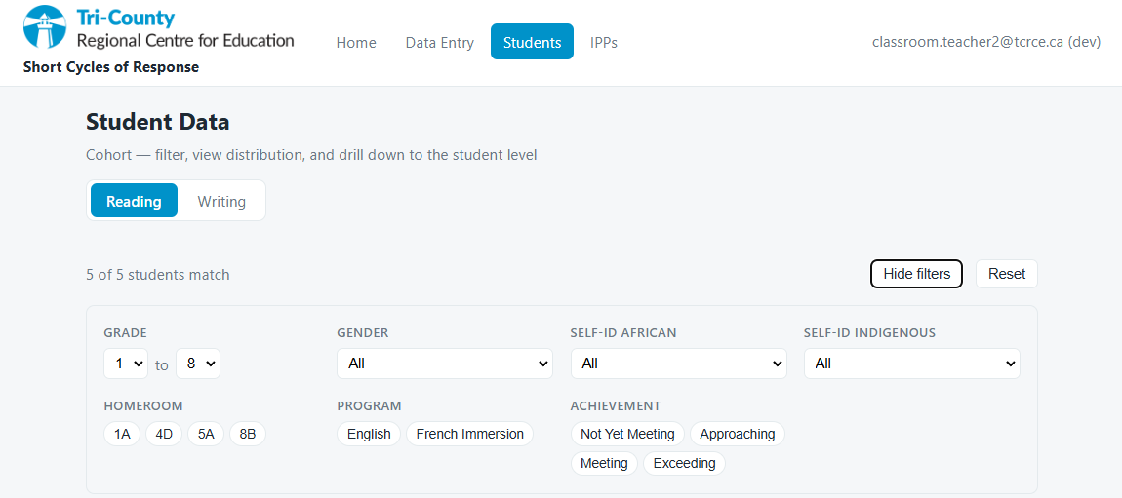
- Set the "Grade" range with the two dropdowns.
- Use the other filters to narrow the group. For example, use "Homeroom" or "School".
- Look at the count. It shows how many students match.
- Click "Reset" to clear the filters.

Read the charts
- "Current achievement distribution" — a donut chart. The center shows how many students have a result.
- "Achievement by month (last 6 months)" — a bar chart.
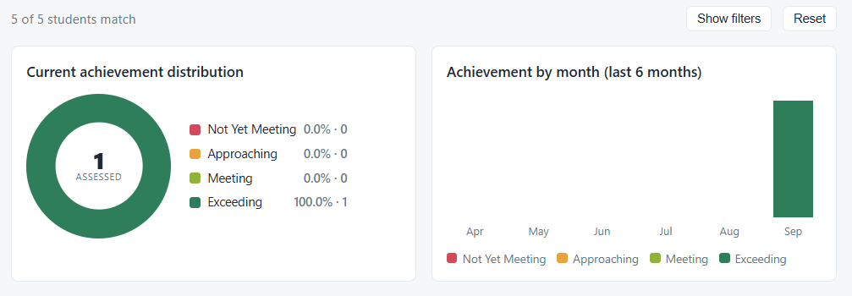
Note: The charts do not count students with an Individual Program Plan. The charts do not count students without a result.

Open one student
- Find the student in the table.
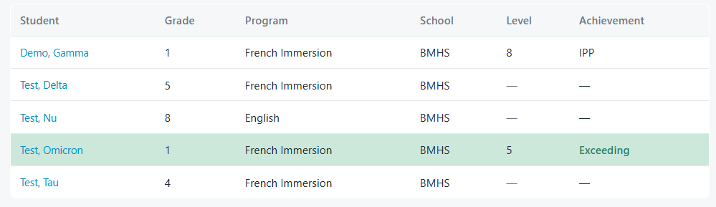
- Click the name of the student.
- Wait for the student page.
Note: For the individual student page, see "View an Individual Student".

