View an Individual Student
Short Cycles of Response App — Simplified Technical English (ASD-STE100)

Purpose
This guide tells you how to view the result history and the progress of one student.

Before you start
- Sign in to the app. See the "Access the App and Sign In" handout.
- Open the "Student Data" page. See "View Cohort Student Data" handout.

Open a student
- On the "Student Data" page, find the student in the table.
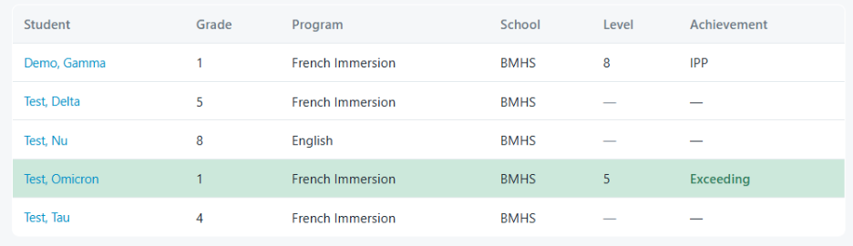
- Click the name of the student.
- Wait for the student page. The title is the name of the student.

Read the page
- The line under the name shows the grade, program, school, homeroom, and IPP status.
- Click "Reading" or "Writing" to change the subject.
- "Assessment history" — a table with one row for each result.
- "Reading level over time" or "Writing average over time" — a chart of the progress.
*See other side for individual student screenshot.
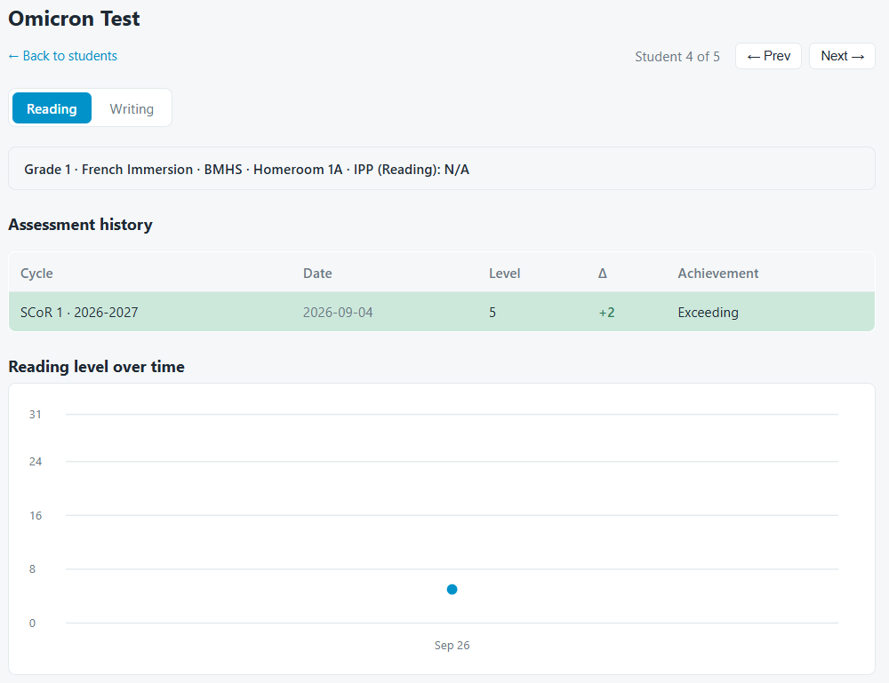

Move to another student
- Click "Next →" to open the next student.
- Click "← Prev" to open the previous student.
- Click "← Back to students" to return to the group.
Note: If the student has a confirmed Individual Program Plan, the app does not show an achievement band. The app tracks the student for personal progress.

