Confirm Student IPPs

Purpose
This guide tells you how to confirm which students have an Individual Program Plan. The app uses this to read and interpret the data correctly.

Before you start
- Sign in to the app. See the "Access the App and Sign In" handout.

About IPP confirmation
PowerSchool let’s the app know which students have an Individual Program Plan but can not tell it which subject area(s) that plan may be for. You confirm therefore need to clarify for the app if it applies to literacy, math, both, or neither. You do not create the plan in the app.

Open the IPP page
- Click "IPPs" in the top menu.
- Look at the page title "IPP Subject Confirmation".
- Look at the count. It shows how many students still need confirmation.

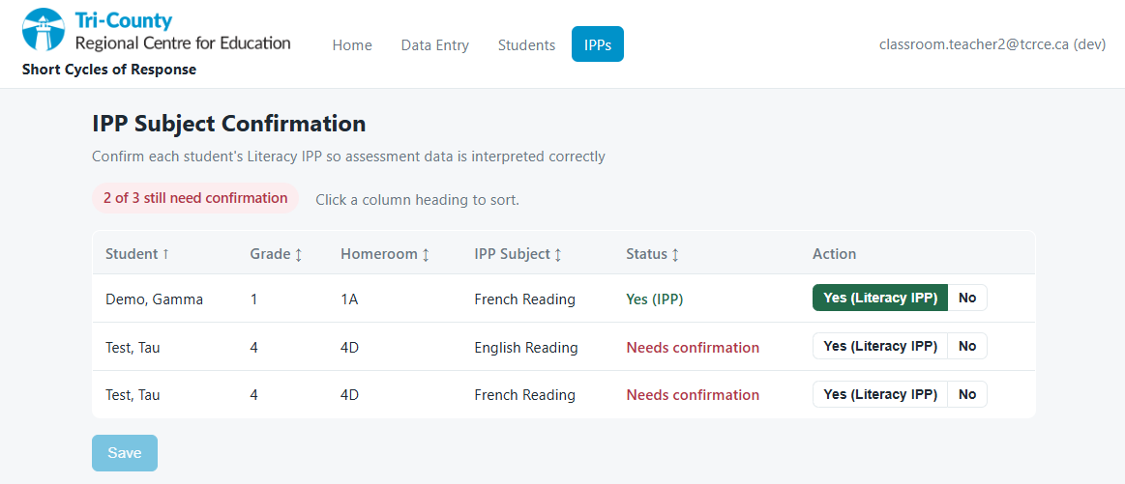

Confirm a student
- Find the student row.
- Read the "IPP Subject" column. For example, it shows "English Reading".
- To confirm the plan, click "Yes (Literacy IPP)".
- If the student does not have the plan, click "No".
- Do the same for each student who has an IPP according to PowerSchool.
- Click "Save N changes".
- Wait for the message "Saved N".
Note: The app does not save your choice until you click Save. To undo a choice before you save, click the same value again.

Confirm on the roster
You can also confirm a Literacy IPP on the reading roster or the writing roster. The "Yes (Literacy IPP)" and "No" buttons show in the "IPP" column. The app saves your choice when you save the roster.

