Reports: Class and Cohort
The SCoR Hub · How-to guide · v0.6.0
Purpose
This guide tells you how to view your students as a group. You can filter the group, read charts, and open one student.
Before you start
• Sign in to the app. See "Access the App and Sign In".
Open Reports
1. Click "Reports" in the top menu.
2. Choose a group. See "Choose a Class or Group".
3. Click "Reading" or "Writing" to choose the subject.
Note: Reports shows Reading and Writing. Math reporting is not in Reports yet.
Filter the group
1. Click "Show filters".
2. Set the "Grade" range with the two dropdowns.
3. Use the other filters to narrow the group. For example, use "Homeroom", "School", "Program", or "Achievement".
4. Look at the count. It shows how many students match.
5. Click "Reset" to clear the filters.
Read the charts
• "Current achievement distribution" - a donut chart. The center shows how many students have a result.
• "Achievement by month (last 6 months)" - a bar chart.
Note: The charts do not count students with an IPP. The charts do not count students without a result.
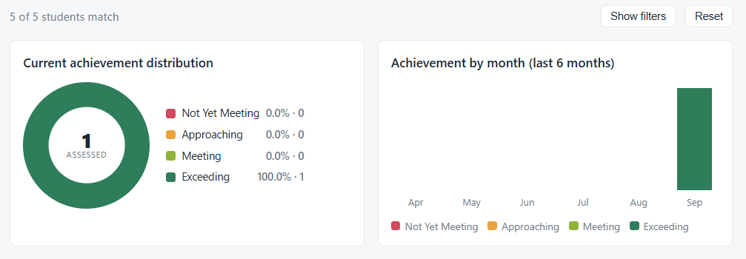
Open one student
1. Find the student in the table.
2. Click the name of the student.
3. Wait for the student page. See "Reports: A Student".
